
Cyber Offence
Assessment S1: Cyber offence simulations
Module Coordinator: Francis Nwebonyi
Marker: Francis Nwebonyi

Date of submission: 31/07/2025
Number of words: 5100~

Methodology and Theory subjects:
- Introduction to pen-testing. (ImmersiveLabs, 2025) “
  - Infrastructure.
    - Basic infrastructure (model, hardware, storage devices, networks)
    - The cloud
    - Hypertext Transfer Protocol (HTTP/HTTPS)
    - File Transfer Protocol (FTP)
    - Server Message Block (SMB)
    - Secure Shell (SSH)
    - Telnet
    - Simple Mail Transfer Protocol (SMTP)
    - Domain Name System (DNS)
  - Mobile applications.
    - Static analysis
    - Dynamic analysis
    - Rooted/jailbroken phone
    - Proxies
    - Report everything
    - Obfuscated code
    - Certificate pinning
    - Integrity checks
  - Web Applications.
    - Injection (SQL, NoSQL, LDAP, code, etc.)
    - Cross-site scripting (XSS)
    - Authentication bypass
    - Broken access control
    - Outdated software
  - The Basics.
    - Reconnaissance
    - Scanning
    - Gaining access
    - Maintaining access
    - Covering tracks (cleanup)
    - Pivoting
    - Reporting
    - ”(ImmersiveLabs, 2025)
- IoT & Embedded Devices. (ImmersiveLabs, 2025b) “
  - What is IoT.
    - IoT at home
    - IoT in the workplace
  - Security issues.
    - Real-world examples
    - Embedded
    - APIs
    - Default credentials
    - DDoS/Botnet
  - Network protocols and security.
    - Transport Layer Security (TLS)
    - SSL splitting attack
    - Server & Client-side certificates
    - User Datagram Protocol (UDP)
    - Universal Plug & Play (UPnP)
    - Nat
    - Radio communication protocols (Zigbee & Z-Wave)
  - Hardware reverse engineering.
    - Pseudorandom number generators (PRNGs)
    - Firmware extraction via Universal Asynchronous Receiver/Transmitter (UART)
    - Joint Test Action Group (JTAG)
    - eMMC/Flash Chip
    - Buffer overflow
    - Static Keys
  - Best practice for embedded devices.
    - Security based mindset
    - Clear, simple, secure firmware update mechanisms
    - Only push HTTPS to authorised clients
    - Implement TLS as much as possible
    - Disable UART and JTAG post-production
    - Implement password wall for root-shell if needed
    - Set bootloader delay to 0
    - Set bootloader fail-secure to auto-shutdown
    - Store filesystem with LUKS encryption
    - Custom bootloader
    - Reverse engineering countermeasures
    - ”(ImmersiveLabs, 2025b).

Lab Findings and Vulnerability assessment
- Introduction to penetration-testing.
  - Infrastructure (ImmersiveLabs, 2025).
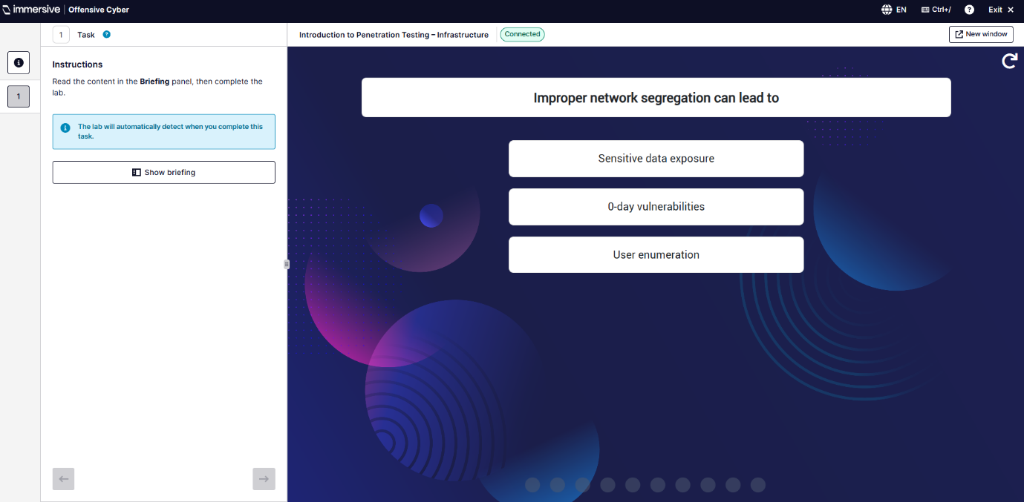
All these were multiple choice questions.
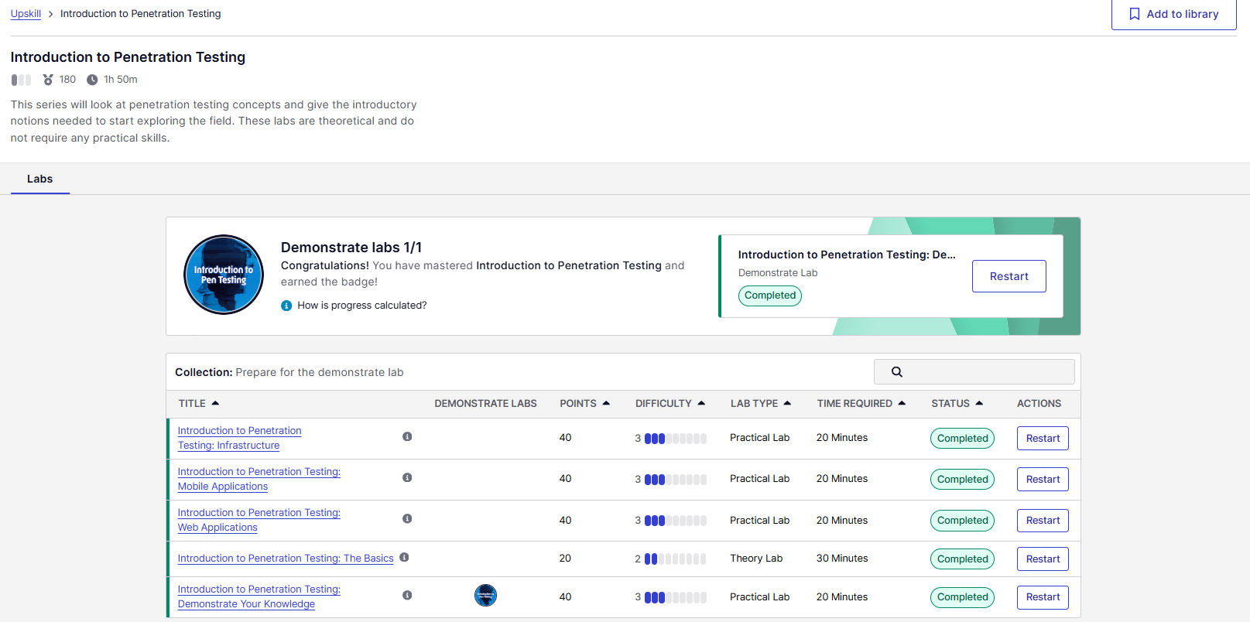
This is a screenshot of all of them being completed.
- OSINT. (ImmersiveLabs OSINT, 2025) “
  - Cached and Archived Websites.
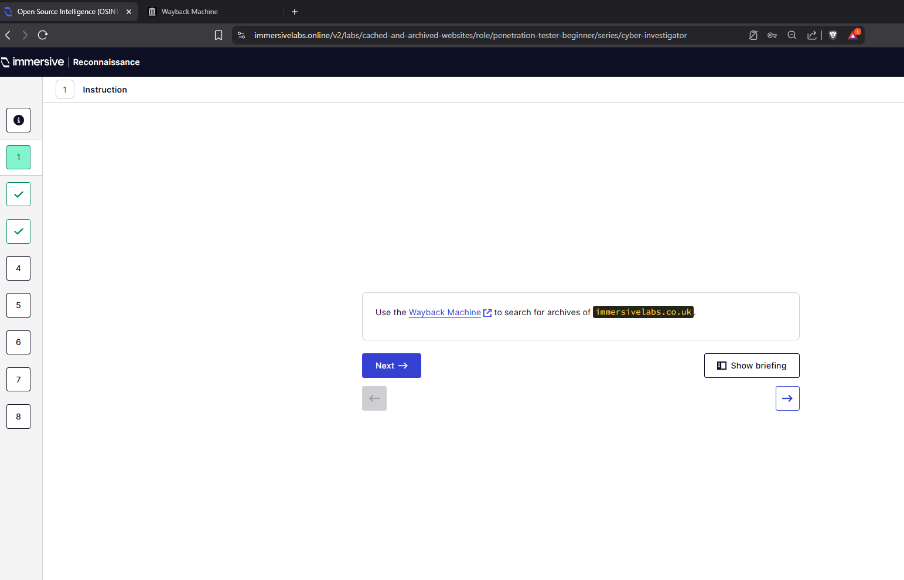
Q1 - Use Wayback Machine to search for archives of immersivelabs.co.uk.

Q2 - What is the first date or snapshot?
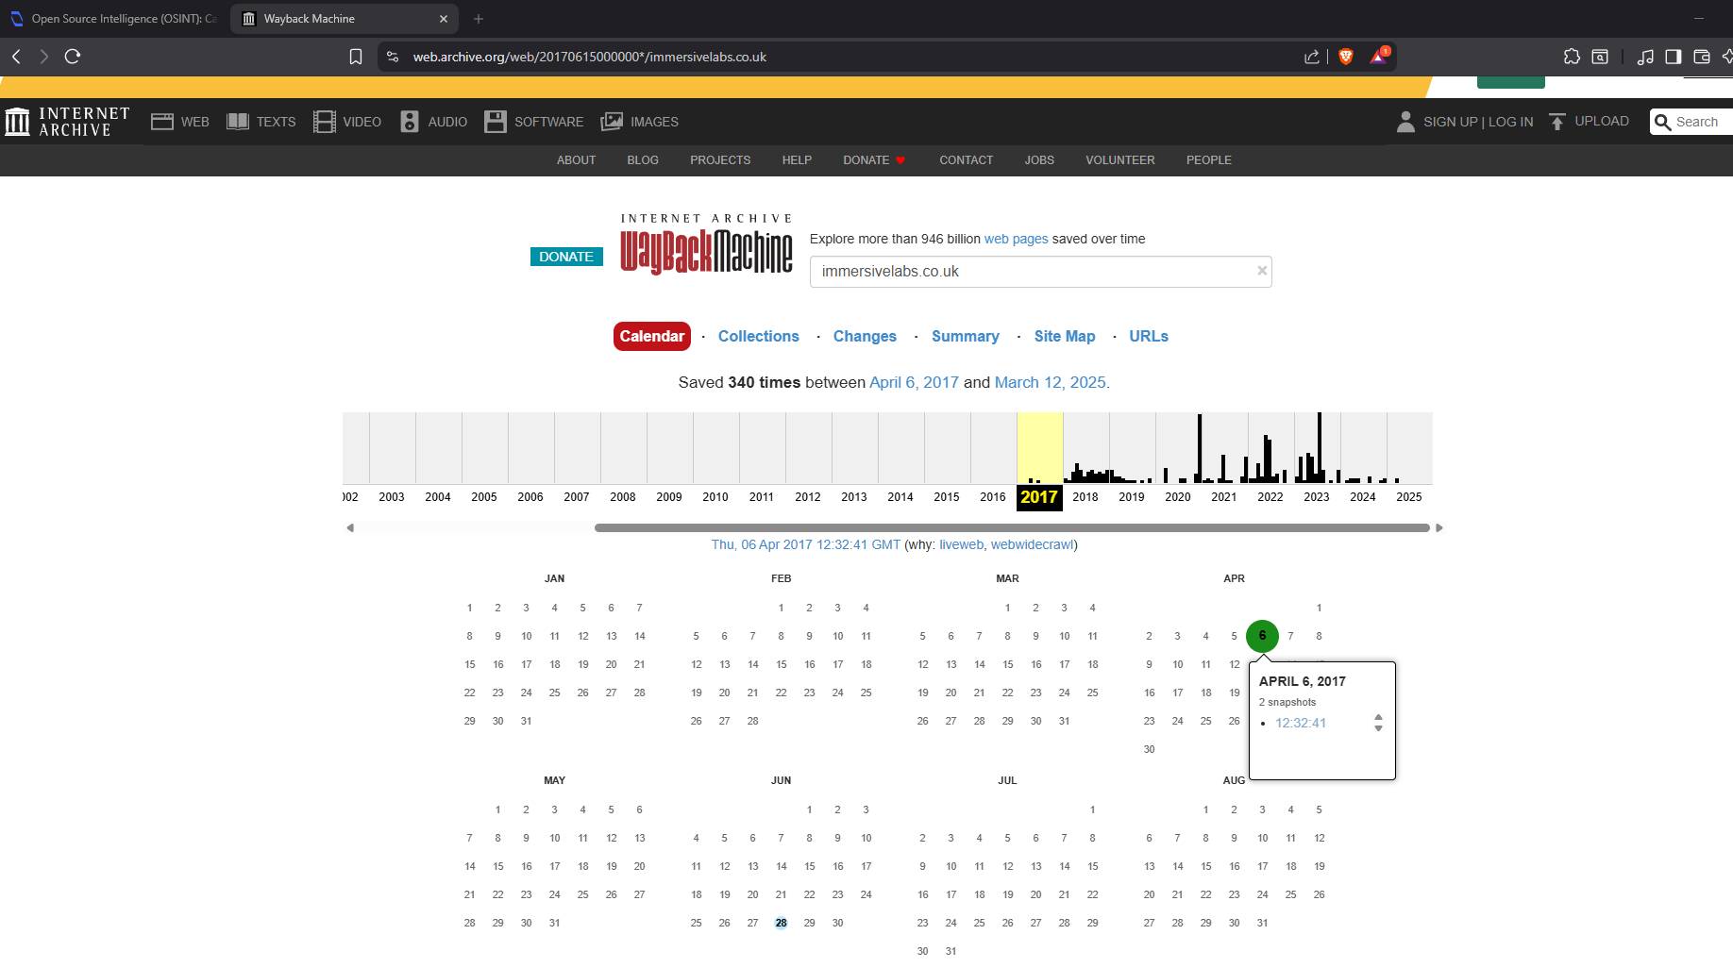
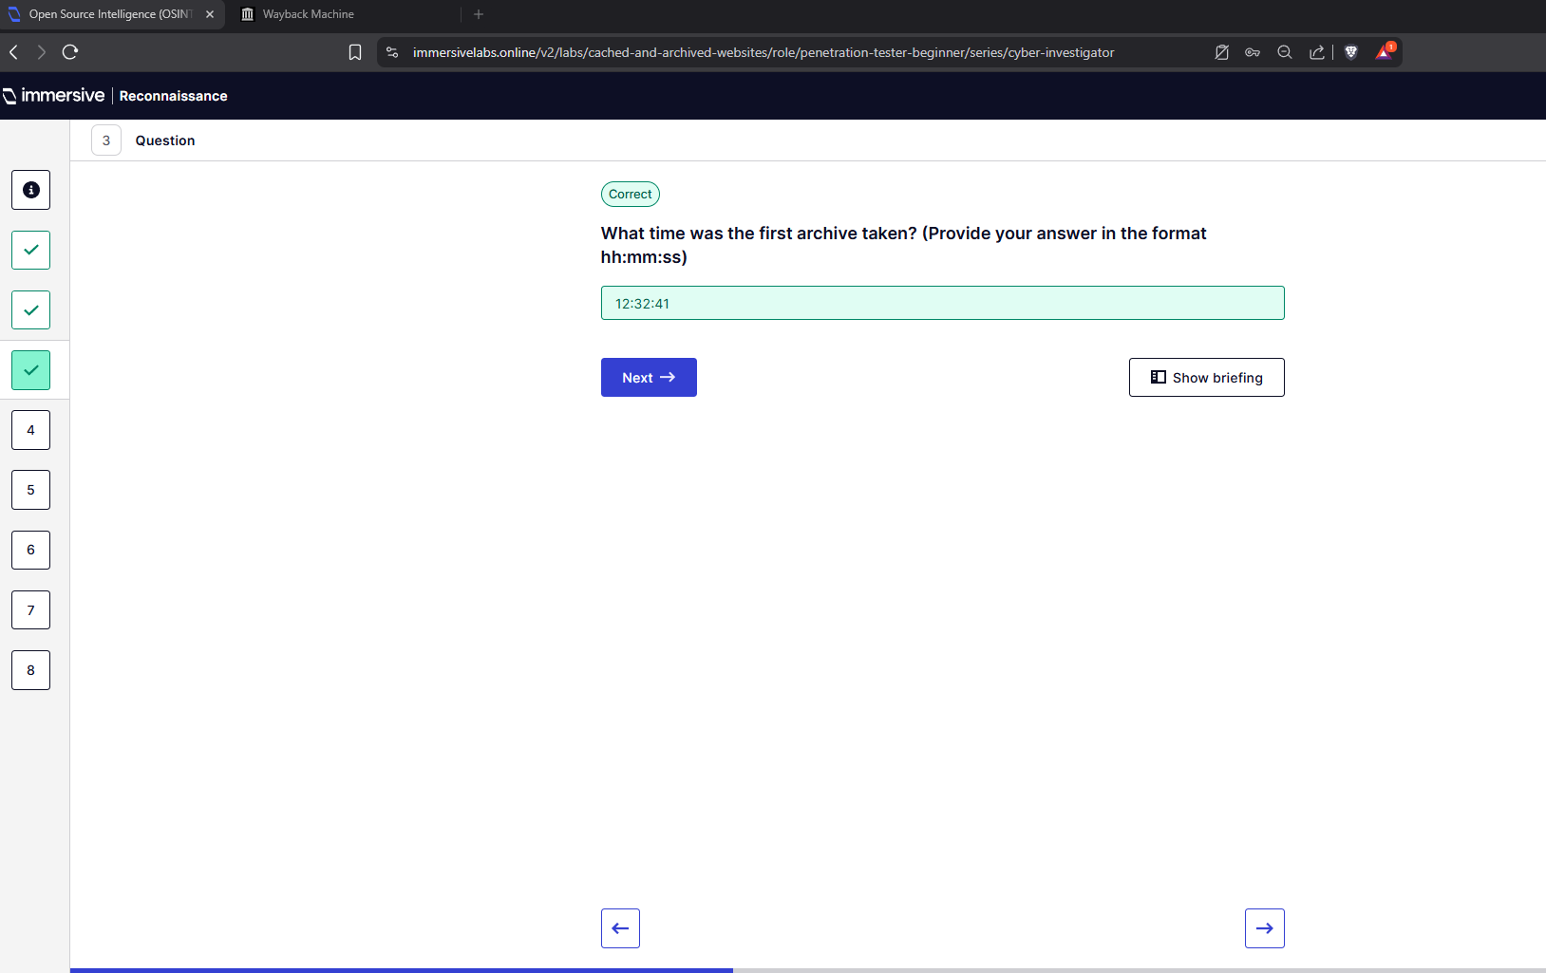
Q3 – What time was the first archive taken?

Q4 – Find the snapshot taken on May 7th, 2021.
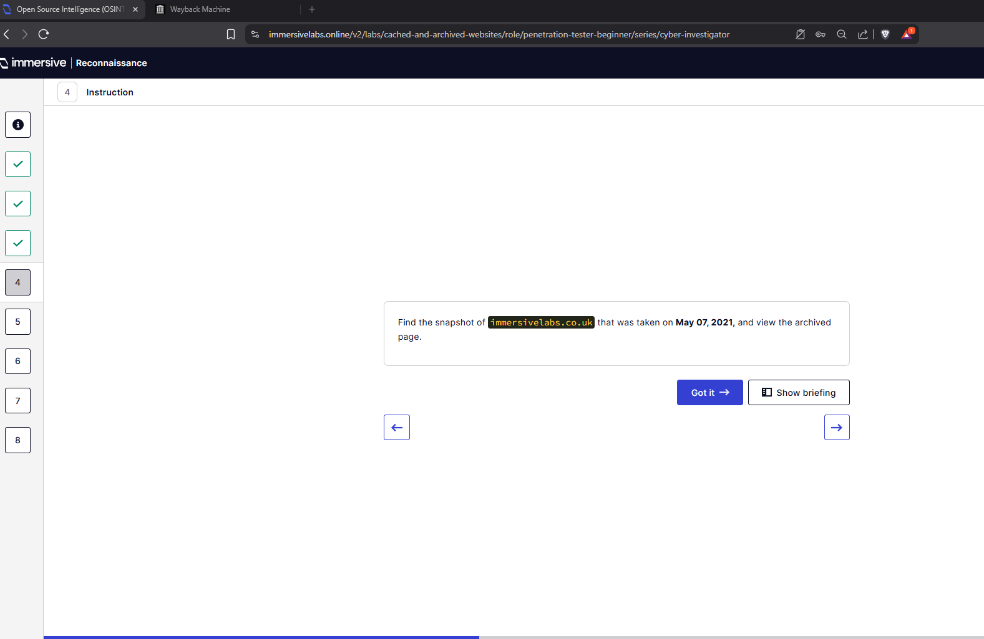
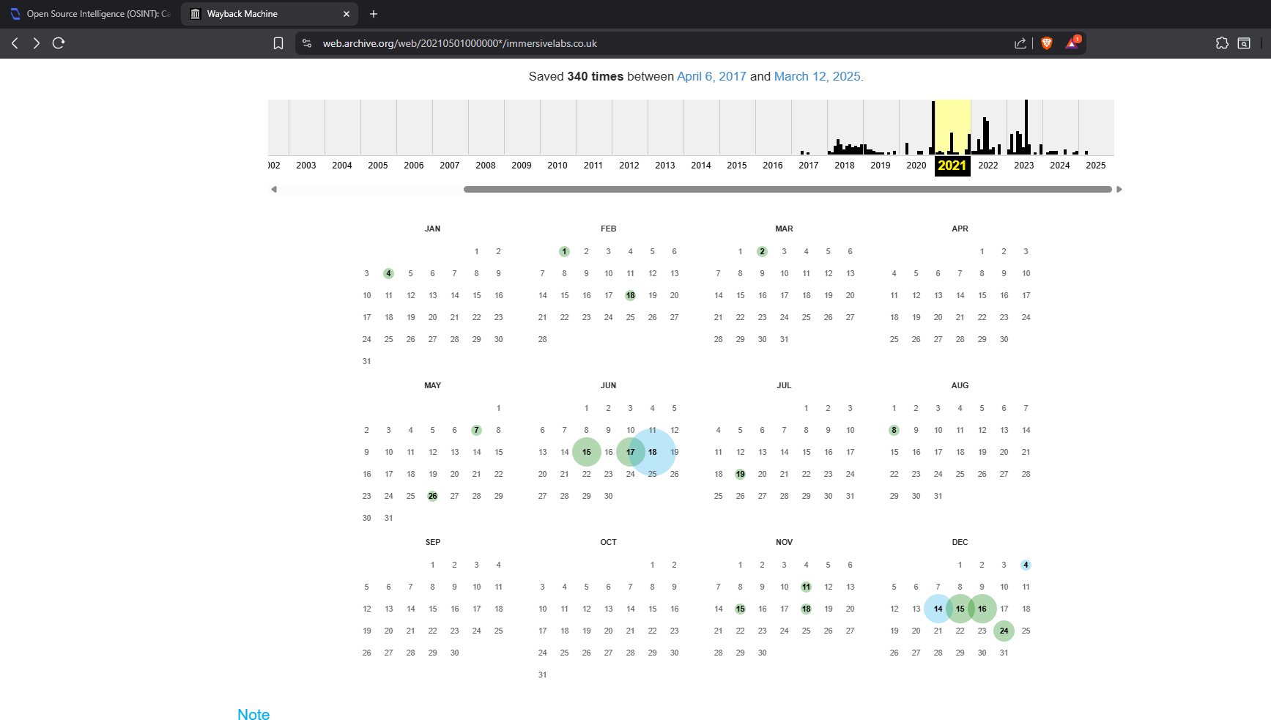
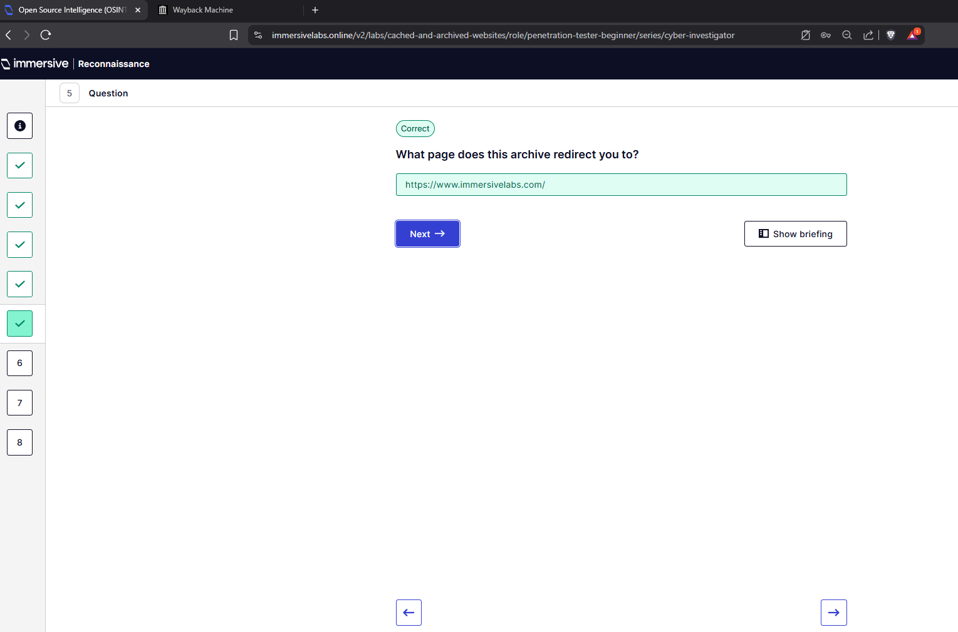
Q5 – What page does this archive redirect you to?

Q6 – What date was the Interdependence and teamwork blog posted?
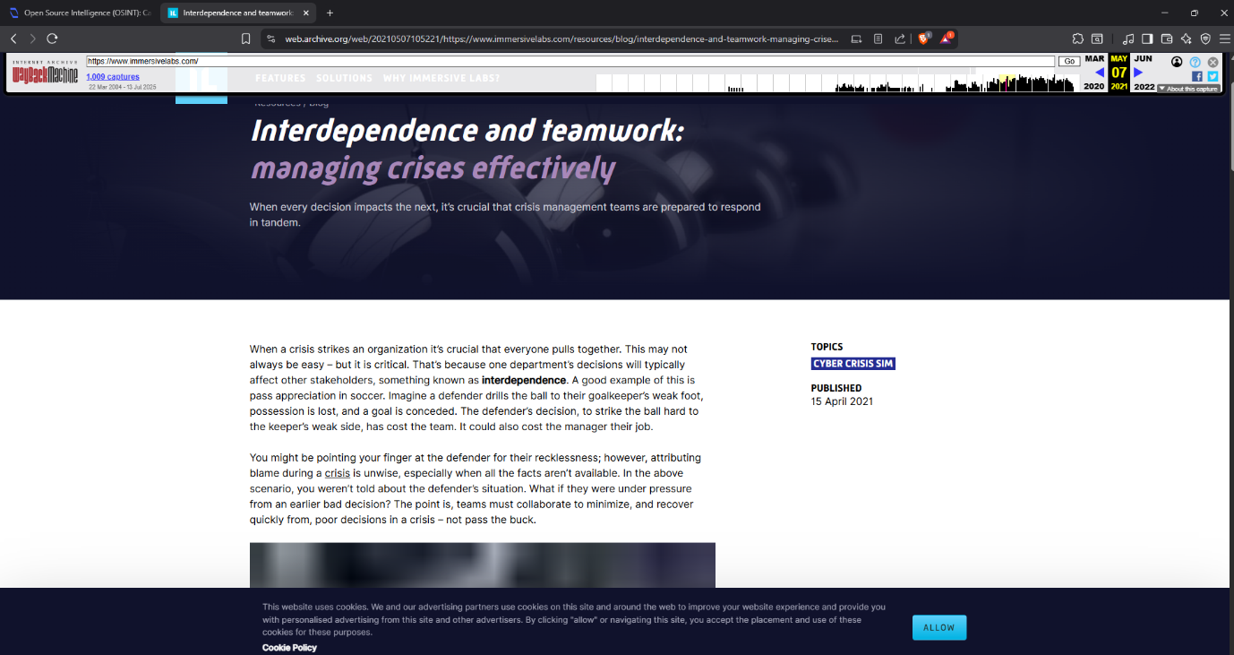
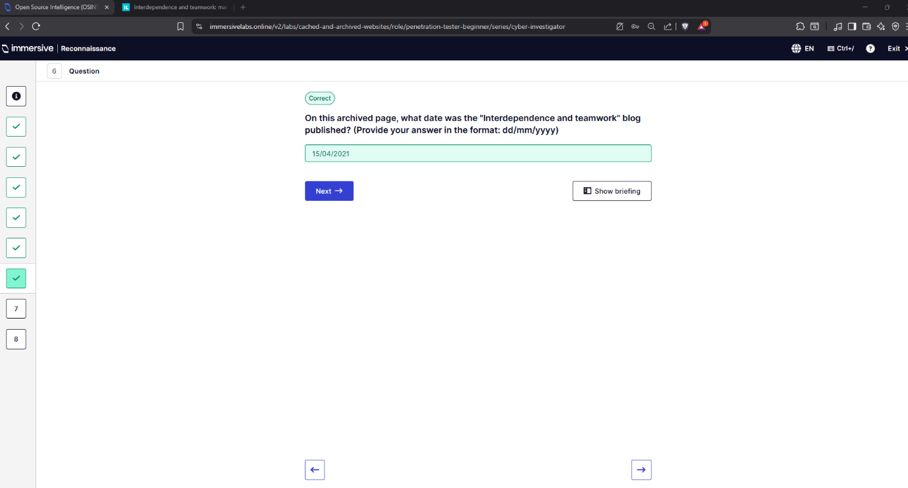
Q7 – Navigate to BBC snapshot.
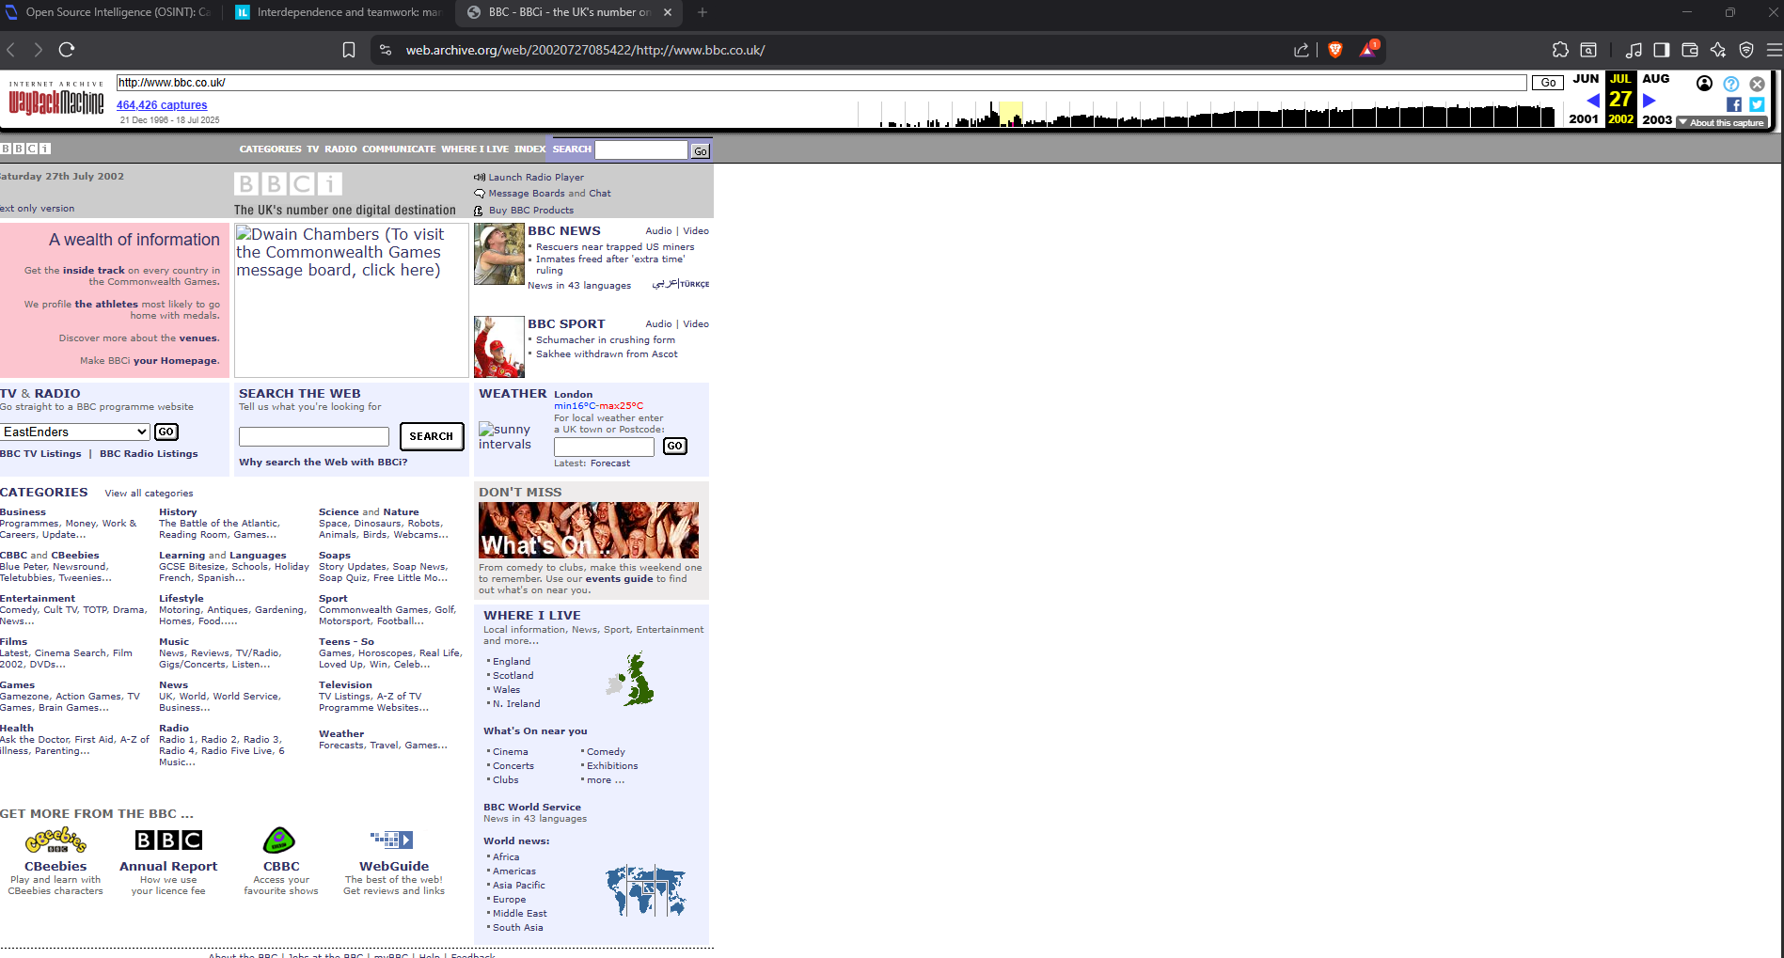
Q8 – What date was the snapshot taken?
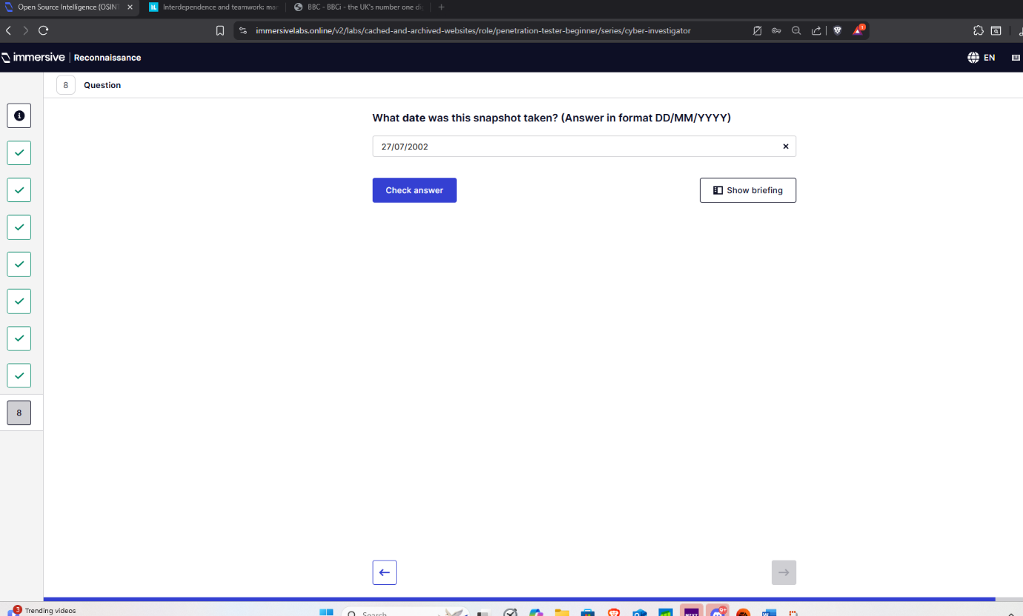
- Social media and Privacy
Q1 – Find Dade’s star sign which was Virgo.
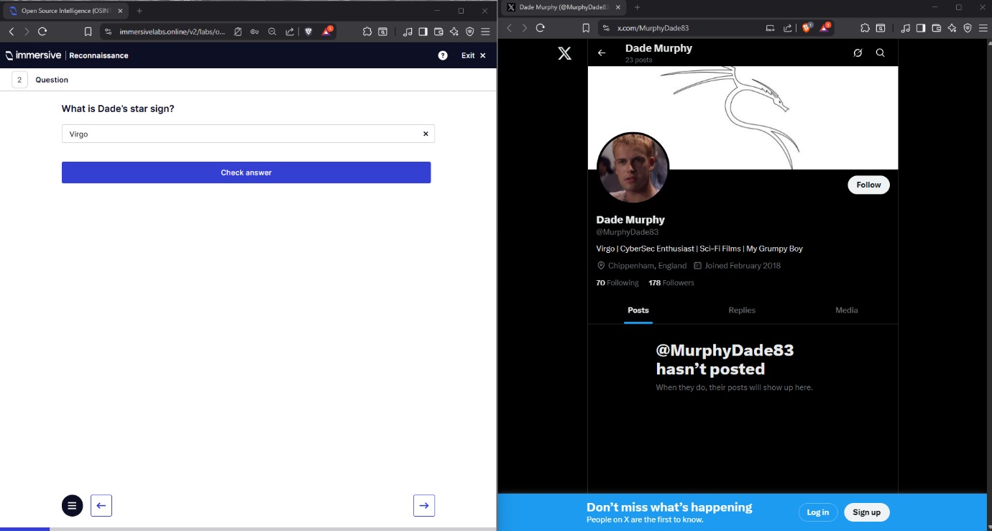
Q2 – What part of England is Dade from?
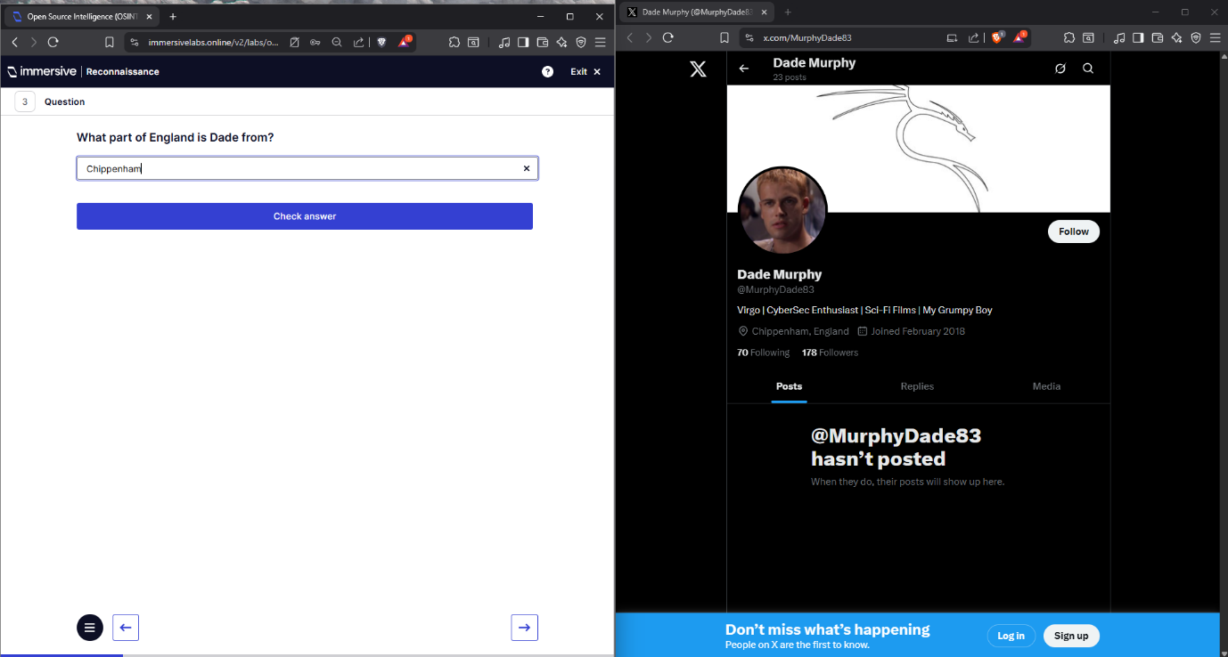

Q3 – What film does Dade advise people to watch?
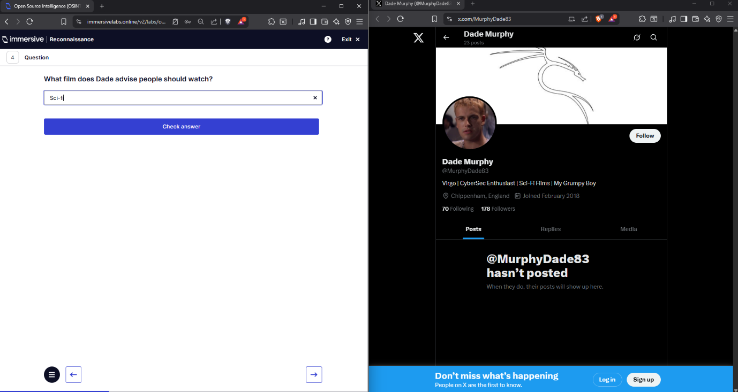
Q4 – What film does Dade advise people to watch?
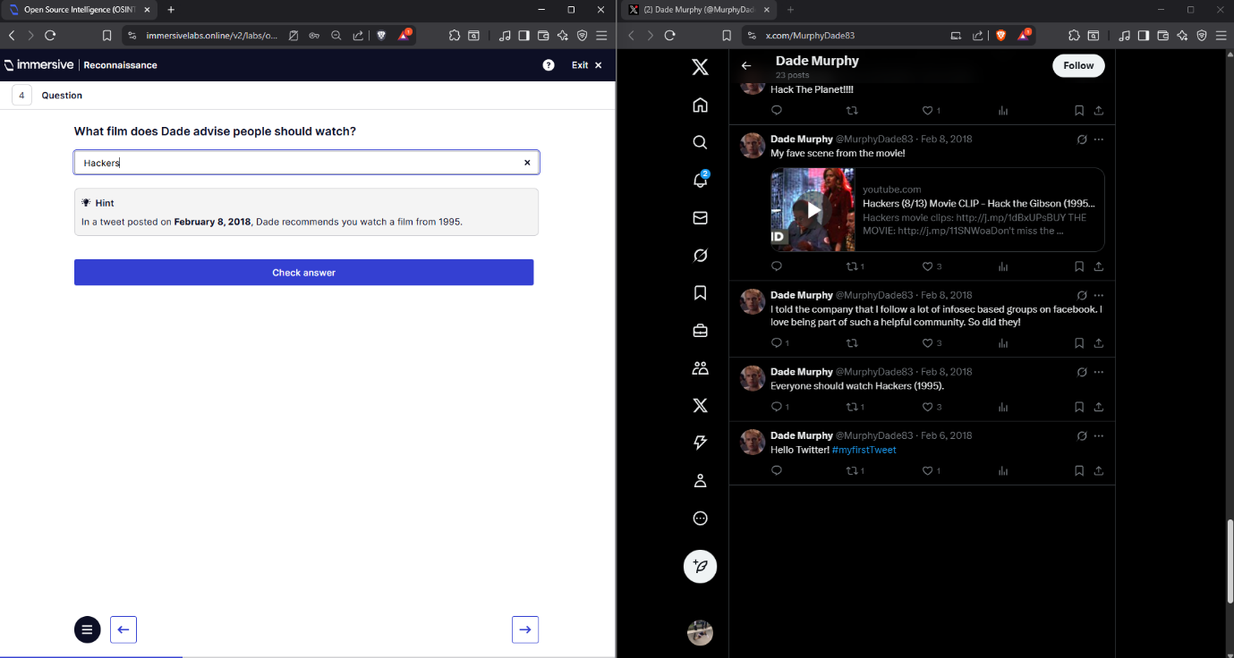
Q5 – What does Dade love writing?
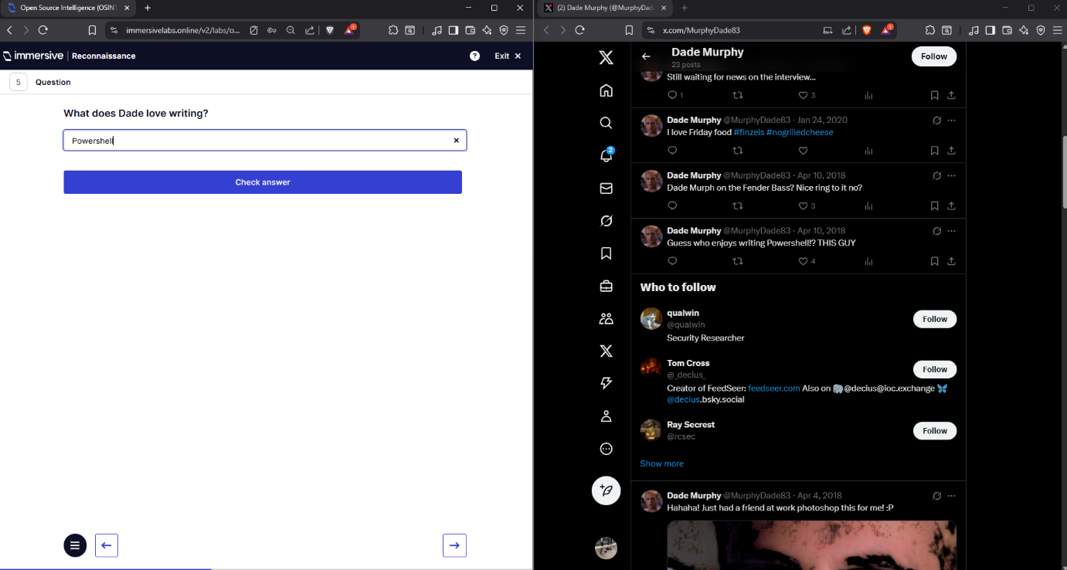
Q6 – Used reverse image searching to find Dade’s favourite holiday location. Which was Dabovs.
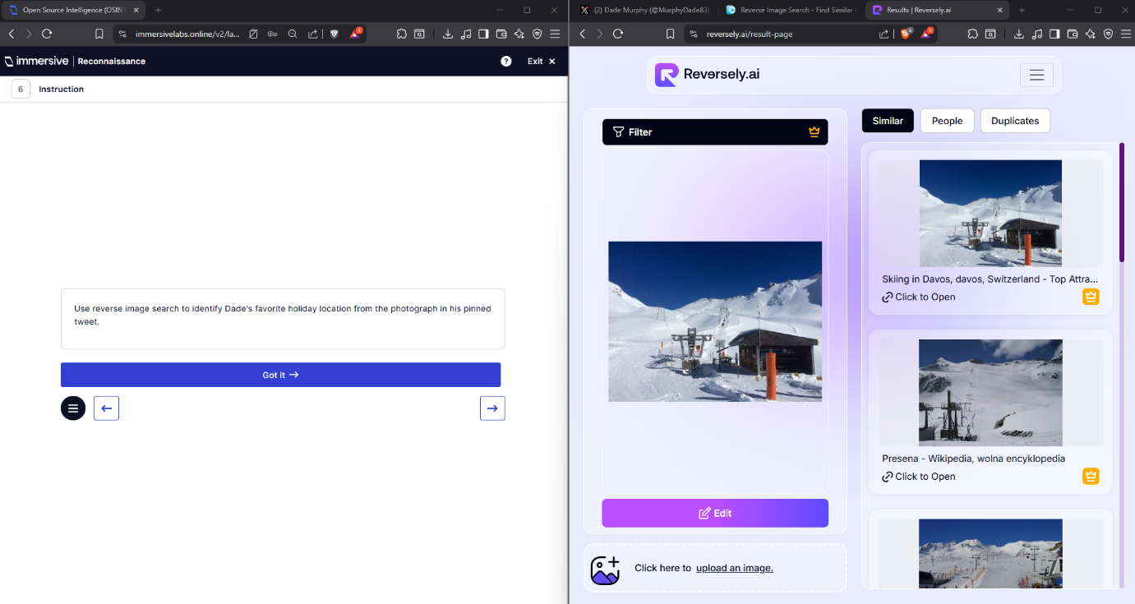
Q7 – In which ski area did Dade have the “best holiday ever”?
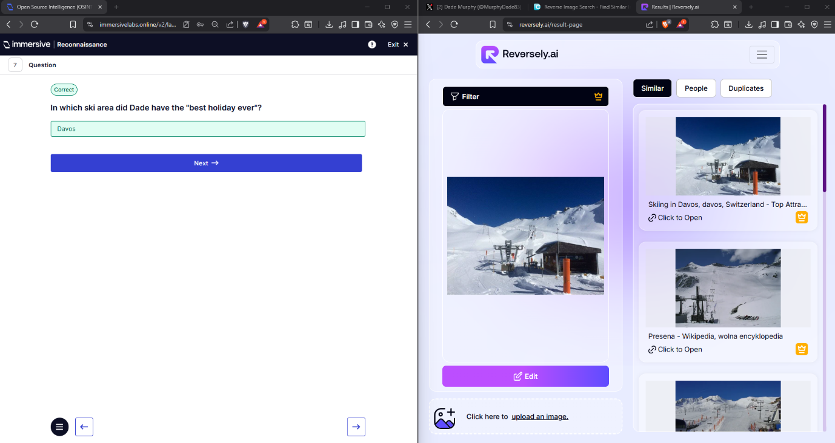
Q8 – Find a way to Dade’s deleted Facebook page!
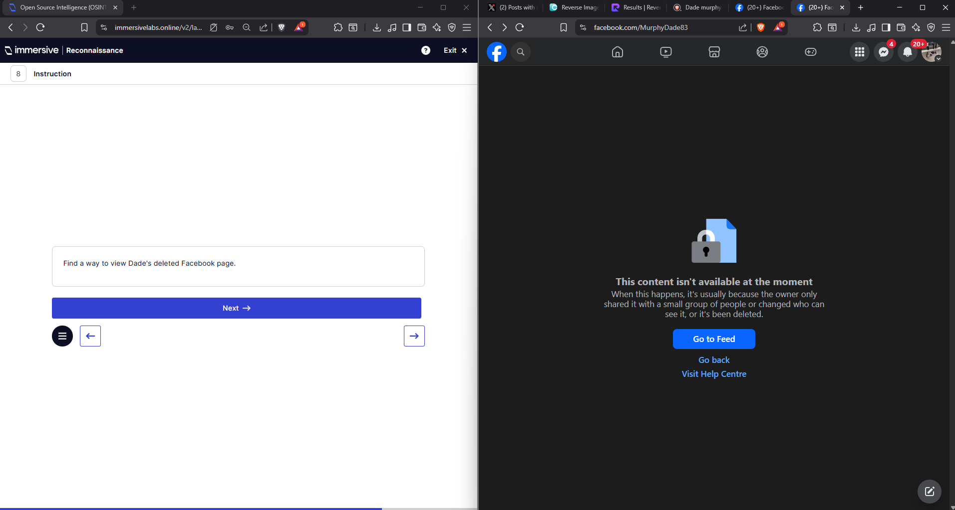
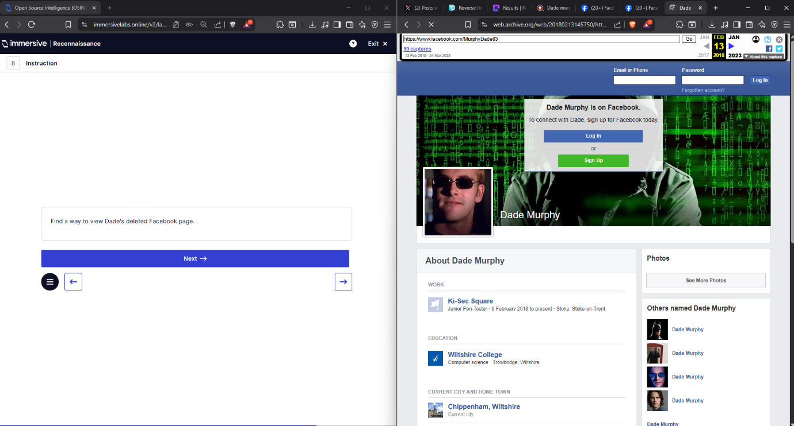
Q9 – What is Dade’s full job title on his Facebook profile?
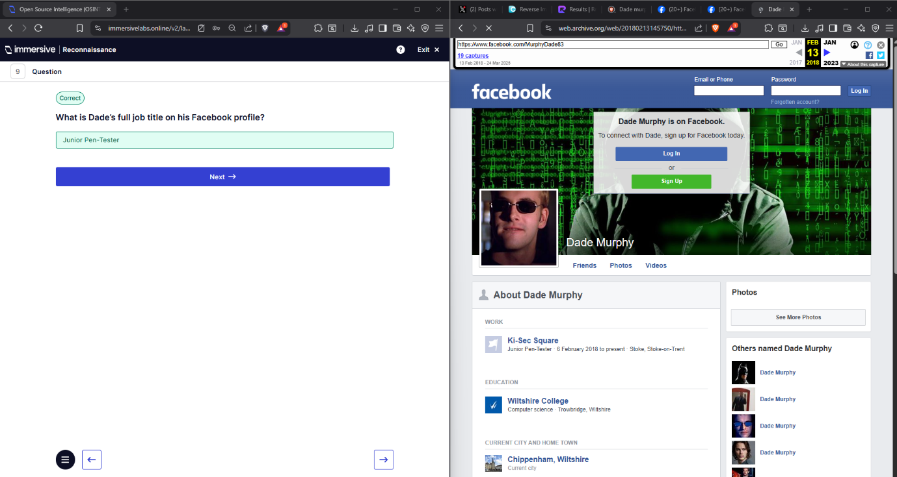
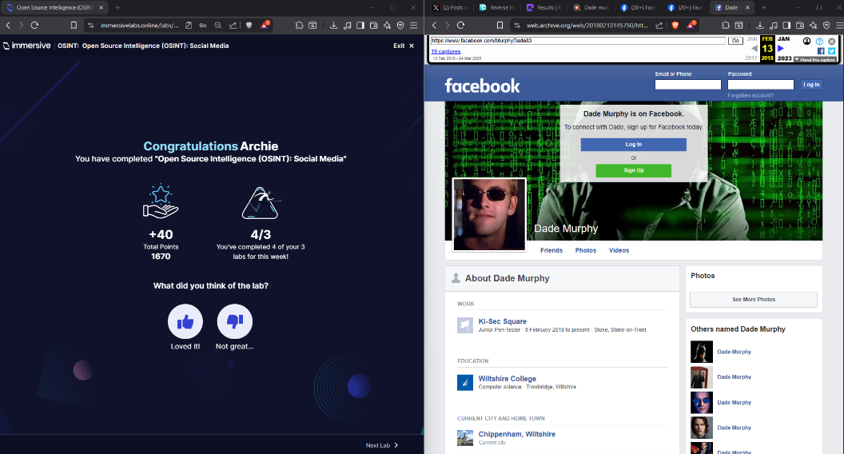

  - Boarding Pass.
    - This was Question 1 – Answer was PDF417 which is the type of barcode used with boarding passes?
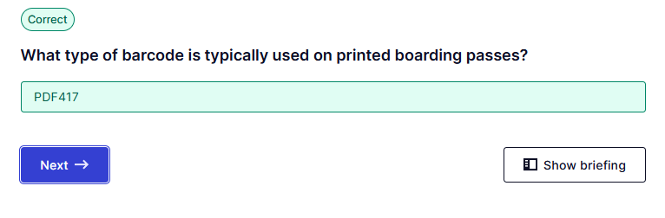
Q2 – The Answer was 2A found by using inlite barcode reader of the Boarding pass.
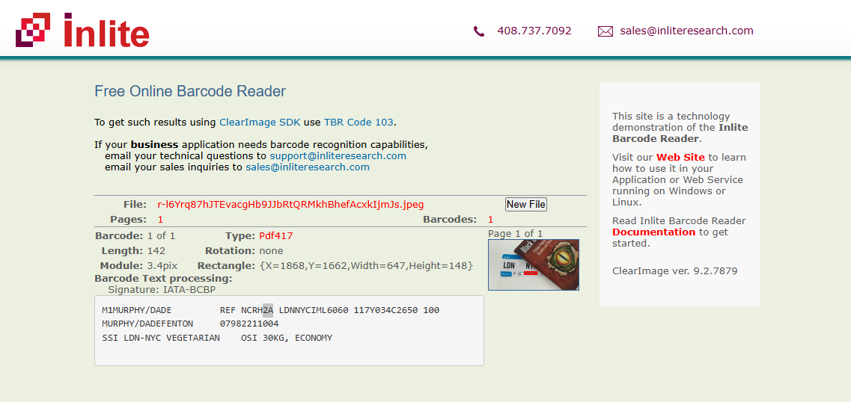
Q3 – The answer is A30 found on the image provide in the lab!
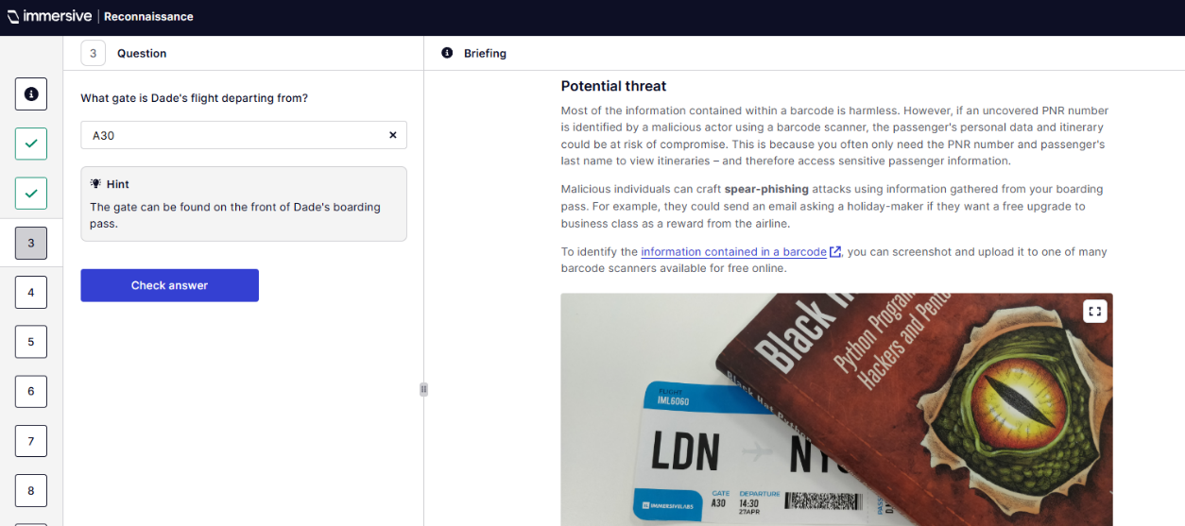
Q4 – Which was finding Dade’s PNR number
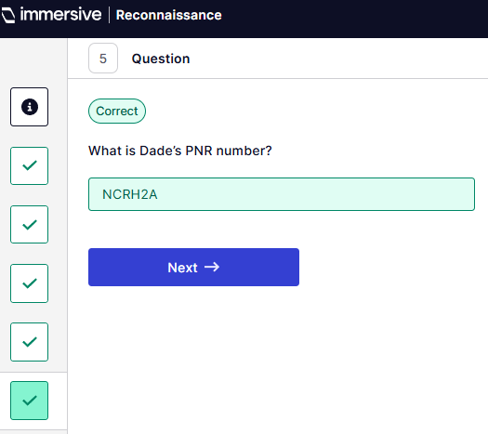
Q5 which is finding the flight number.
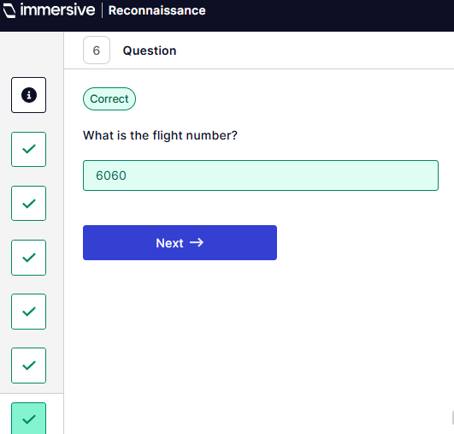
Q7 – to find the Julian date of the flight.
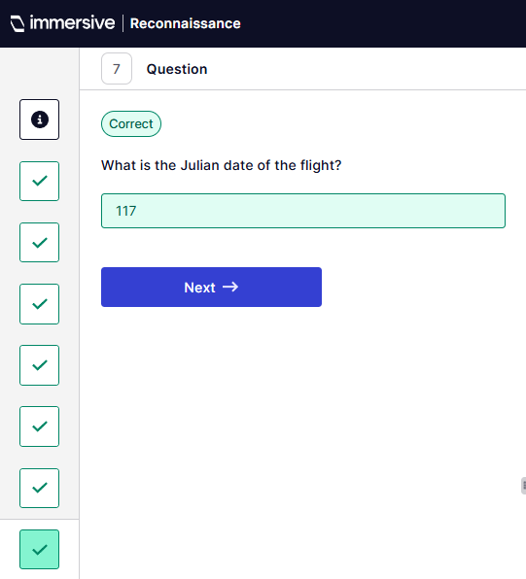
Q8 – to find the character used on boarding pass barcodes to denote the economy cabin which was Y.
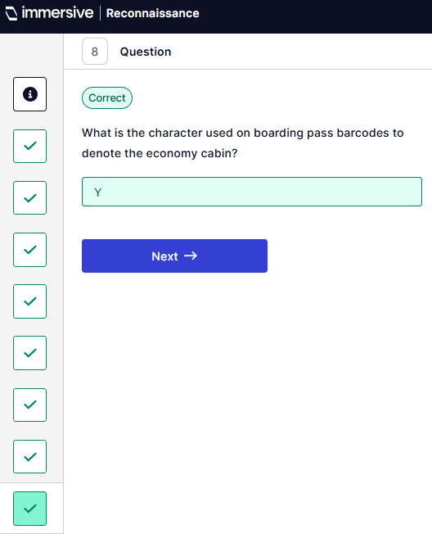
Q9 – Finding Dade’s seat number which was 034C
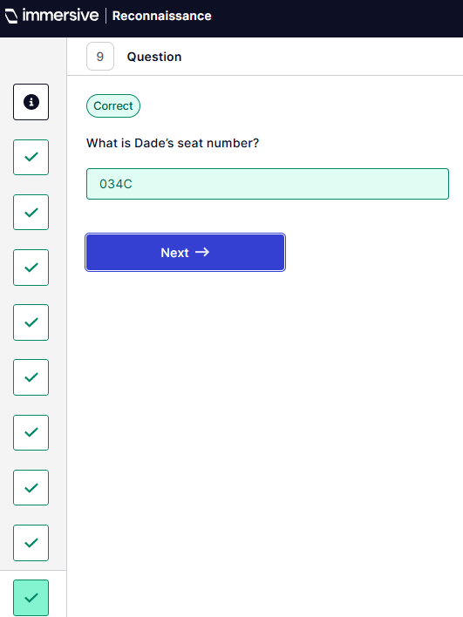
This is the completion of that lab.
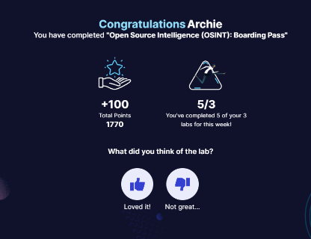
  - Deleted Tweet
Q7 – Which month was the second deleted tweet posted.
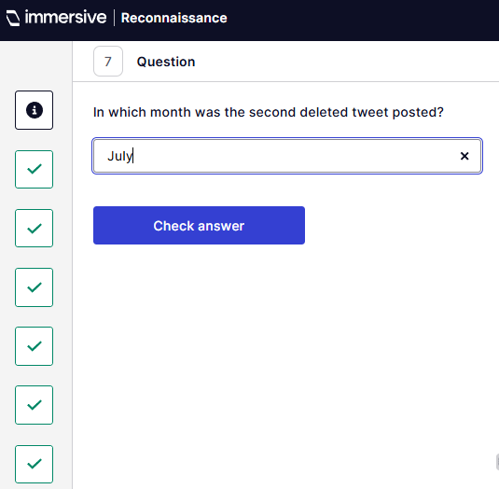
Q8 – How many followers does Dade have when he posted the second deleted tweet.
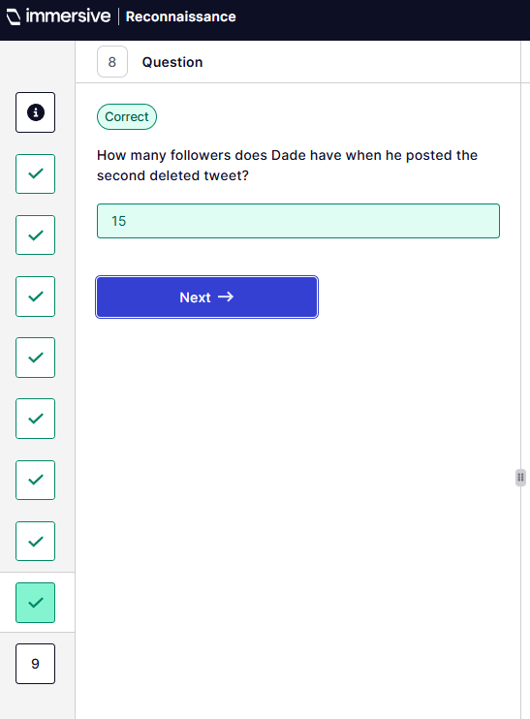
Q9 – What is the title of the employee that Dade is complaining about?
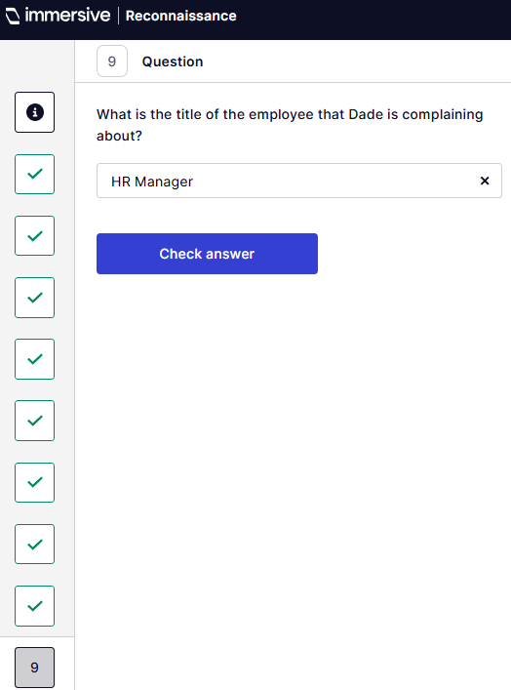
  - Default Credentials.
Q1 – Use cirt.net to identify the default credentials.
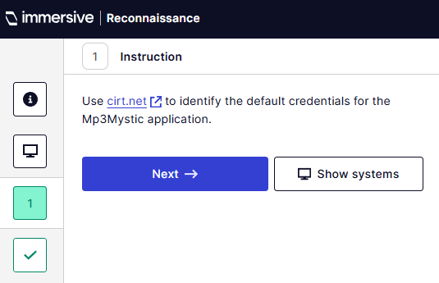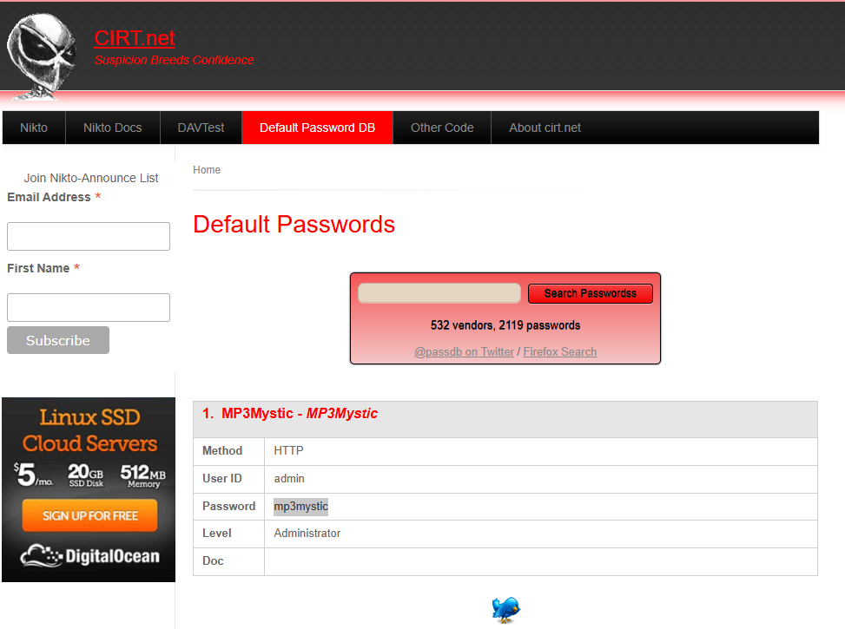
Q2 – What is the default password for admin
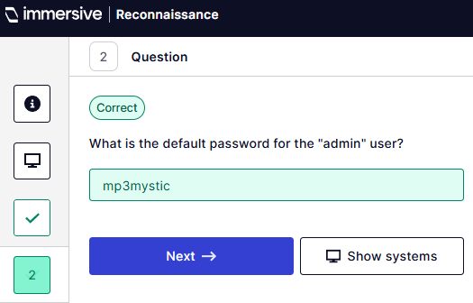
Q3 – What is the default password for admin?
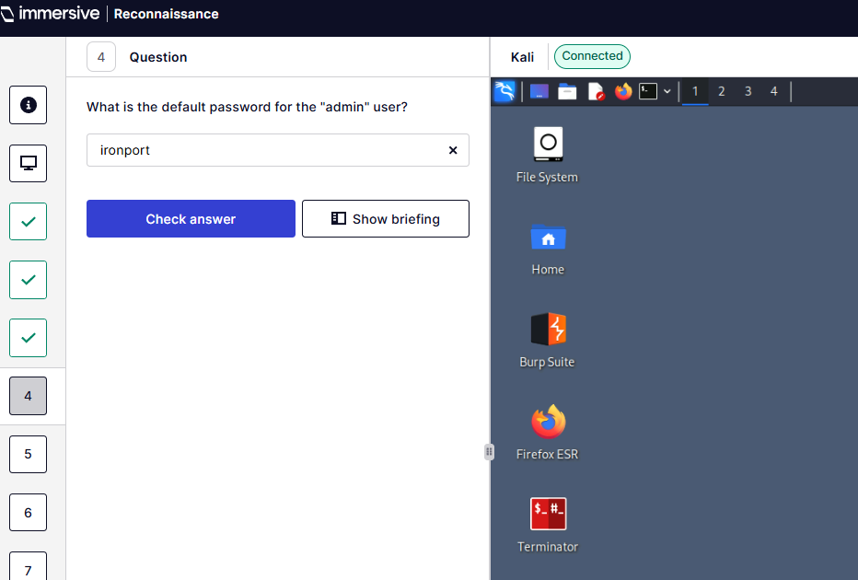
Q7 - What is the name of the router’s manufacturer?
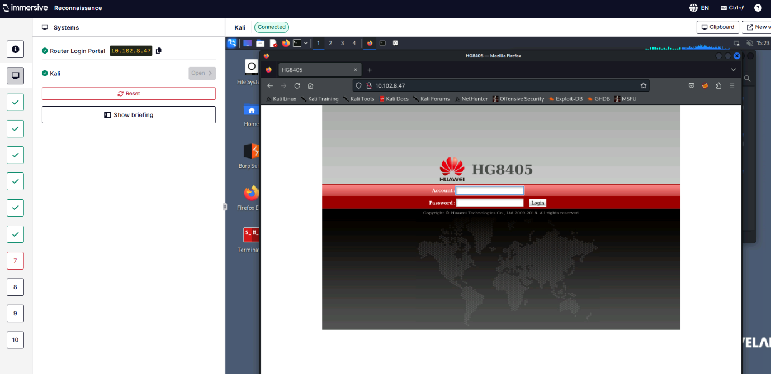
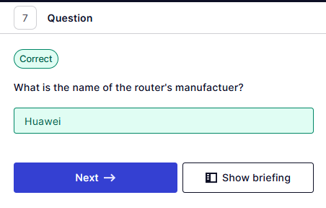
Q8 – What is the model of router?
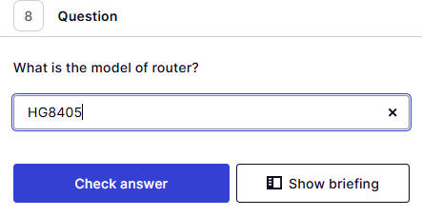
Q10 – What is the token received when logging in.
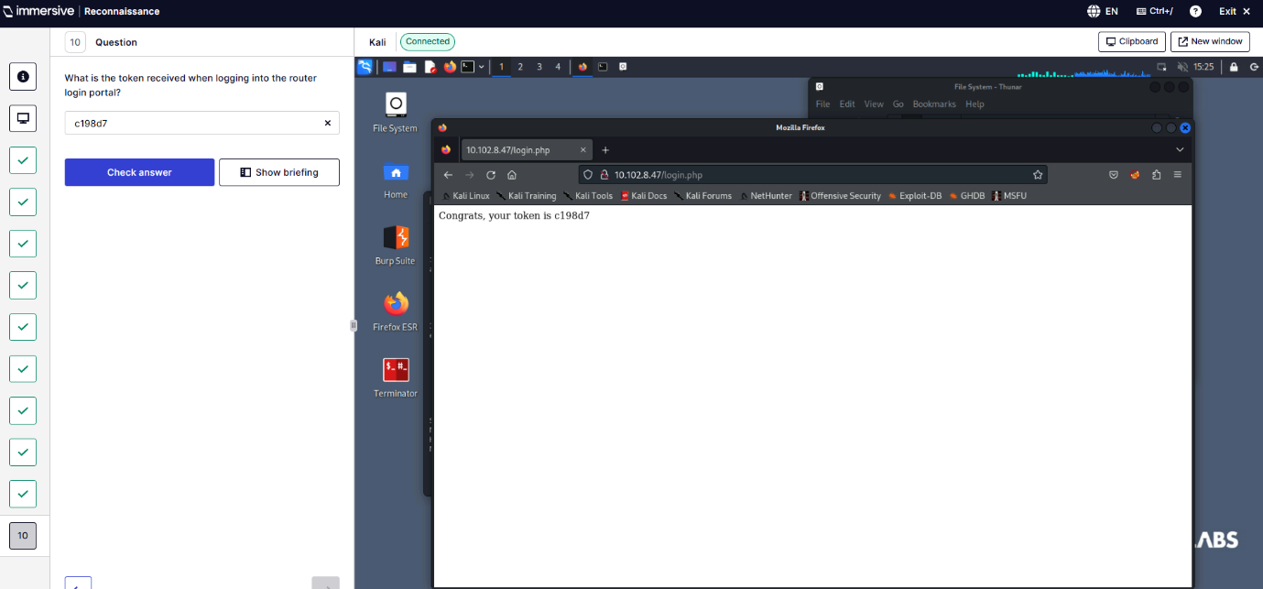
  - Domain Intel
Q2 – Use CentralOps domain dossier to search for imlbank.info
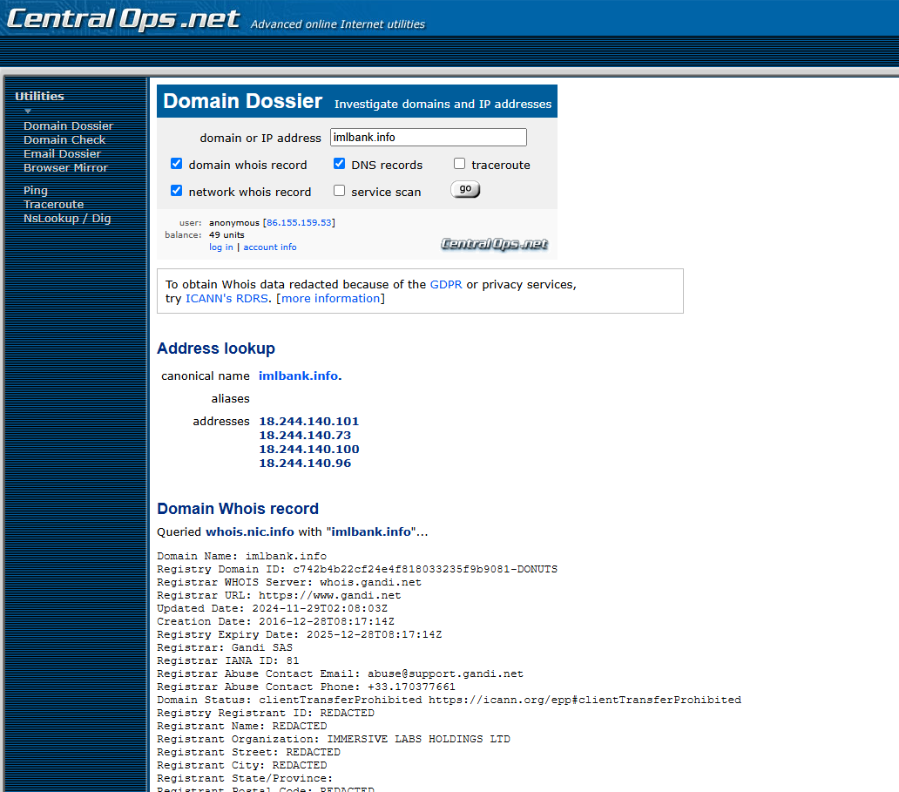

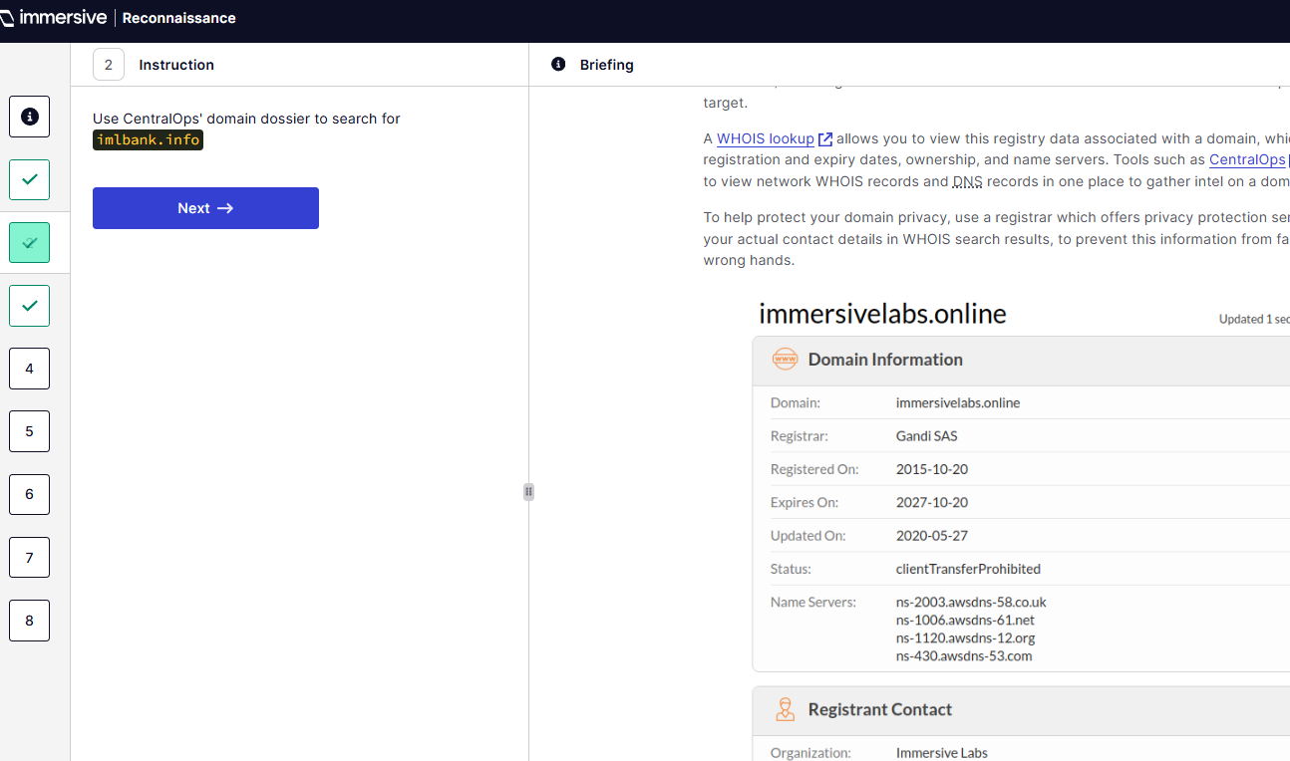
Q3 – What is the OrgID for who is record.
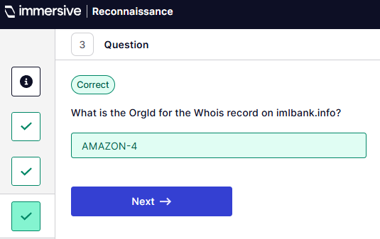
Q4 – Finf SOA DNS email address
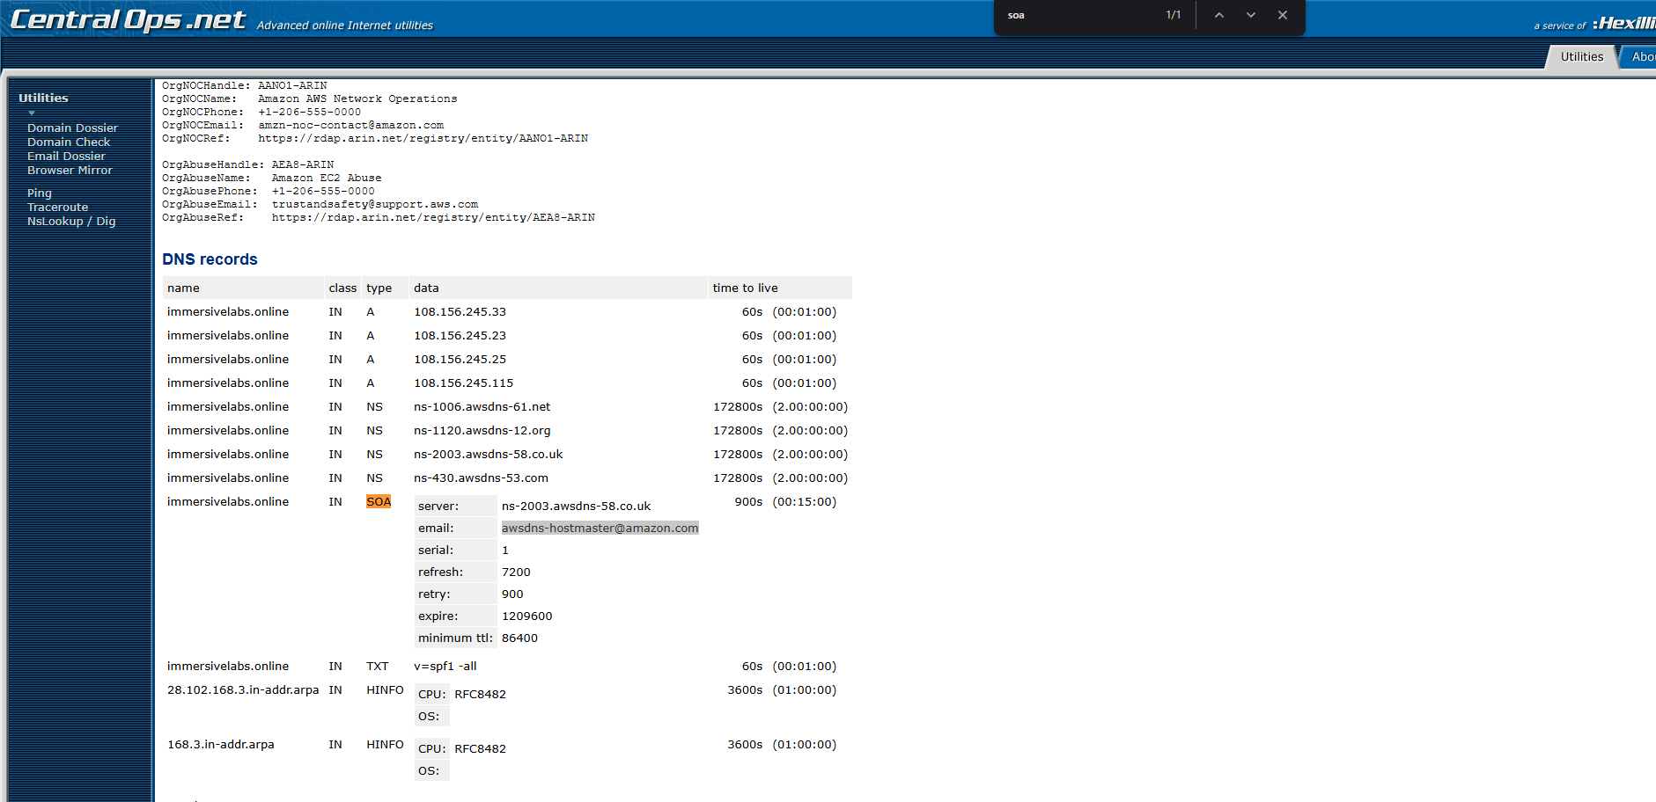
Q5 – What is the email address?
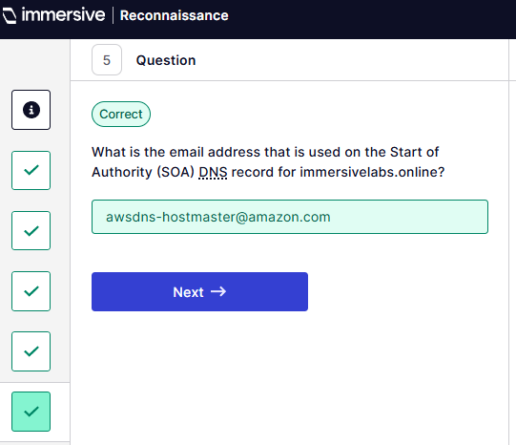
Q6 – Find the name of mail servers
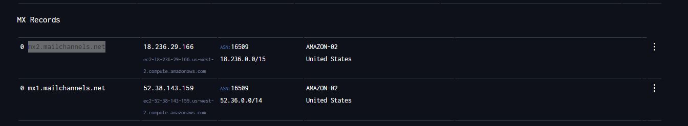
Q7 – Name one of the two mail servers used by bartertowngroup.com
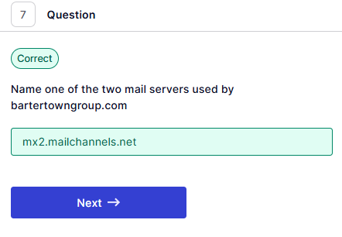
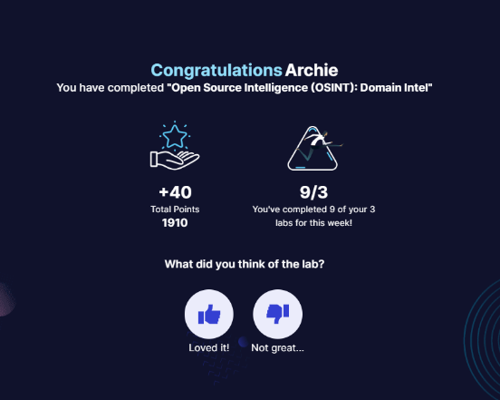
- SQL Injection Basics. (ImmersiveLabs SQL, 2025) “
  - Basic SQL Injection.
Q2 – What is the value for marketing_emails for allan@examplecorp.uk
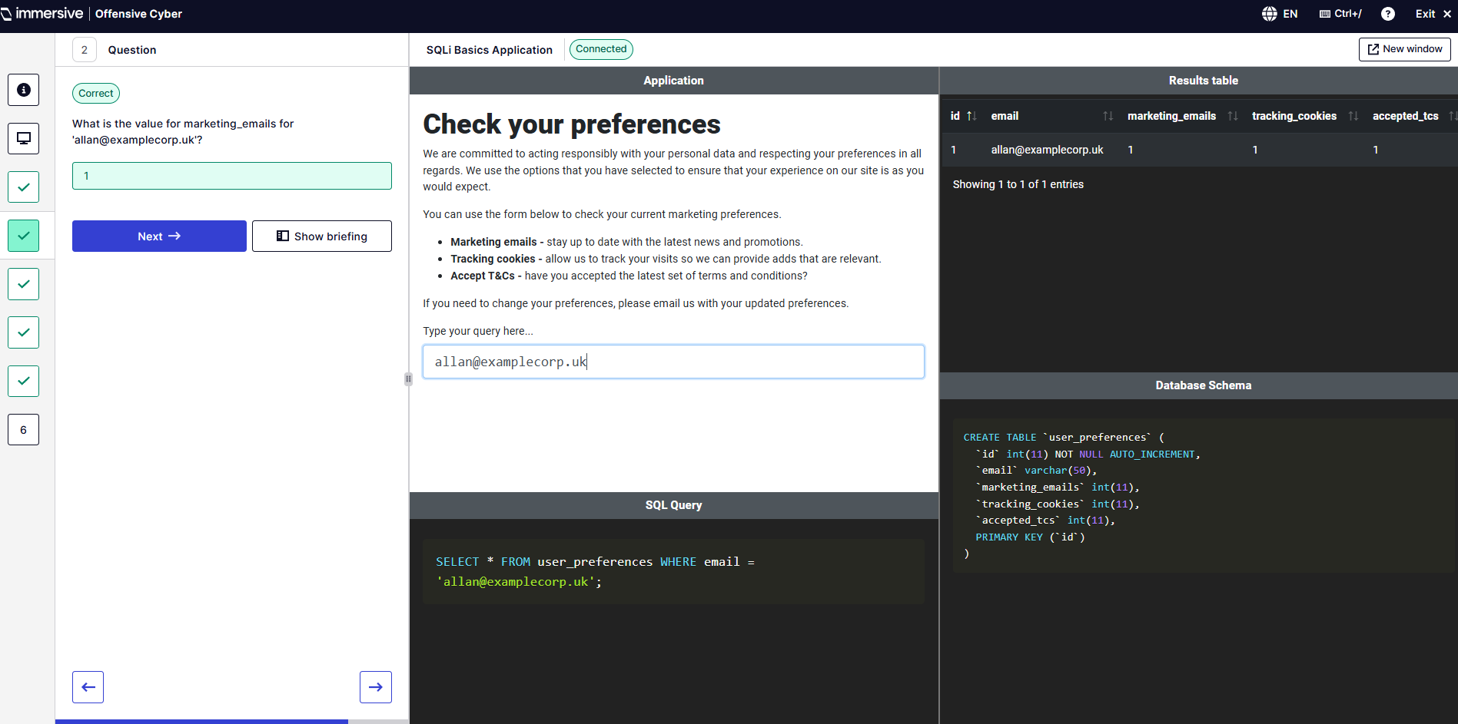
Q3 – What are the preferences for the user mstraaten@parven.edu
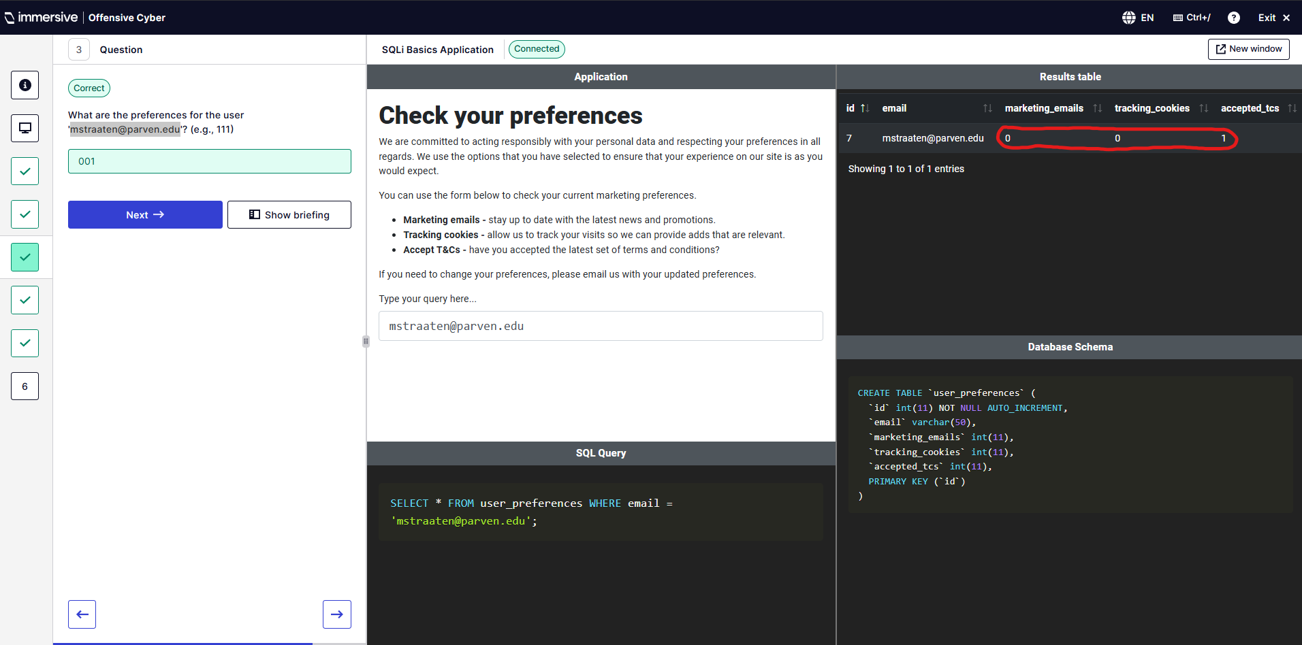
Q4 – Which of the following is a TRUE expression?
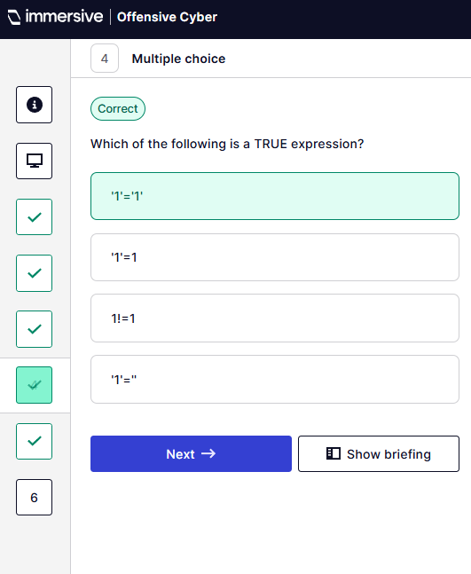
Q6 – How many rows are in the table?
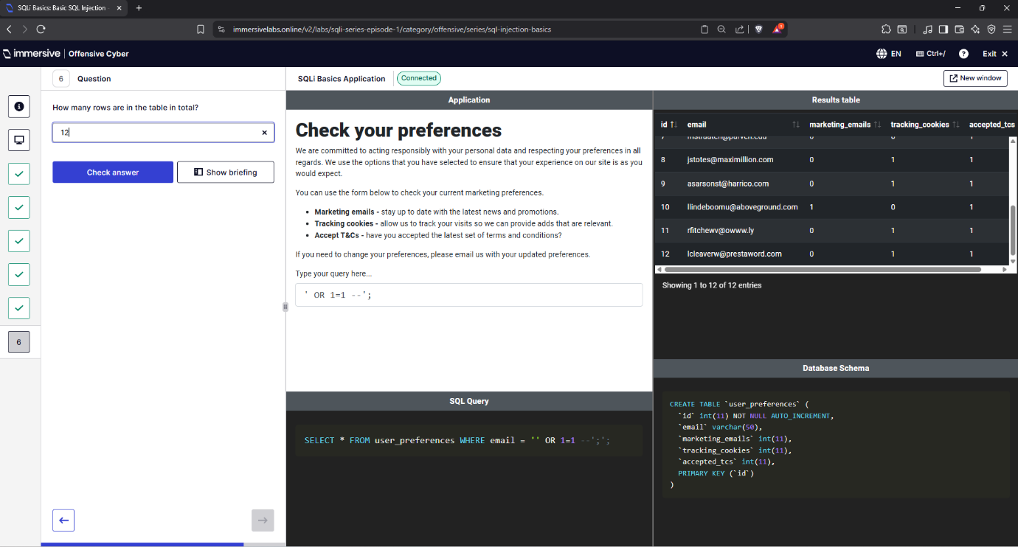

  - UNION Query
Q3 – Which SQL operator allows you to execute multiple SQL statements
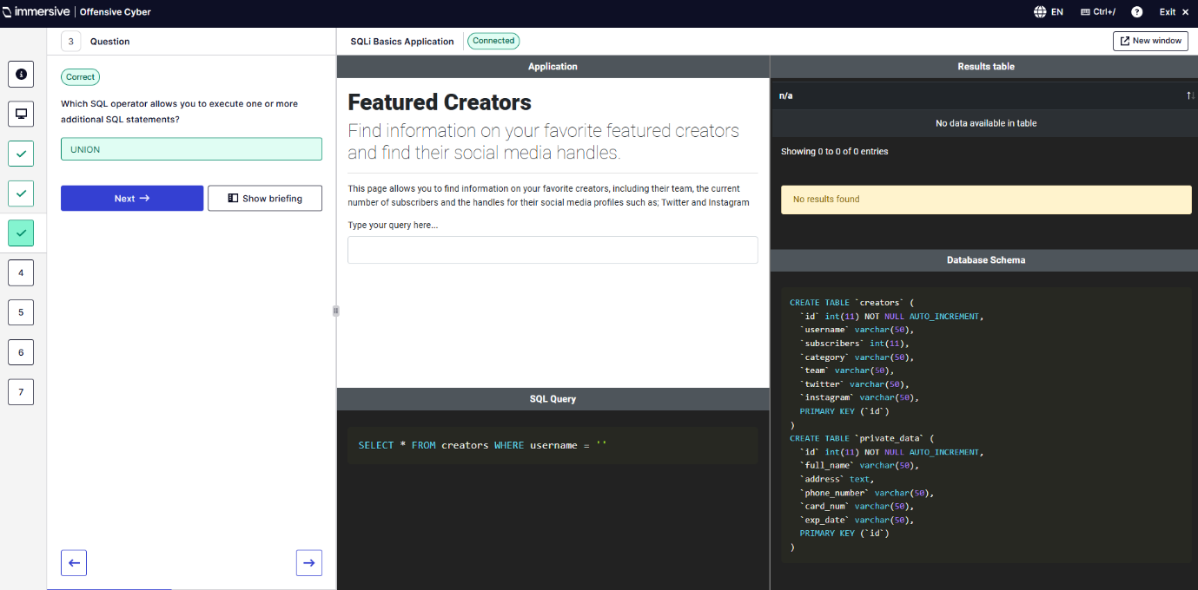
Q4 – What is Dante Balwin’s address?
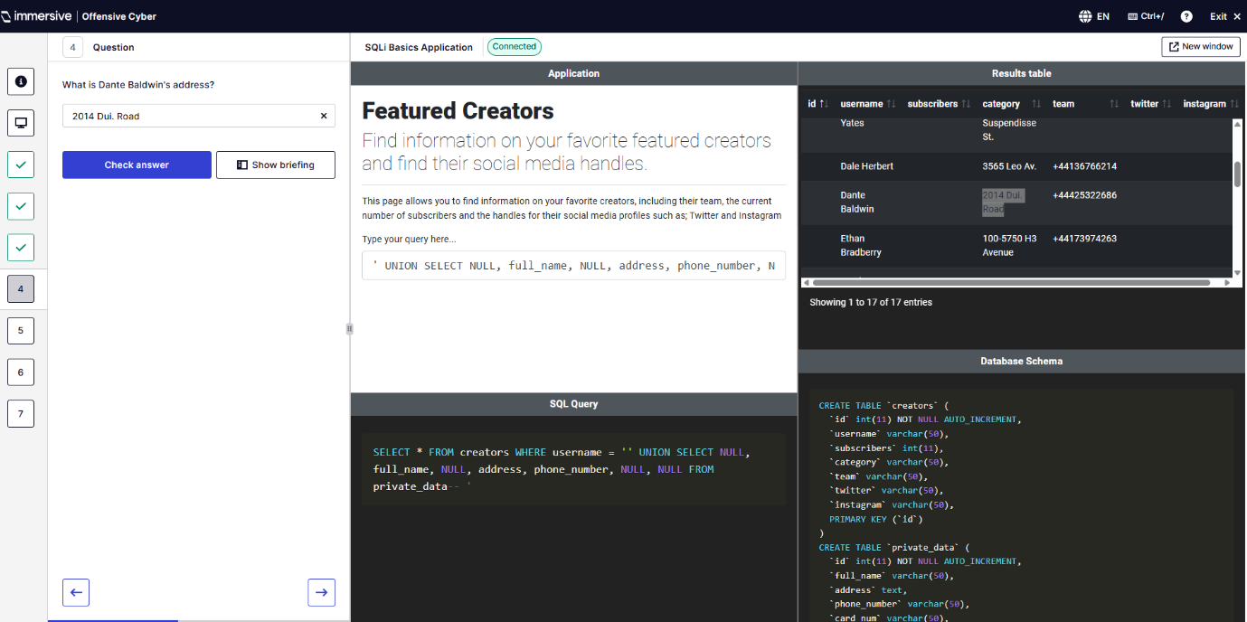
Q5 – What is Ronan Hunter’s phone number?
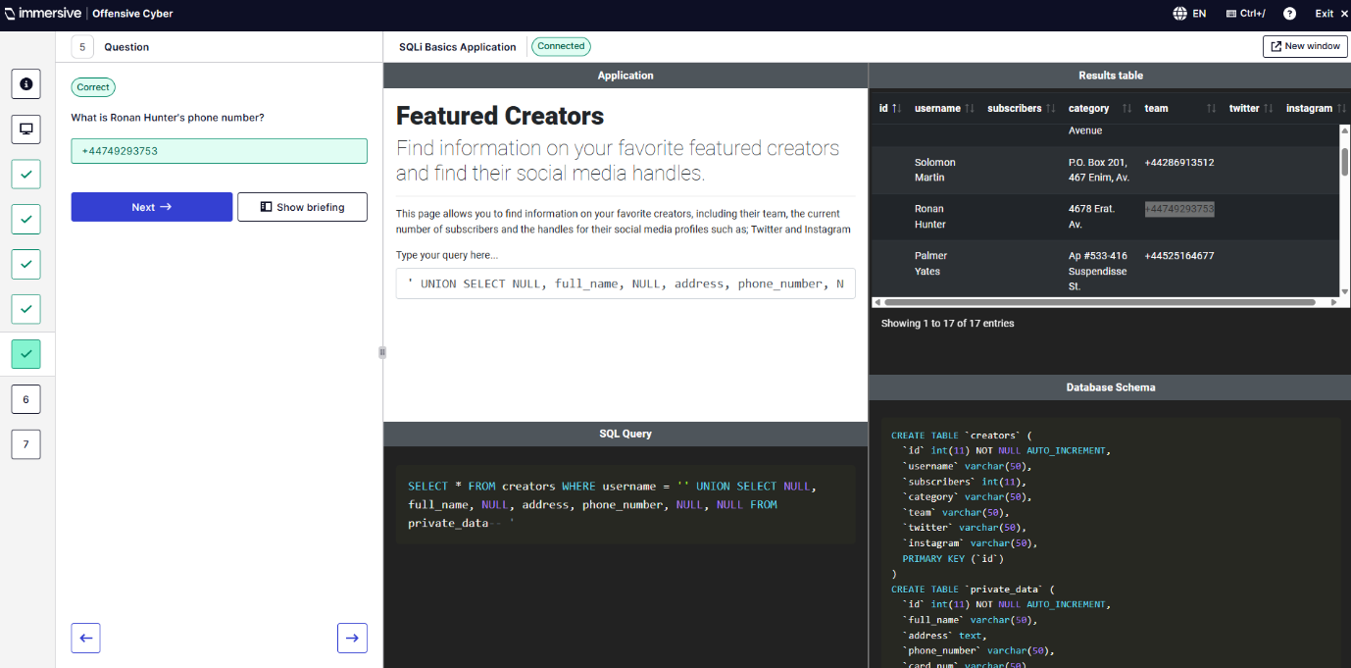
Q6 – What is Amos Meadows’ card number?
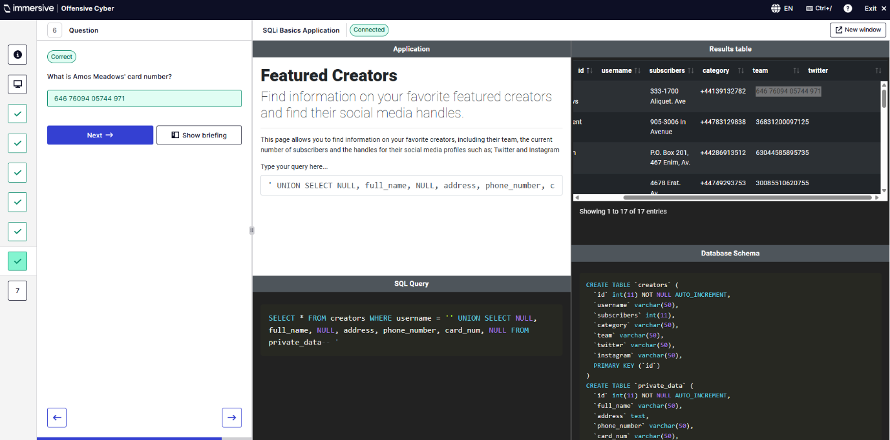
Q7 – What is the expiry on Palmer Yates’ card?
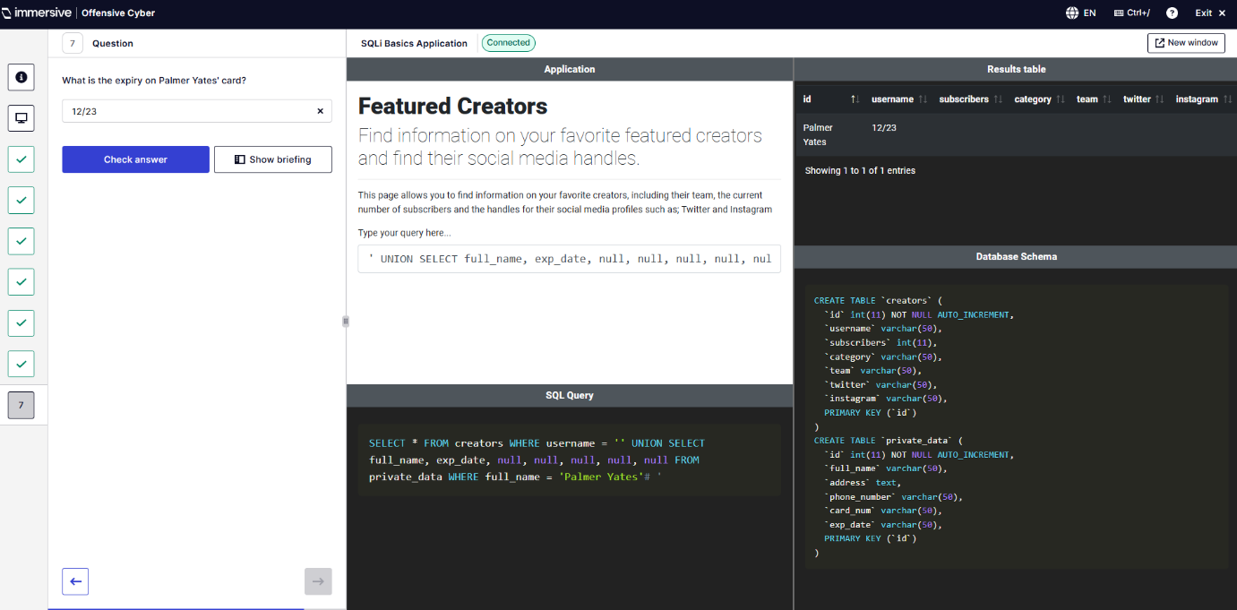
  - Hidden Data
Q2 – What are the characters used in SQL to begin a comment “--"
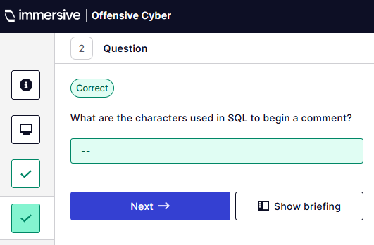
Q3 – Which clause is vulnerable to SQL Injection?
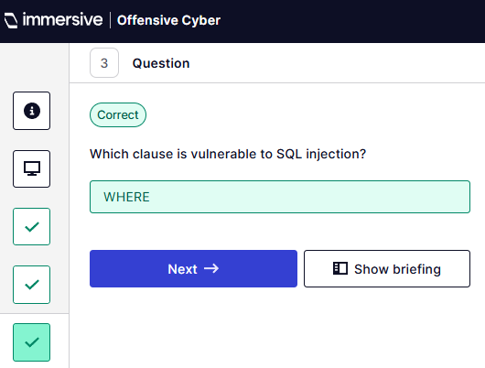
Q5 – What is the title of the unannounced RPG game? (Conquer of Heroes)
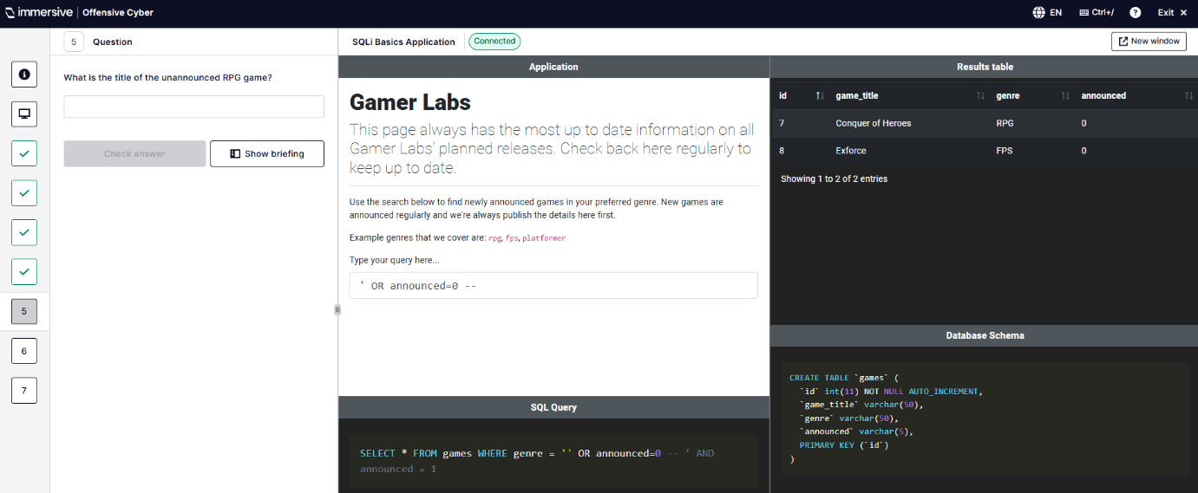
Q7 – What is the title of the second unannounced game?
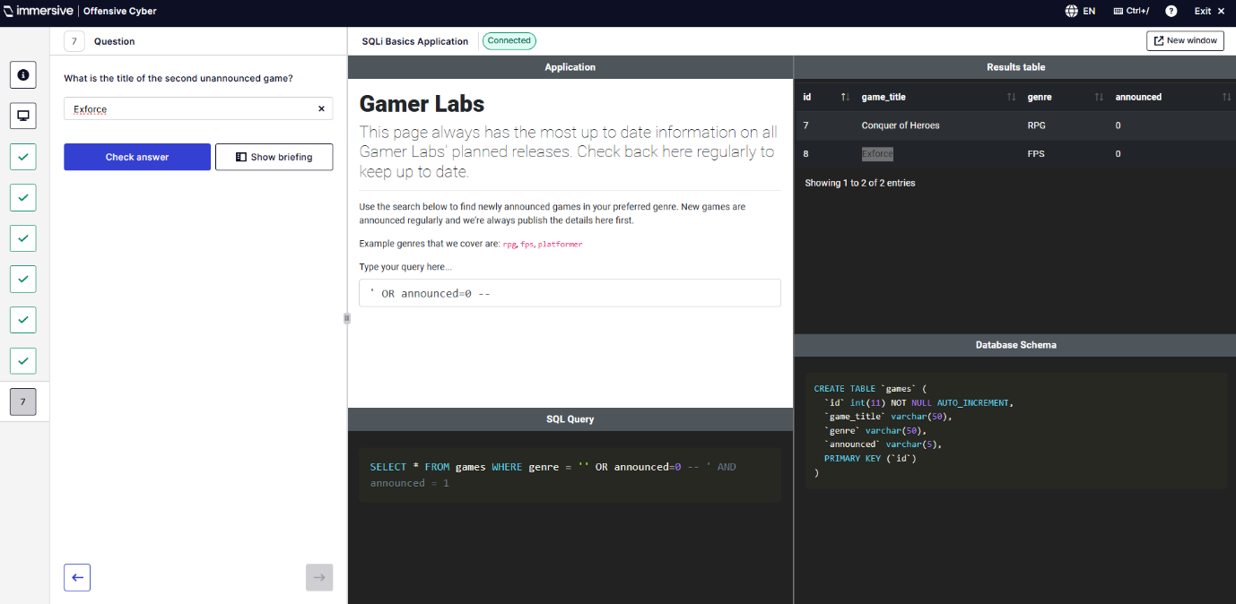
  - Filter Evasion
Q3 – What does WAF stand for?
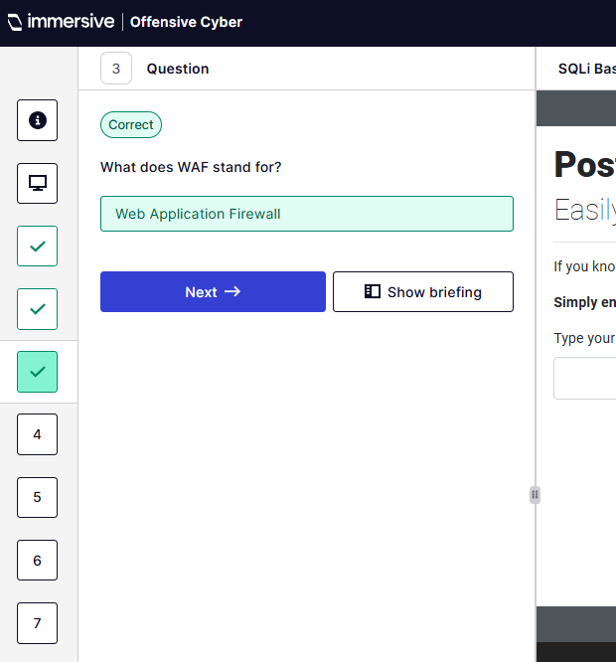
Q4 – What did author 3 post?
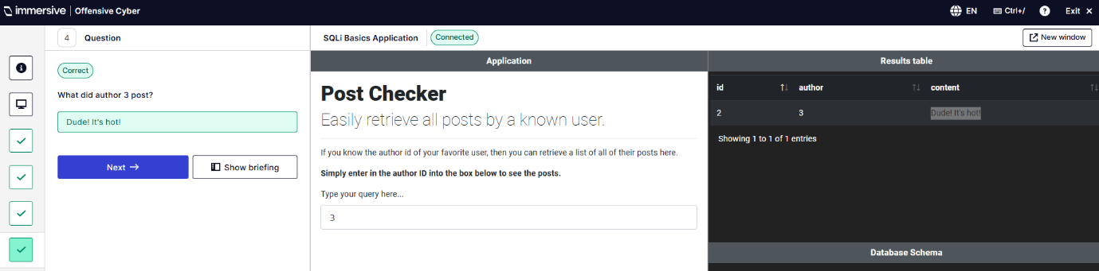
Q5 – What is swizzlestick’s password hash?
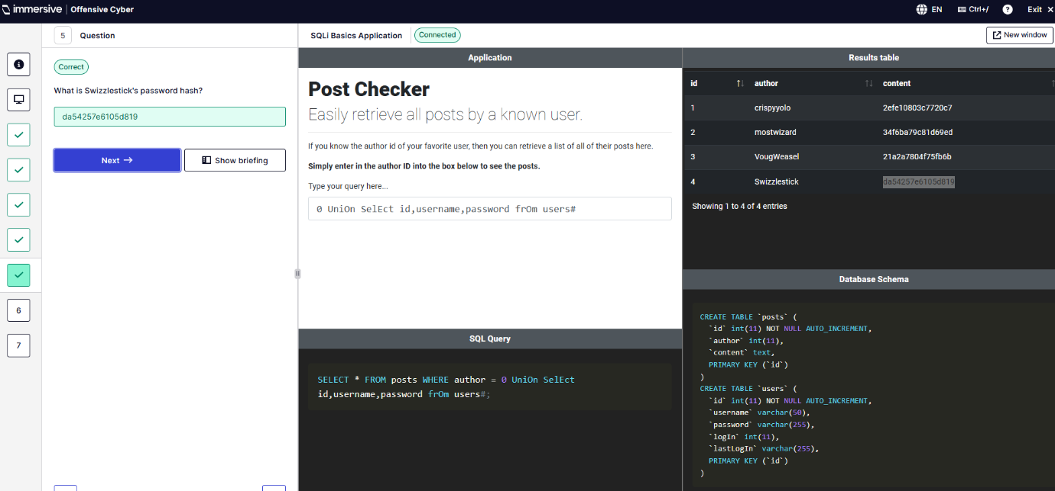
Q6 – When did mostwizard last log in?
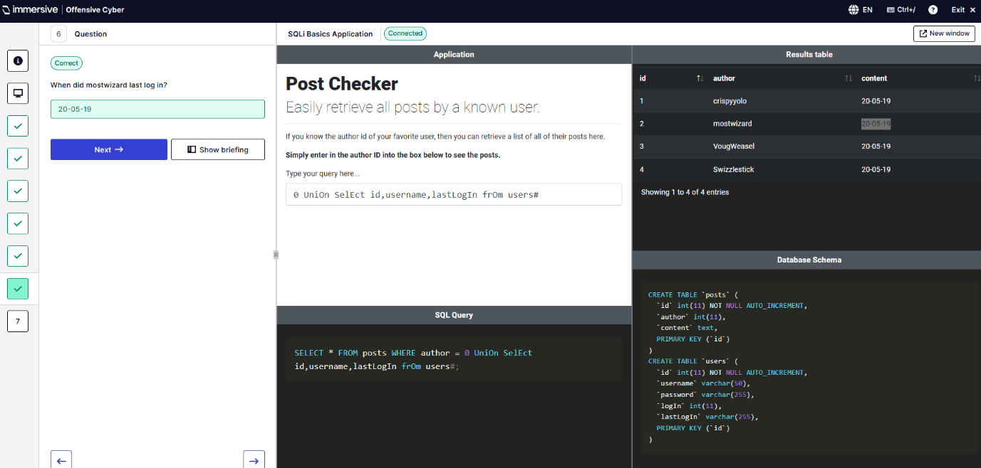
Q7 – How many users in total are stored in the users table?
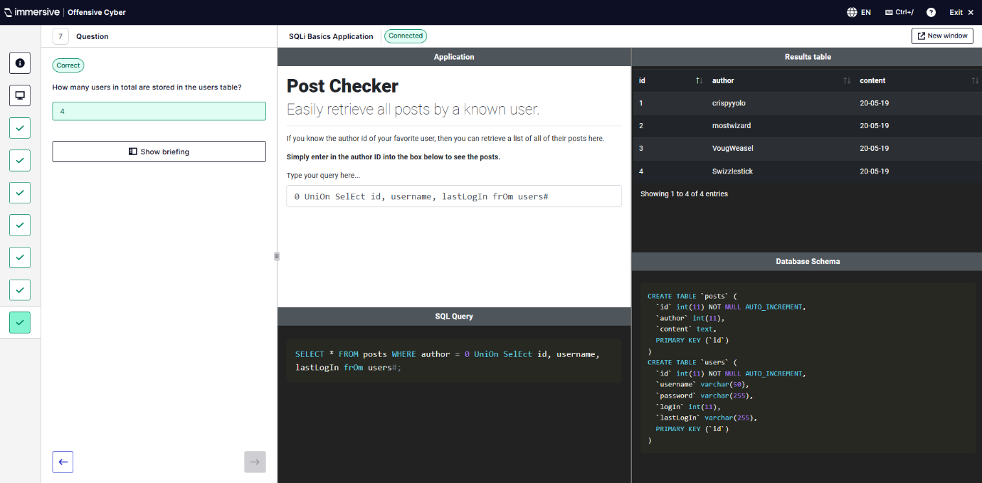
  - String Concatenation
Q2 – Which SQL function adds two string together?
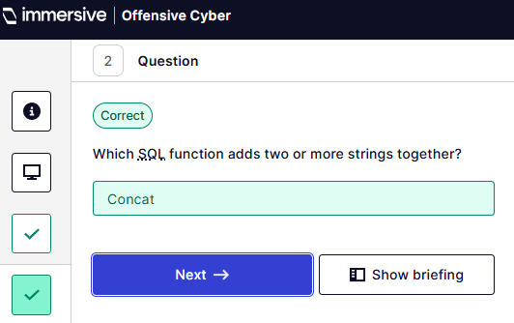
Q3 – Which SQL function returns the character based on ASCII code?
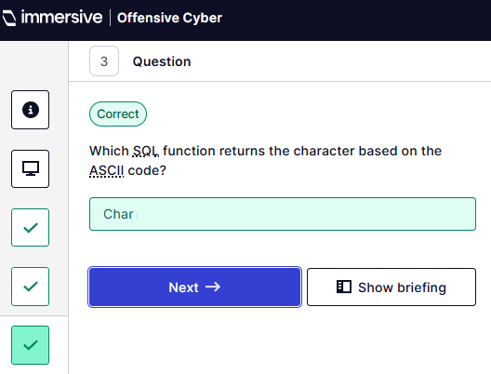
Q5 – What is Alice’s hidden password?
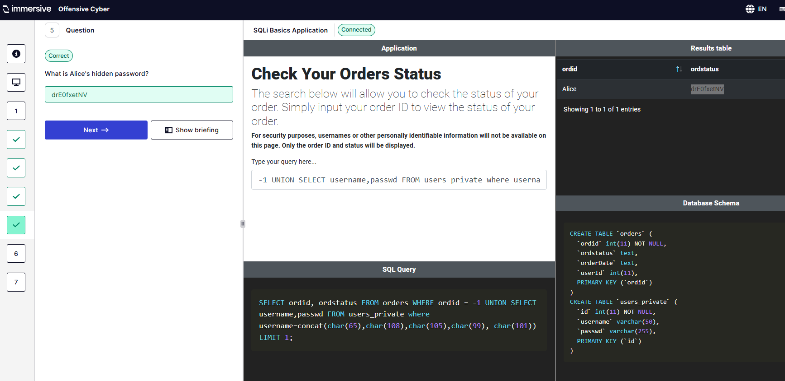
Q6 – What is Jane’s hidden password?
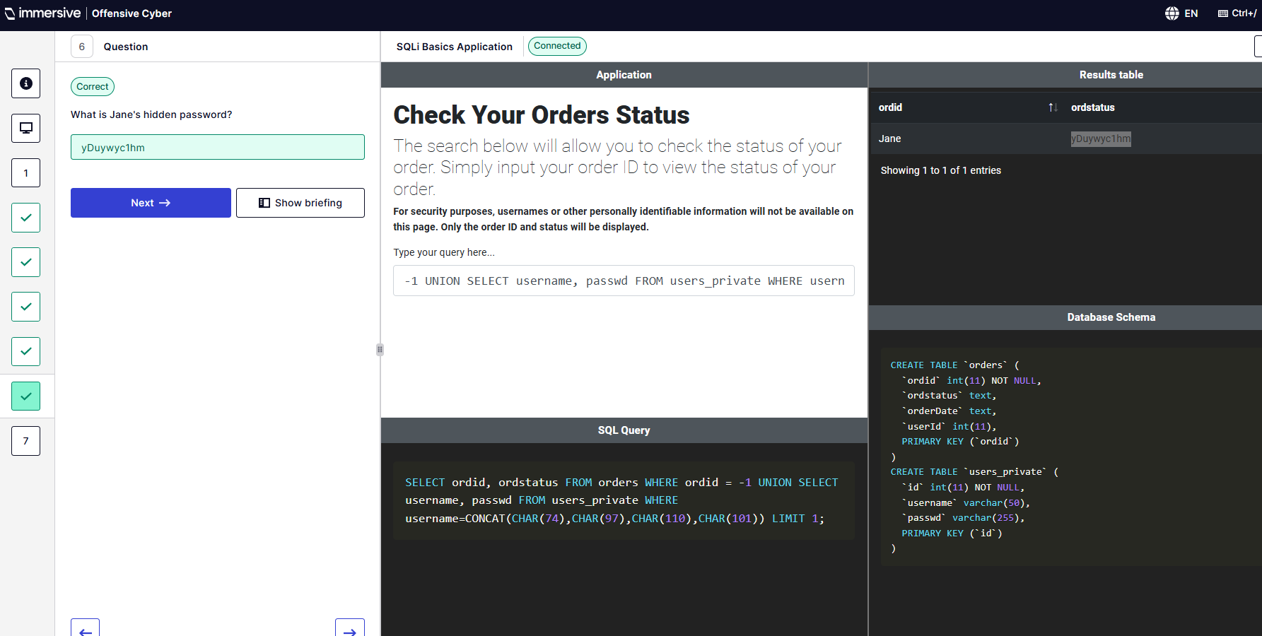
Q7 – What is James’s hidden password?
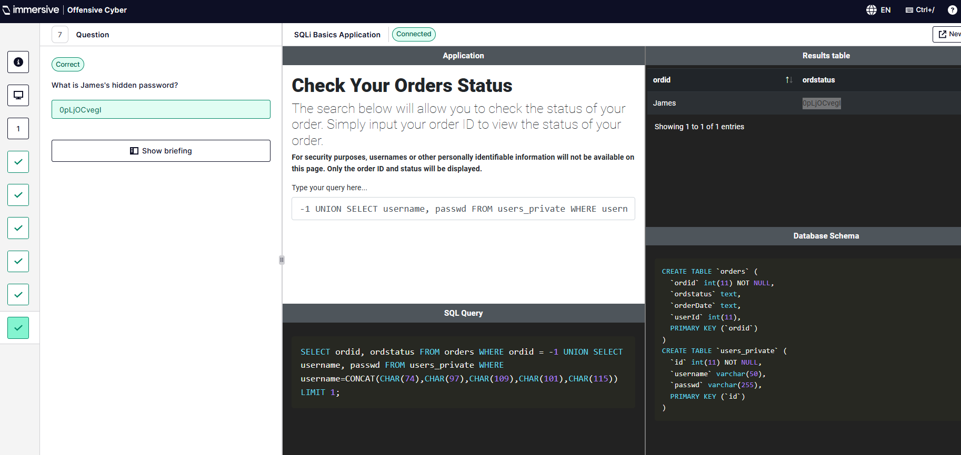
  - Enumerating the Database
Q3 – How many columns are in the original SELECT statement? Order by 3 doesn’t show an error whereas ORDER by 4# provides an error.
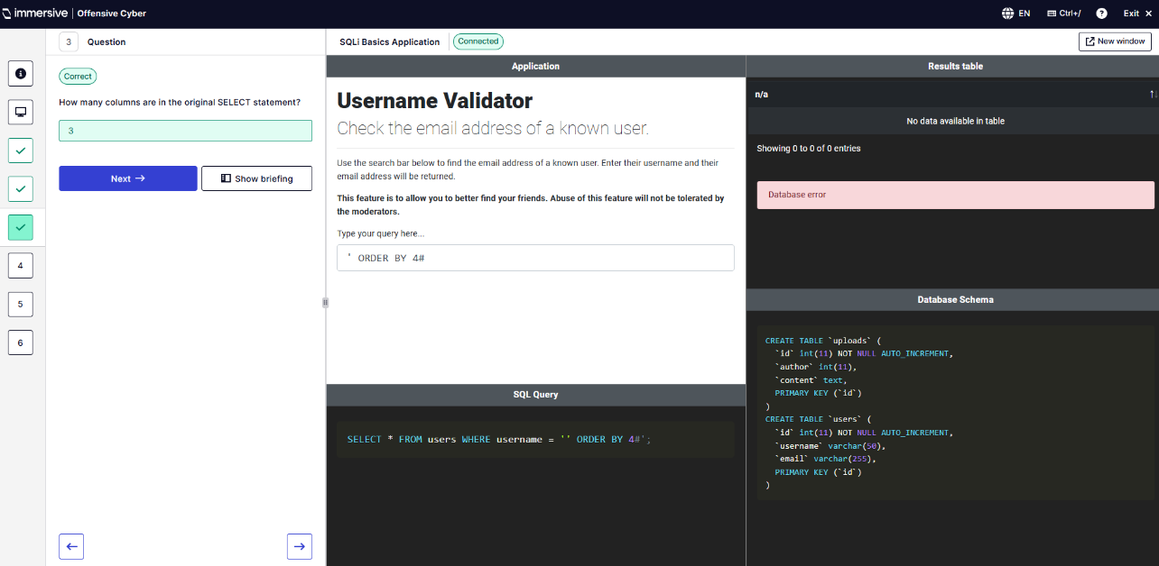
Q4 – What is the name of the database the application sits in?
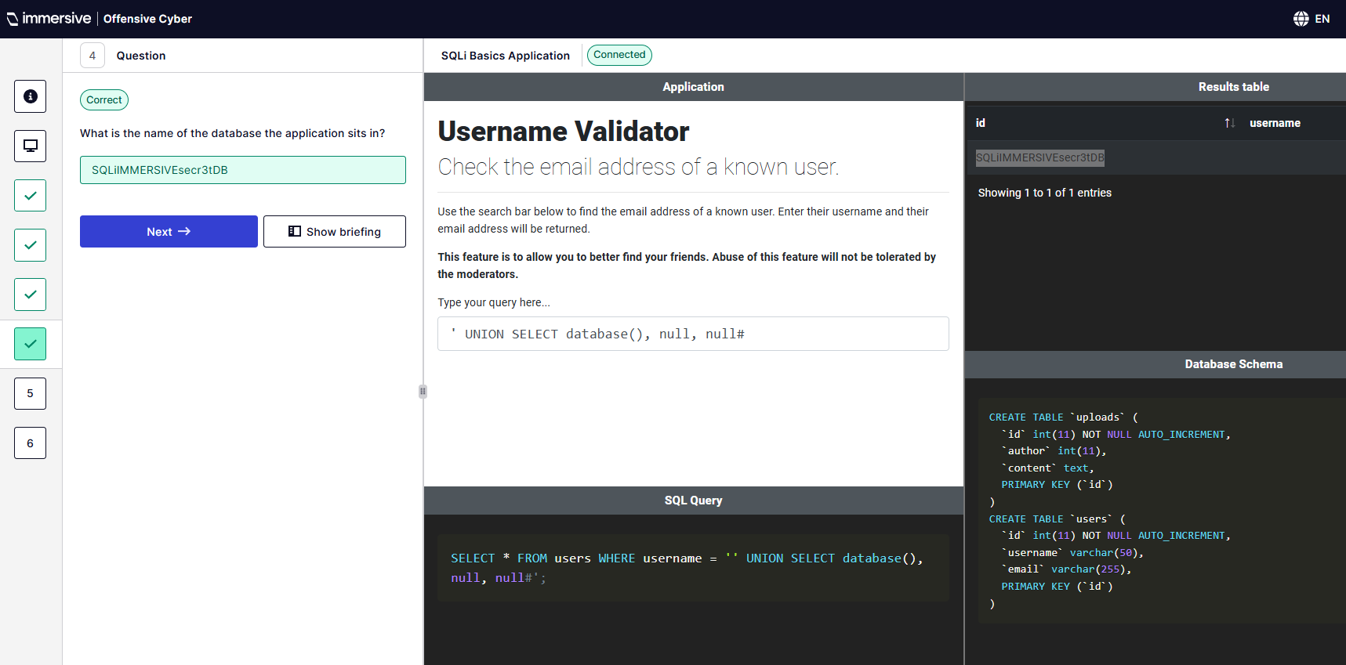
Q6 – What is the name of the current database software?
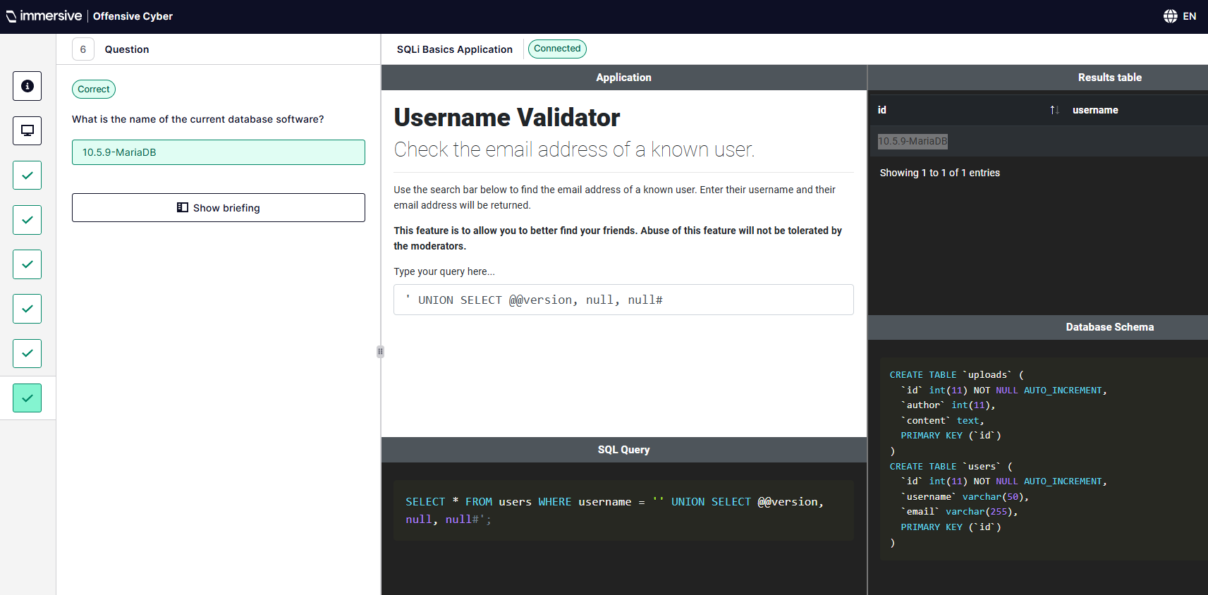
  - Demonstrate Your Skills
Q3 – What is the parameter vulnerable to SQL Injection?
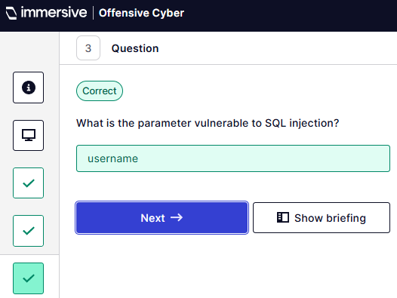
Q4 – Give an example of a keyword filtered by the application.
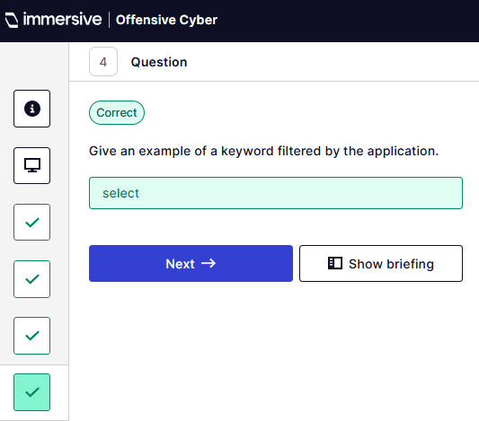
Q6 – What is the name of the non-default secret table?
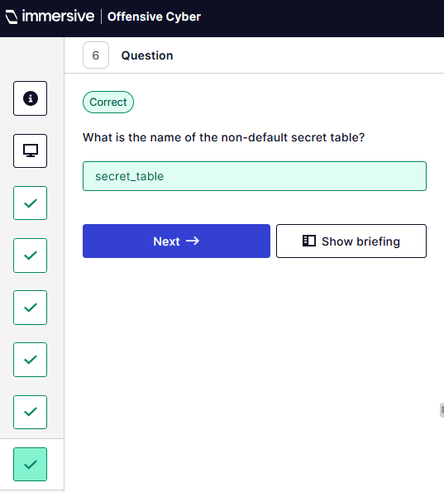
Q7 – What are the names of the columns in the table from the previous question?
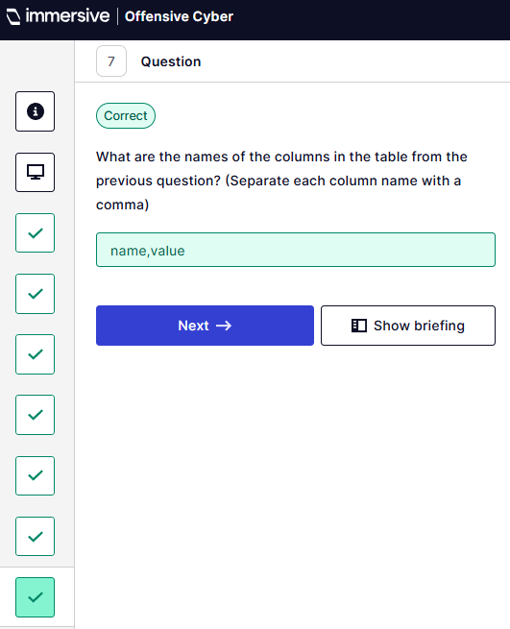
Q8 – What is the token found in this table?
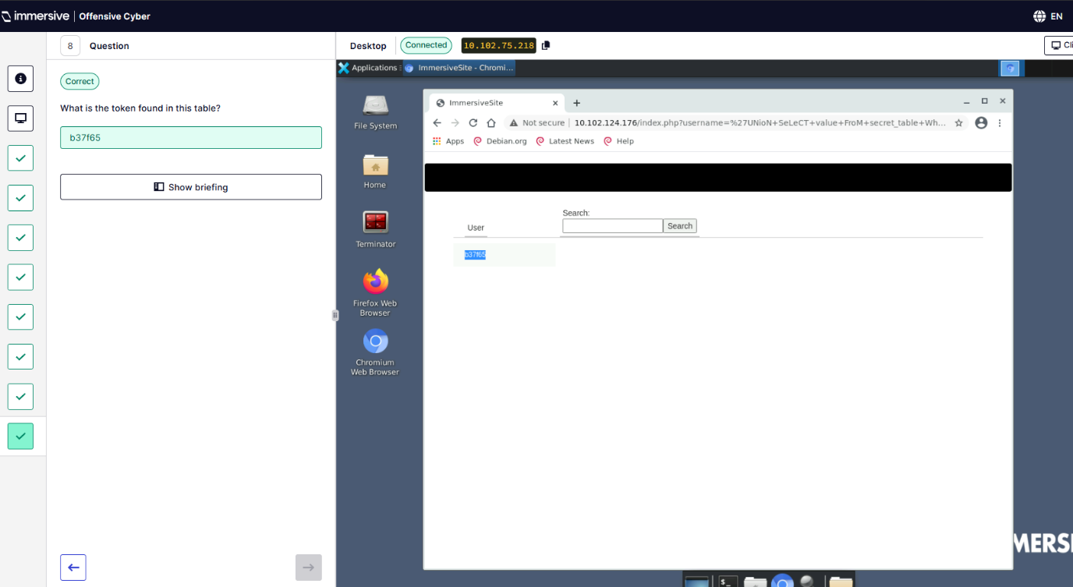
” (ImmersiveLabs SQL, 2025).
- Cross-Site Scripting (XSS). “ (ImmersiveLabs XSS, 2025)
  - What is Cross-Site Scripting
This one was a multiple-choice question lab.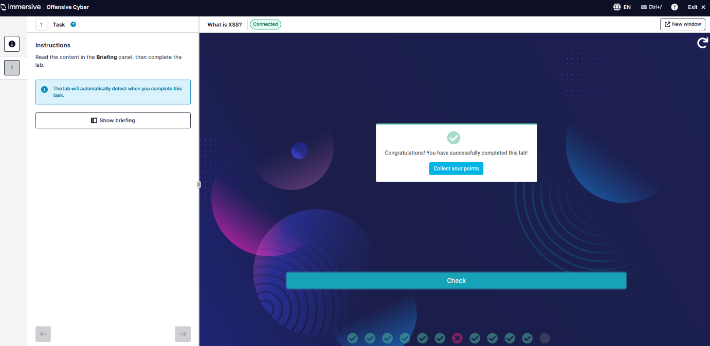
  - Reflected XSS
Q1 – Open Firefox and navigate to wildcard-cycles.bitnet.
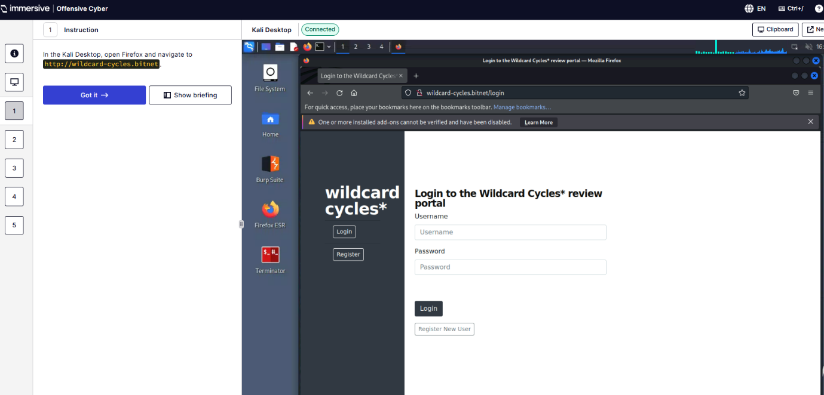
Q2 – Register.
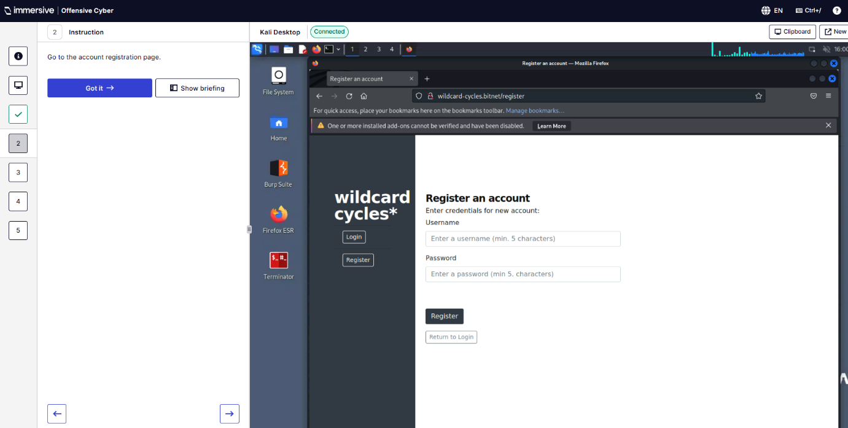
Q3 – When registering a user, data is sent using what HTTP method?
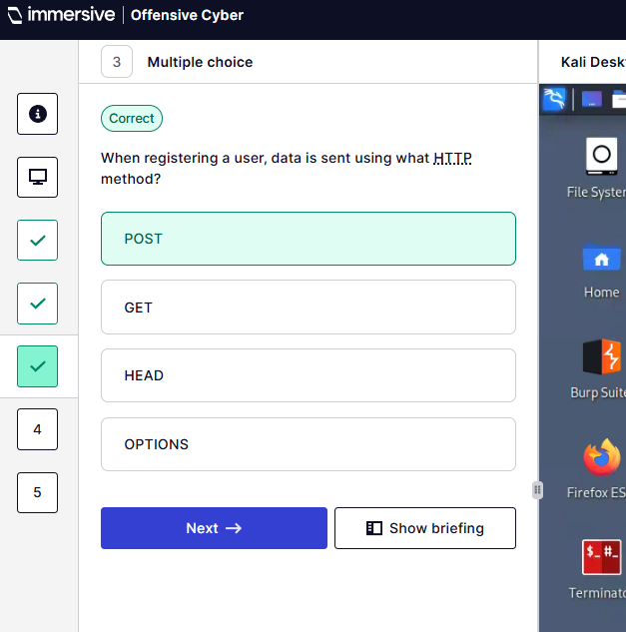
Q4 – Which of the following characters cannot be included in a username?
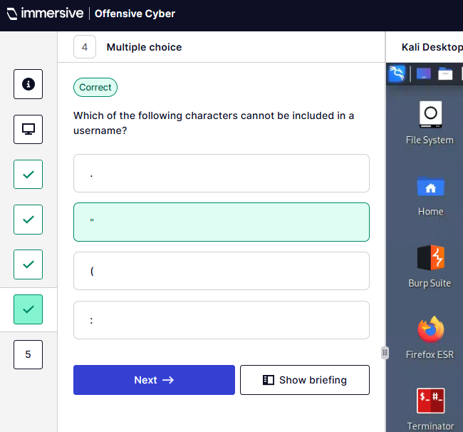
Q5 – Exploit the reflected XSS vulnerability to get the alert function to pop up.
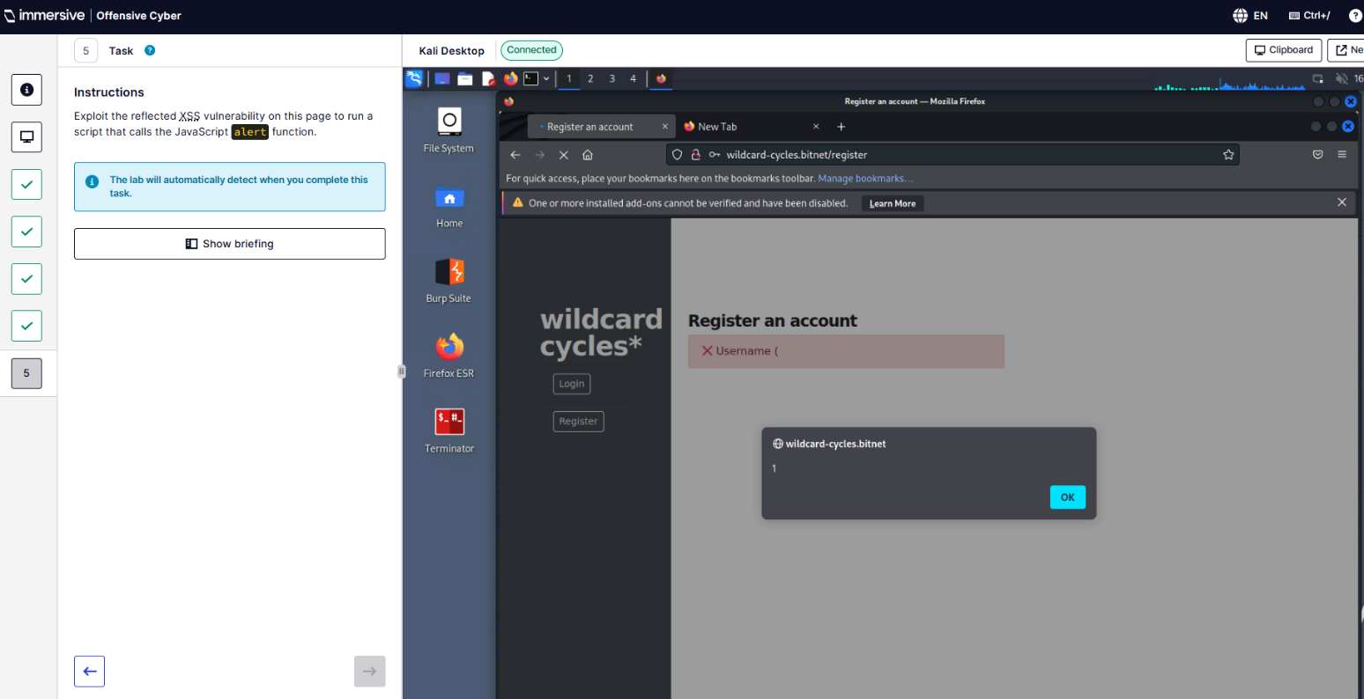
  - Stored XSS
Q1 – Open Firefox and navigate to wildcard-cycles.bitnet
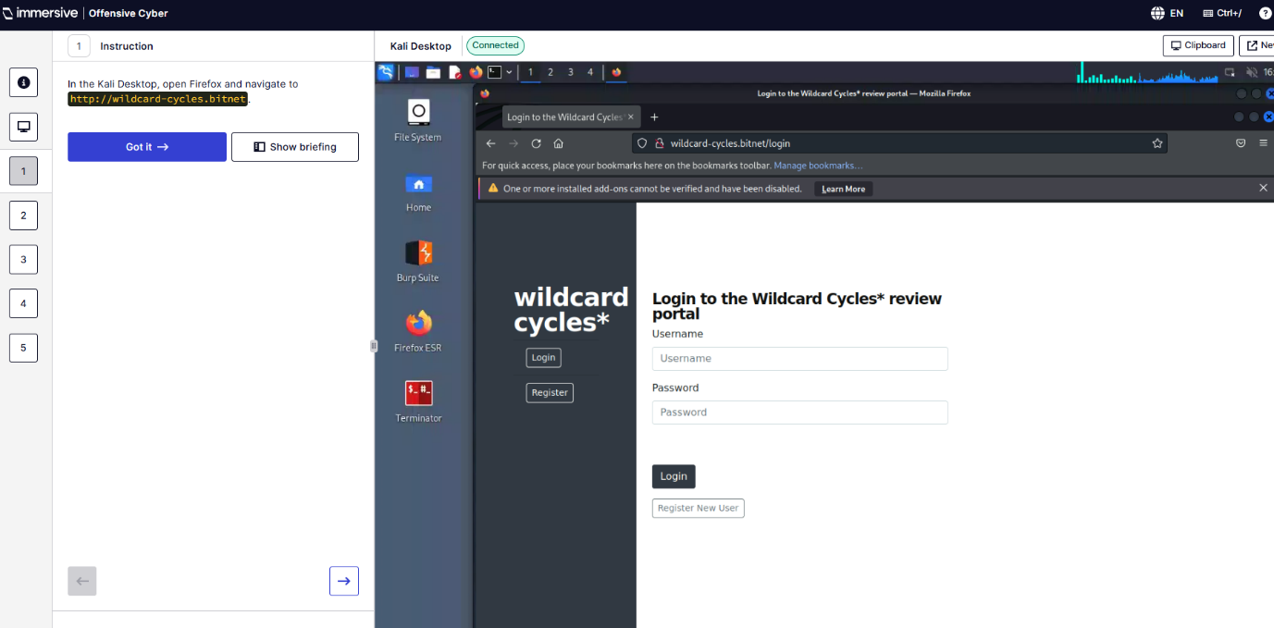
Q2 – Log in.
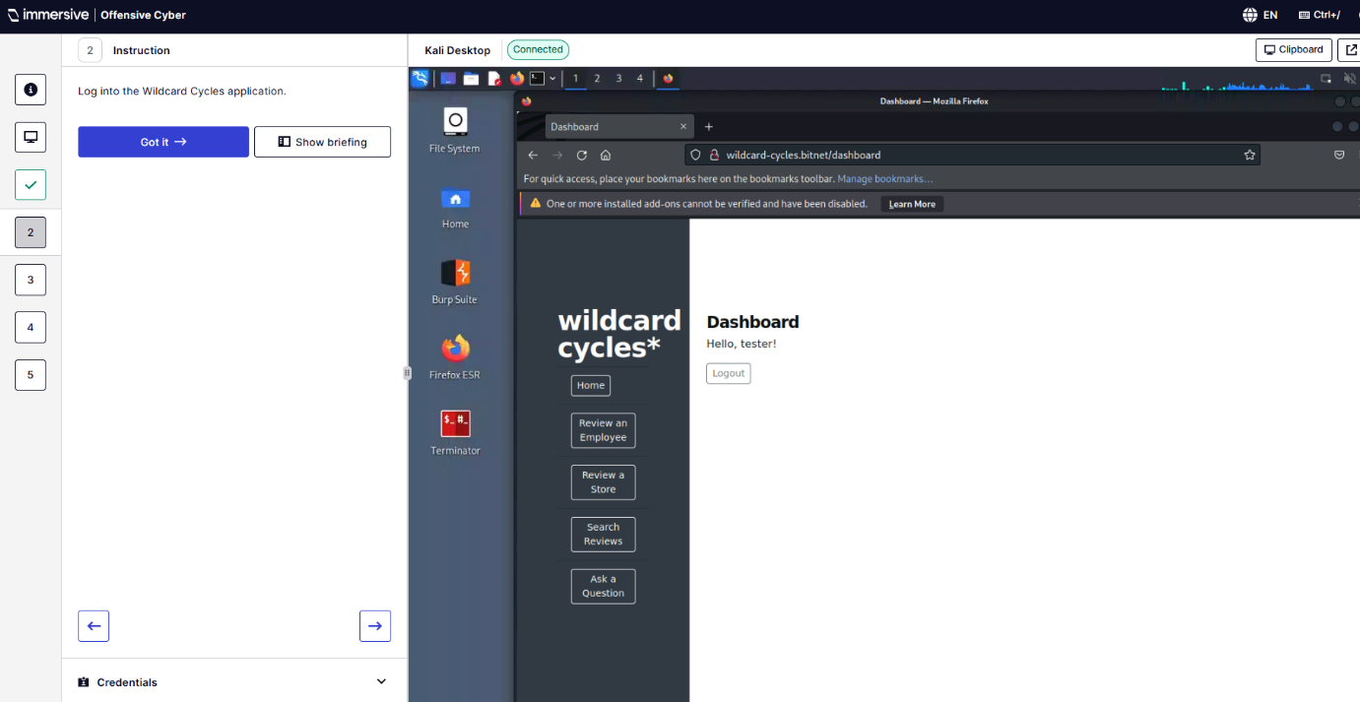
Q4 – Which filed in the form is susceptible to stored XSS.
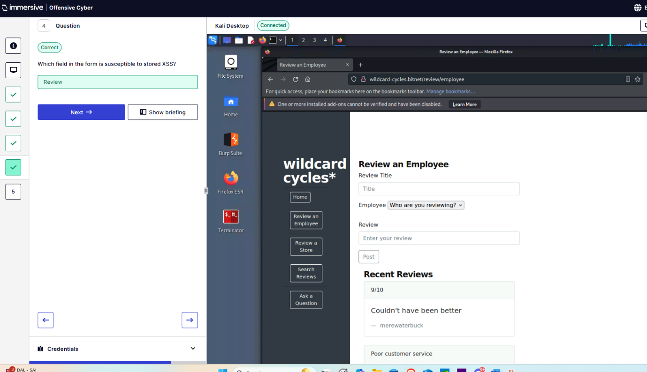
Q5 – Exploit the stored XSS vulnerability to run a JavaScript alert.
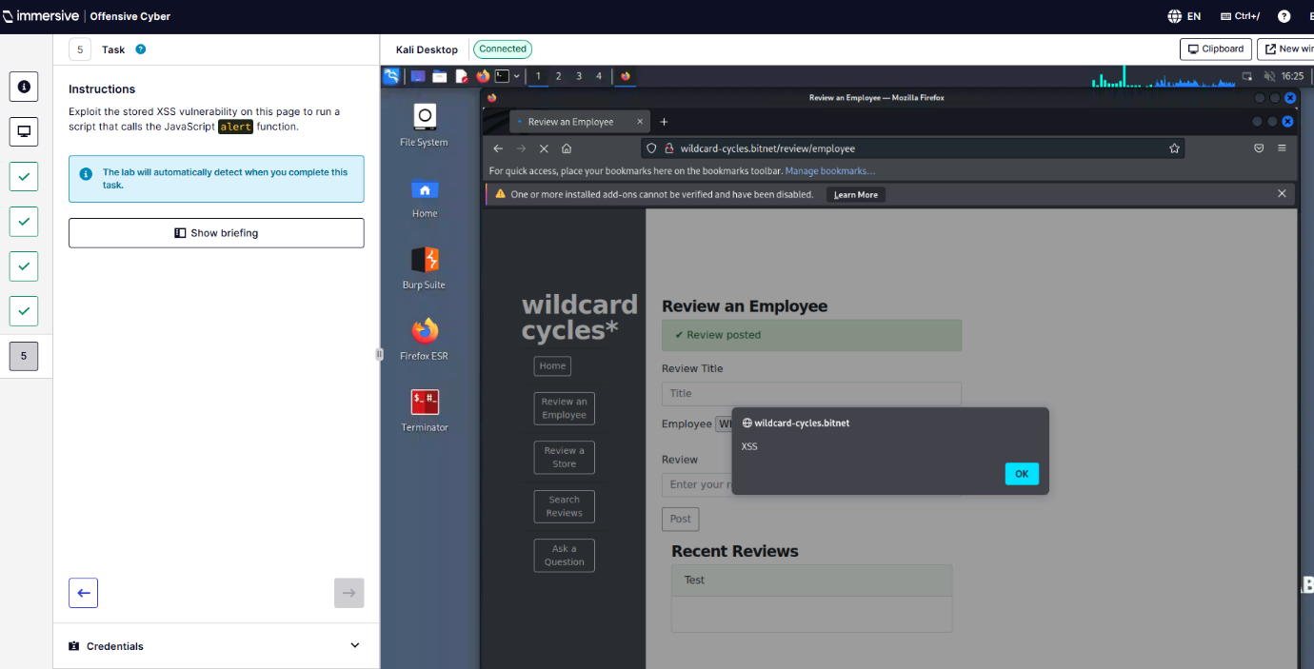

  - DOM-Based XSS
Q1 – Open Firefox and navigate to wildcard-cycles.bitnet
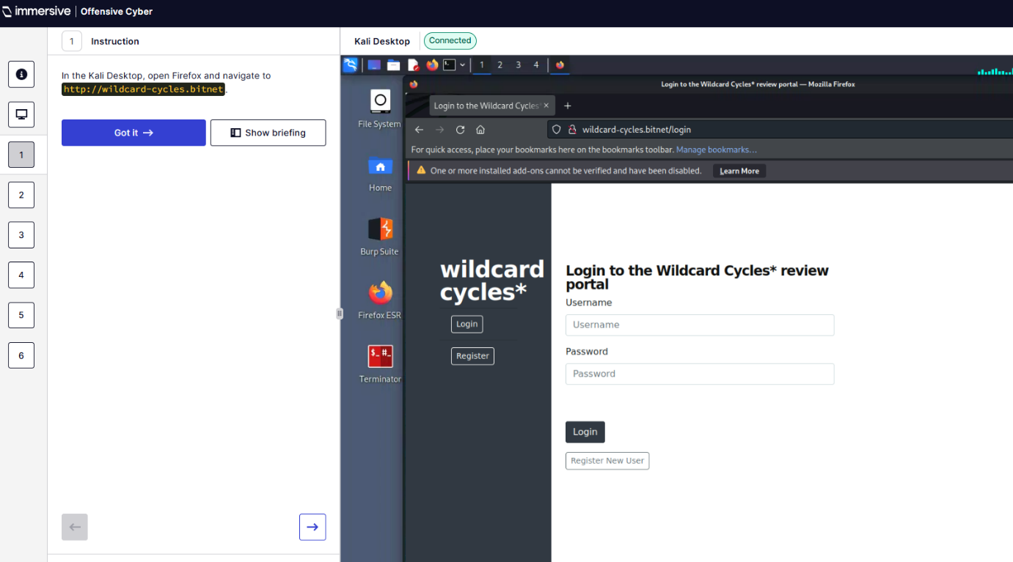
Q2 – Log in and open Search Reviews page
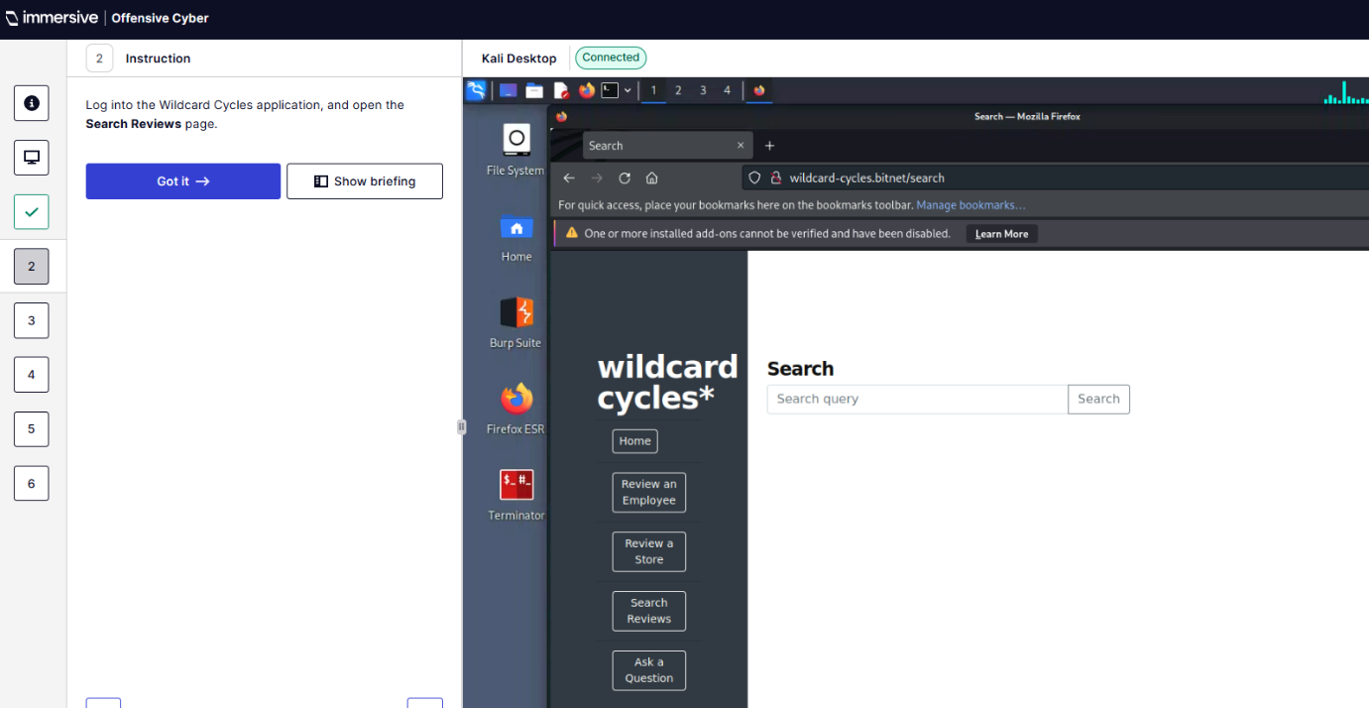
Q3 – What is the filename of the client-side script added to the search results page?
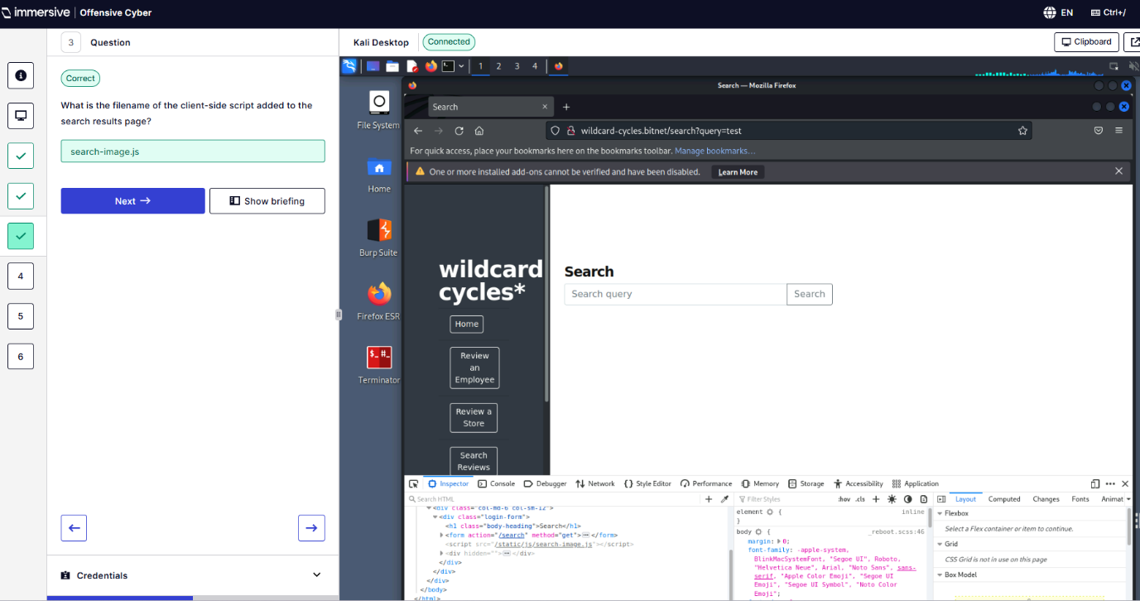
Q4 – What is the filename and extension of the image added to the application by this script?
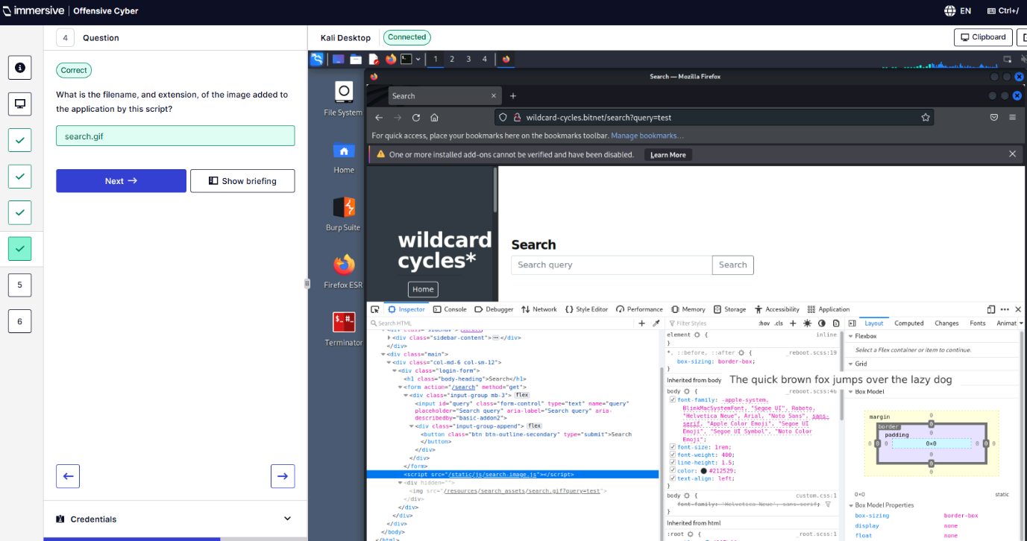
Q6 – Exploit this DOM-based XSS vulnerability to display an alert.
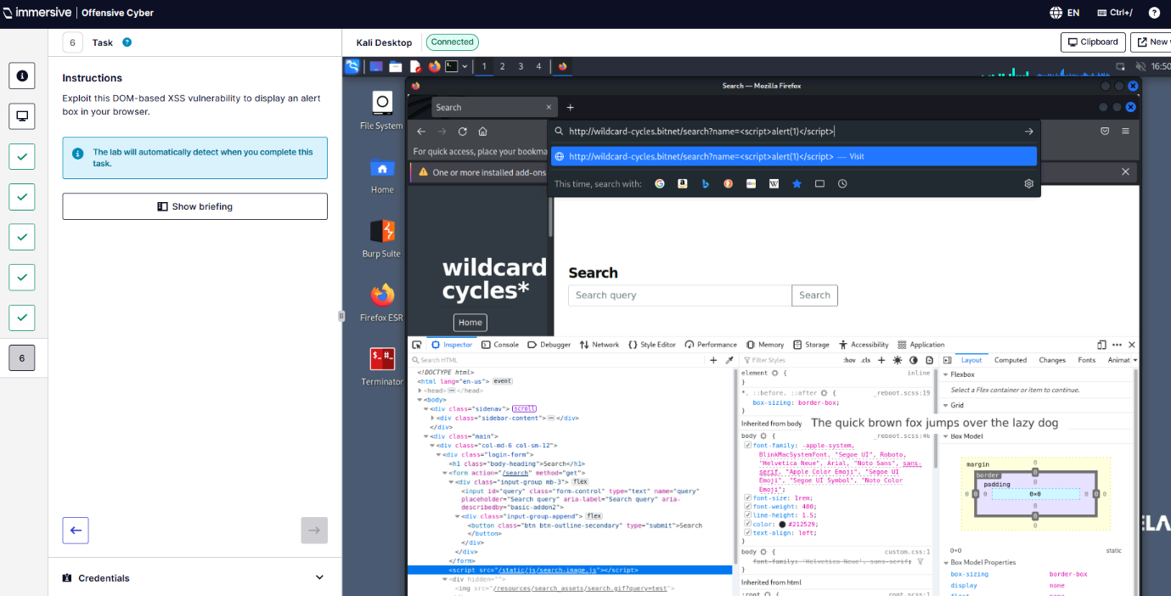
  - Filter Evasion
Q1 – Open Firefox and navigate to wildcard-cycles.bitnet
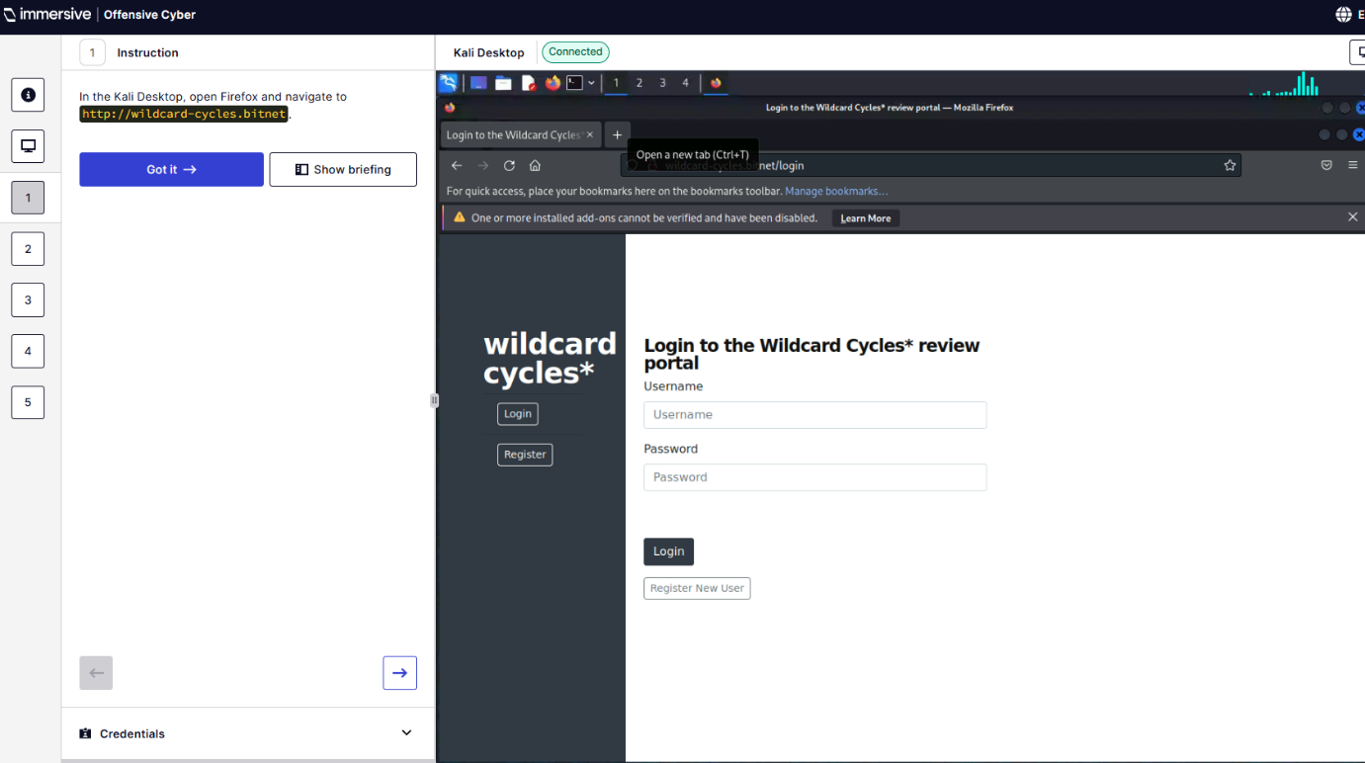
Q2 – Log in and open Review a Store page
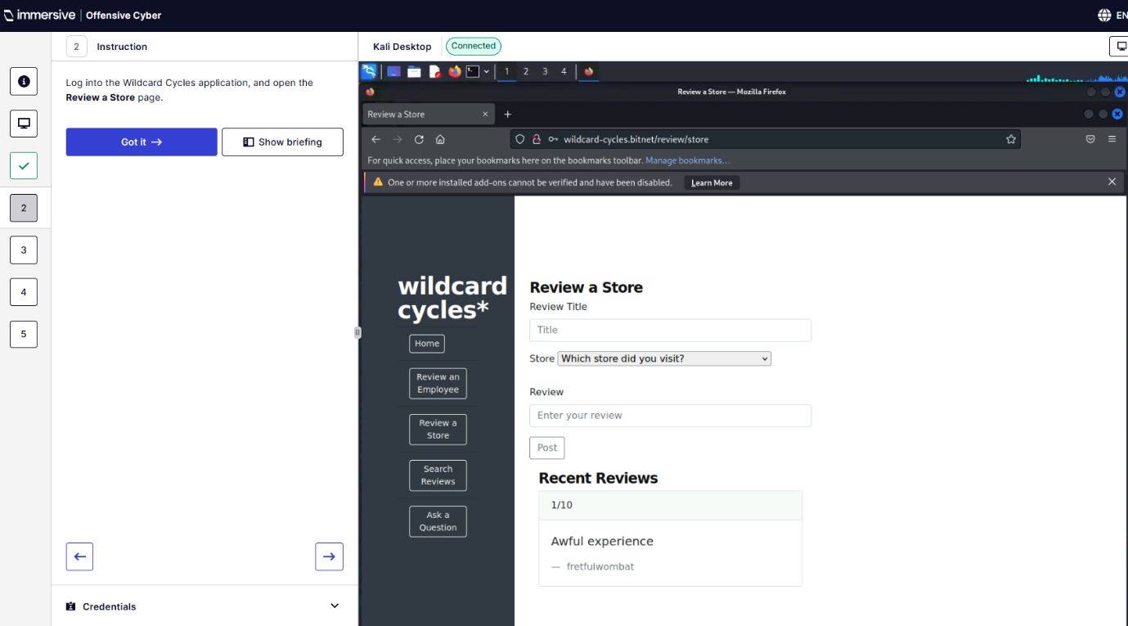
Q3 – Which of the following characters cannot be sent to either filed in the form?
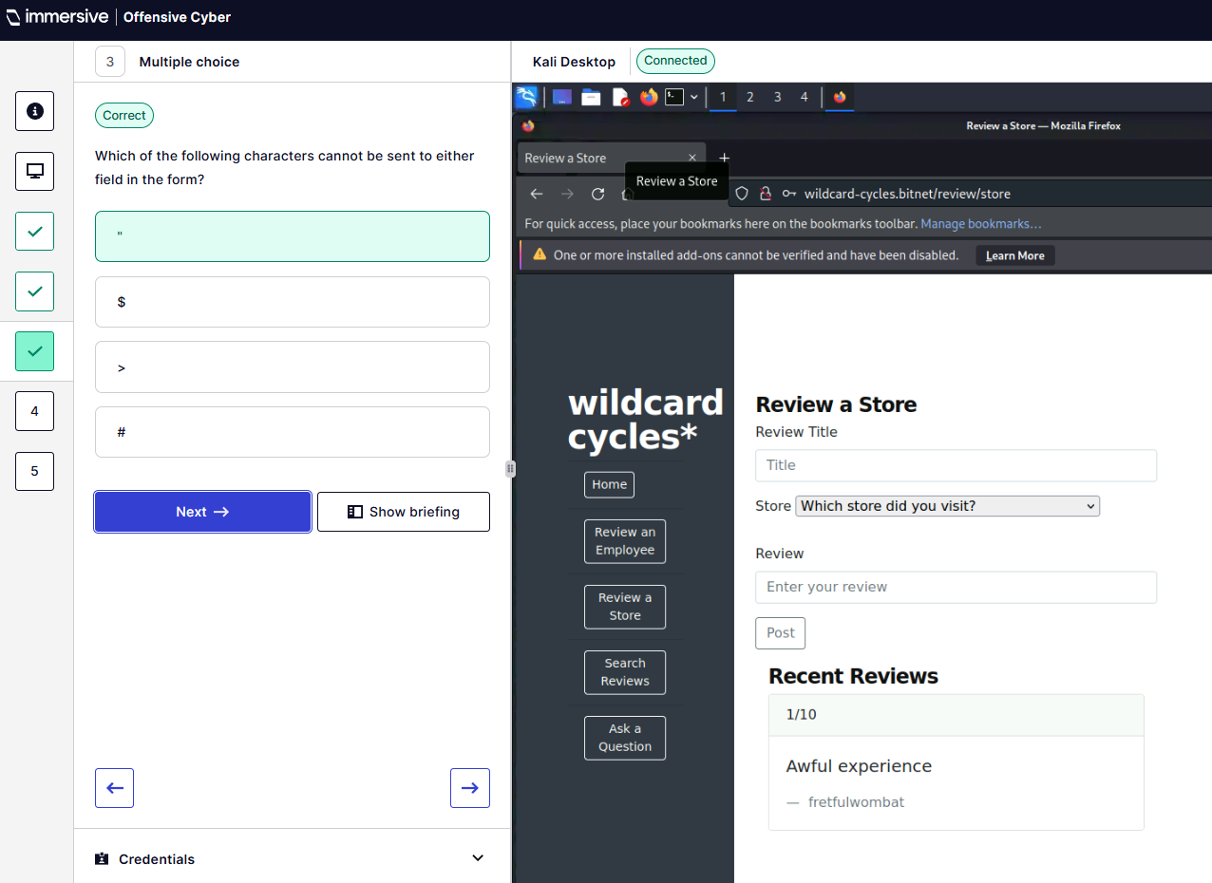
Q5 – Exploit this stored XSS vulnerability to display an alert box – This one I had a bit of trouble with and took me a while. I ended up making it work by having a click me function that would call the XSS script when clicked.
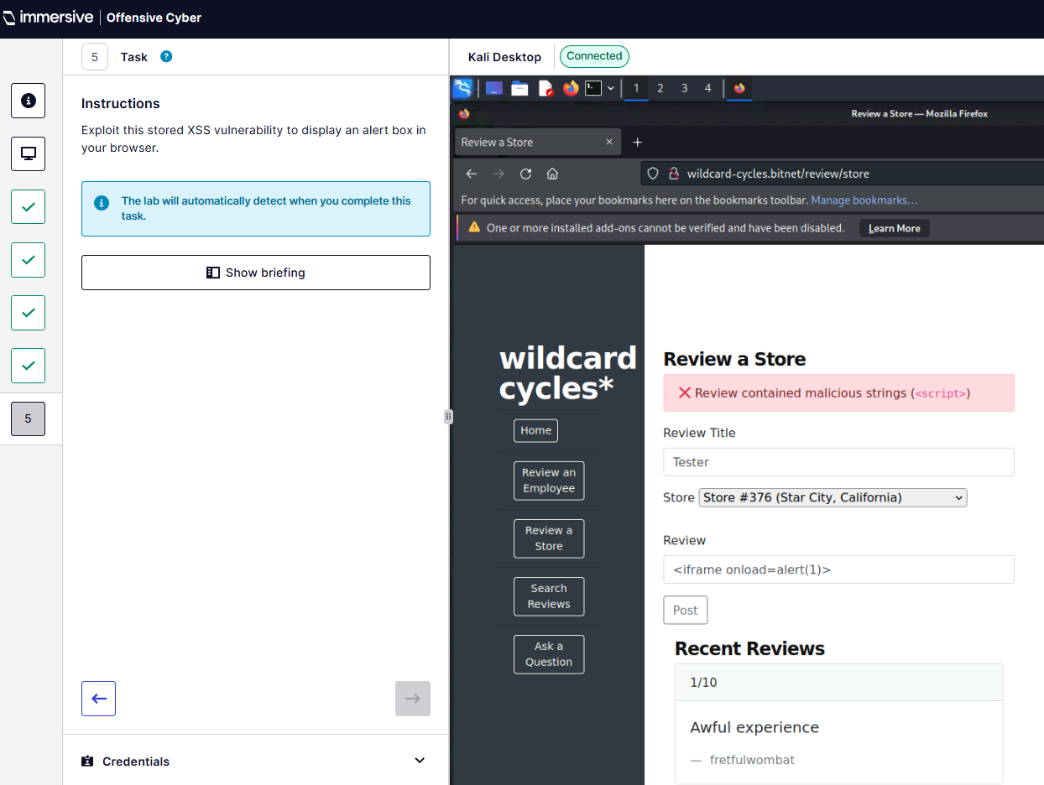
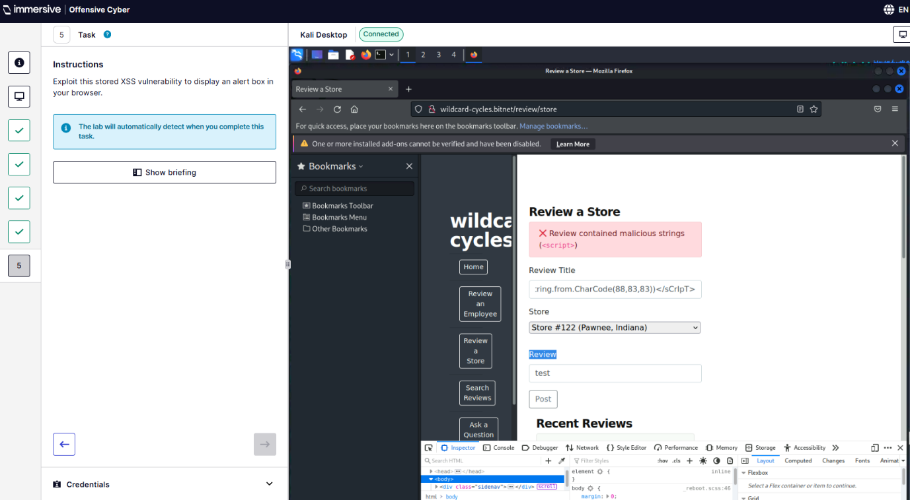
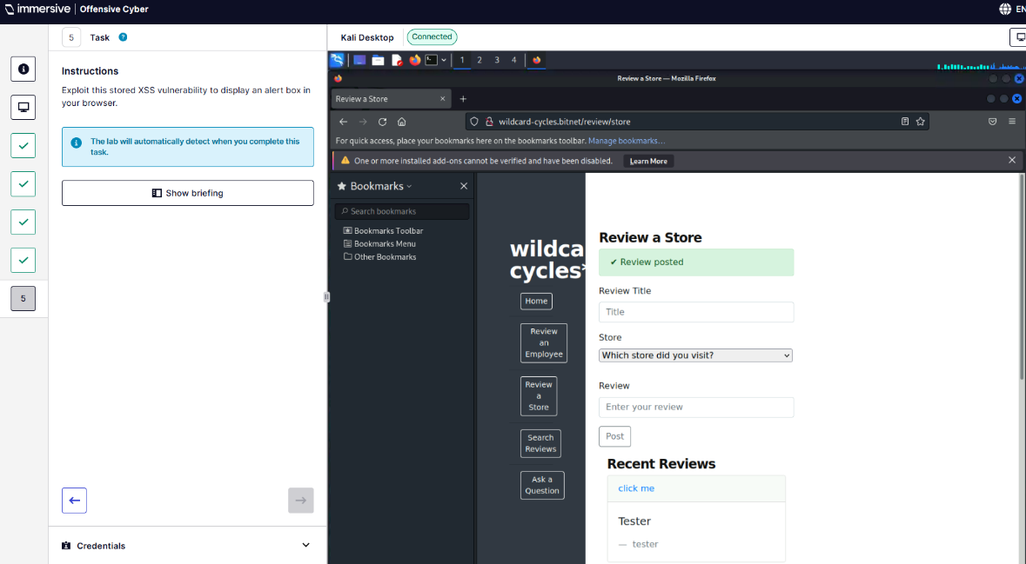
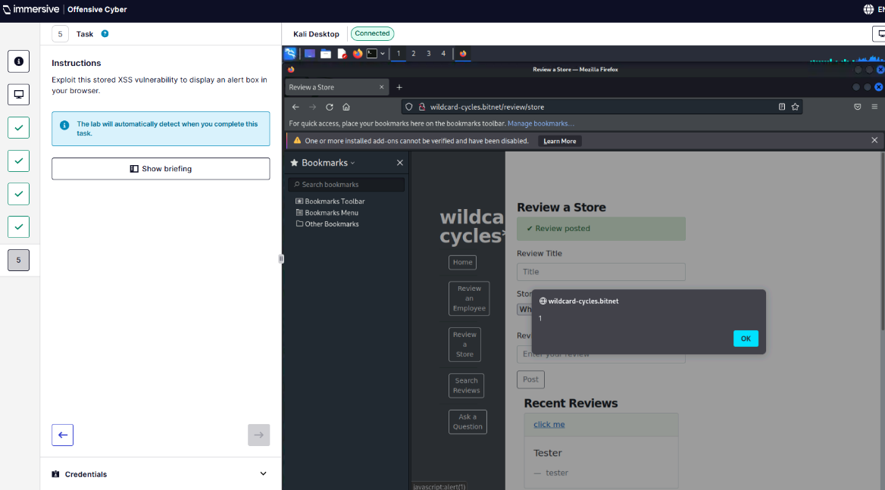
  - Further Exploitation
Q5 – What is the username of the user who opened the message?
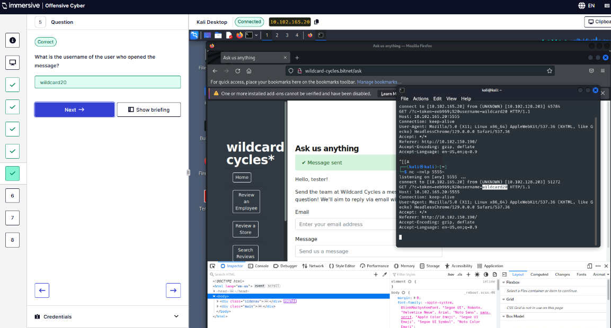
Q6 – What is the token found in the token cookie?
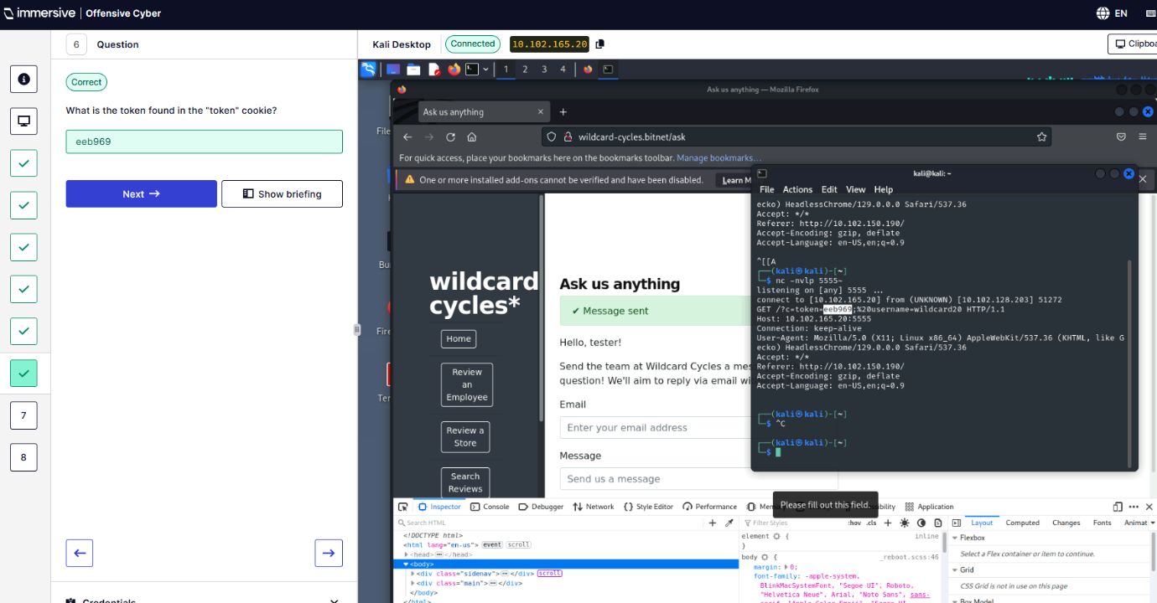
Q7 – Extend the XSS vulnerability to view the contents of /admin/token page with SSRF.
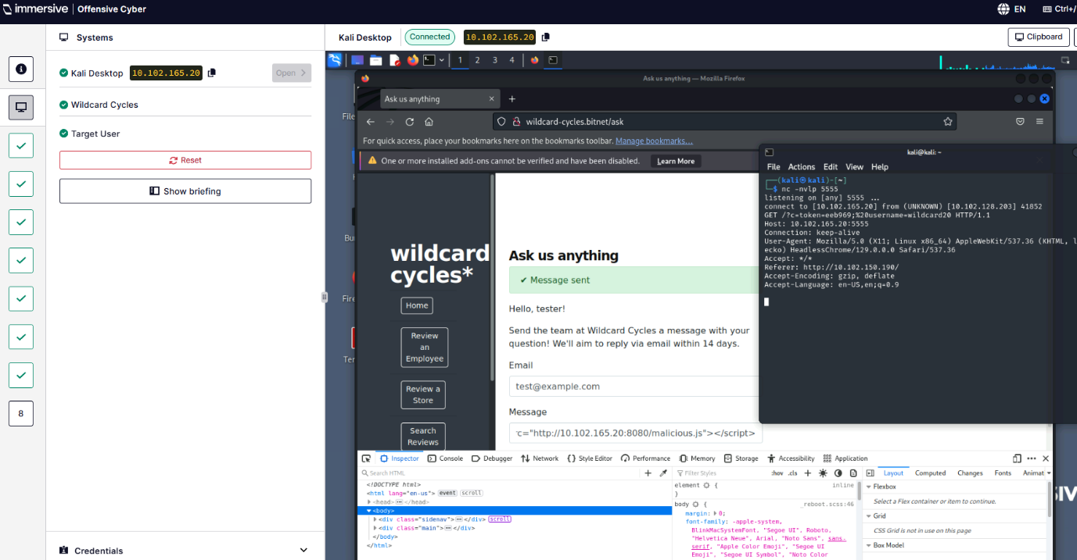
Q8 – What is the token on this page?
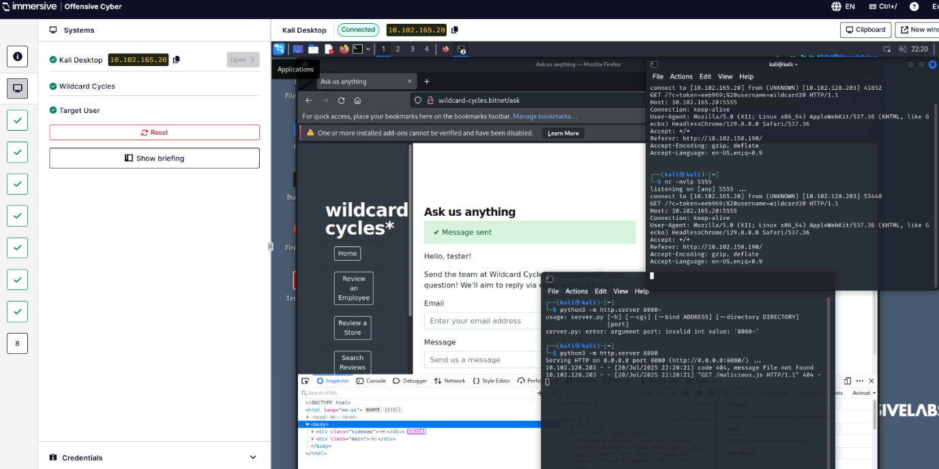
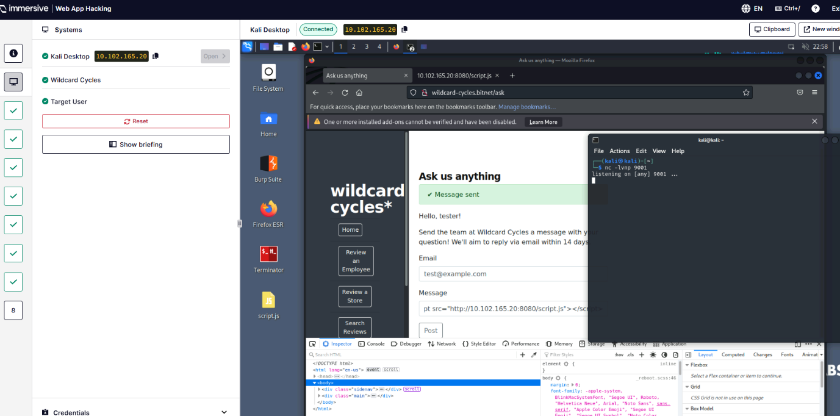
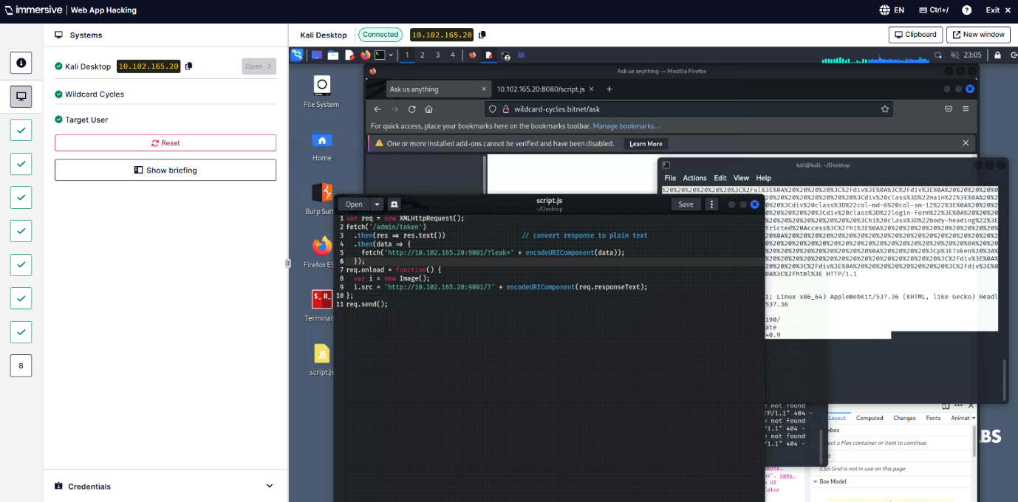
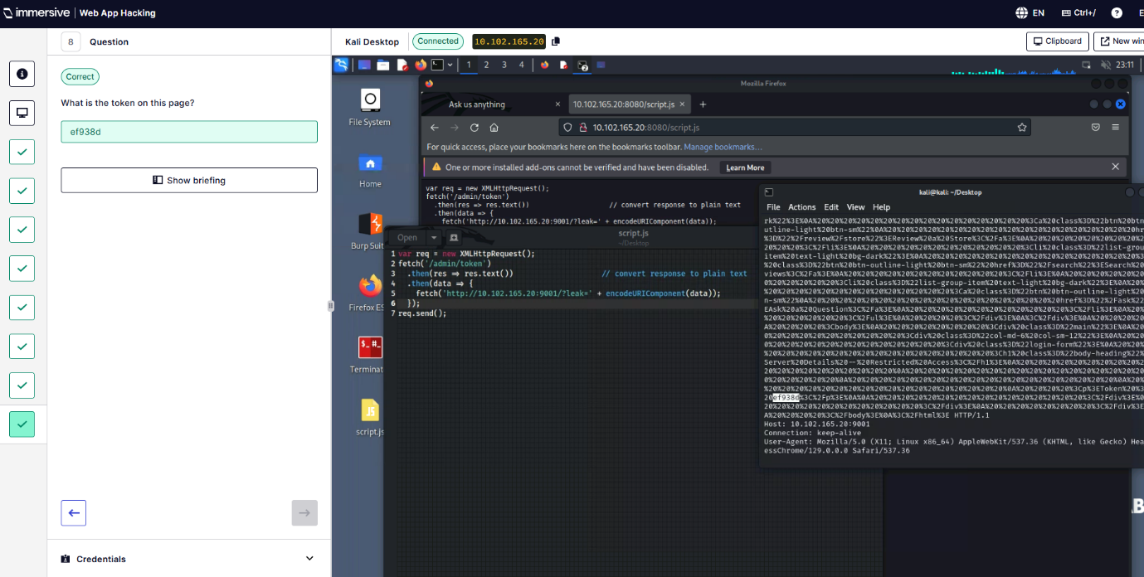
  - Demonstrate Your Skills
Q4 – Exploit this reflected XSS to display an alert box.
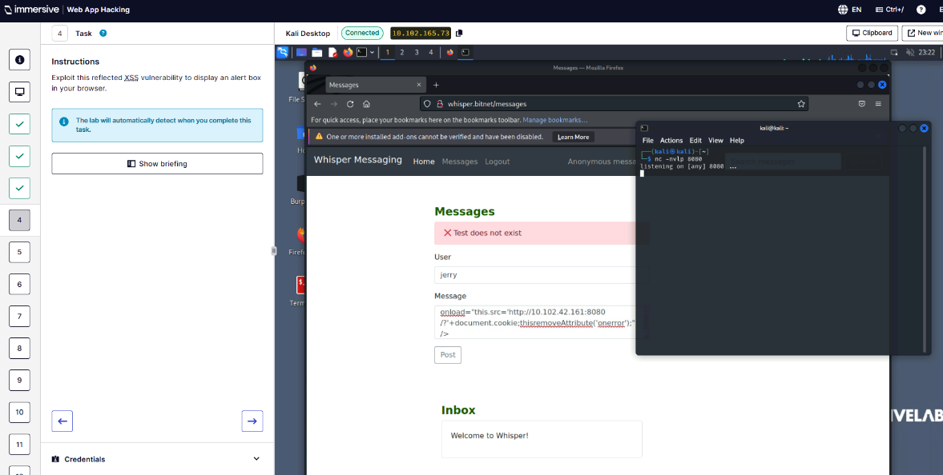
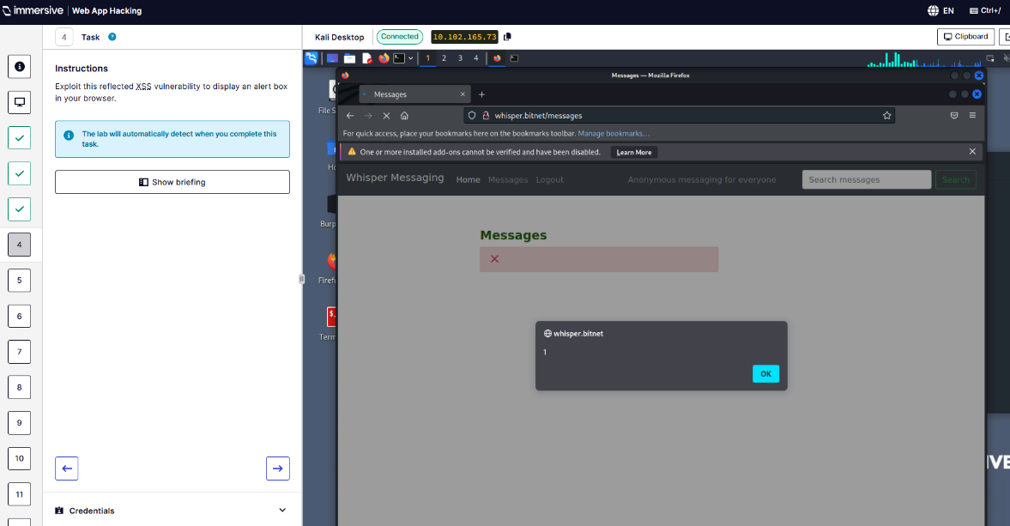
Q5 – What is the full URL to the page containing this reflected XSS vulnerability?
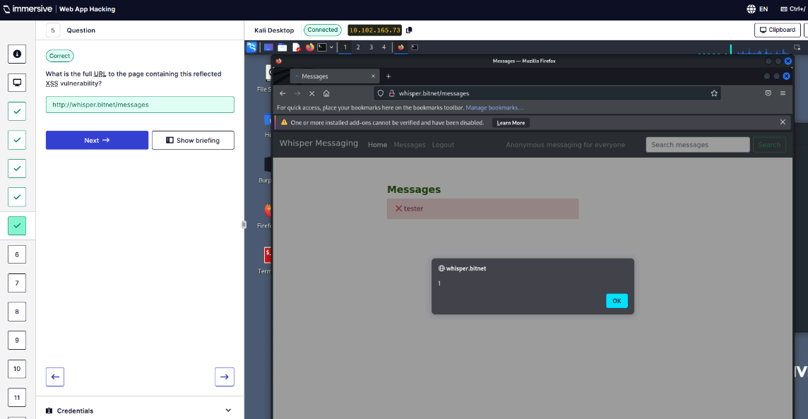
Q7 – Exploit this stored XSS vulnerability to display an alert box.
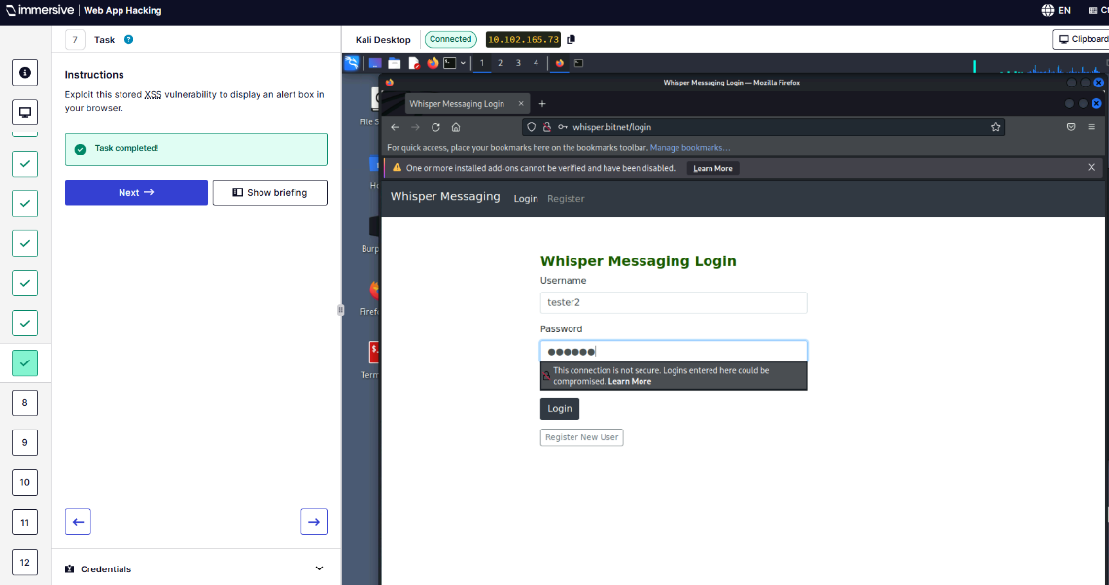
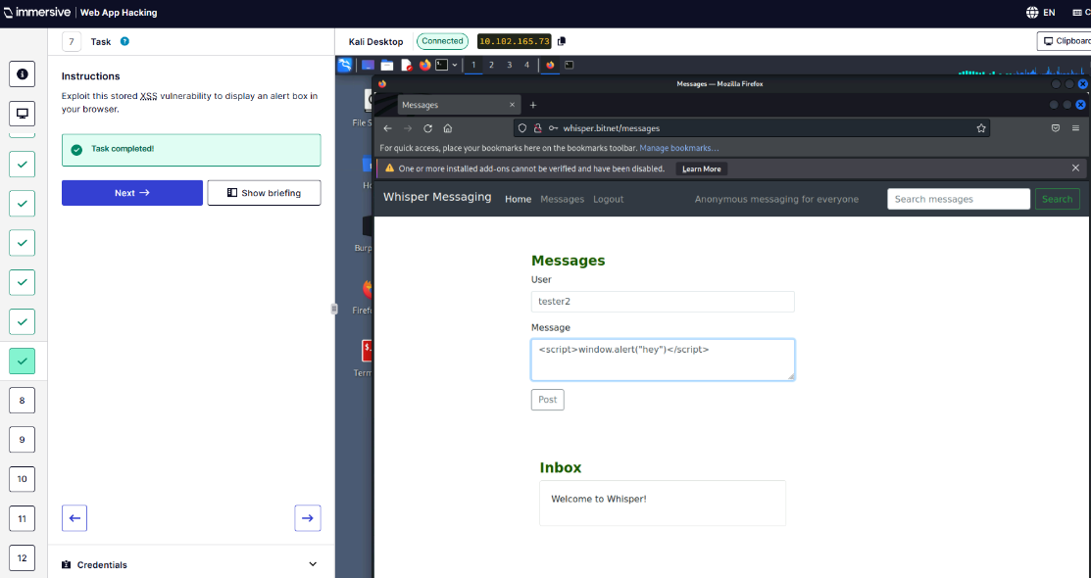

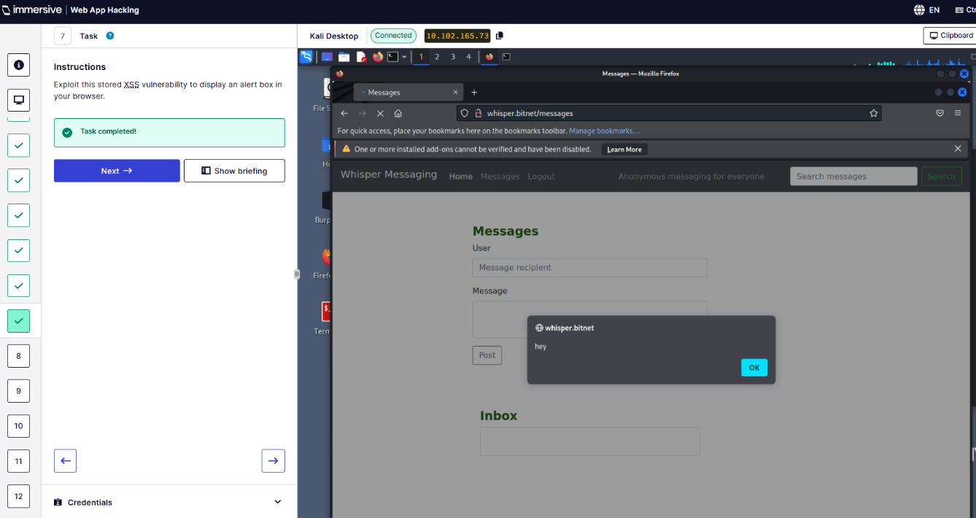
Q9 – What is the value of Jerry’s token cookie?
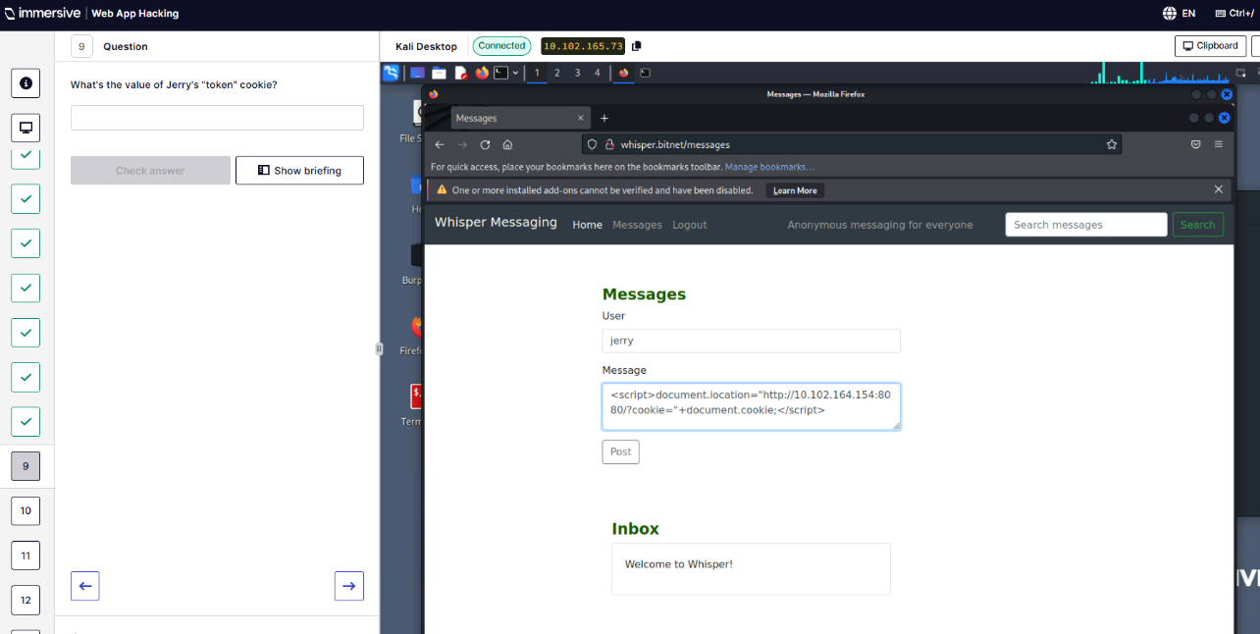
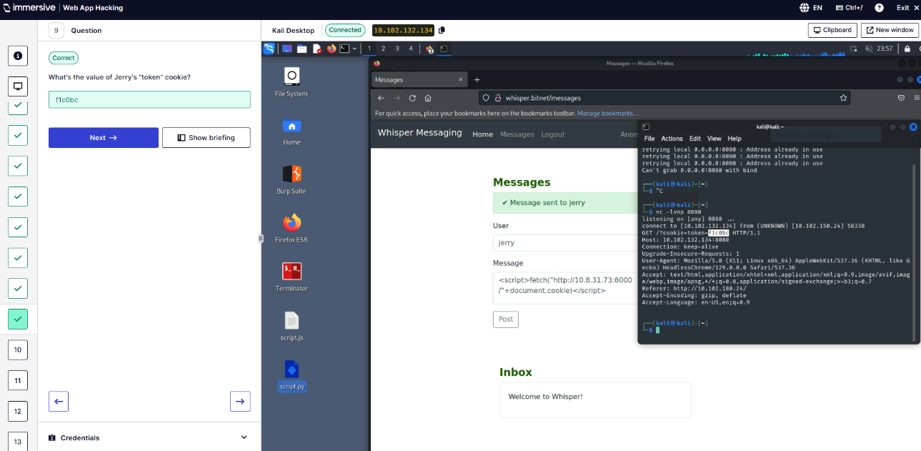
Q10 – Bypass the filter to exploit this stored XSS vulnerability and display an alert.
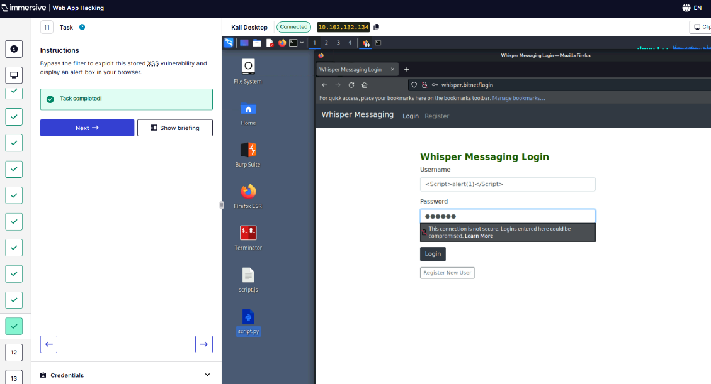
Q13 – Exploit this DOM-based XSS vulnerability to display an alert.
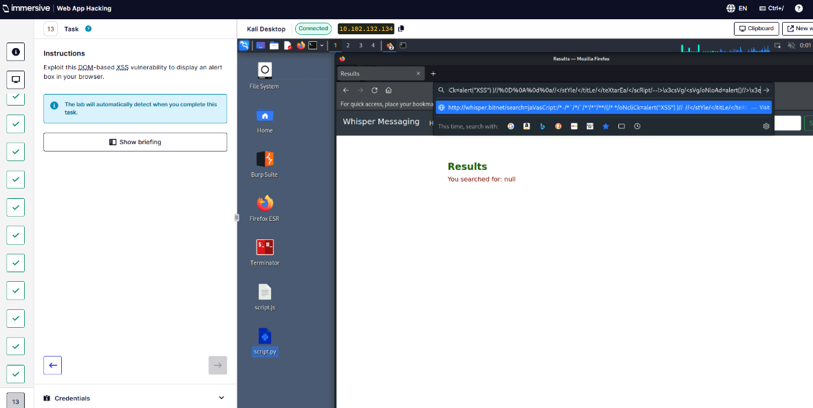
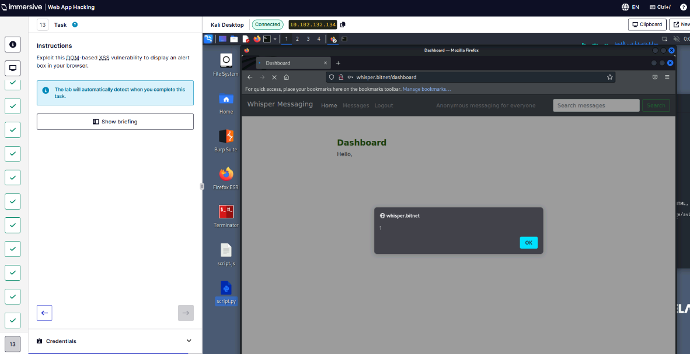
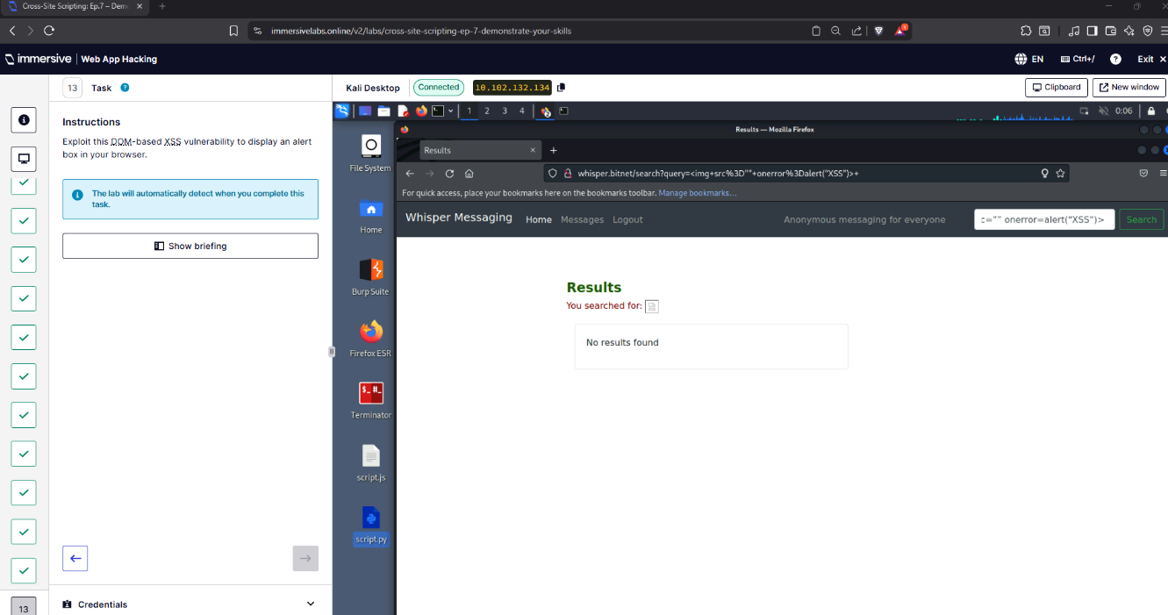
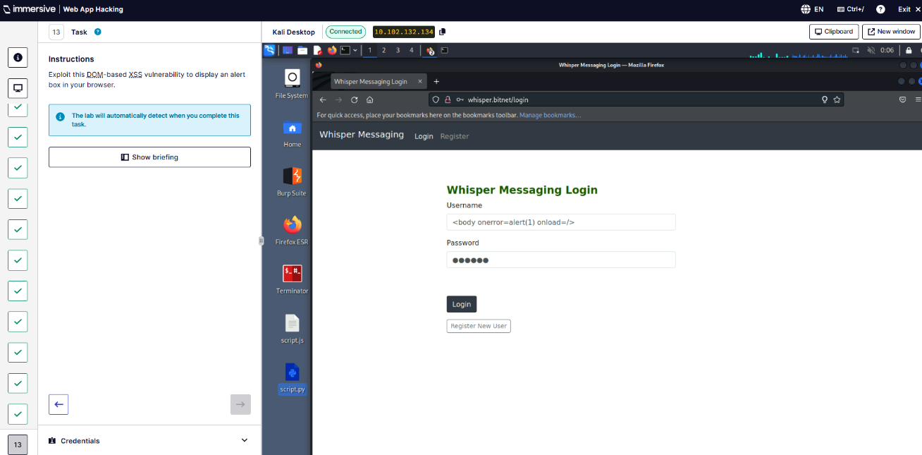
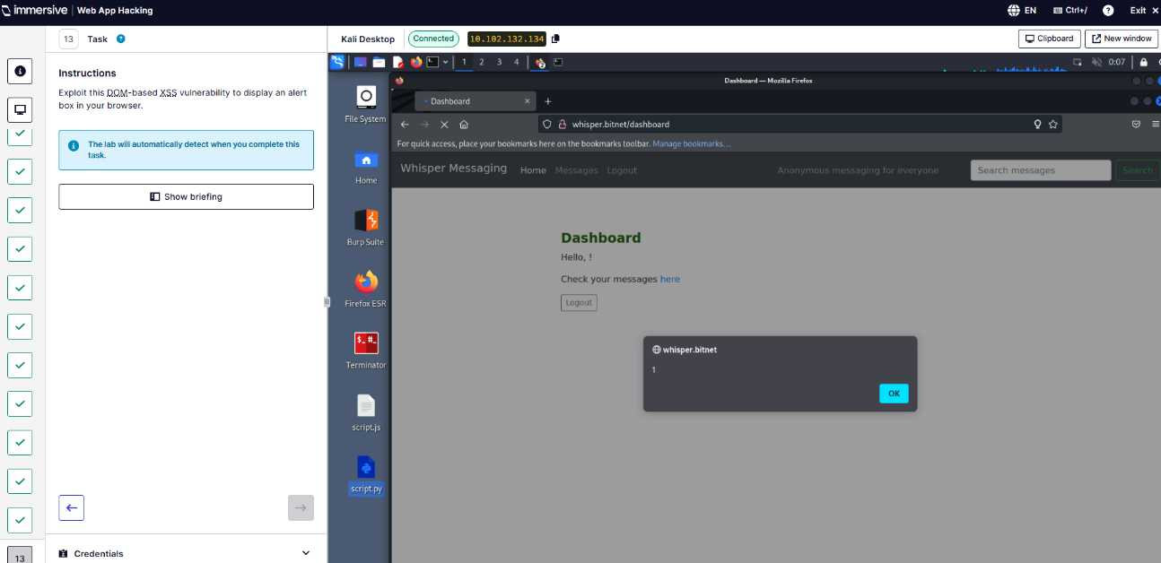
” (ImmersiveLabs XSS, 2025).
- Infrastructure Hacking “(ImmersiveLabs Infrastructure Hacking , 2025)
  - Bash History
Q1 - Use the command history to identify the username and password needed to access the remote machine.
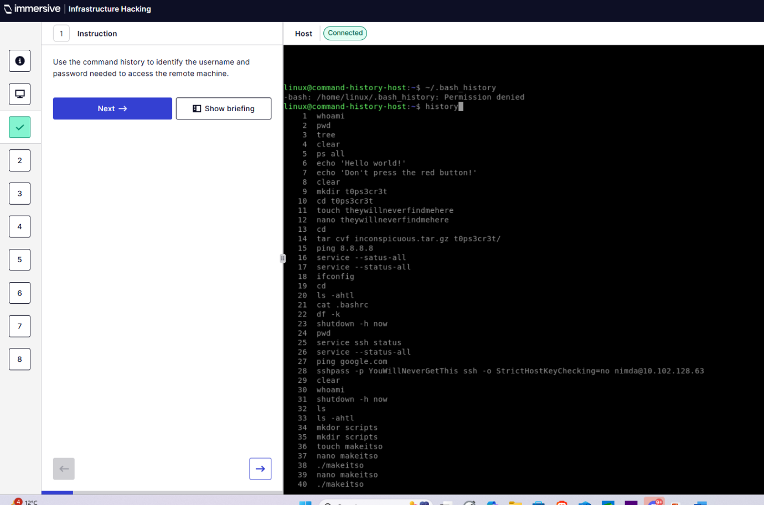
Q2.
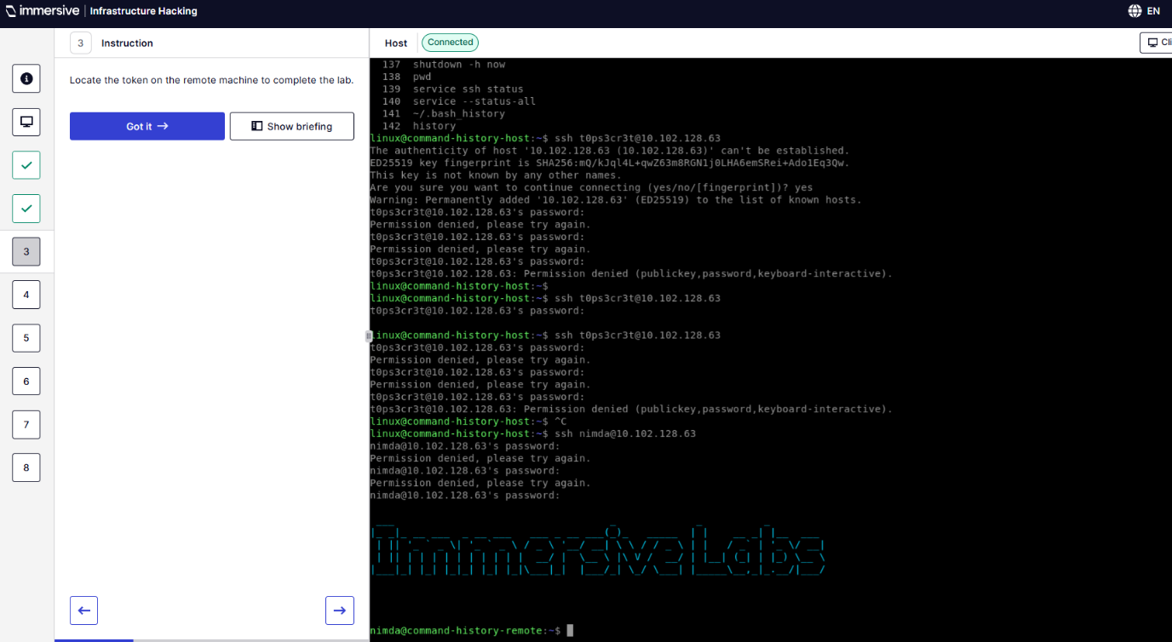
Q3 – Locate the token.
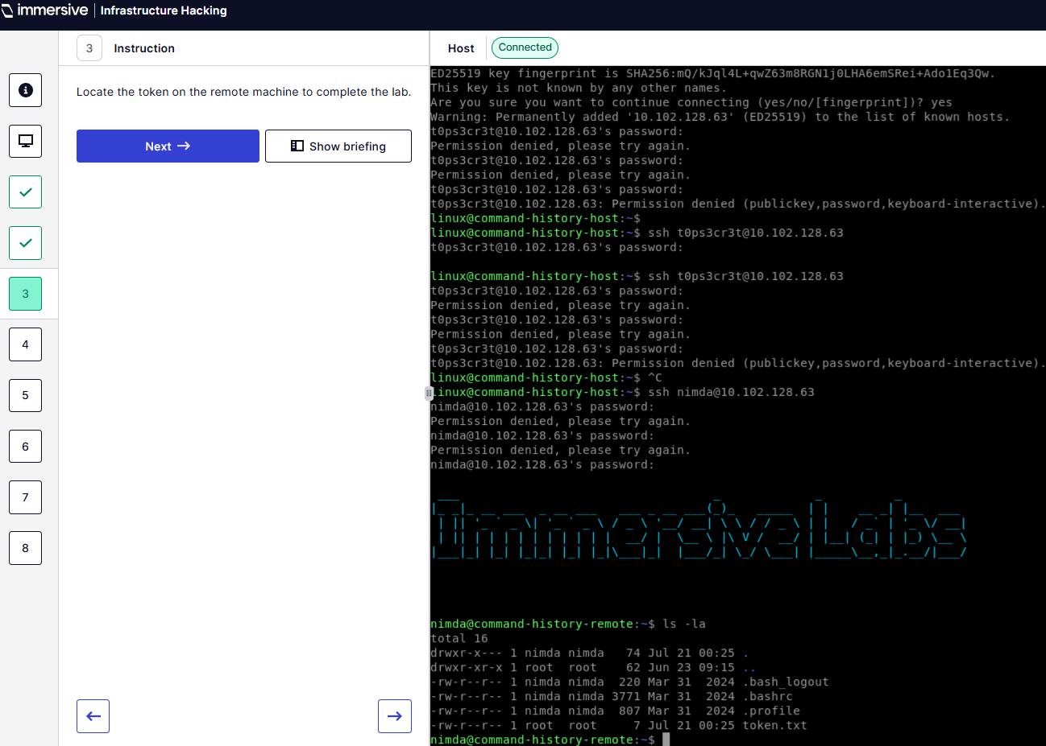
Q4 – What character is used to prevent it from being saved to history?
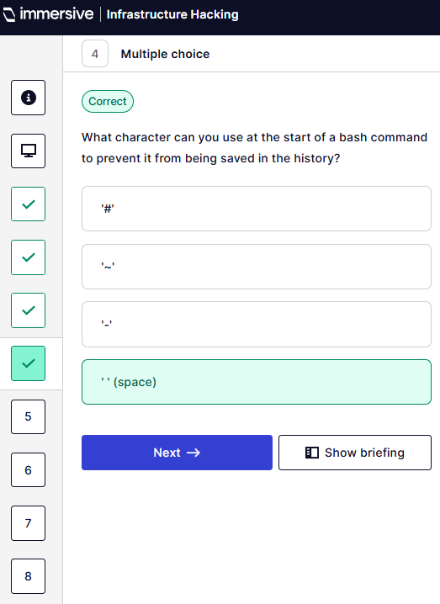
Q5 – What commands are used to suspend and resume recording of command history?
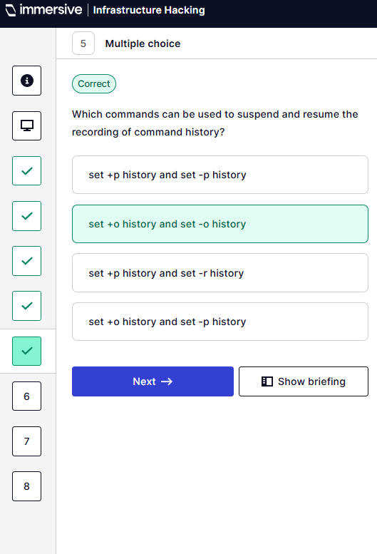
Q6 – What value would set HISTCONTROL environment so commands can’t be hidden?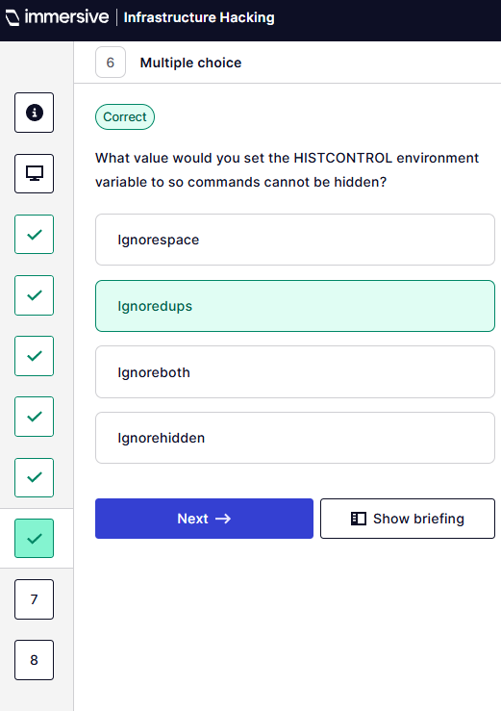
Q7 – What is the password to connect using SSH?
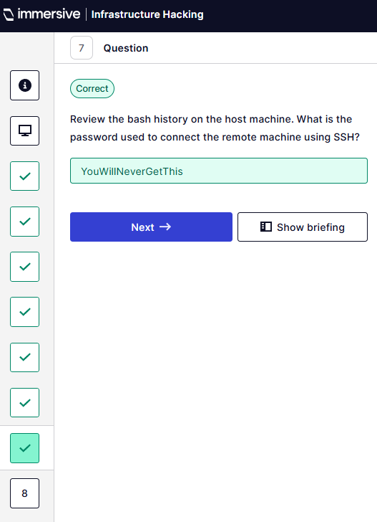
Q8 – What is the token?
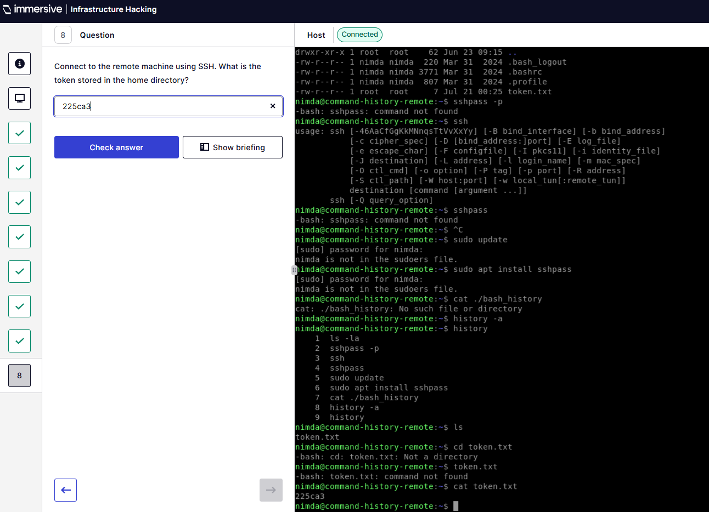
  - XSL Script Processing
Q4 – Execute the script tag using msxsl.exe.
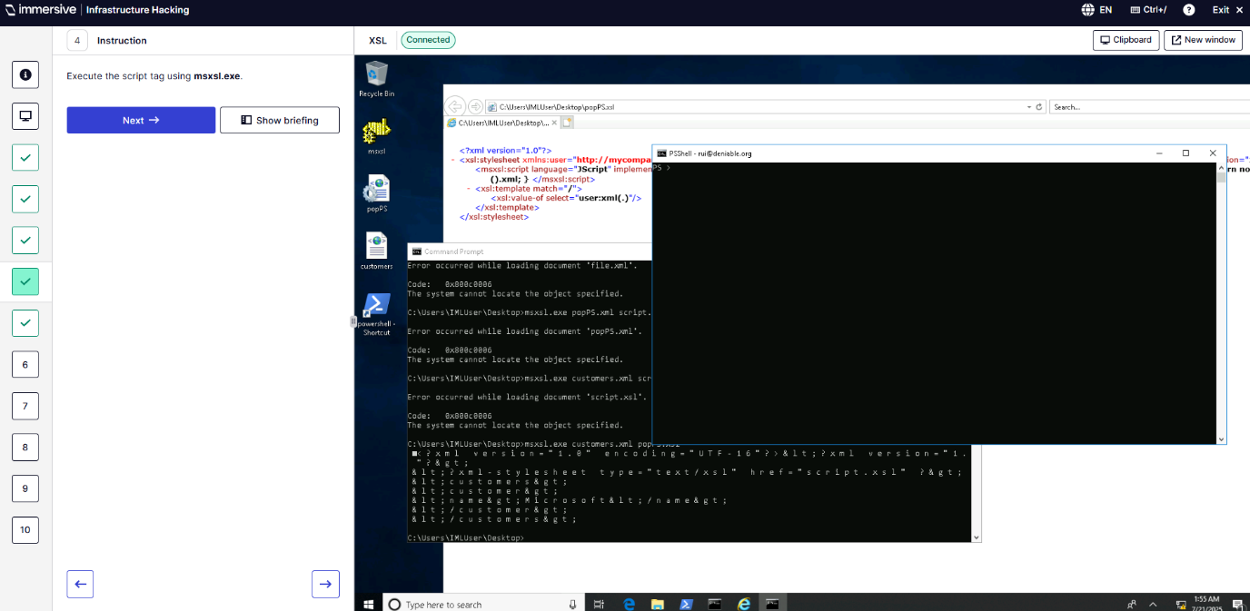
Q5 – Run Get-Token to receive token.
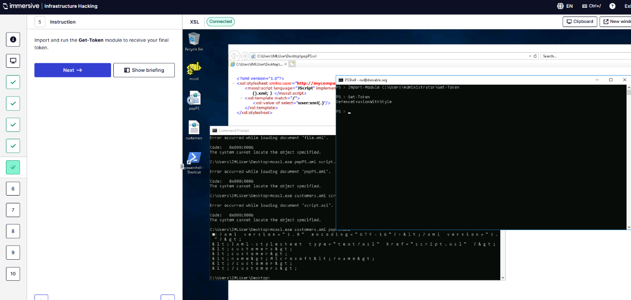
Q6 – What does XSL stand for?
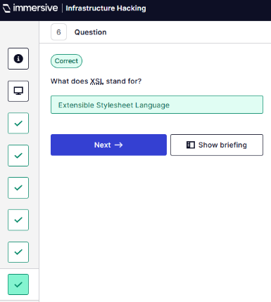
Q7 – Which tag is responsible for executing the script?
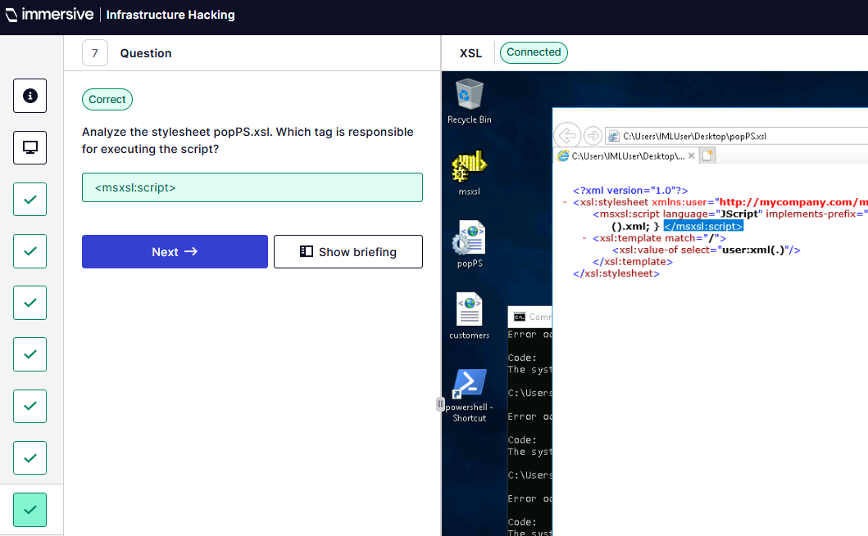
Q8 – What language?
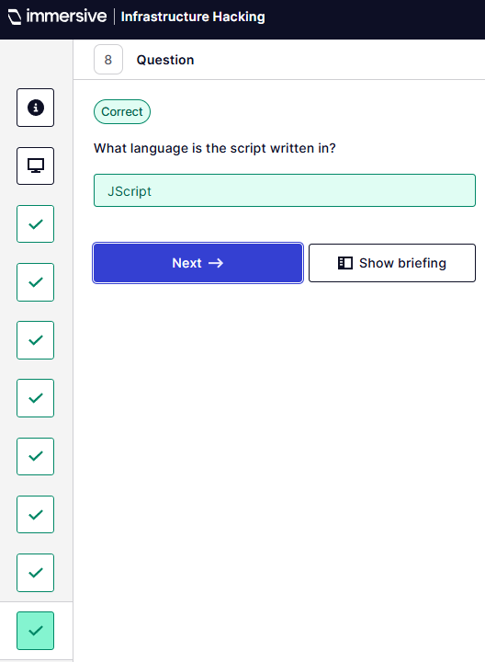
Q9 – Usage of msxsl.exe?
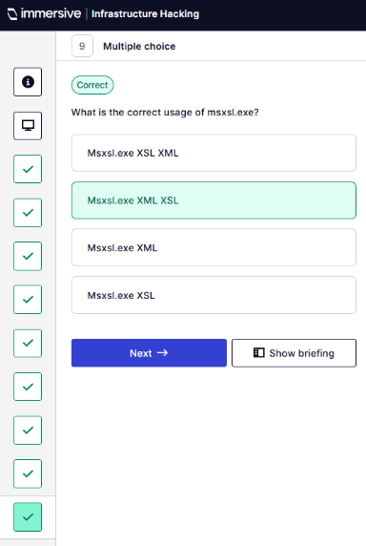
Q10 – What is the token received after using Get-Token in PSShell?
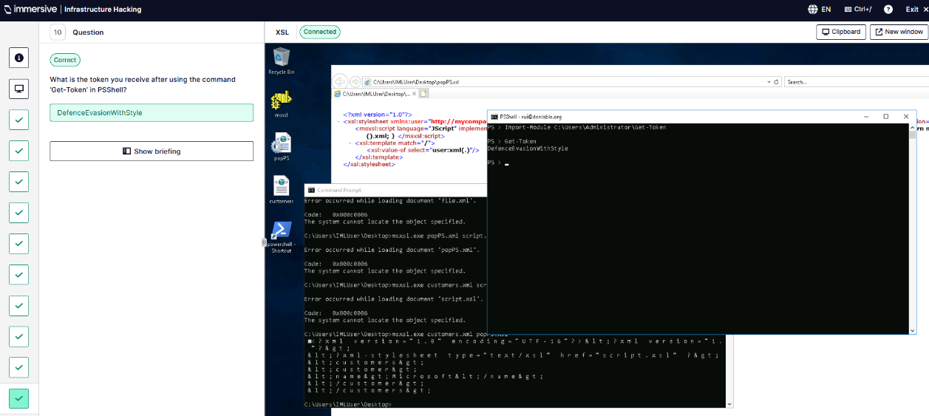
  - Sudo Caching
Q3 – Caching period for sudo credentials?
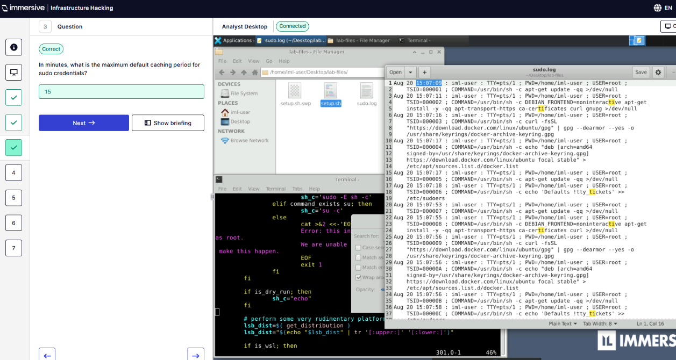
Q4 – What setting can be given to allow sudo-cache to persist between multiple sessions?
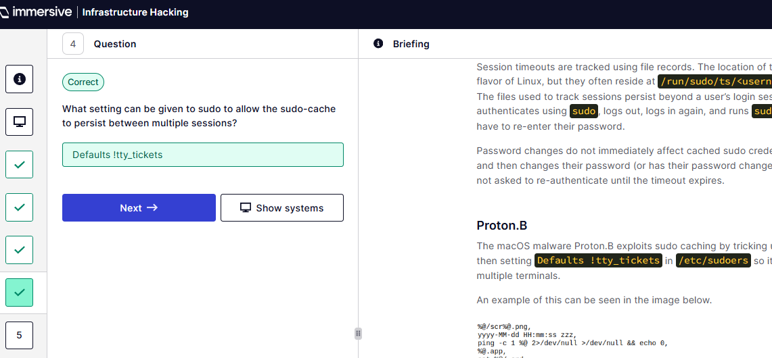
Q5 – What user account ran the command to disable the tty_tickets functionality?
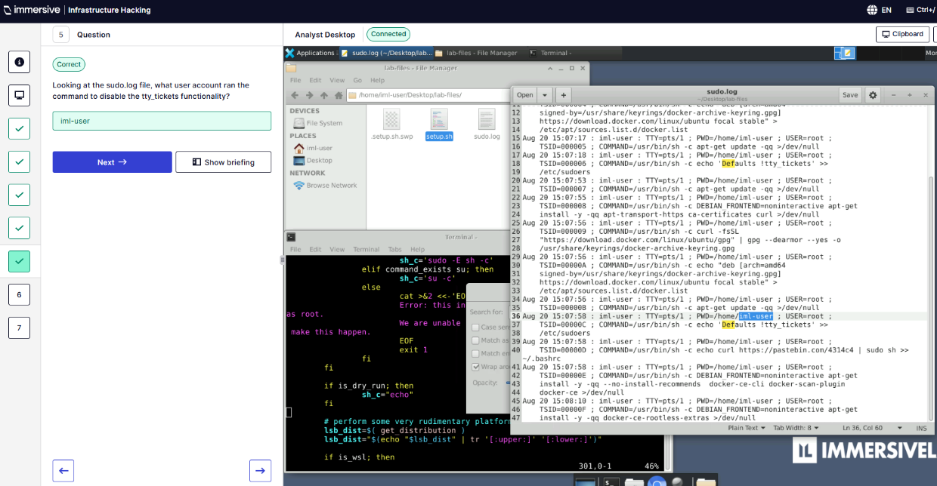
Q6 – What are the last six characters of the Pastebin URL?
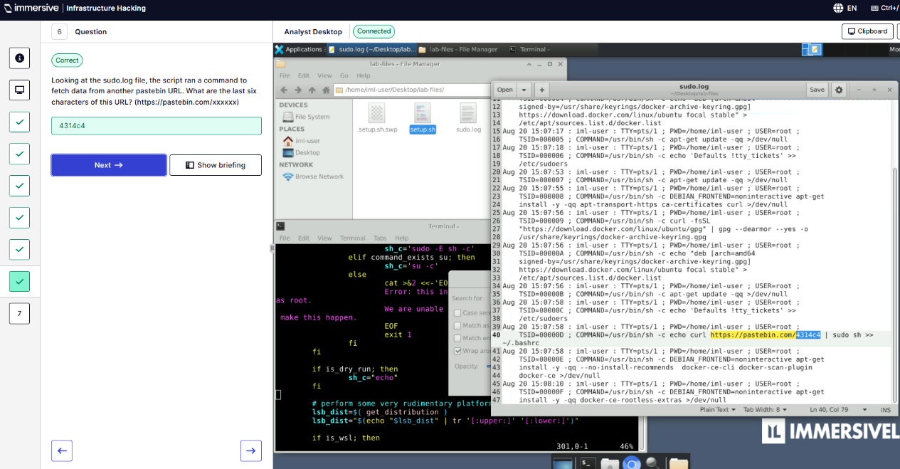
Q7 – Identify the line number in the setup.sh file that matches the sudo log TSID=000006 entry.
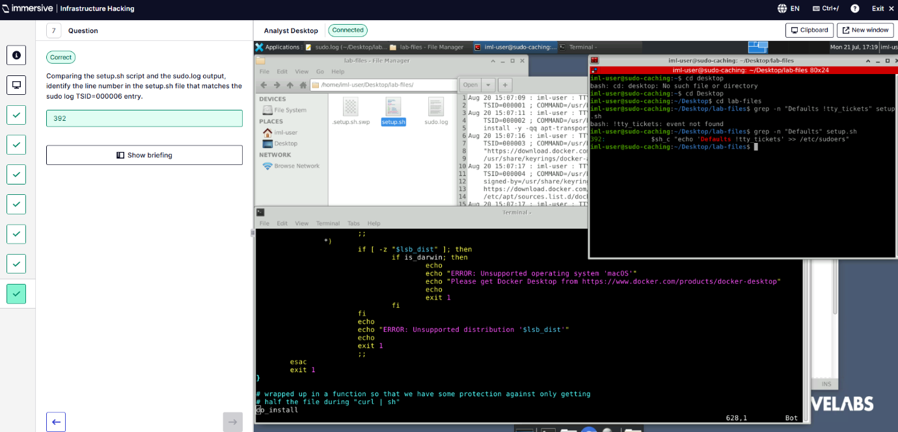
  - SSL Scanning
Q4 – Is sslscan.immersivelabs.com vulnerable to the LUCKY13 attack?
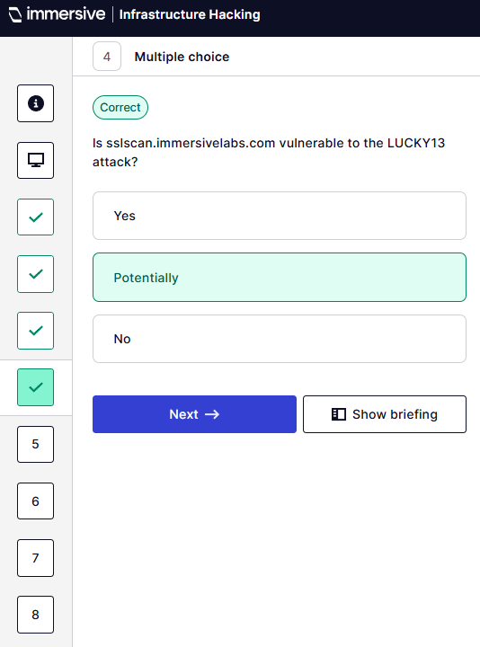
Q5 – What is the server banner?
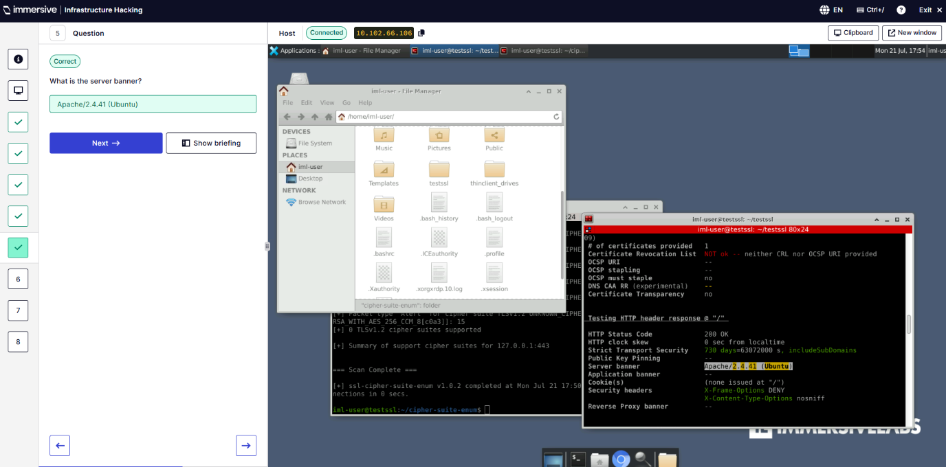
Q6 – PEM file that isn’t present in testssl/etc/ folder?
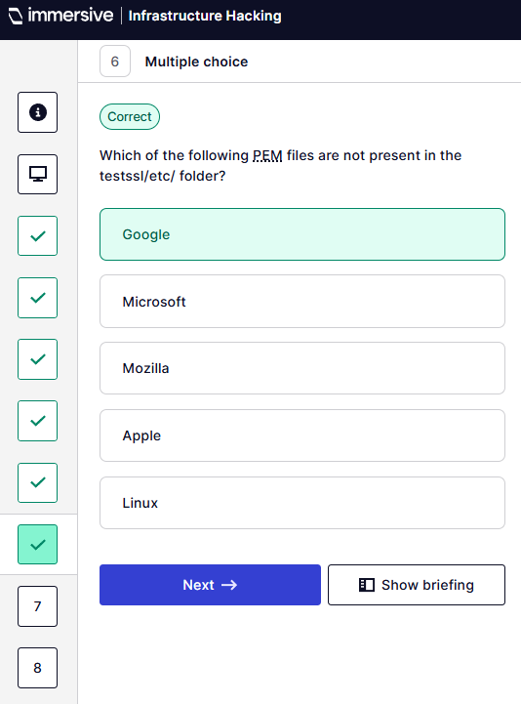
Q7 – When does the server certificate expire?
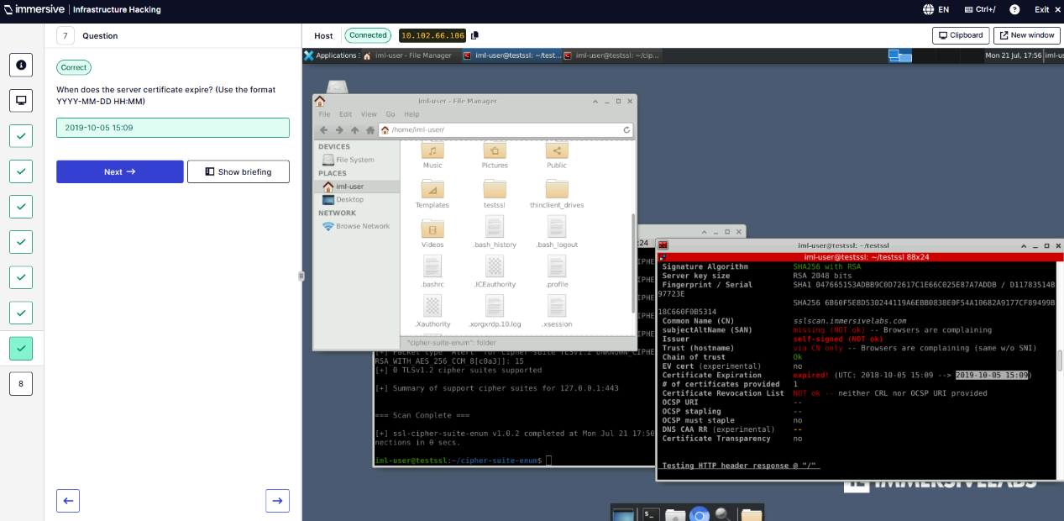
Q8 – Cipher suite chosen via Android 6?
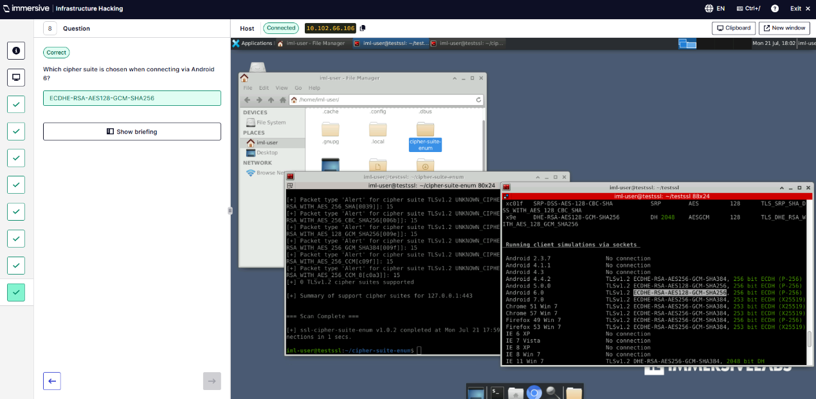
  - SimpleHTTPServer
Q1 – What is a SimpleHTTPServer?
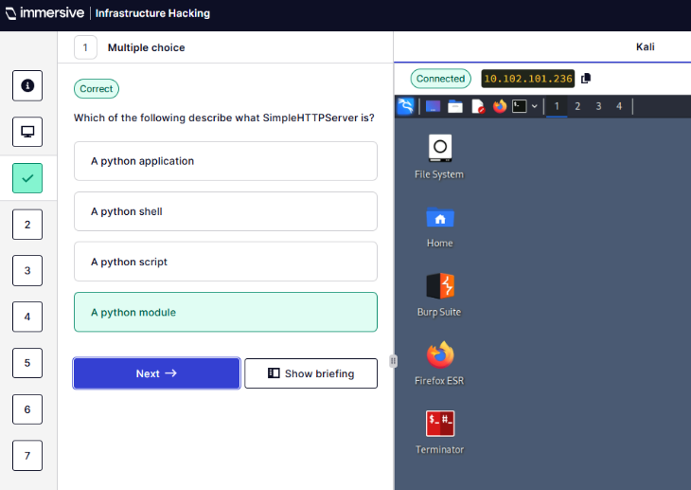
Q2 – Use msfvenom to create a Meterpreter payload called shell.exe
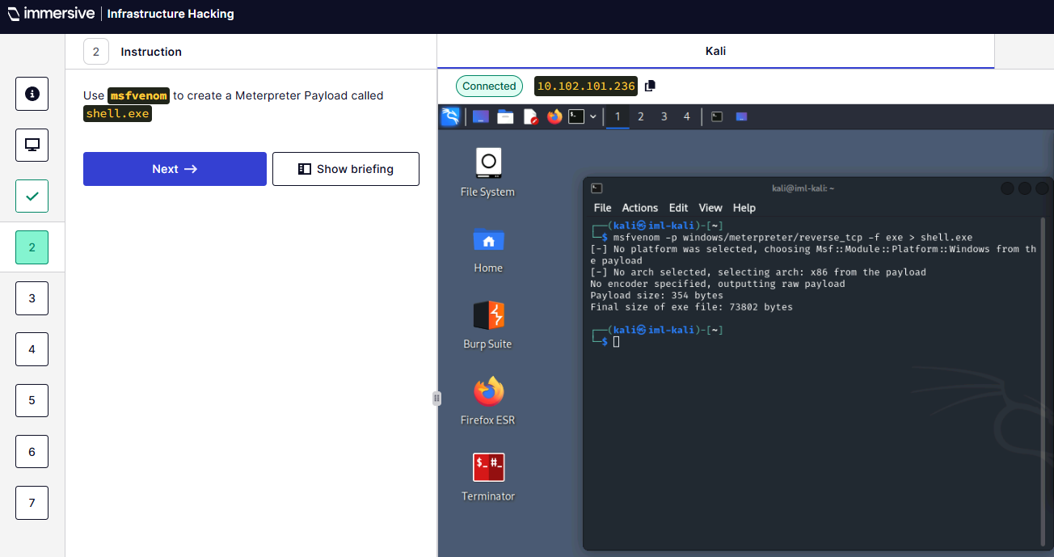
Q3 – Create a Payload directory and place the executable in there.
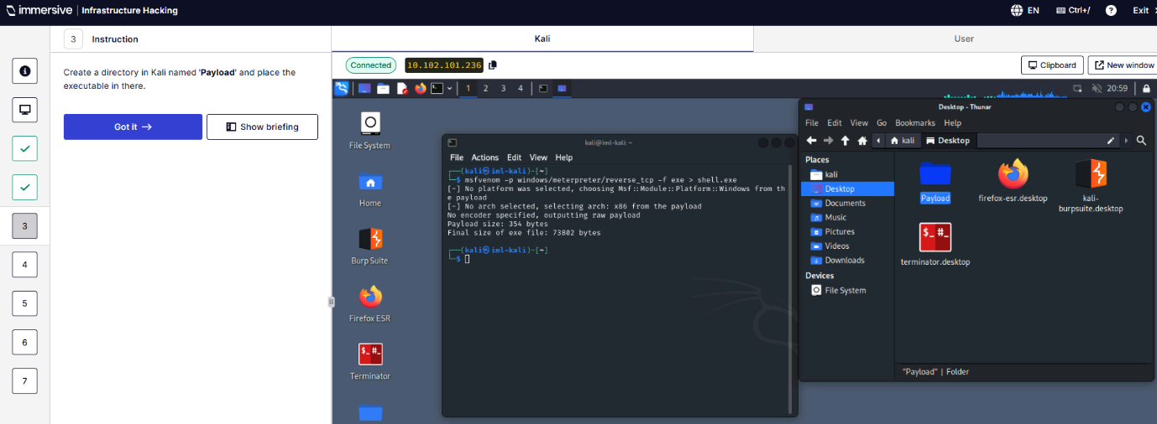
Q4 – Launch SimpleHTTPServer in Payload.
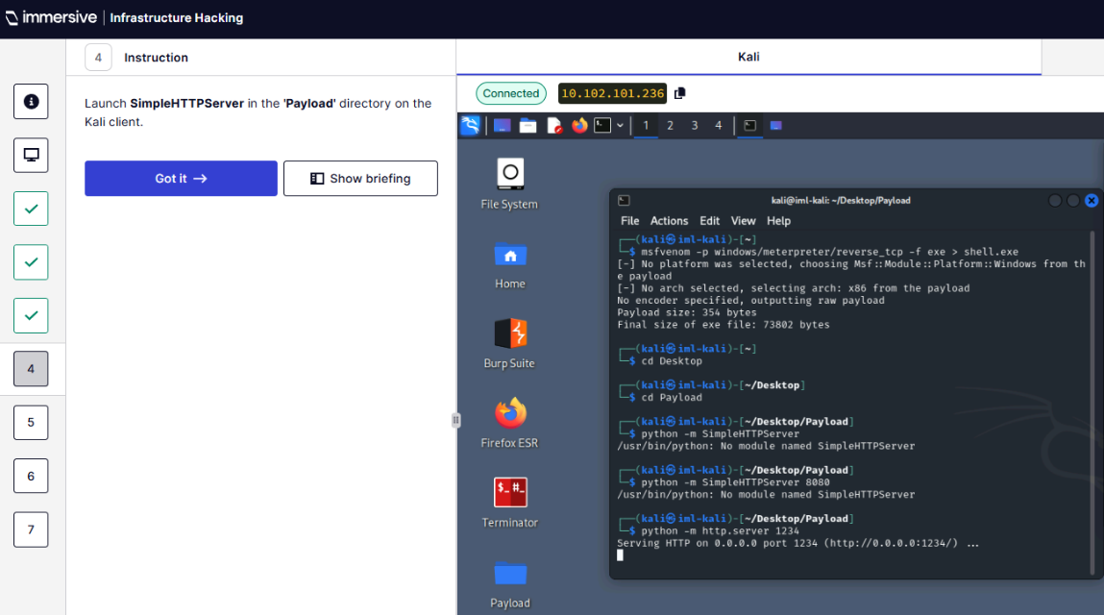
Q5 – Download payload on user machine in /home/iml-user/Desktop.
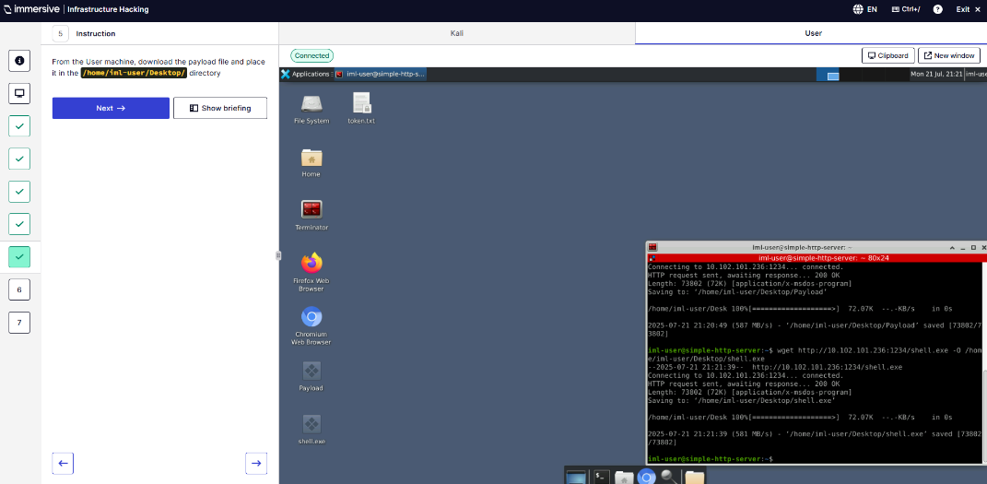
Q6 – Read token.txt
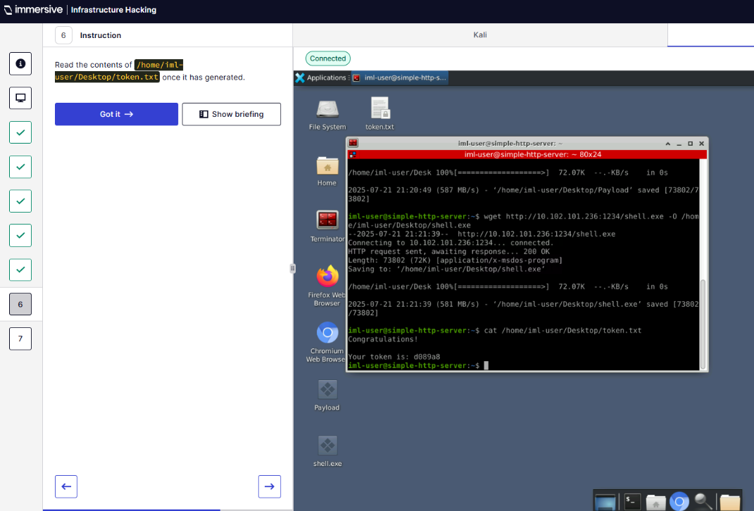
Q7 – What is the token?
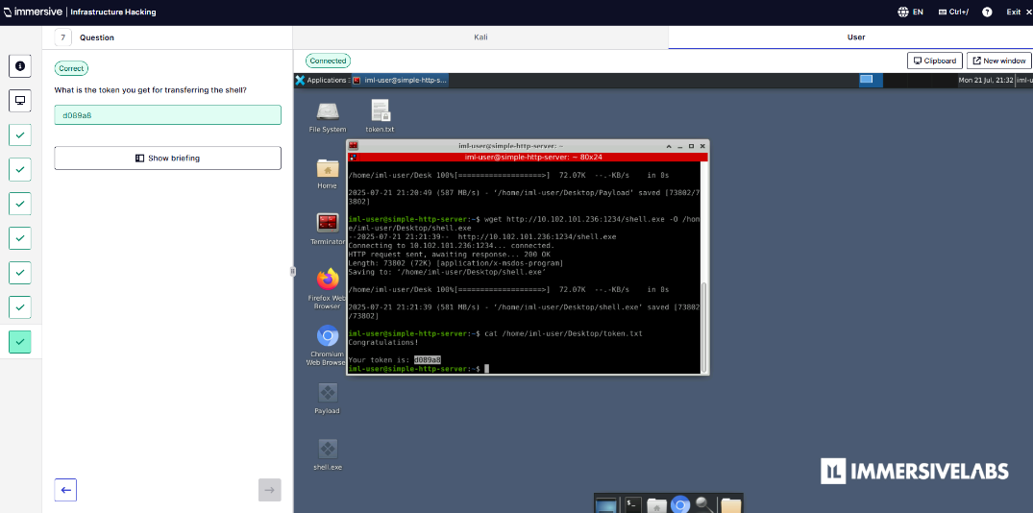
  - Space After Filename
Q2 – What is the true file type of gift.jpeg?
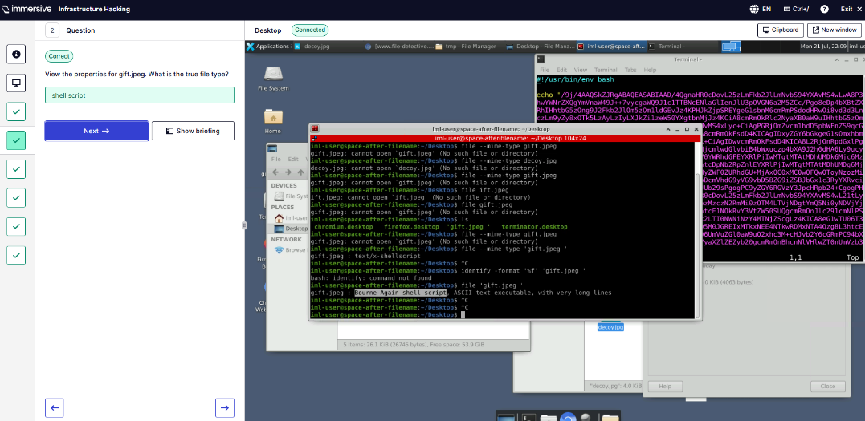
Q3 – Does the image viewer run?
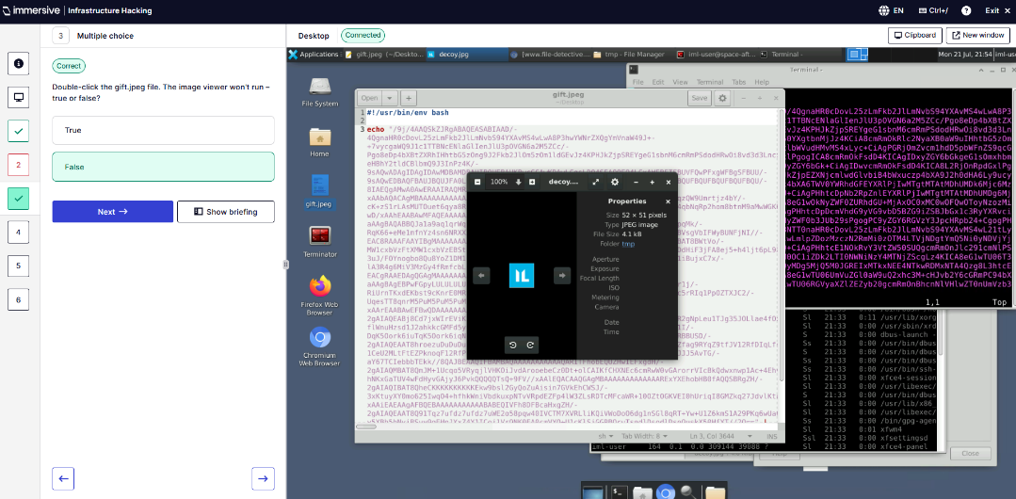
Q4 – What is the name of the file being opened?
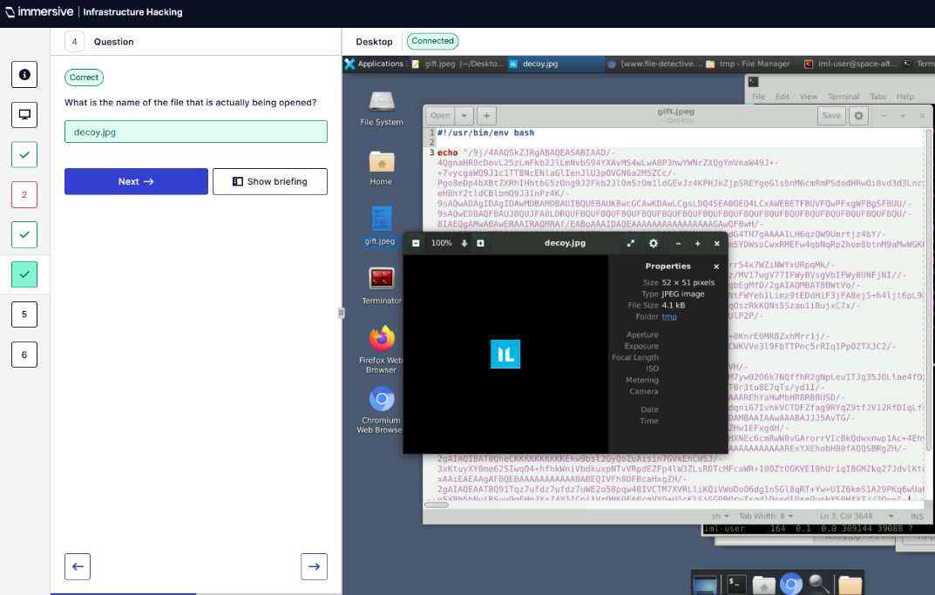
Q6 – What port in Netcat listening on?
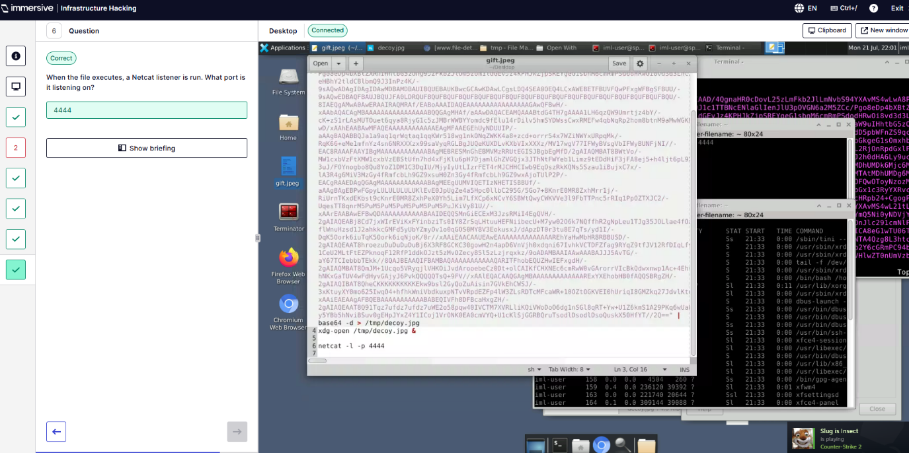
” (ImmersiveLabs Infrastructure Hacking , 2025).
- Windows Sysinternals. “(ImmersiveLabs Sysinternals, 2025)
  - Introduction to Sysinternals
Q1 – AccessChk is used to:
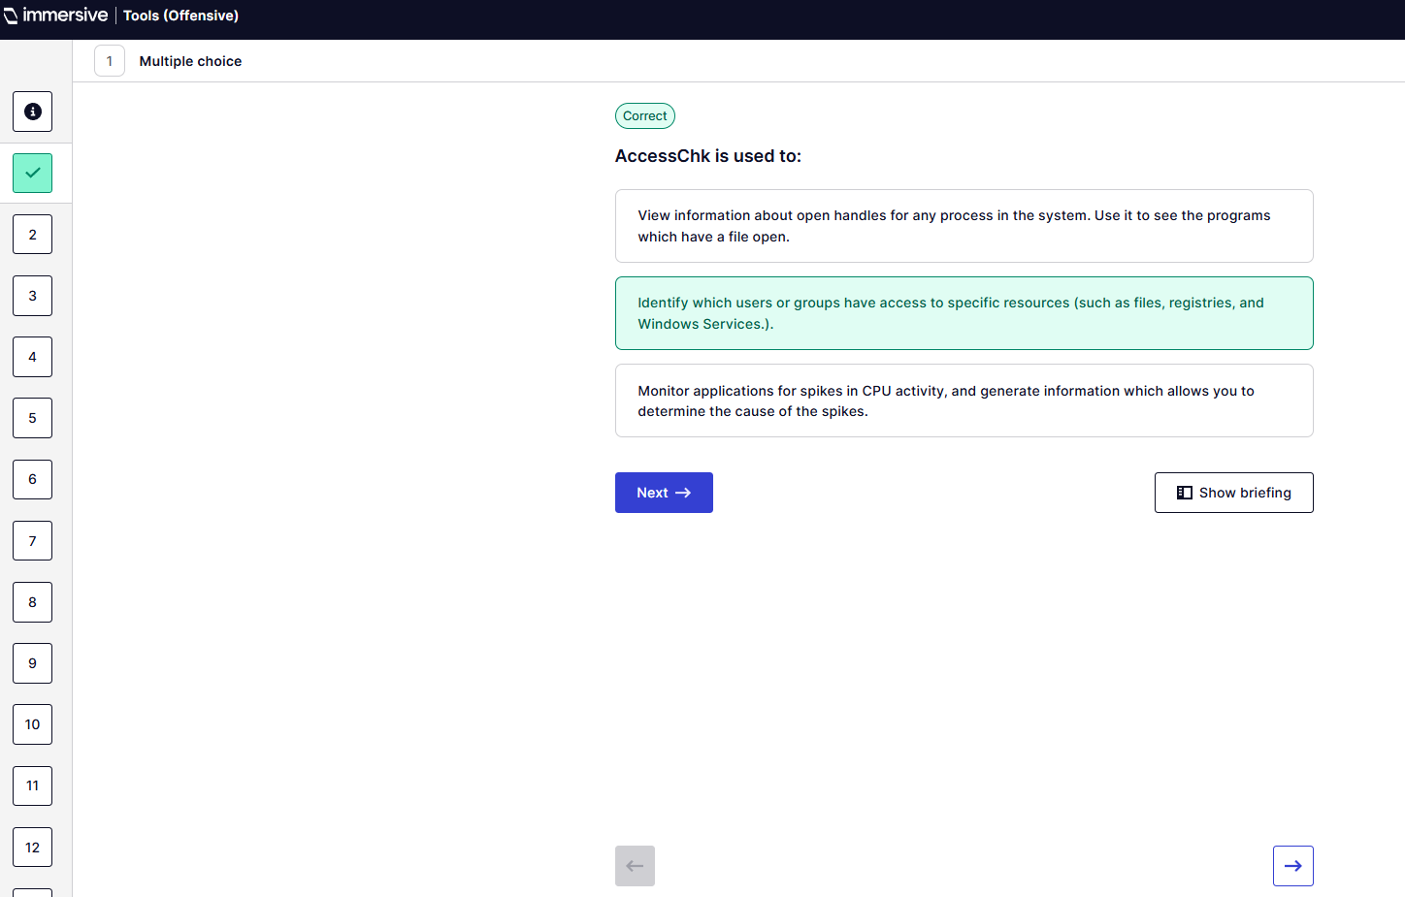
Q2 – ADExplorer is used to:
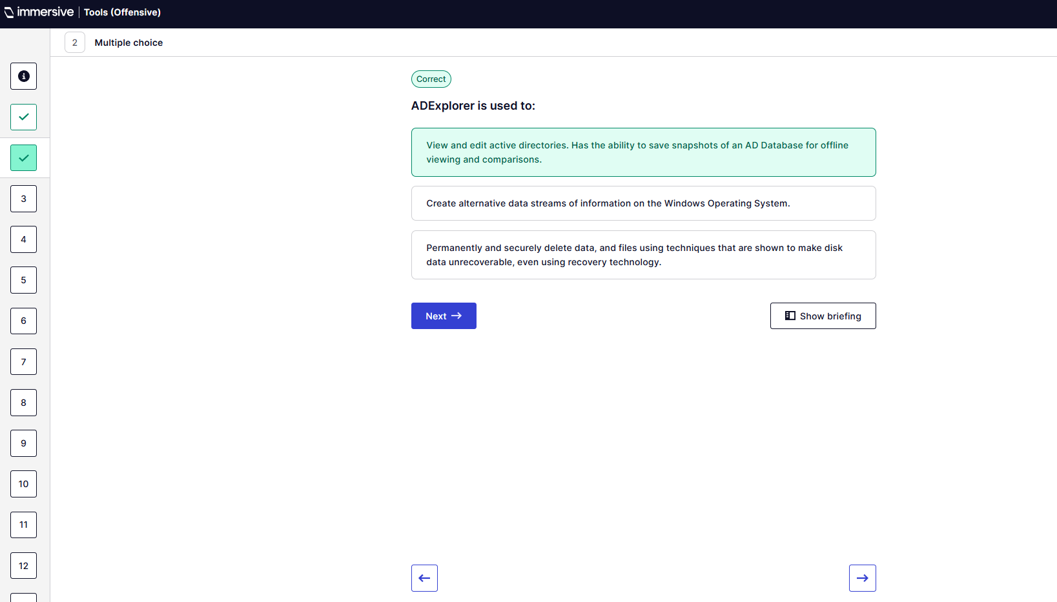
Q3 - AutoRuns is used to:
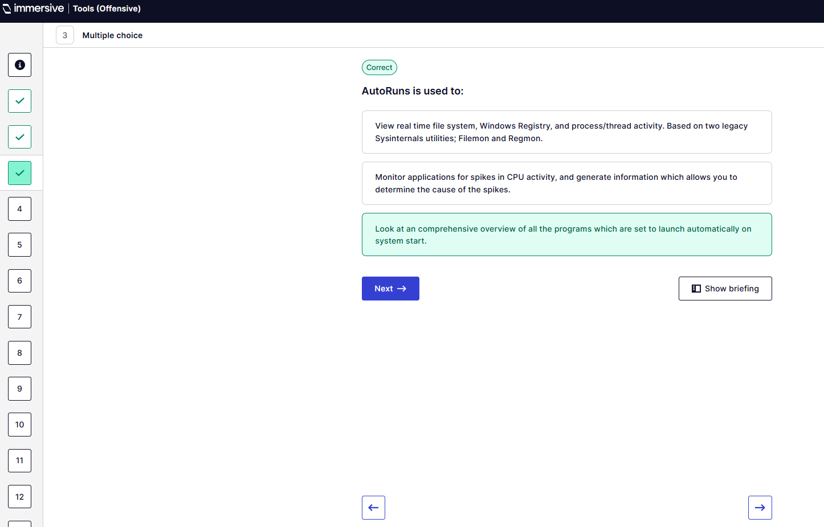
Q4 – ProcDump is used to:
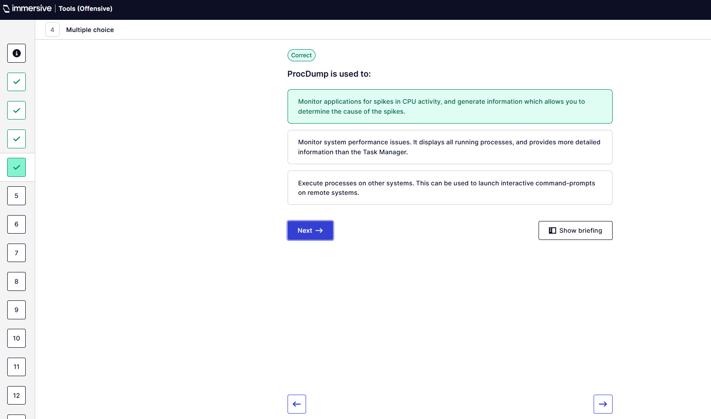
Q5 – ProcExp is used to:
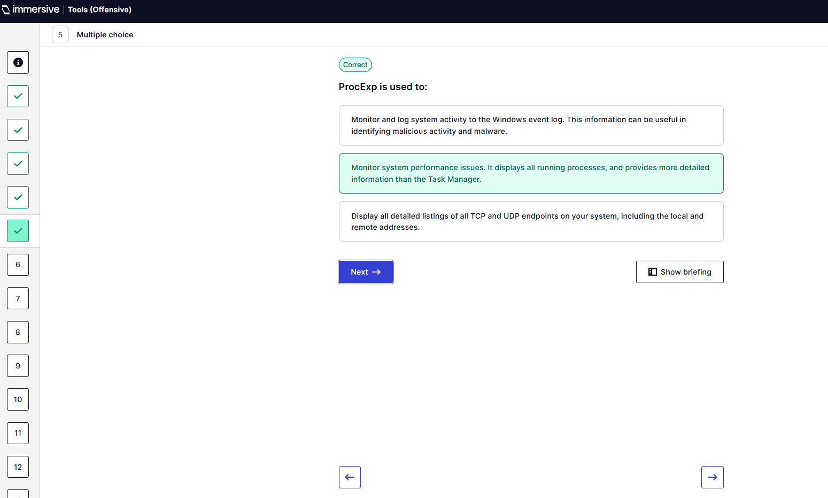
Q6 – PsExec is used to:
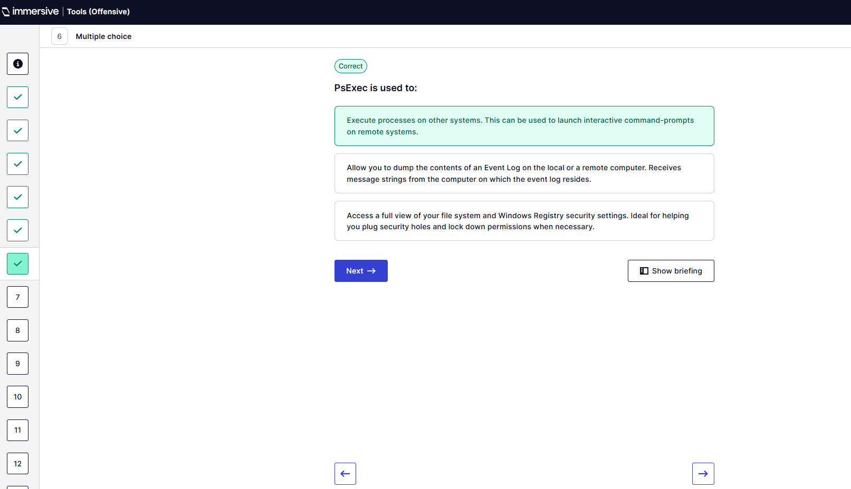
Q7 – SysMon is used to:
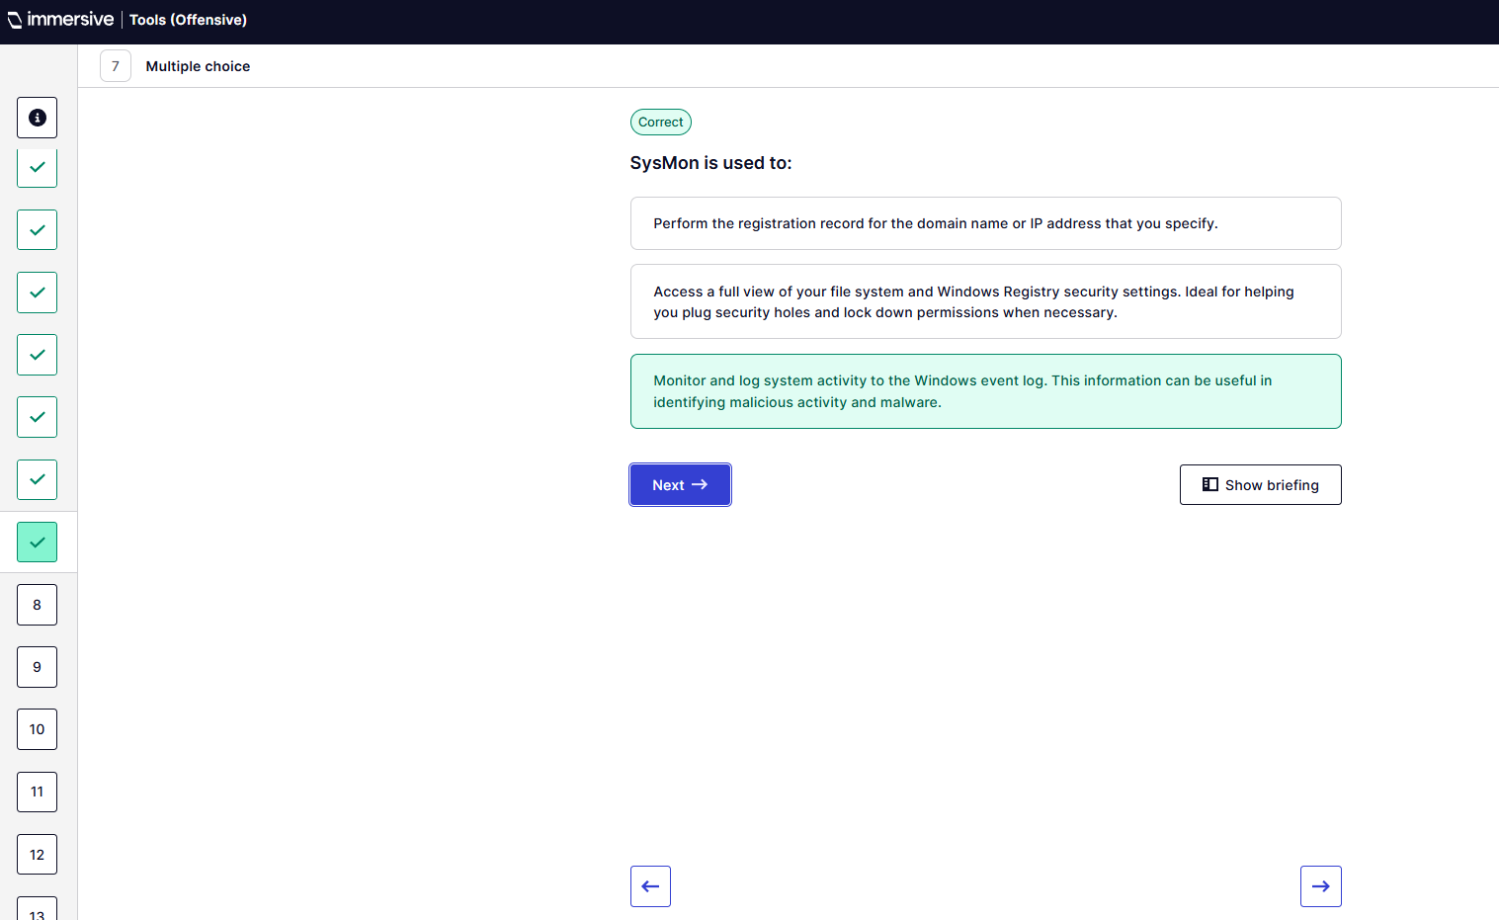
Q8 - ProcMon is used to:
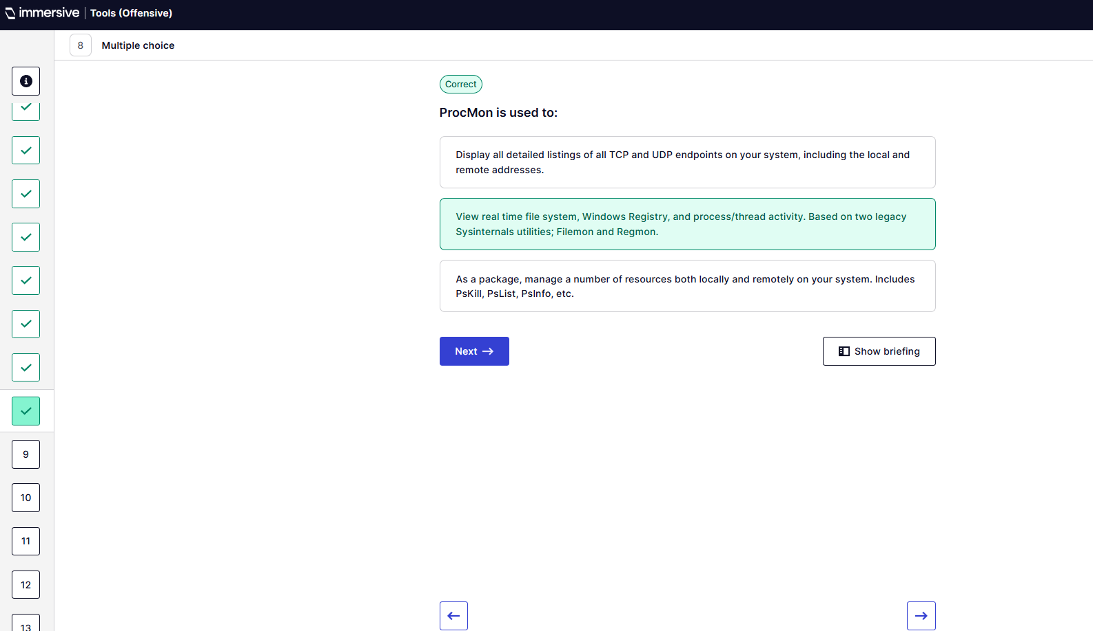
Q9 - AccessEnum is used to:
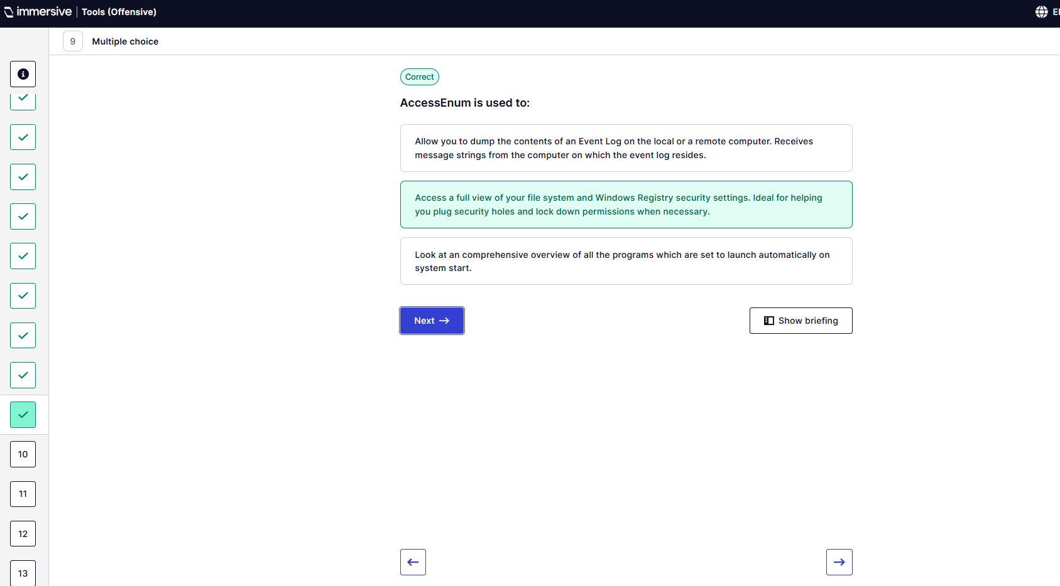
Q10 – Handle is used to:
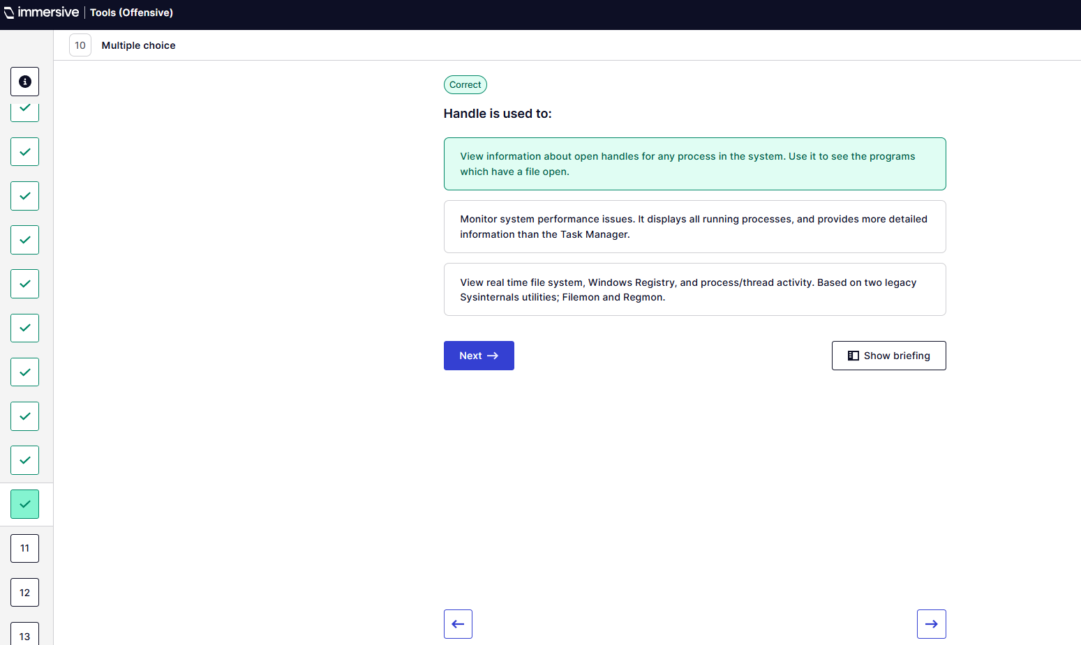
Q11 – PortMon is used to:
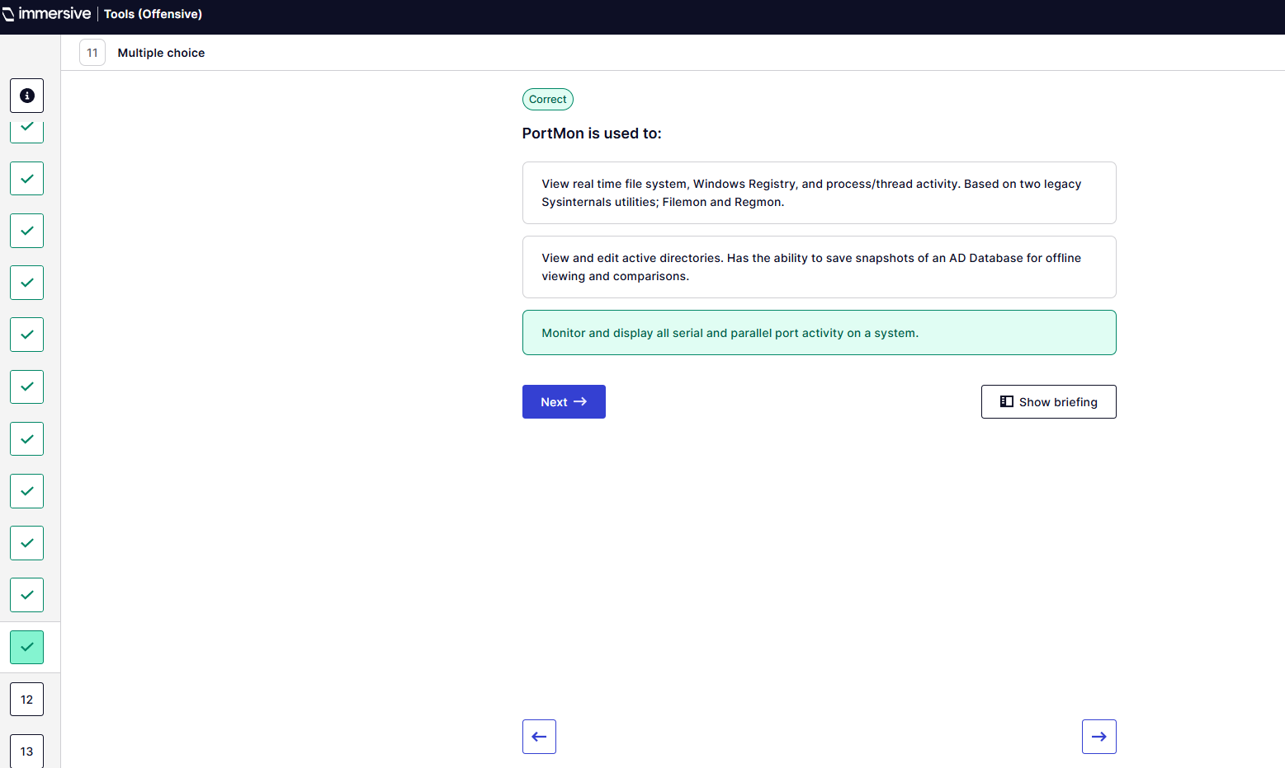
Q12 – PsLogList is used to:
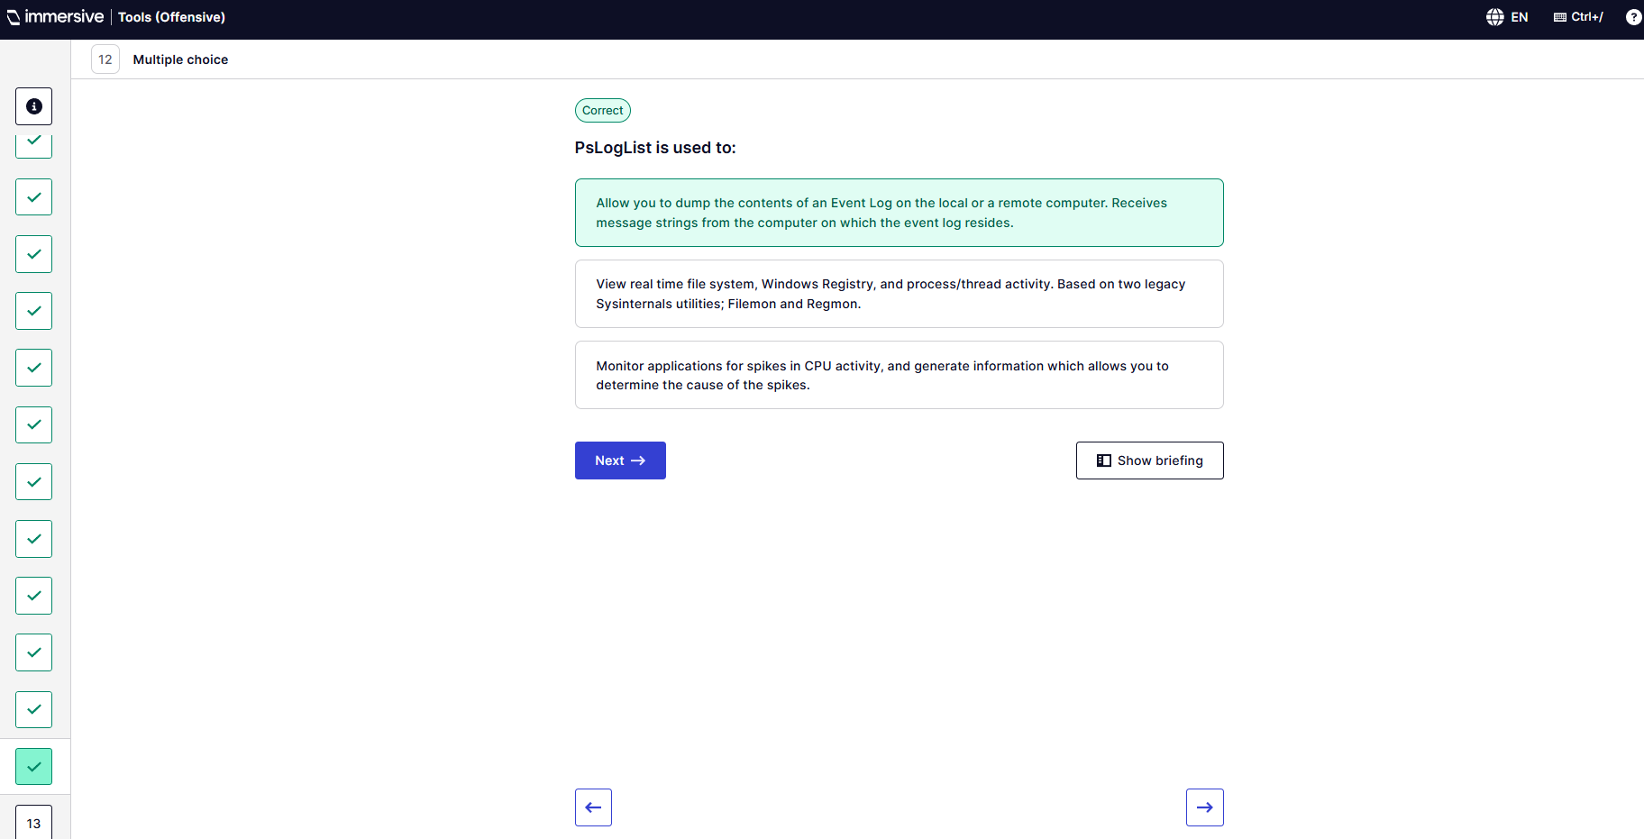
Q13 – PsTools is used to:
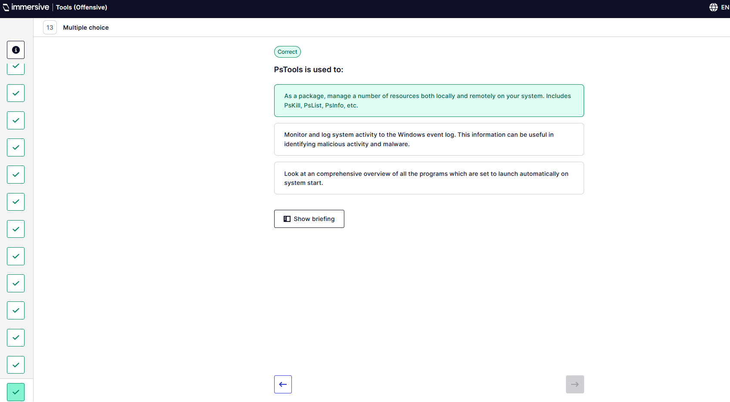
  - Sysmon
Q1 – Open Sysmon log in Event Viewer.
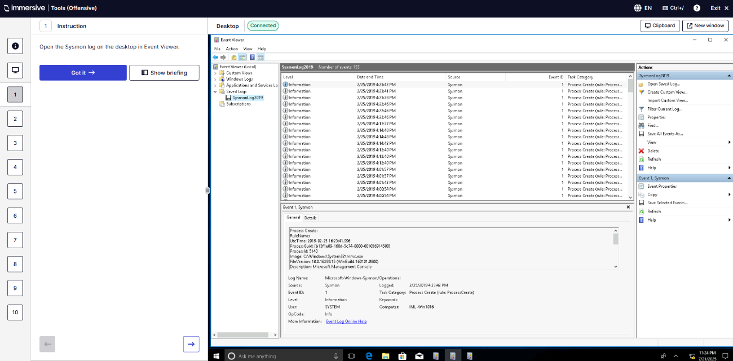
Q2 – Analyse events.
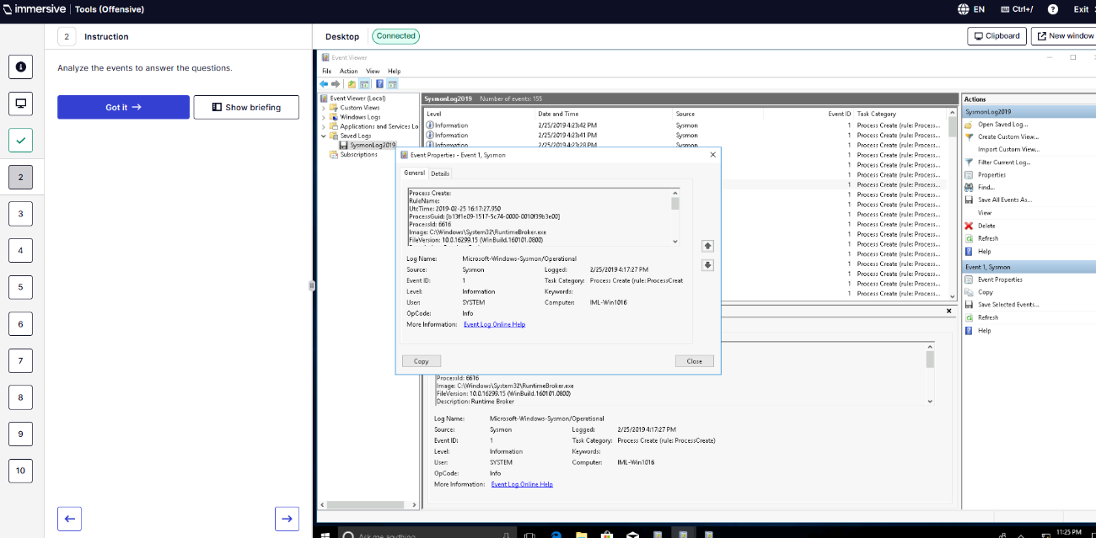
Q3 – ID of terminated process?
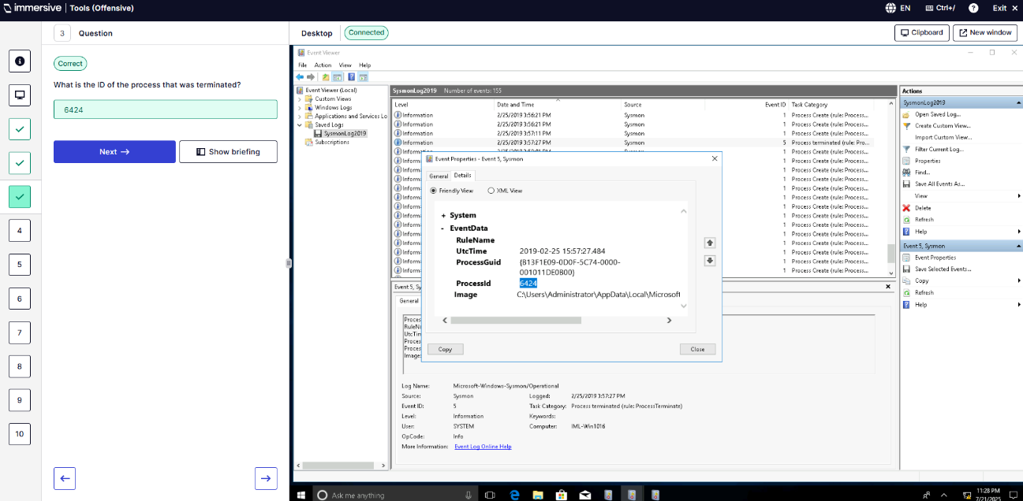
Q4 – First 5 characters of MD5 hash?
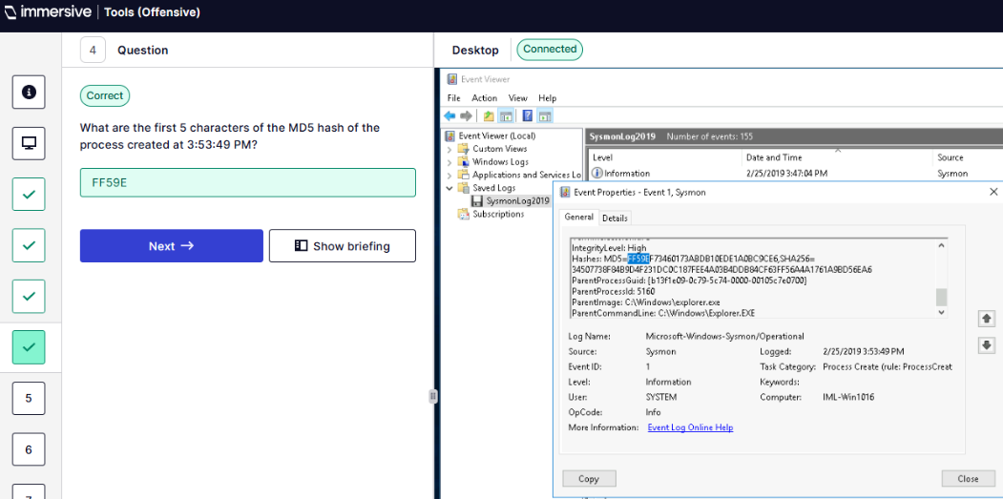
Q5 – Name of process that ran under file create rule at 3:53:49PM?
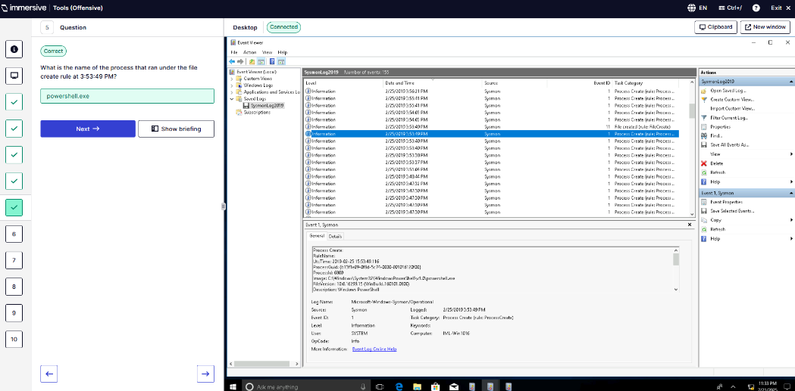
Q6 - Description of process created at 3:53:40PM with Parent Process ID 5160?
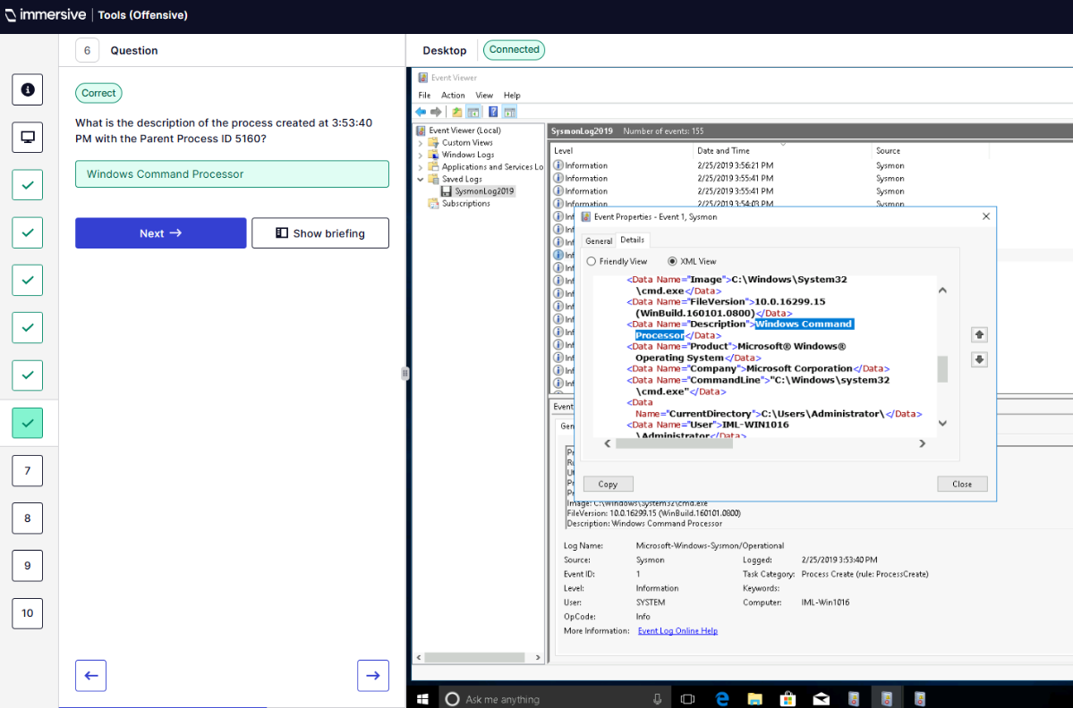
Q7 – Who is the user of process created at 4:01:42PM?
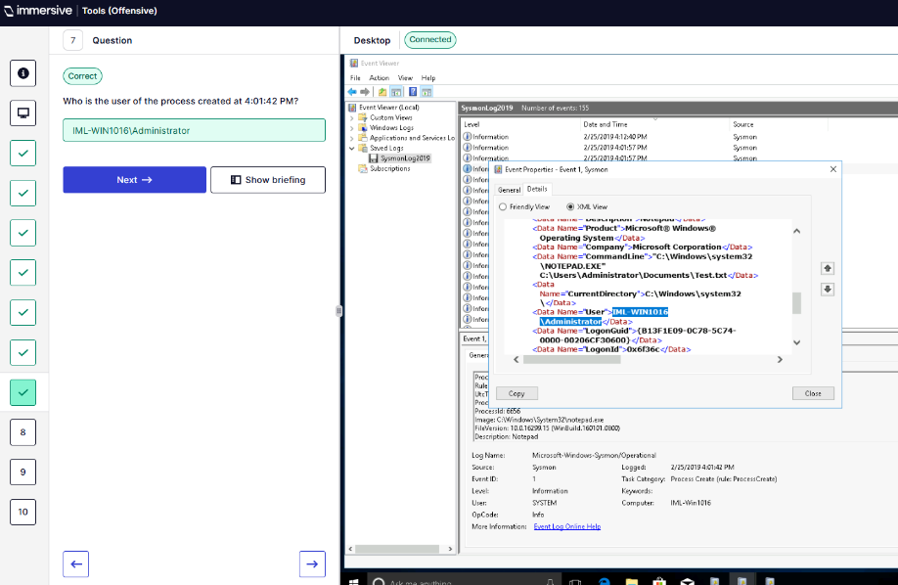
Q8 – First 5 characters of SHA256 hash of process created at 3:53:40PM with process ID 3300?
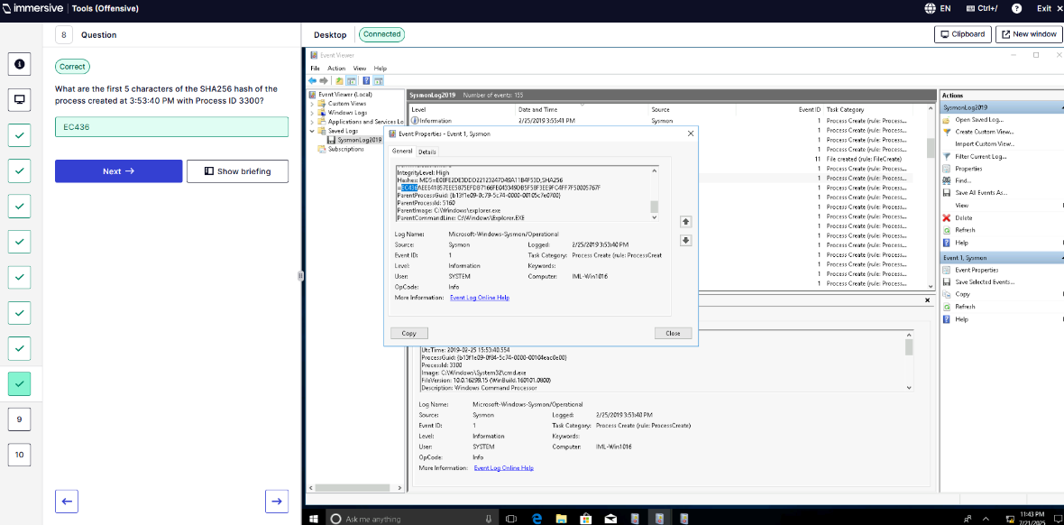
Q9 – What is the cmd process created at 4:14:42PM?
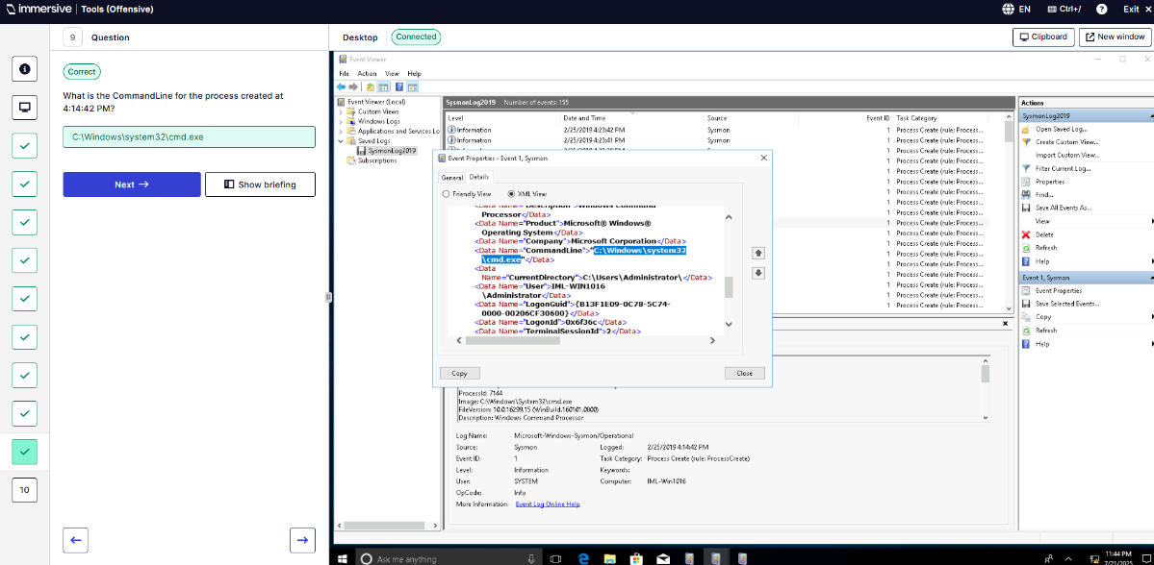
Q10 – What is the integrity level for the process created at 4:14:42PM?
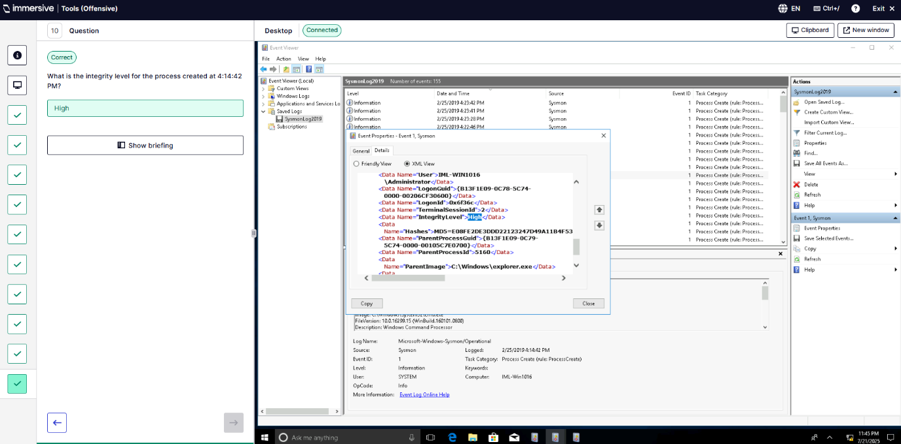
  - Process Monitor
Q1 – Open .PML file using ProcMon.
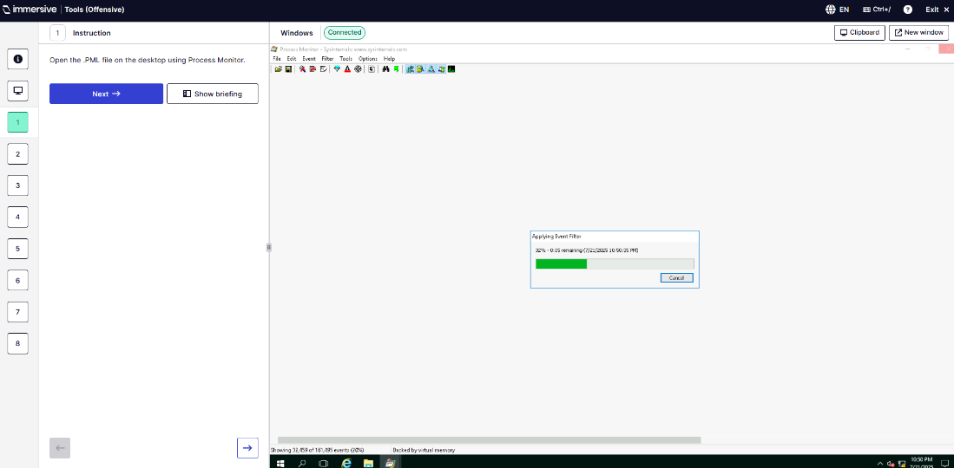
Q2 – Use filters to answer questions.
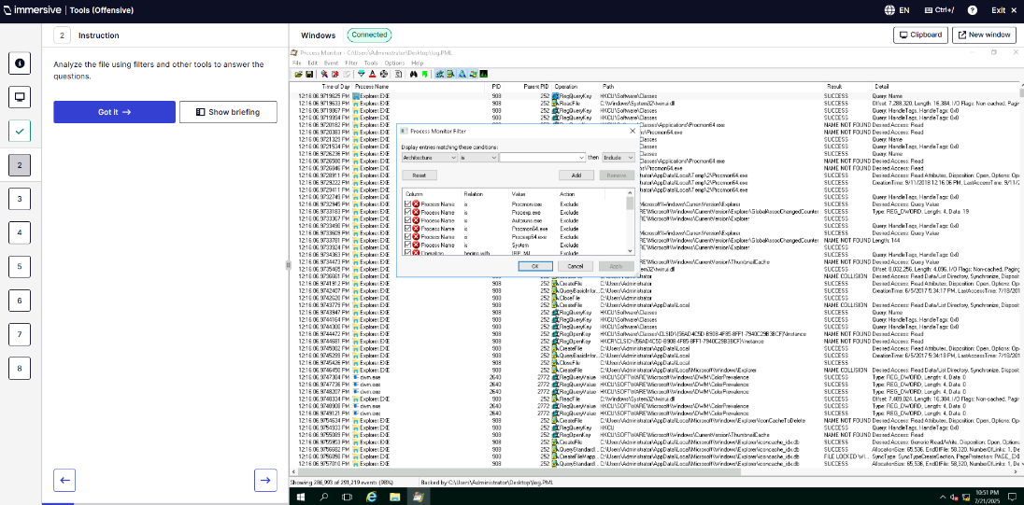
Q3 – How many events are shown?
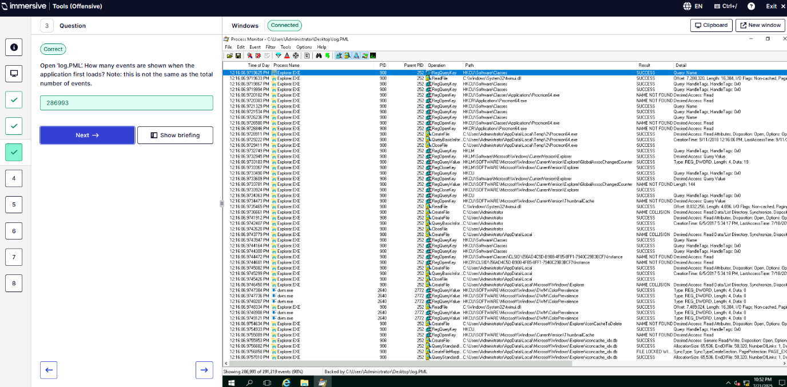
Q4 – Add a filter where Company Contains Mozilla and how many events are shown?
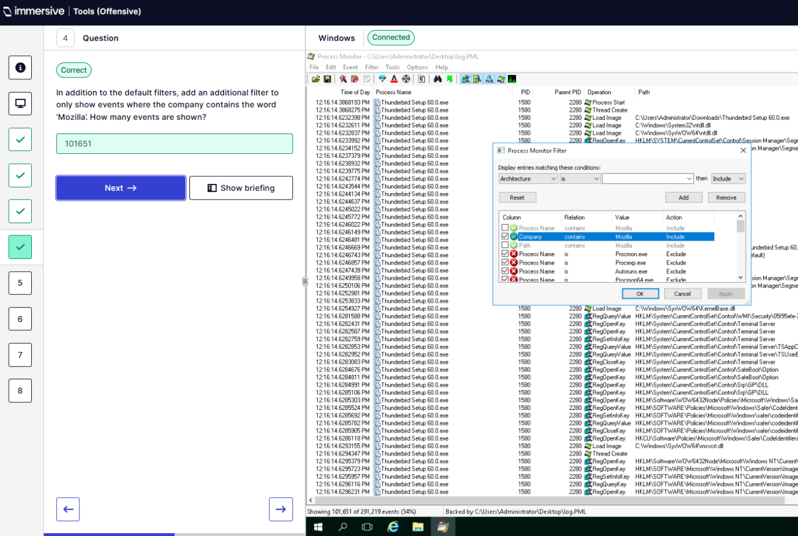
Q5 – What is the name of the process at the start of the process tree for Thunderbird?
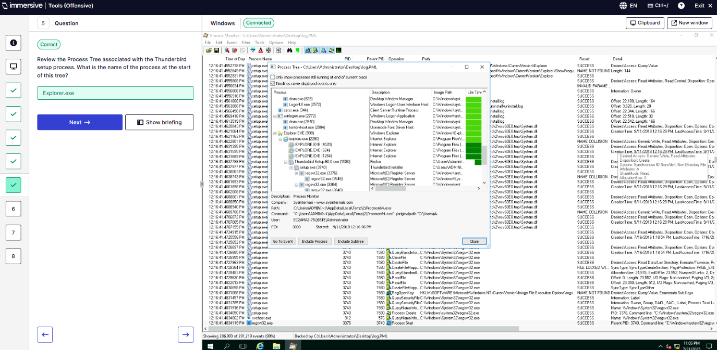
Q6 – Filters to search for events created by Explorer.exe?
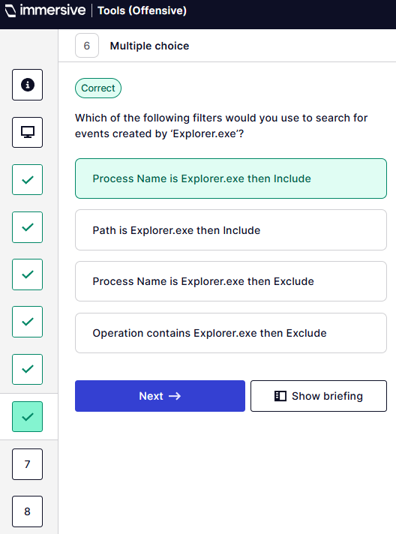
Q7 – What filters would be used to search for events created by PID 901 containing “profile”?
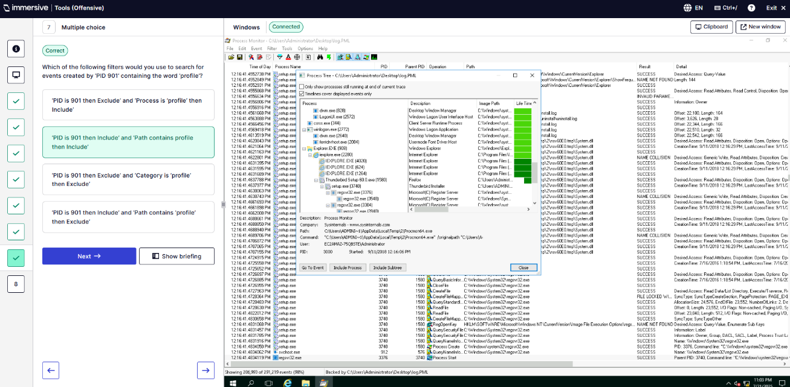
Q8 – Based on the registry value set by thunderbird.exe what is the max size of the log file?
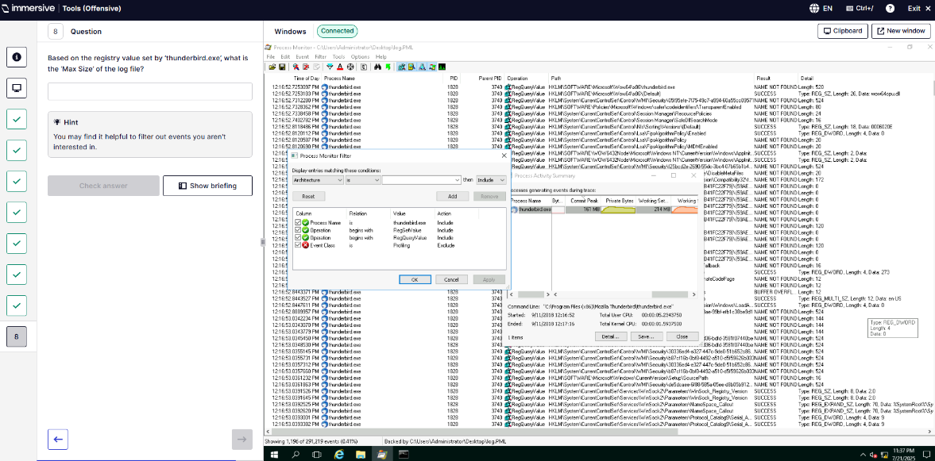
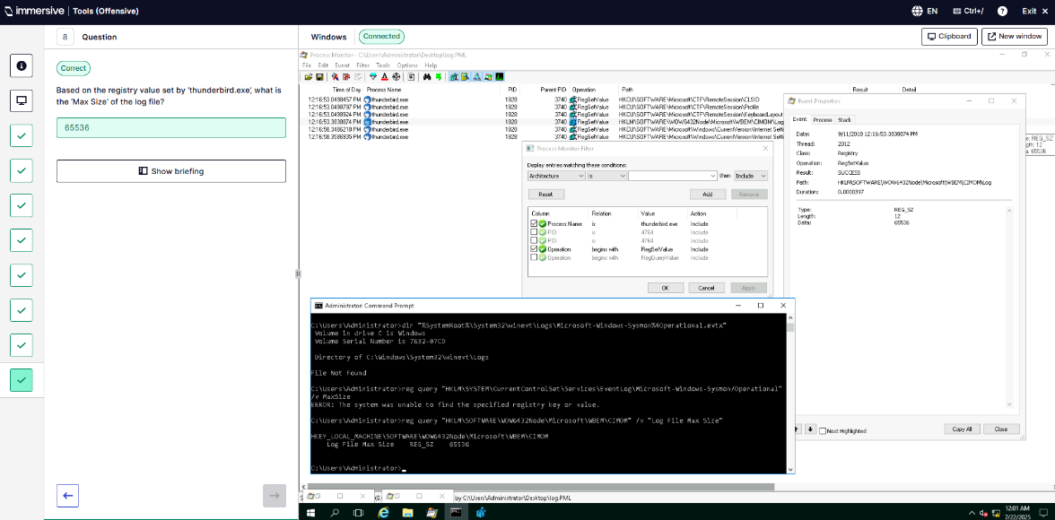
  - Process Explorer
Q1 – Open procexp64.exe.
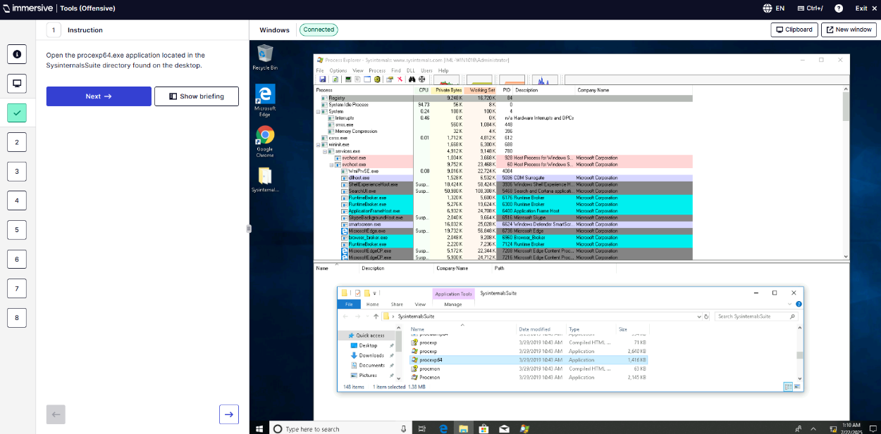
Q2 – Analyse active system processes.
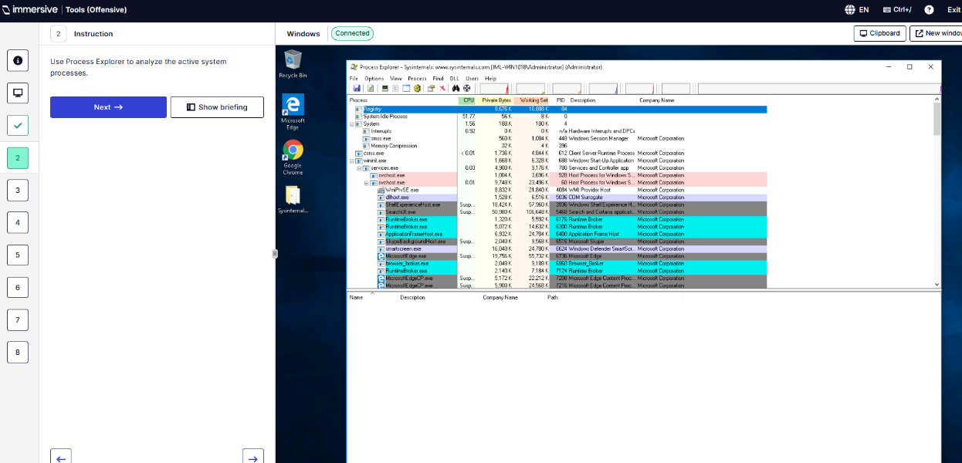
Q3 – Run as administrator to view DLLs.
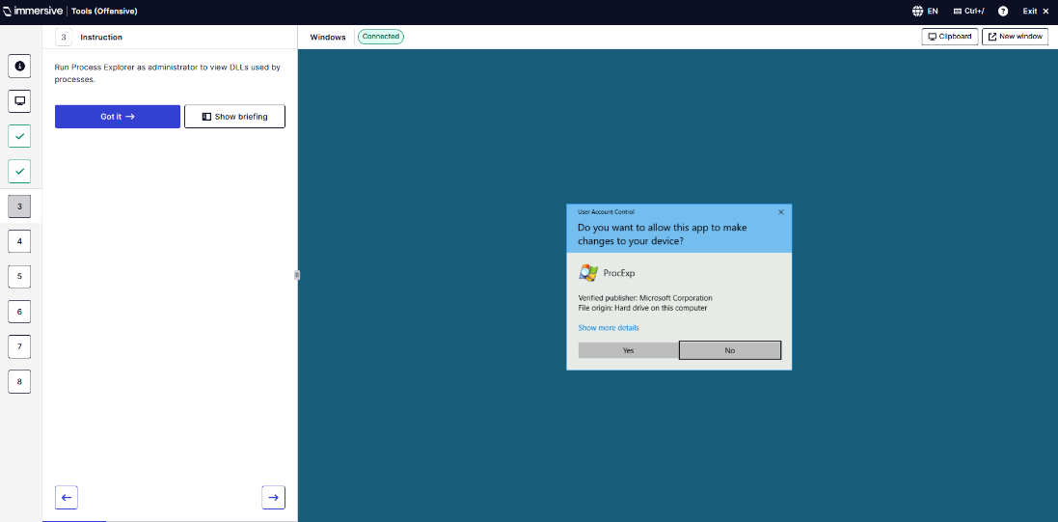
Q4 – What is the PID of the System process?
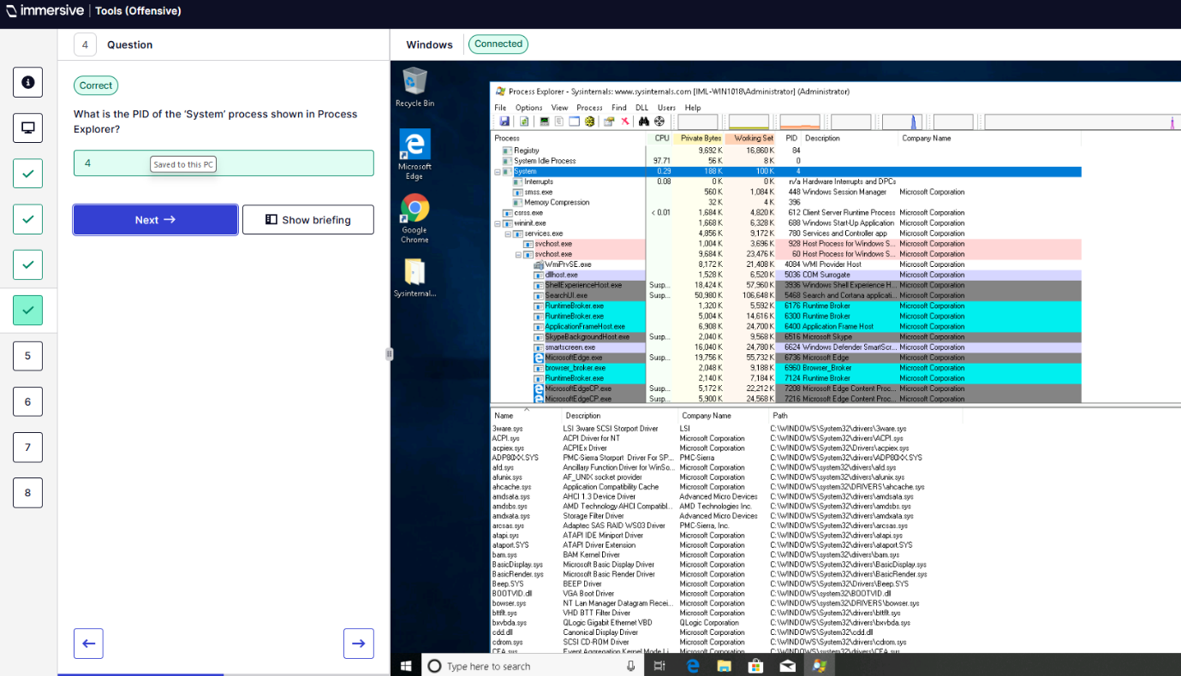
Q5 – How many instances of winlogon.exe have been created?
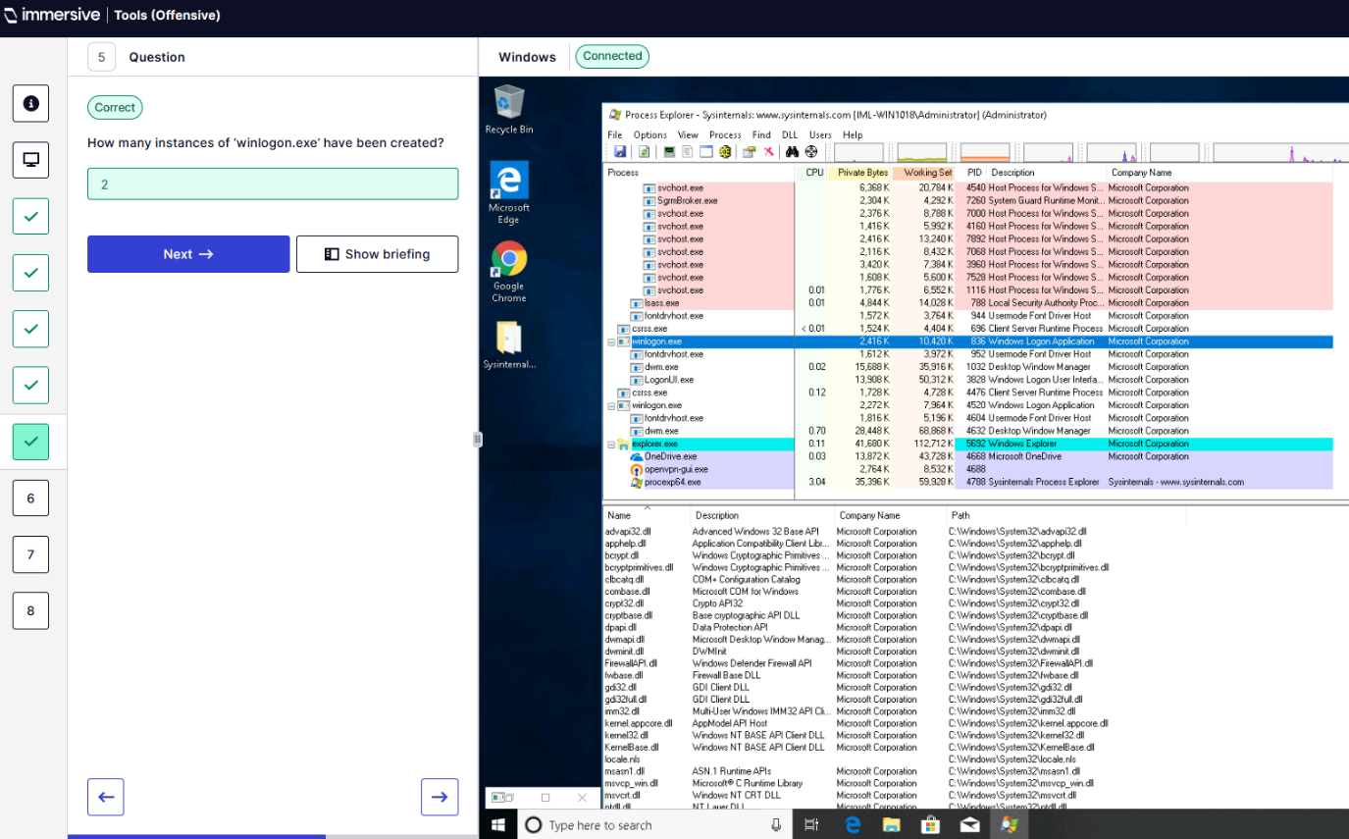
Q6 – Parent process of openvpnserv.exe?
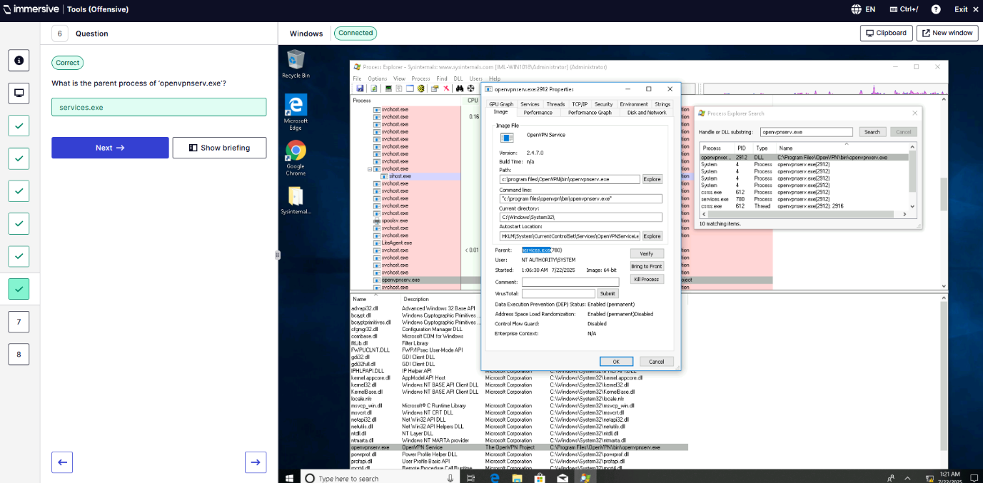
Q7 – What DLL is not used by openvpnserv.exe
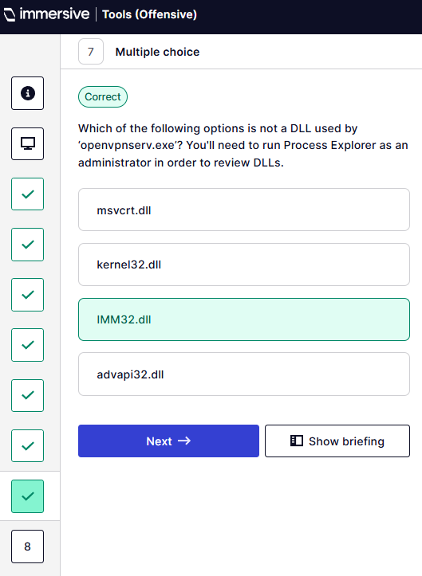
Q8 – Parent process of services.exe?
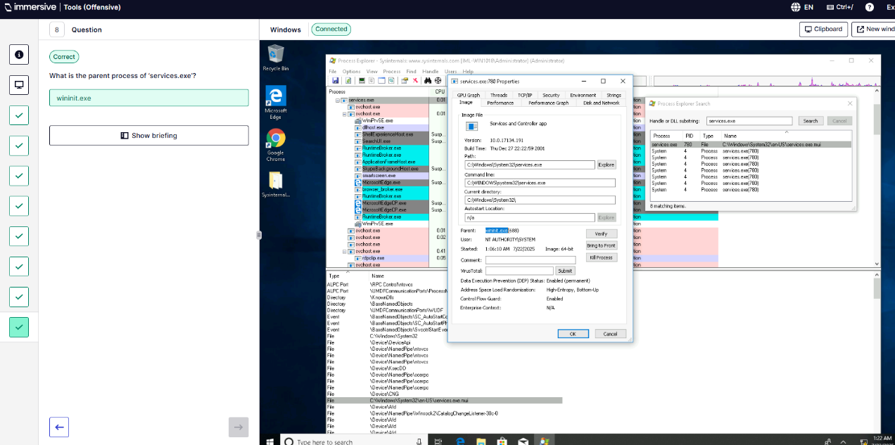
  - AccessChk
Q1&2 – Understand why AccessChk is used and navigate to the folder containing it.
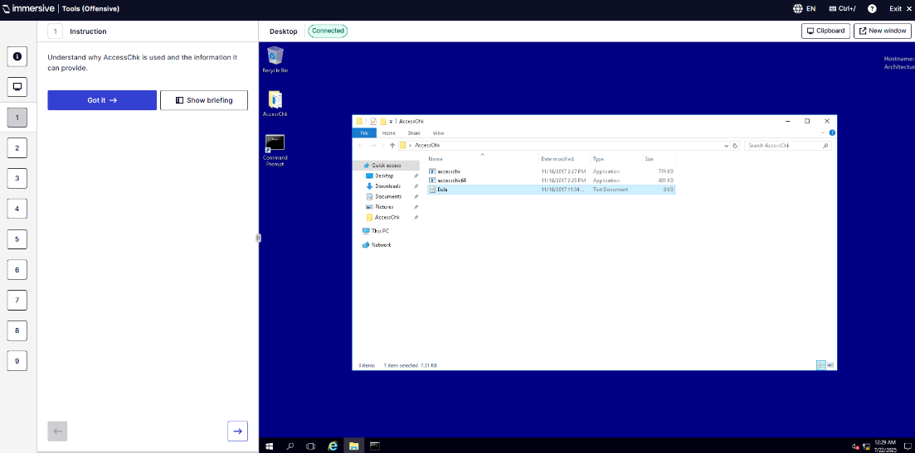
Q3 – How many folders does IMLUser have read-write access to?
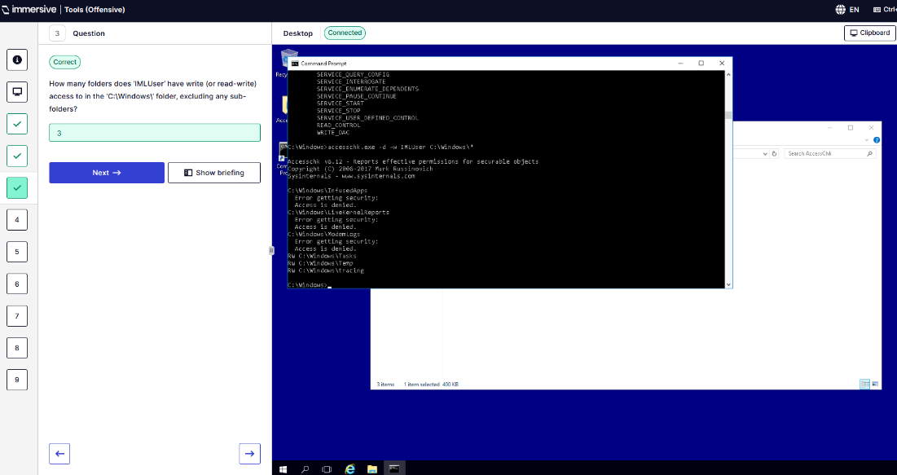
Q4 – What permission does IMLUser have for C:\Windows\System32\Tasks folder?
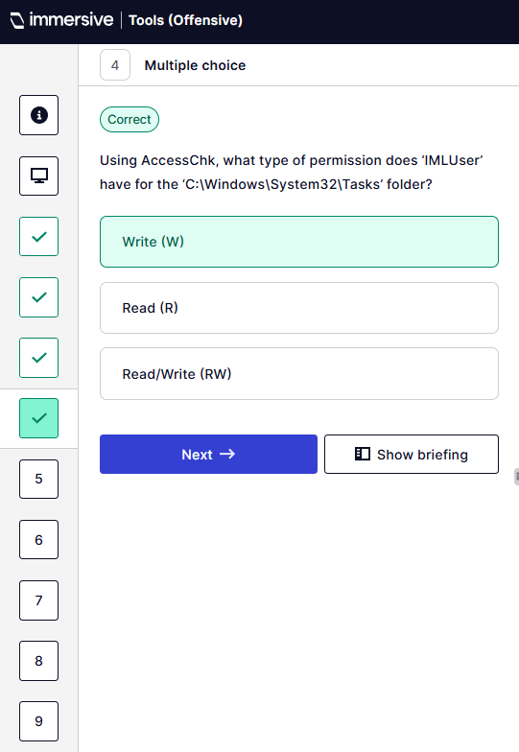
Q5 – What permission does Administrators group have for C:\Windows\System32\Boot folder?
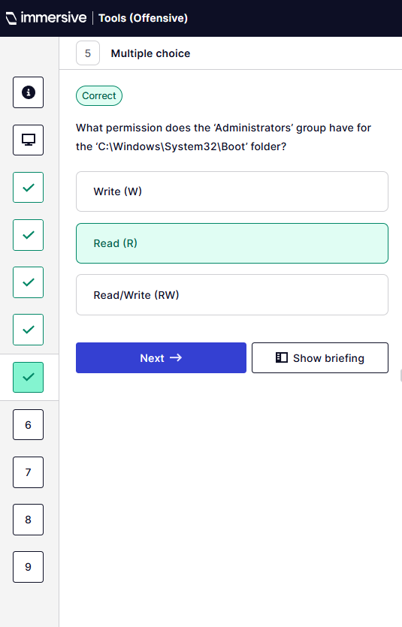
Q6 – What is the name of service IMLUser has write access to?
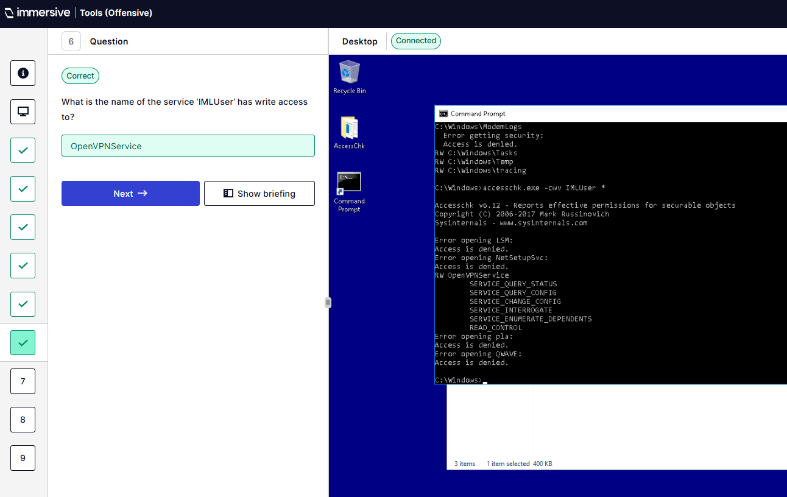
Q7 – Which of the following permissions is not included?
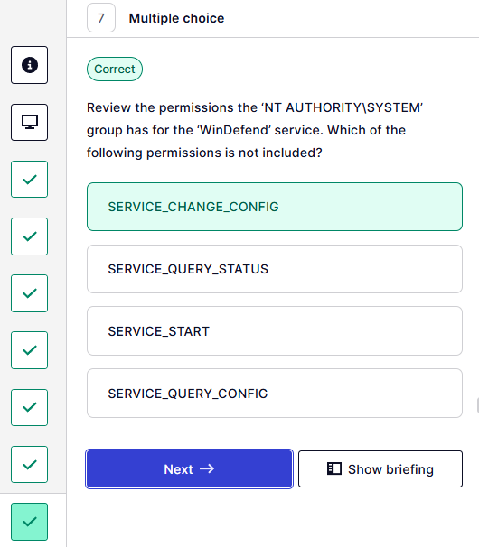
Q8 – Option to suppress error messages when using AccessChk?
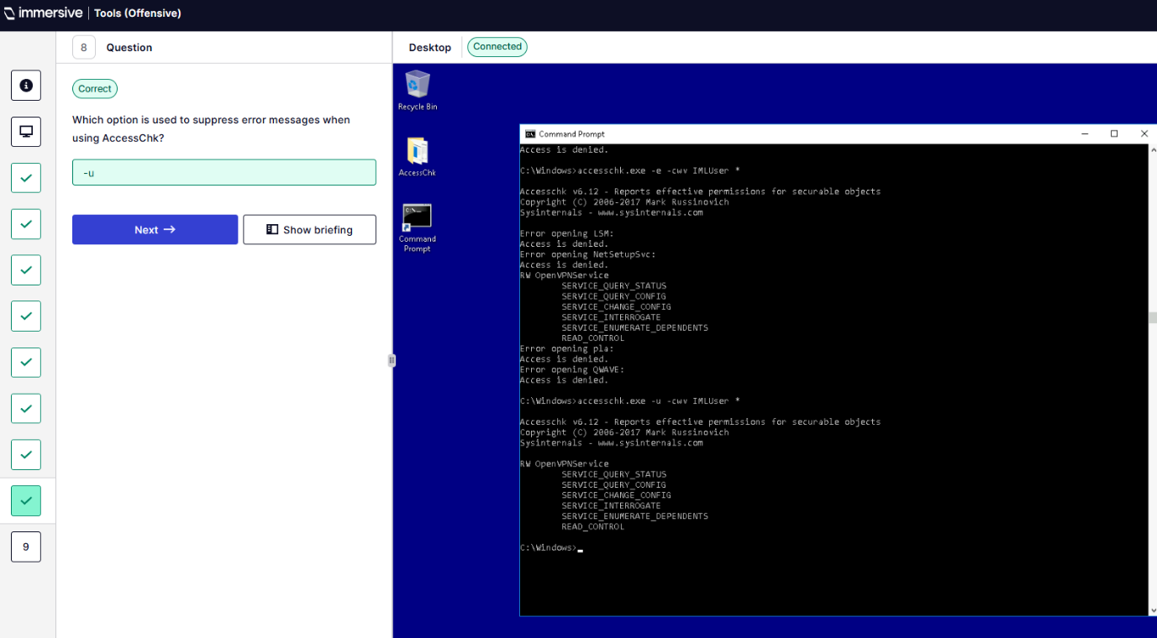
Q9 – Option used to show objects have no access?
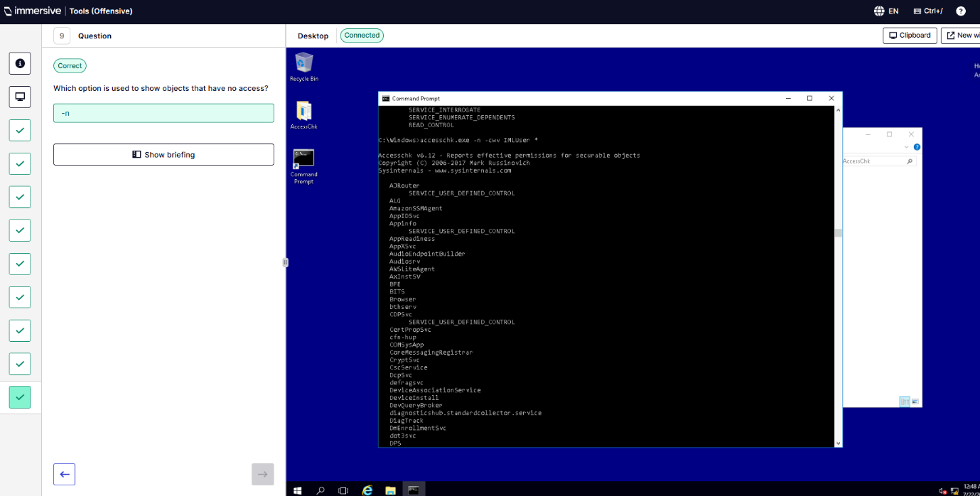
  - Autoruns
Q1 – Open Autoruns.
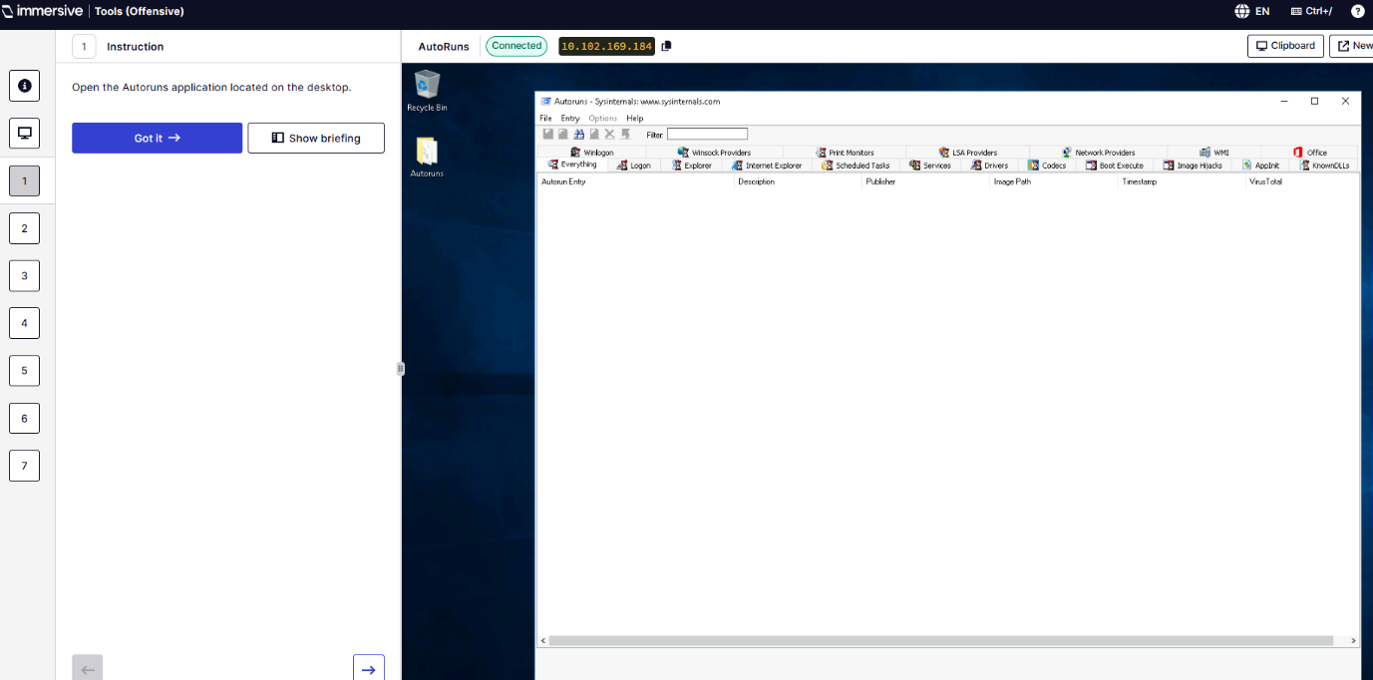
Q2 – Wait for Autoruns to populate system information
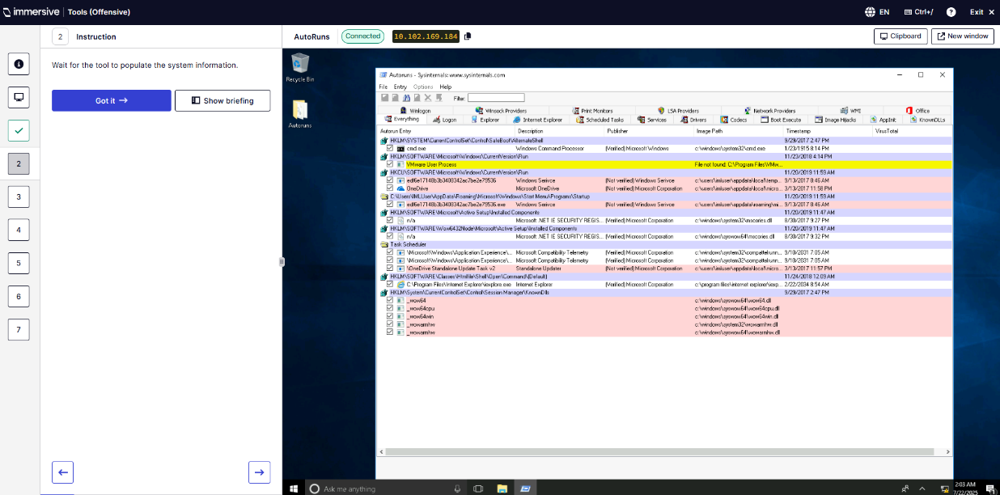
Q4 – What is the name of the malicious executable in the Startup folder?
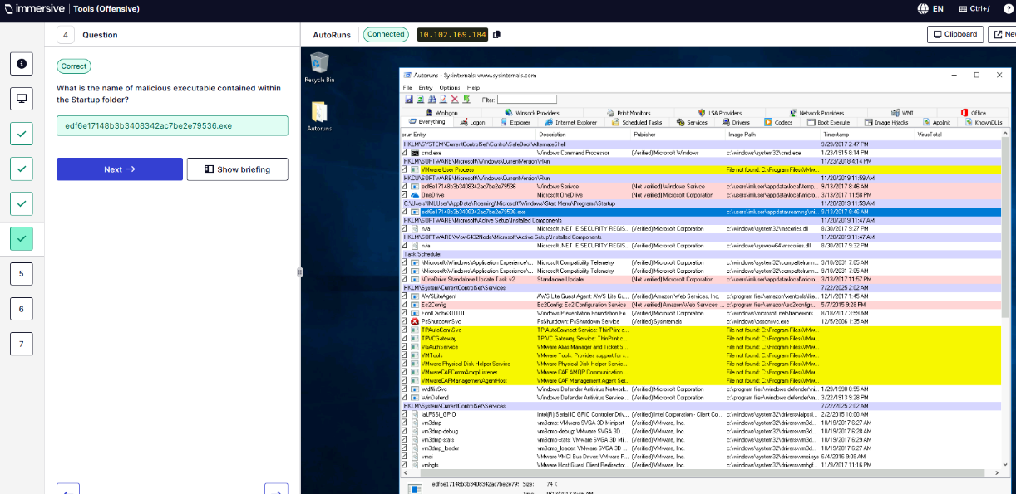
Q5 – Which Registry key is responsible for autorun of the executable?
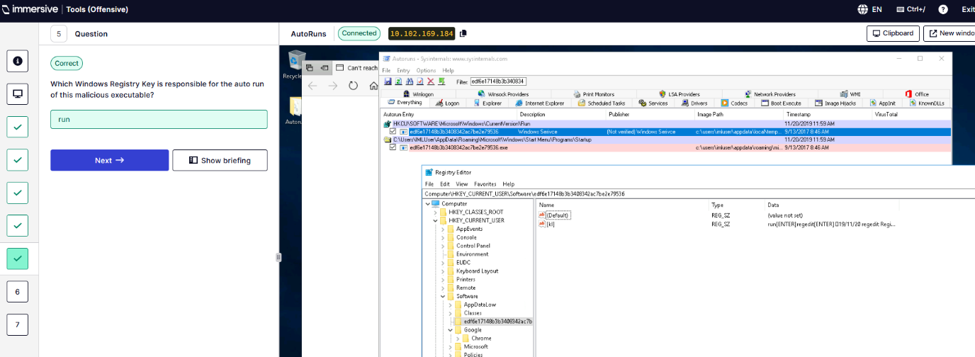
Q6 – What is the Data value of the Registry Key?
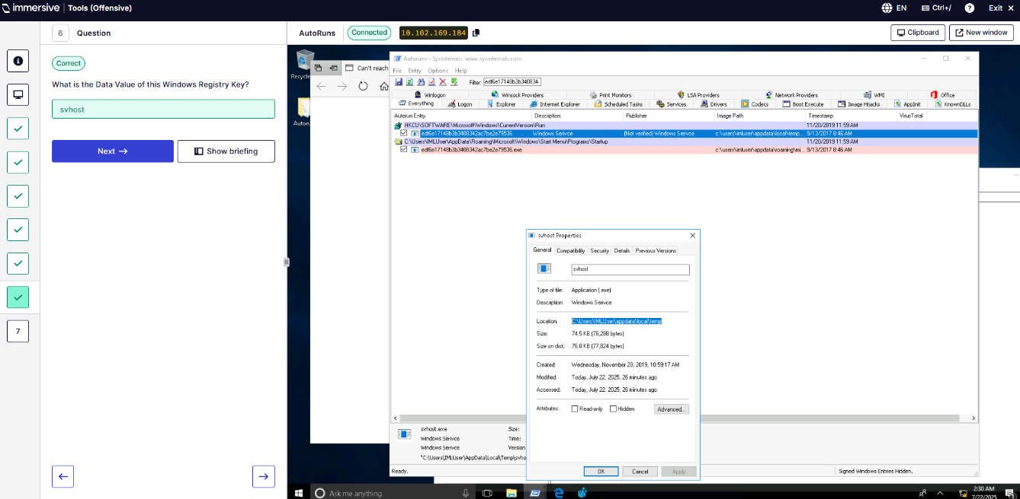
Q7 - What is the original filename of the executable?
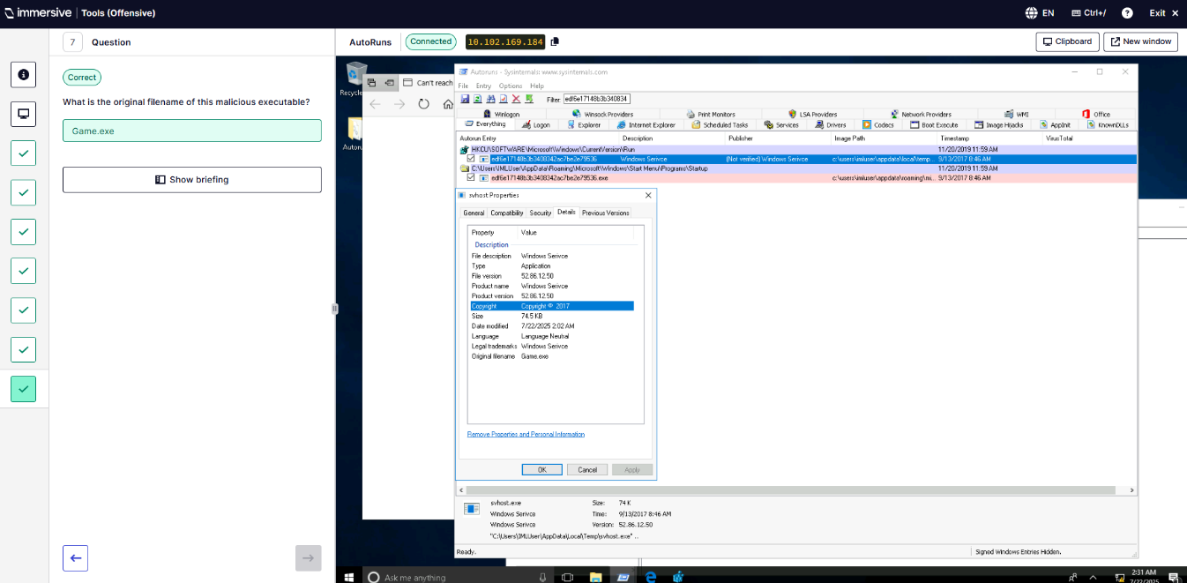
  - Strings
Q1 – Analyse files on the user’s desktop using strings.
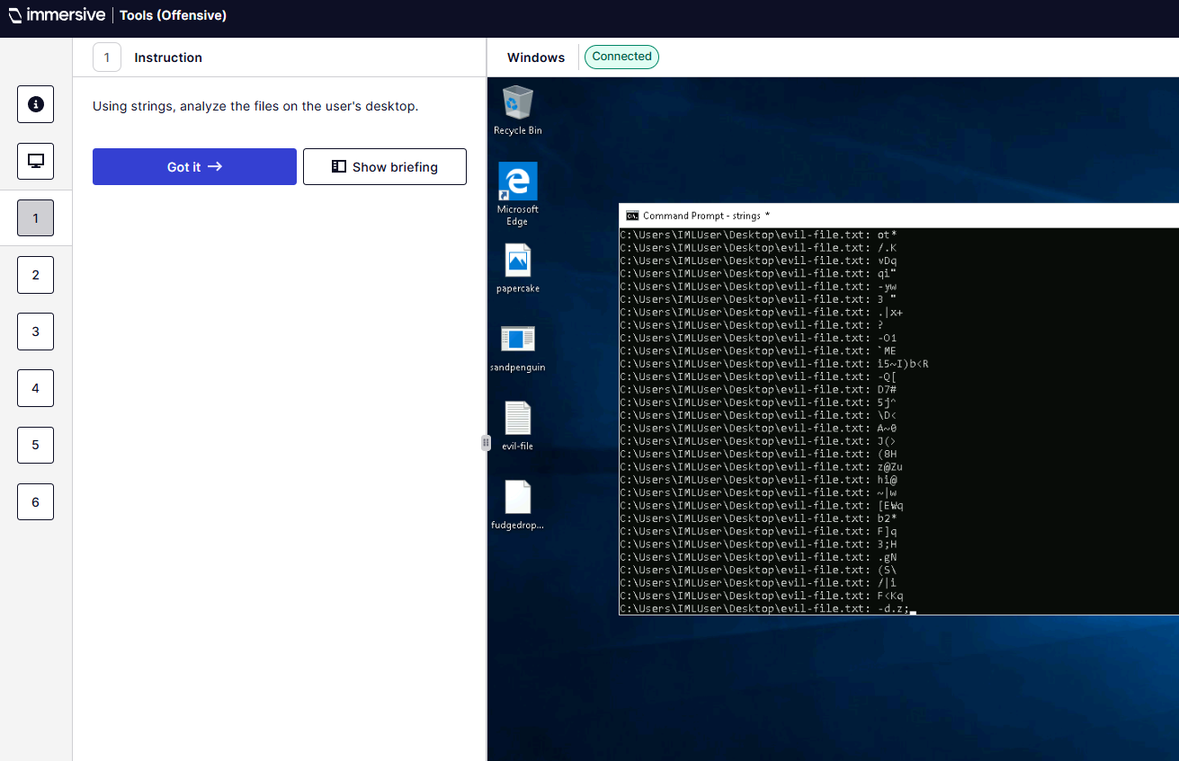
Q2 – Search file fudgedrop with minimum length of 50. How many results?
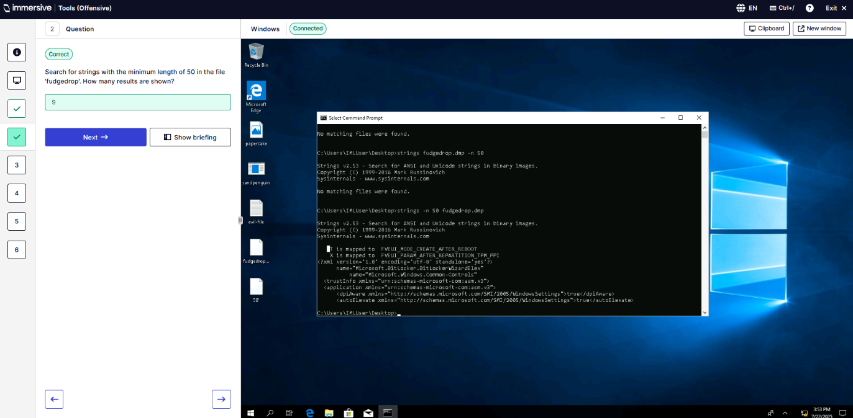
Q3 – Binary analysis?
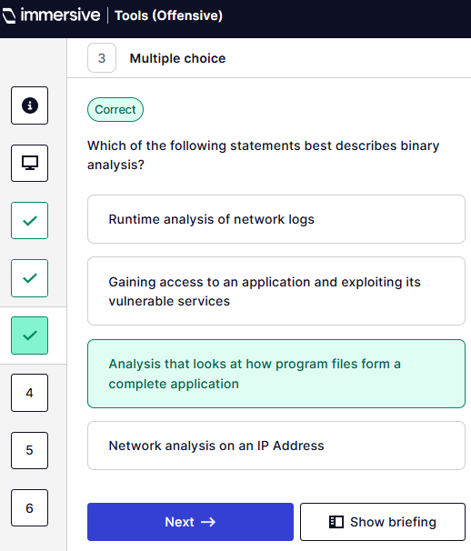
Q4 – Identify what architecture evil-file.txt is referring to?
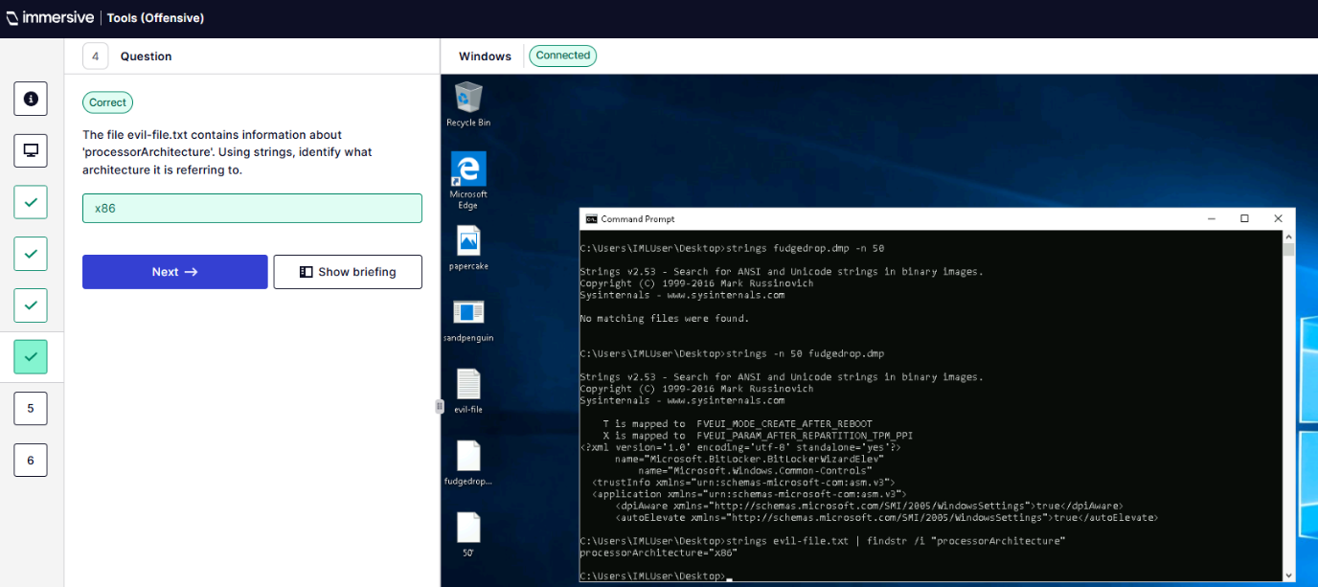
Q5 – Search Papercake for strings containing http. How many results?
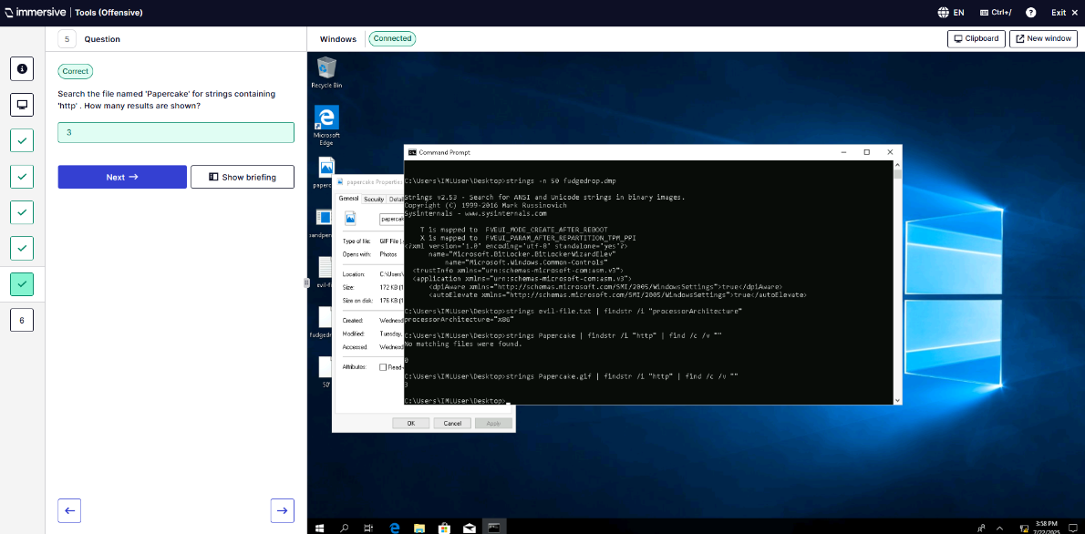
Q6 – What is the name of the executable in SandPenguin?
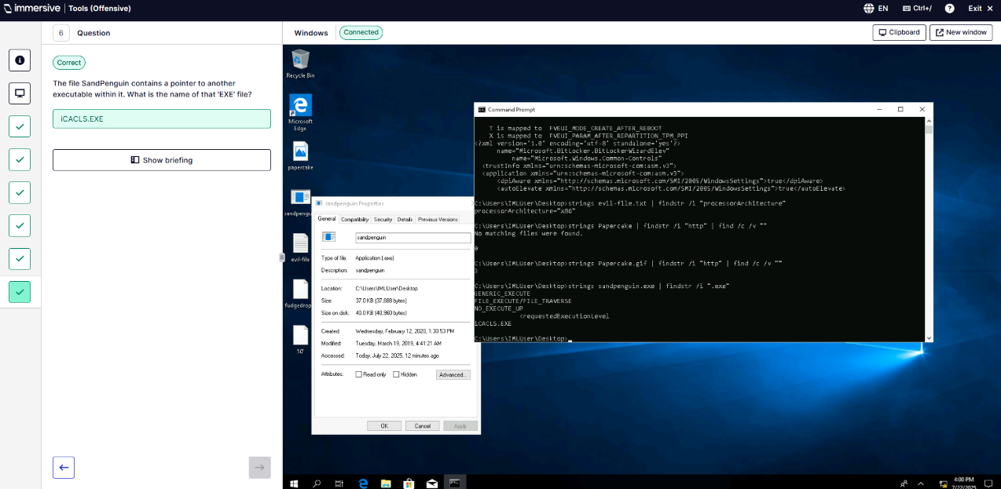
  - Sigcheck
Q1 – Open CMD and use Sigcheck.
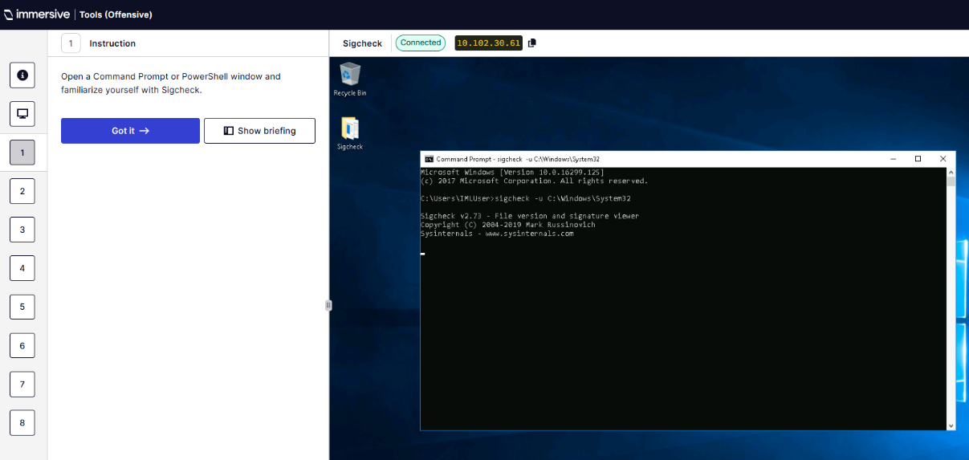
Q2 – What option is used to write to a file?
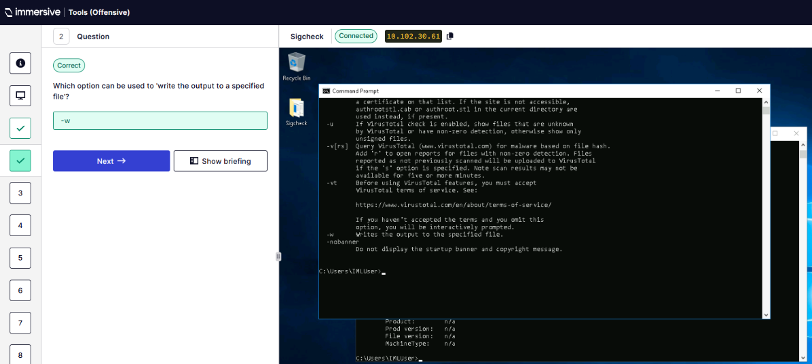
Q3 – Scan and save output of C:\Windows\System32 to a file.
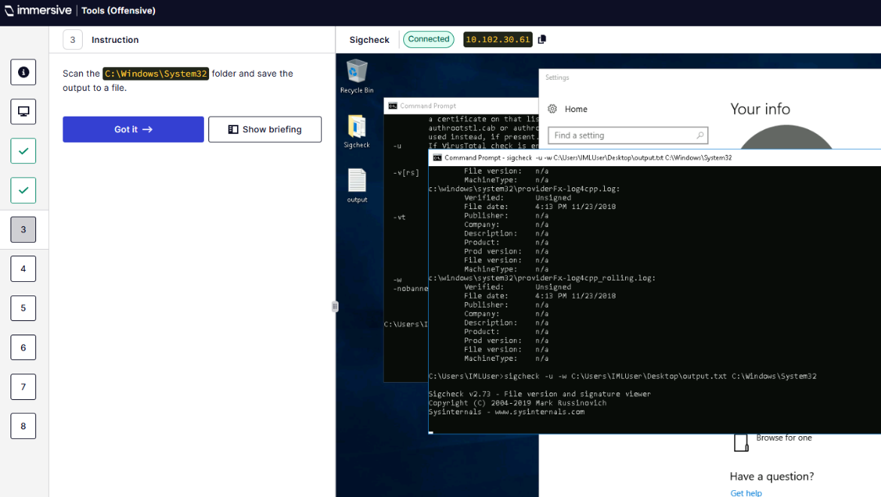
Q4 – What is the signing date of snmpapi.dll?
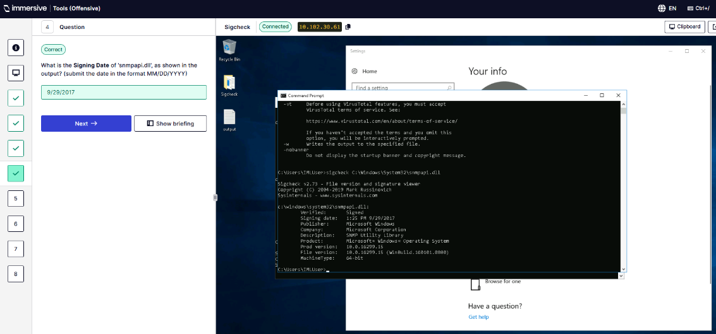
Q5 – Dump contents of catalog file and find the first outputted .log file.
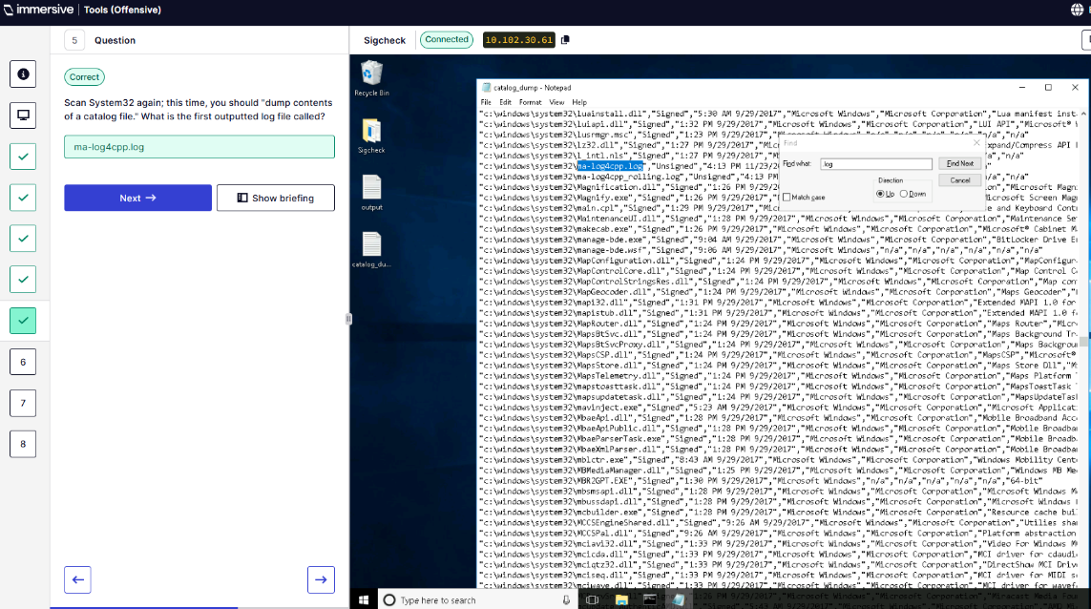
Q6 – Use Sigcheck to locate the malicious .exe hidden inside System32.
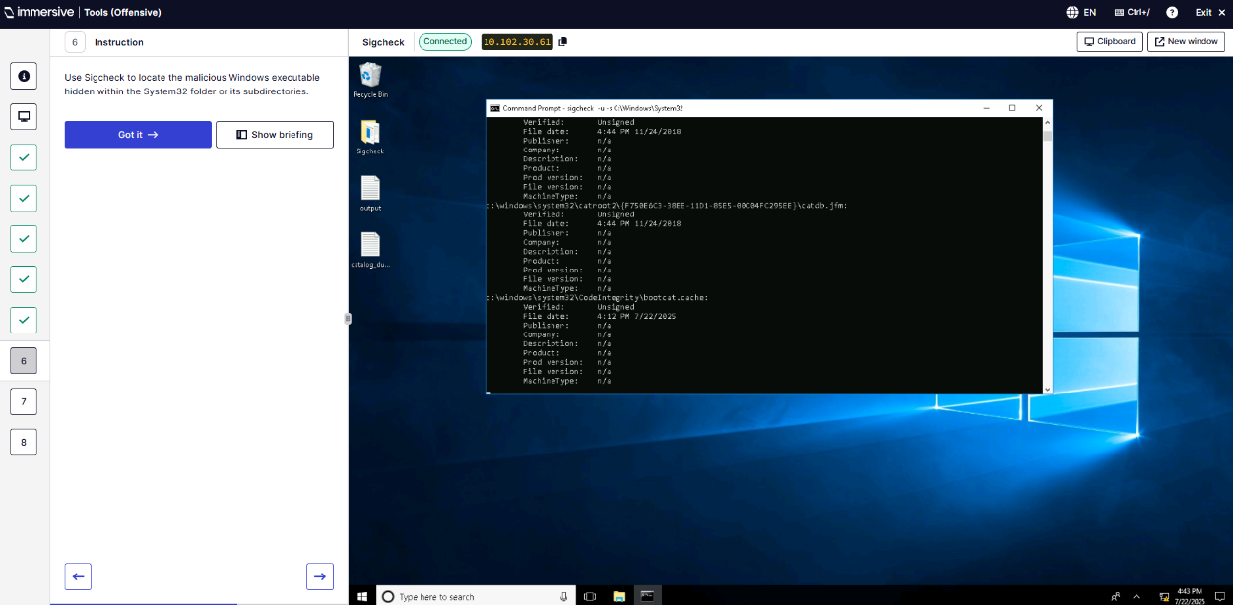
Q7 – What is the name of the binary?
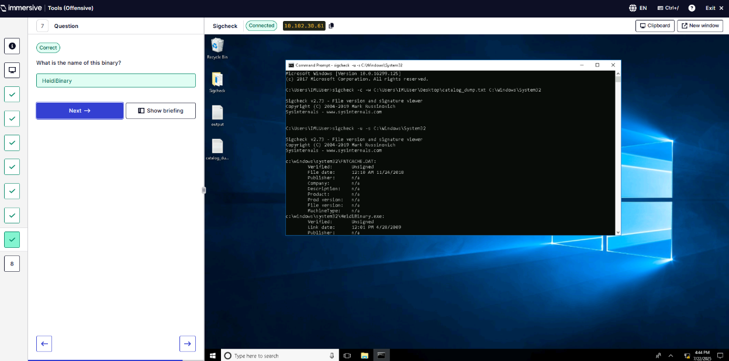
Q8 – What is the SHA256 hash?
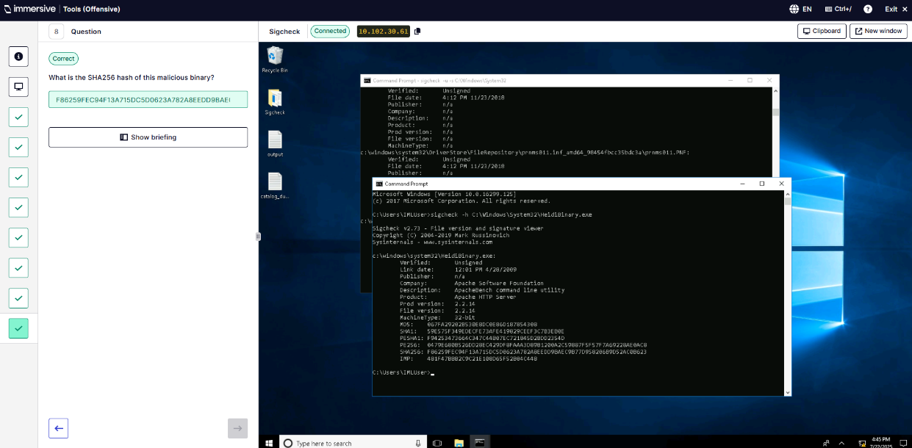
” (ImmersiveLabs Sysinternals, 2025)
- MITRE ATTT&CK. “(ImmersiveLabs MITRE ATT&CK, 2025)
  - Introduction to MITRE ATT&CK.
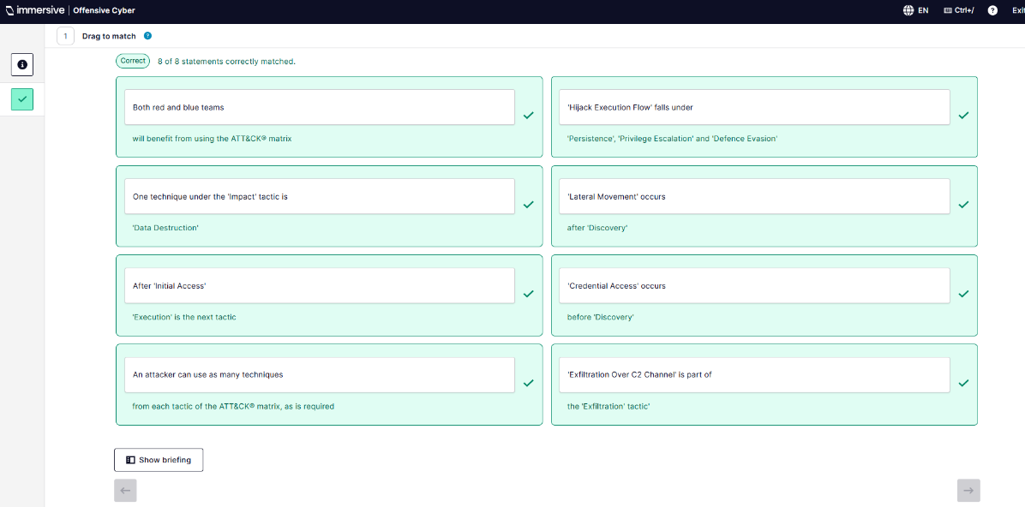
  - Reconnaissance.
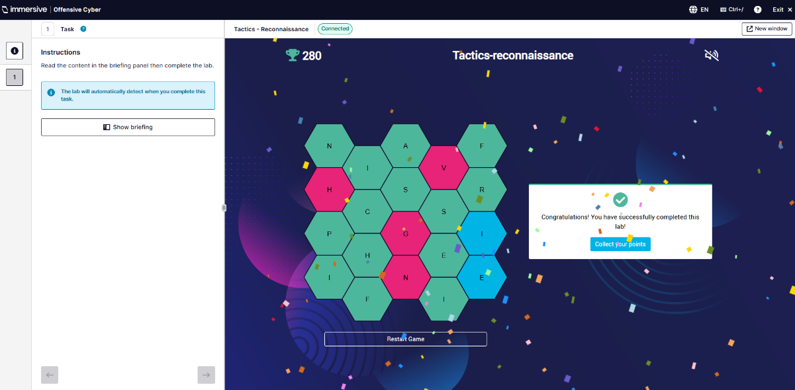
  - Resource Development.
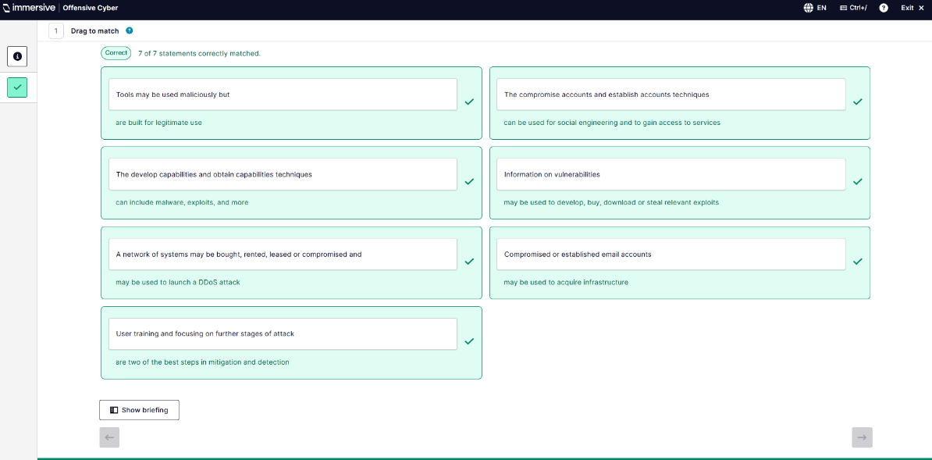
  - Execution.
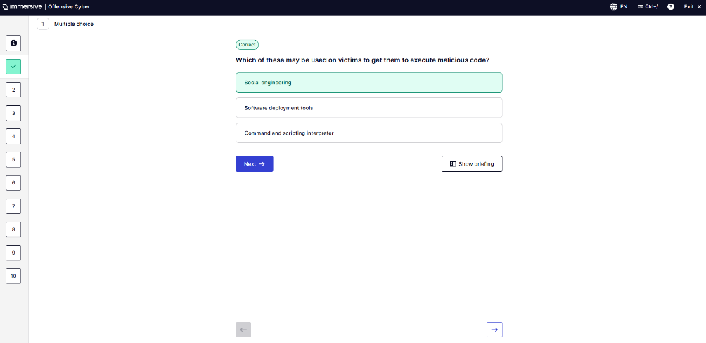
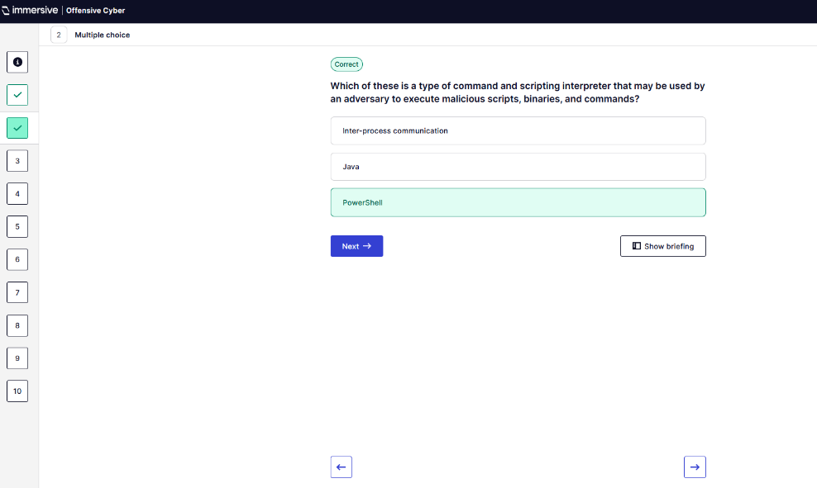
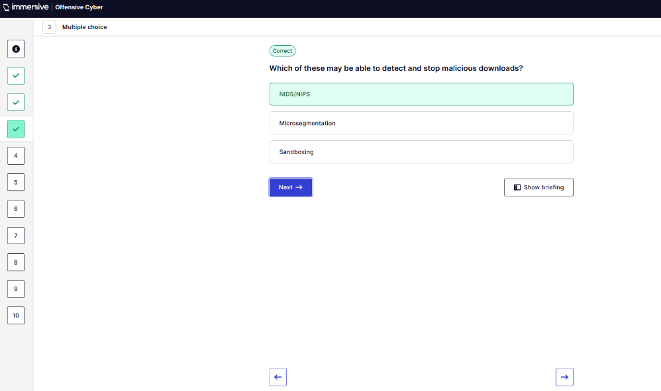
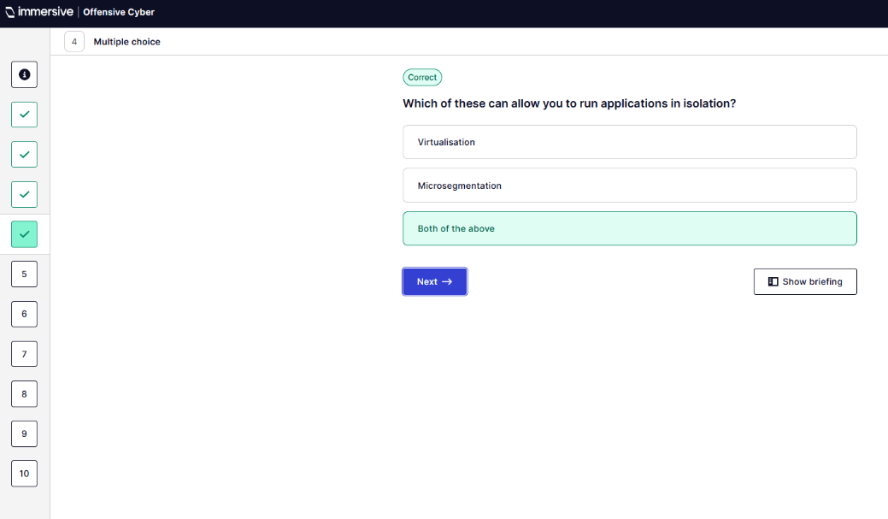
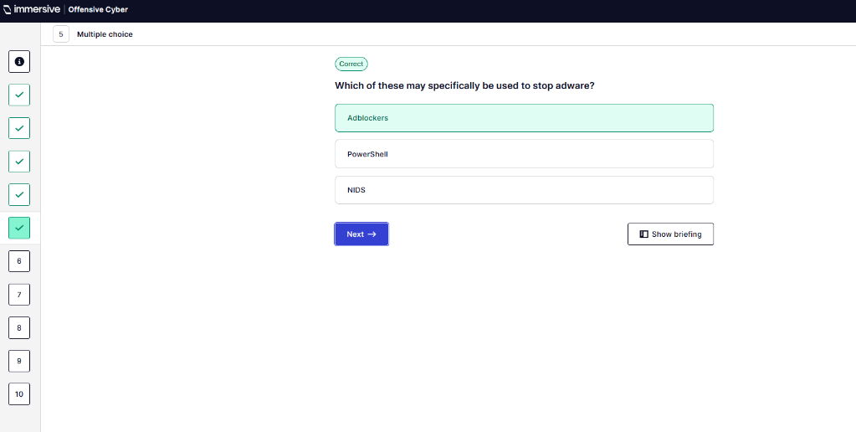
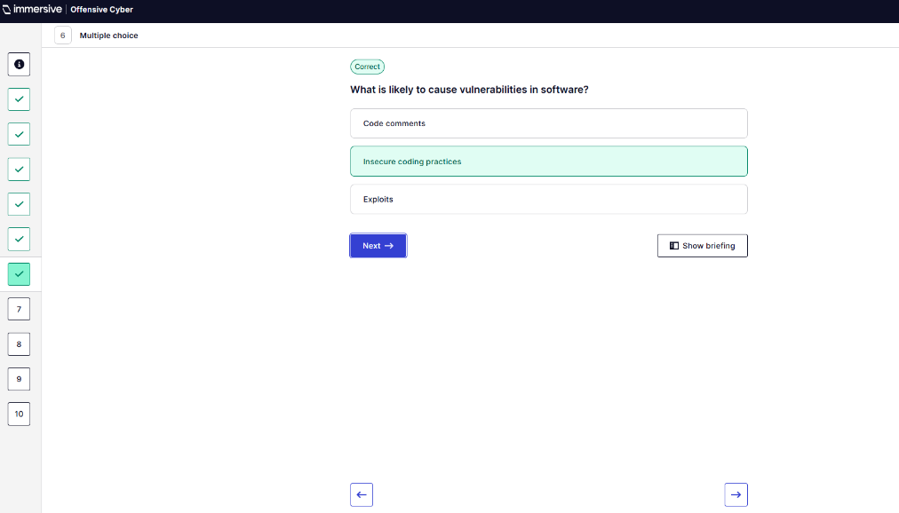
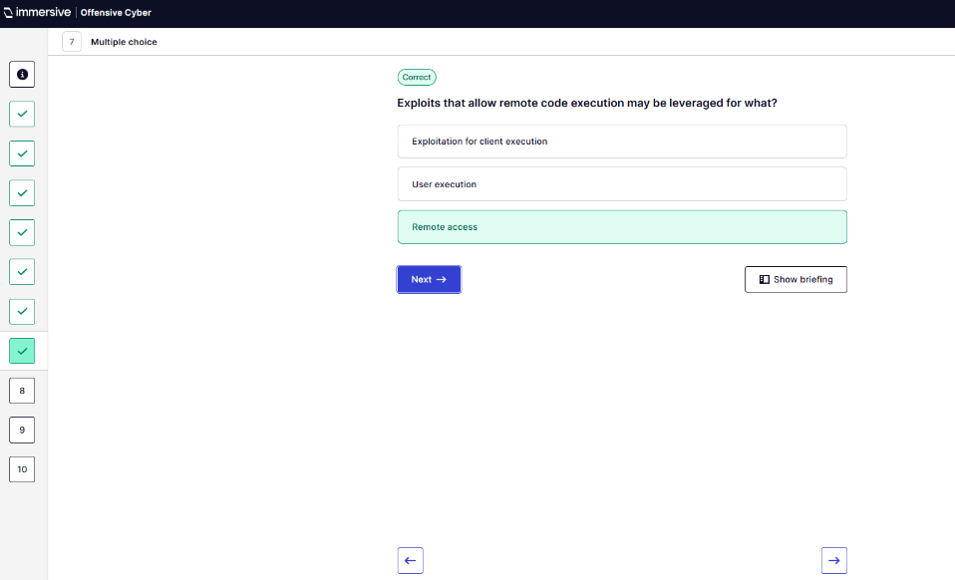
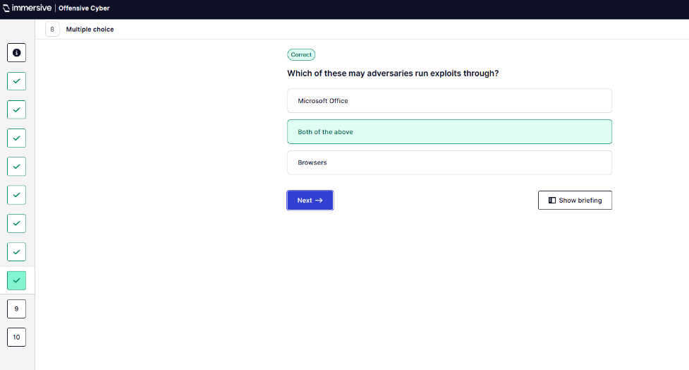
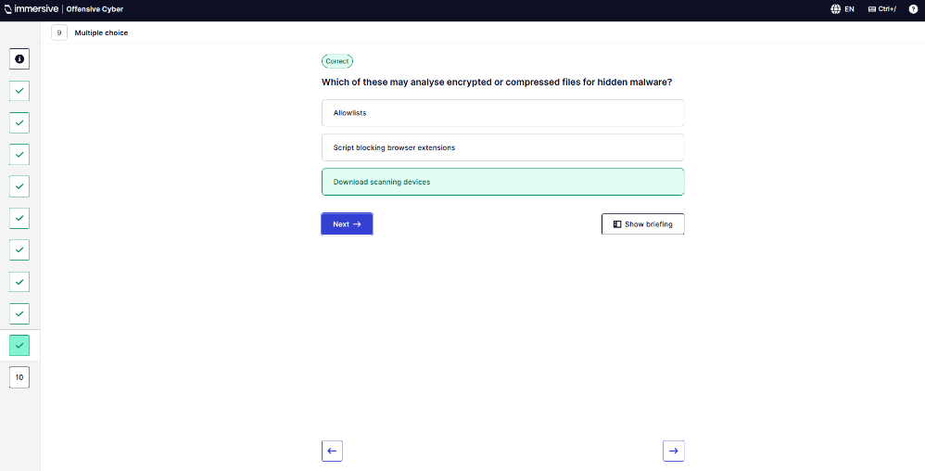
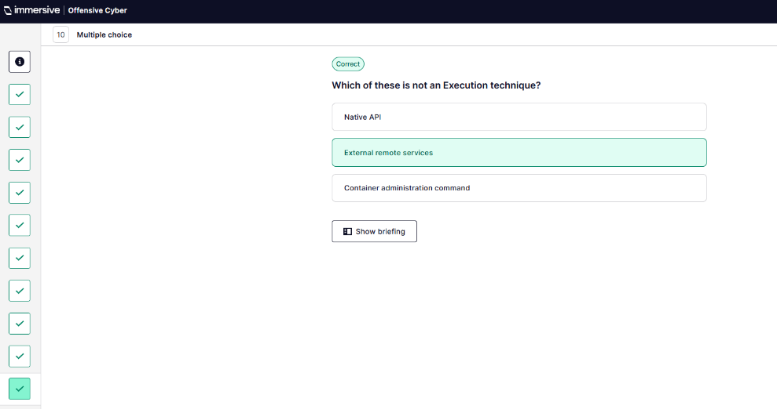
  - Persistence.
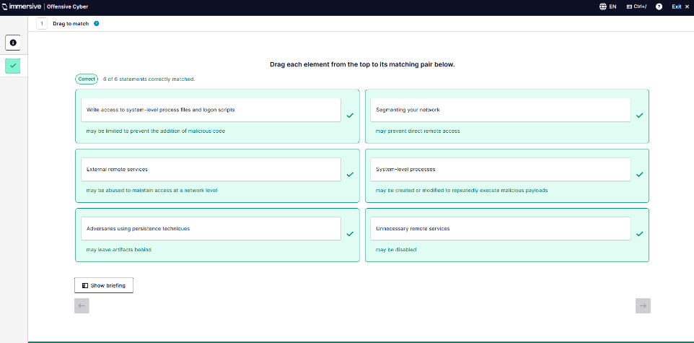
  - Privilege Escalation.
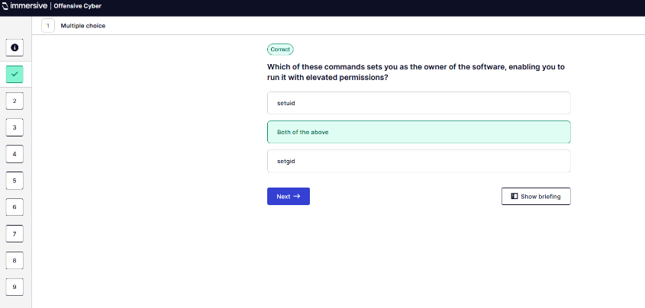
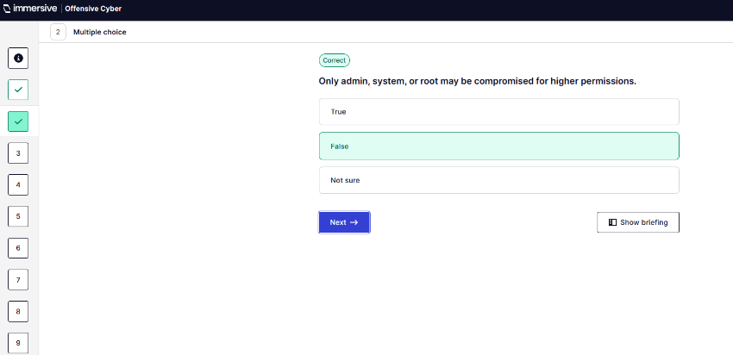
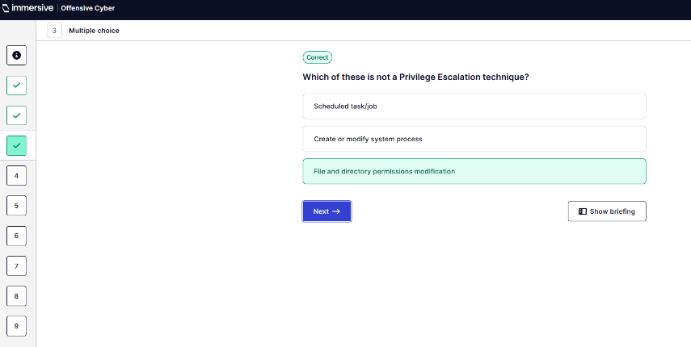
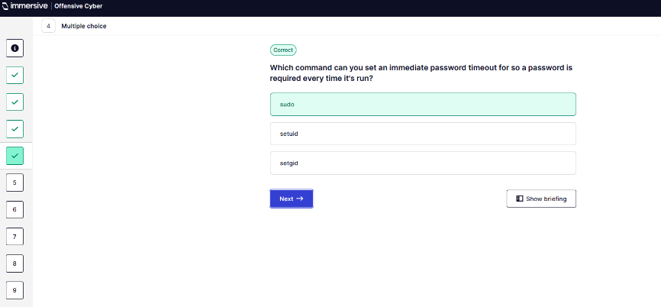
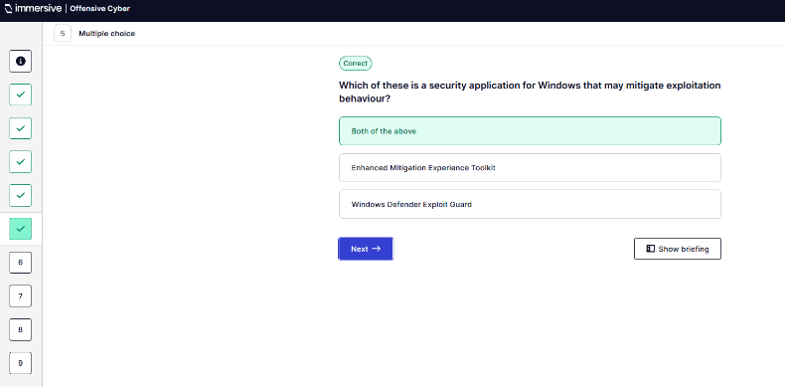
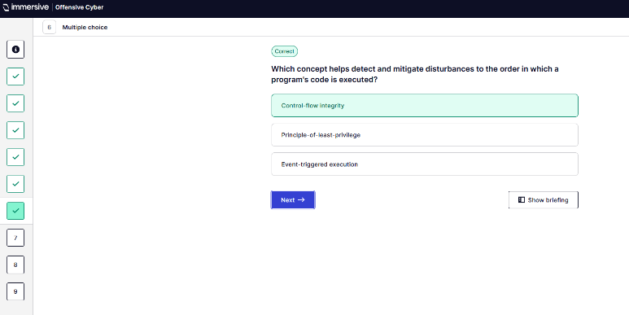
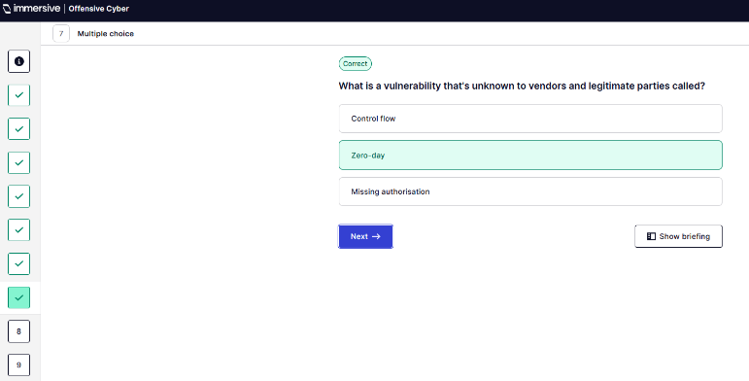
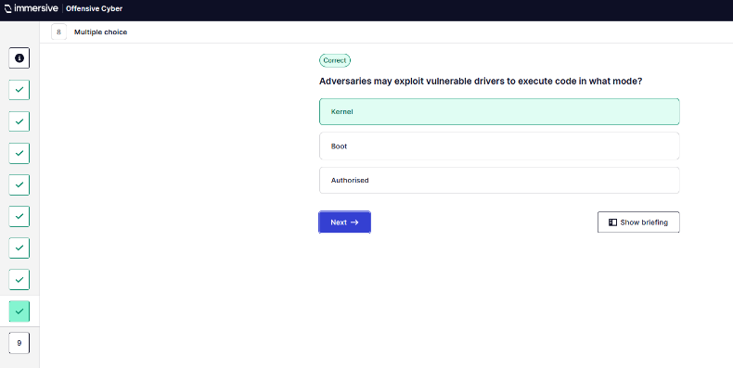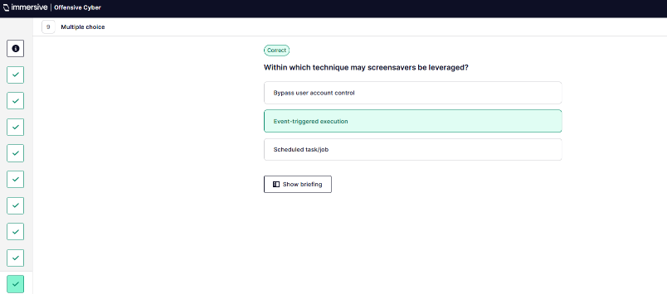
  - Defence Evasion.
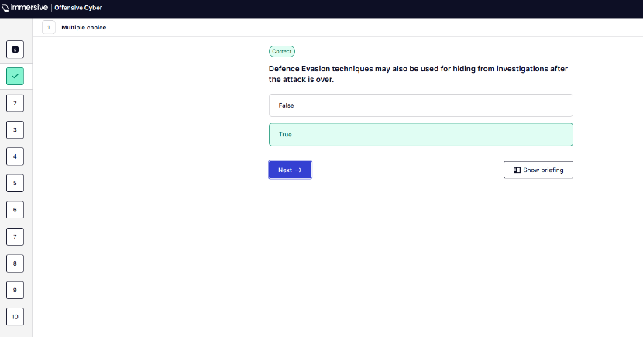
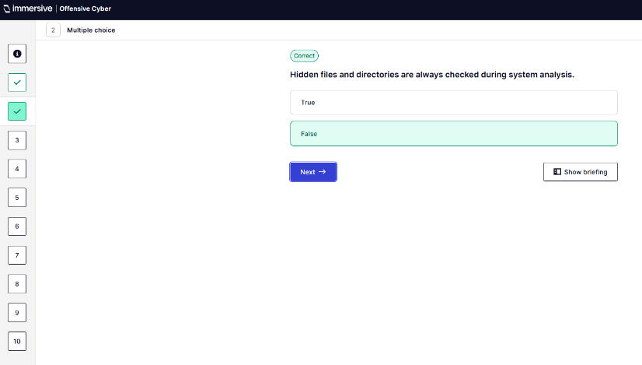
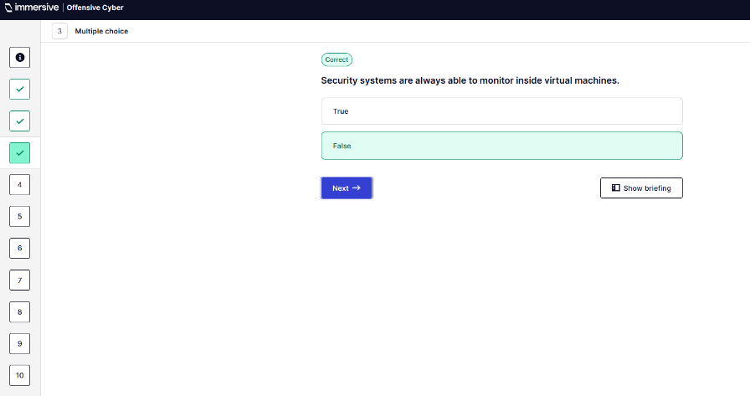
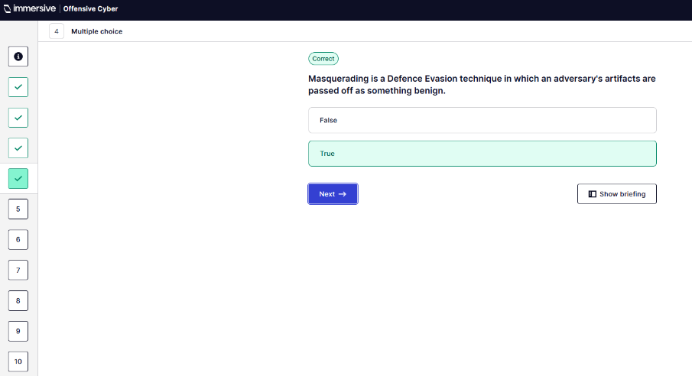
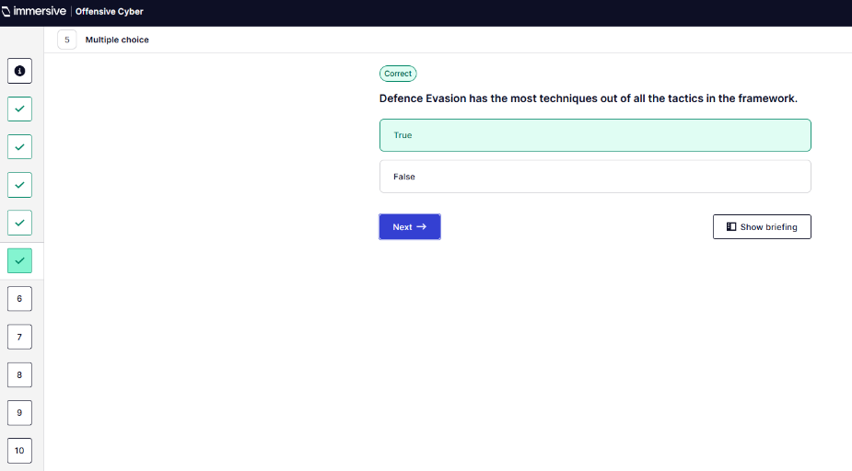
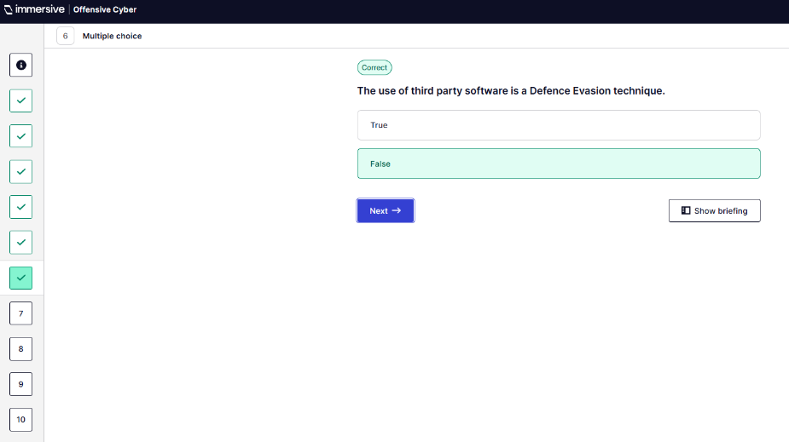
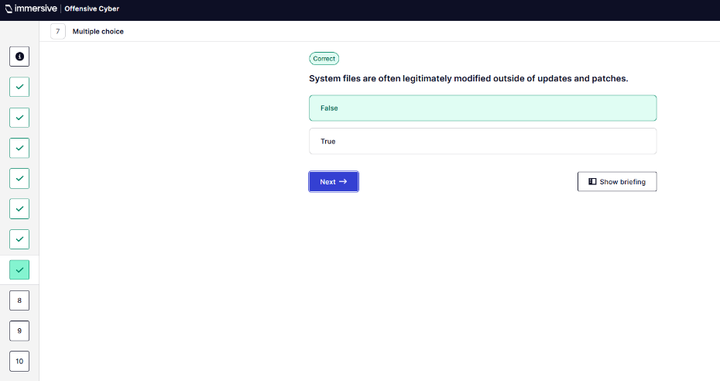
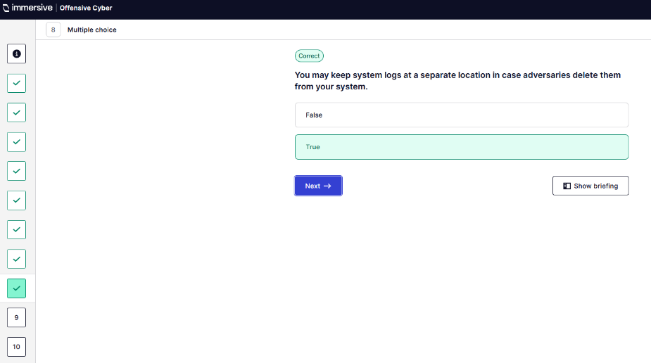
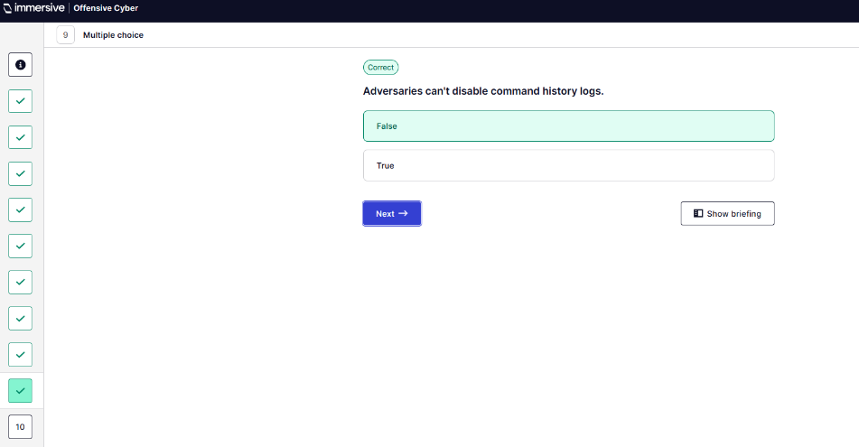
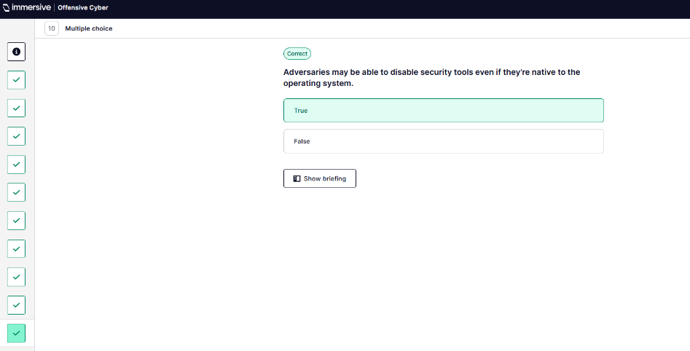
  - Credential Access.
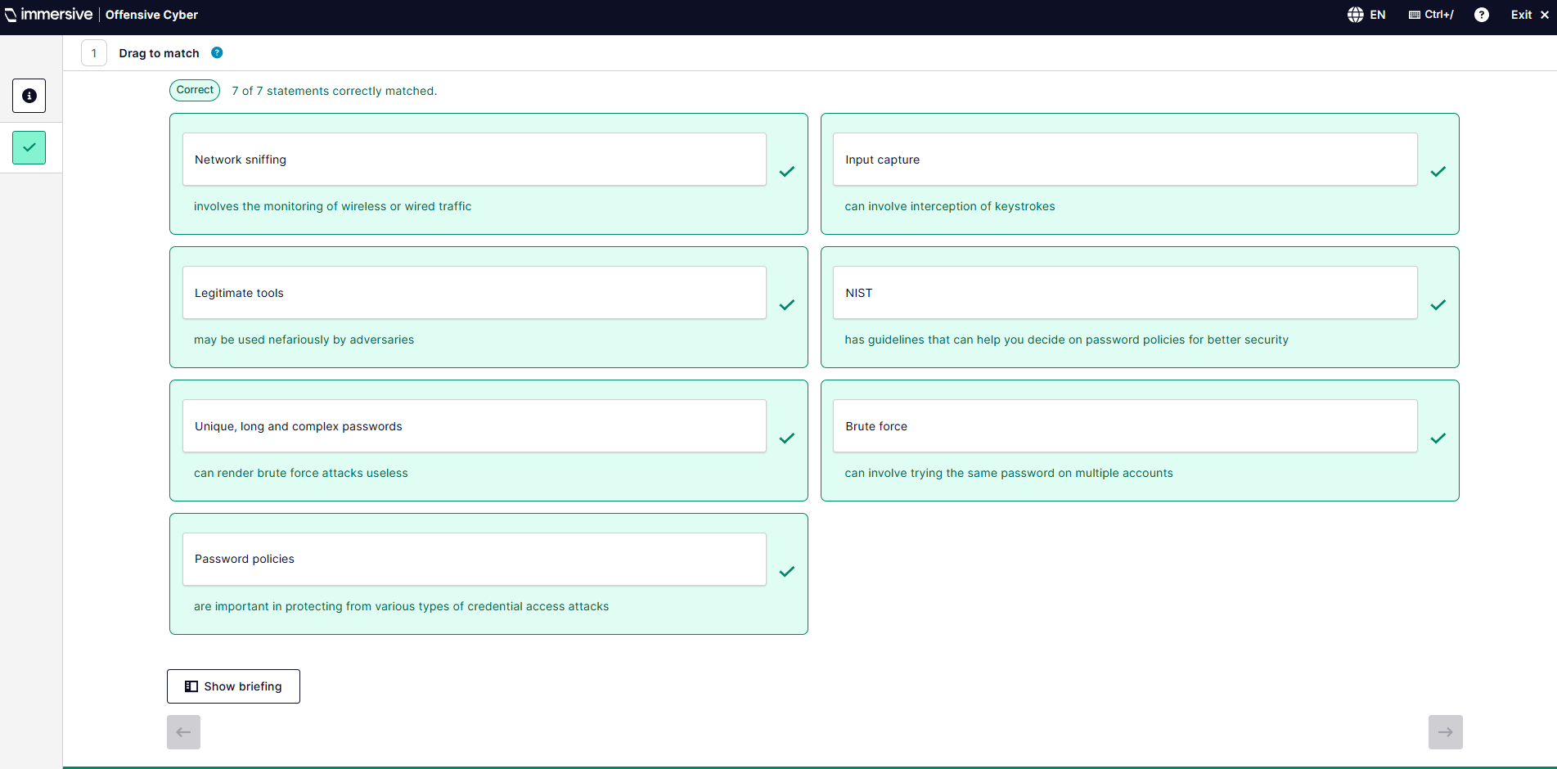
  - Discovery.
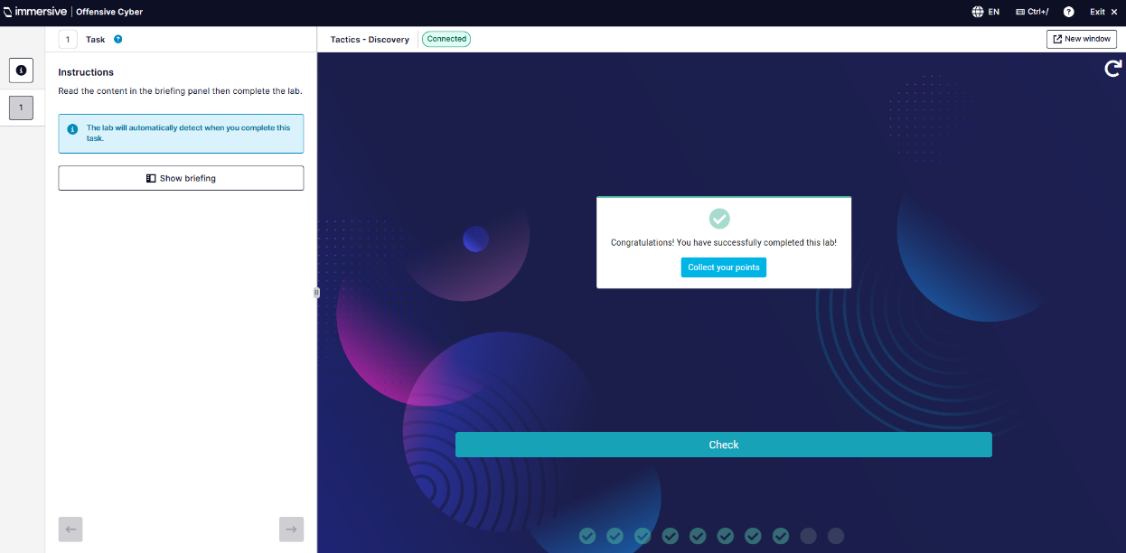
  - Lateral Movement.
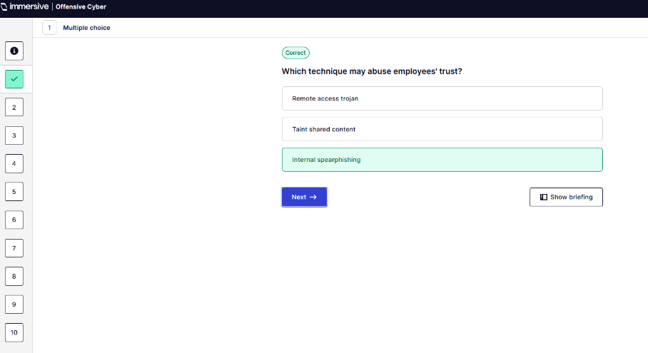
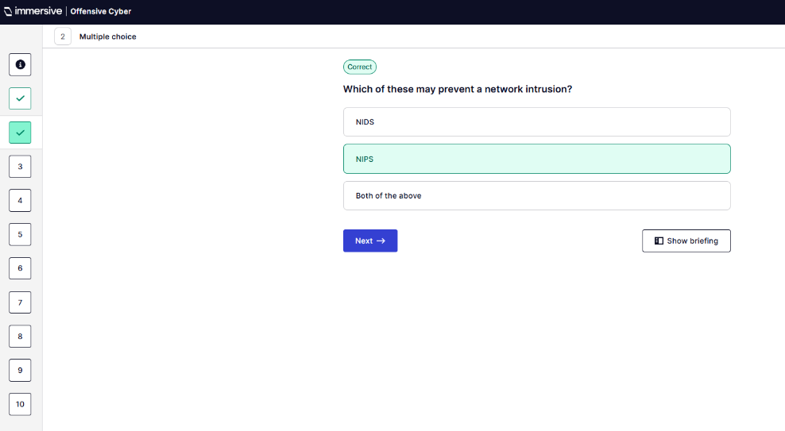
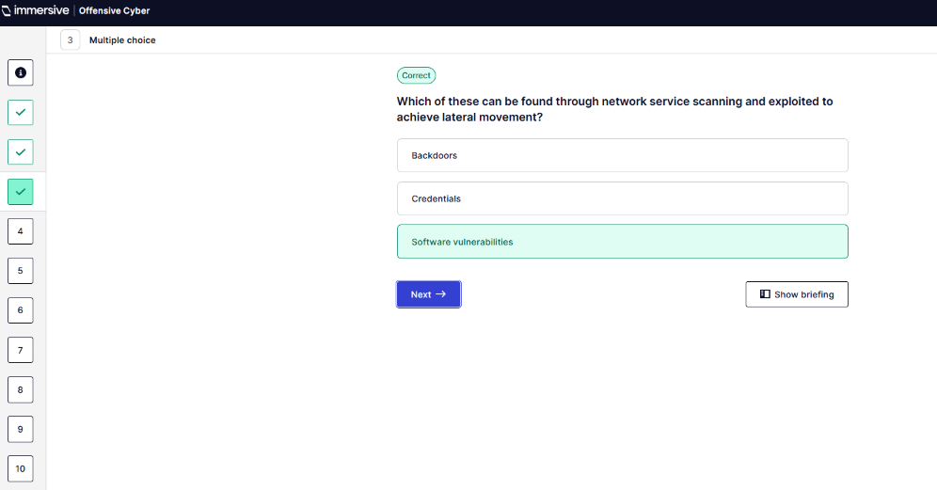
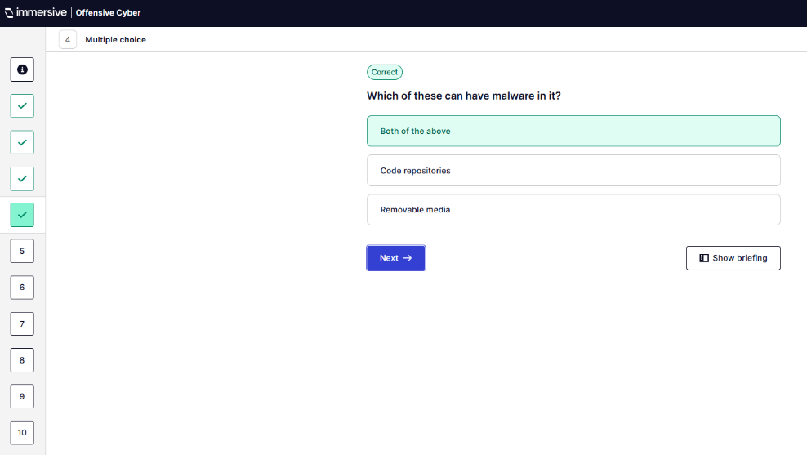
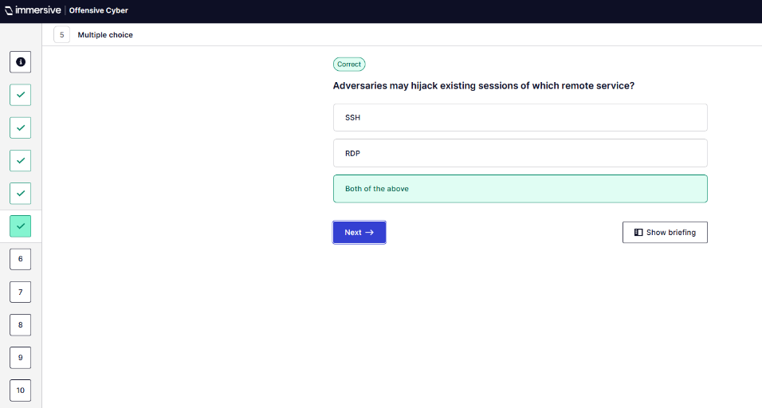
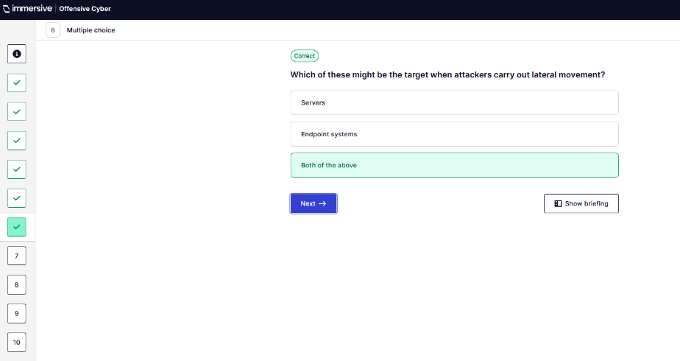
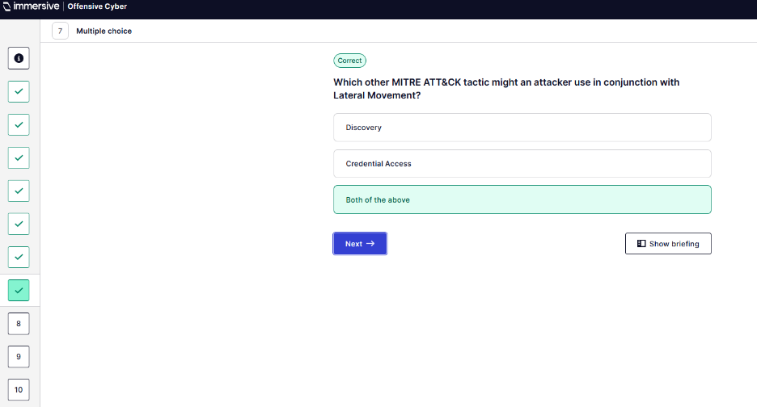
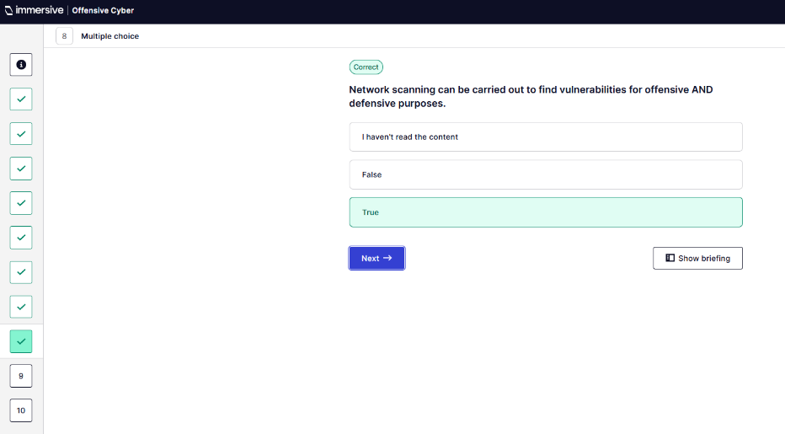
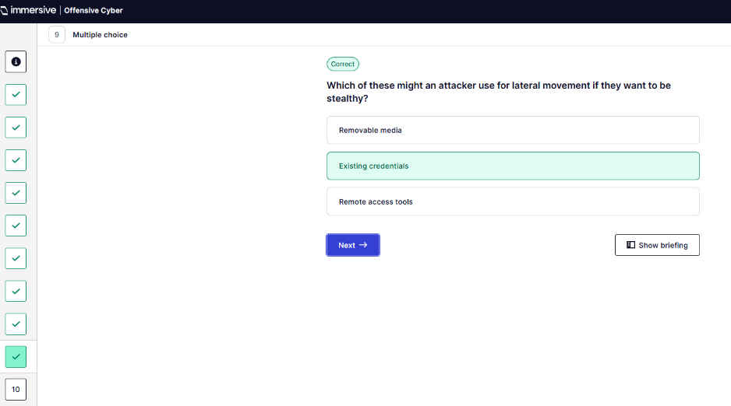
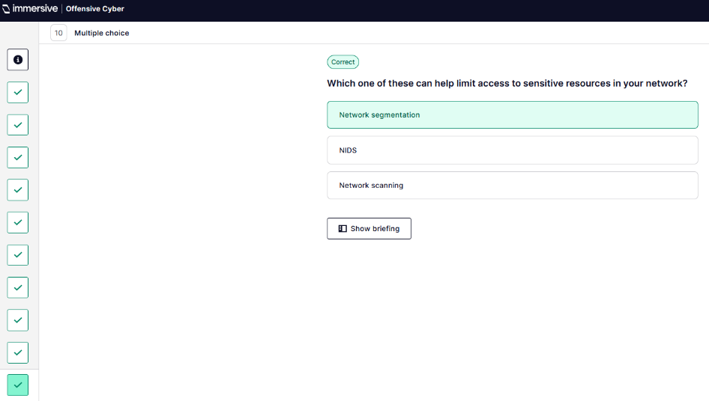
  - Collection.
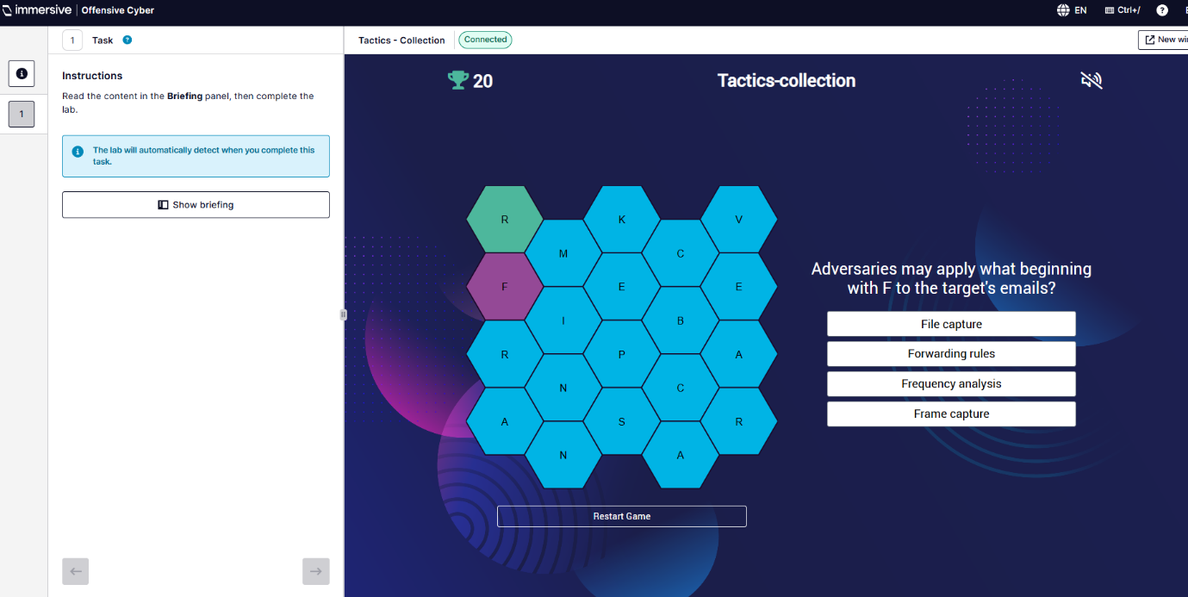
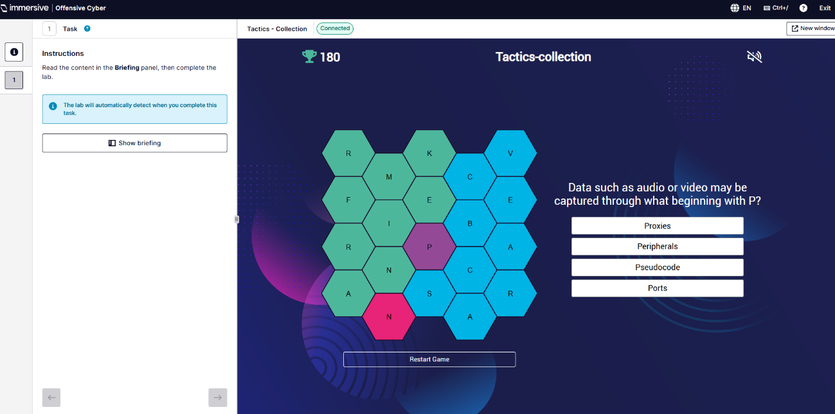
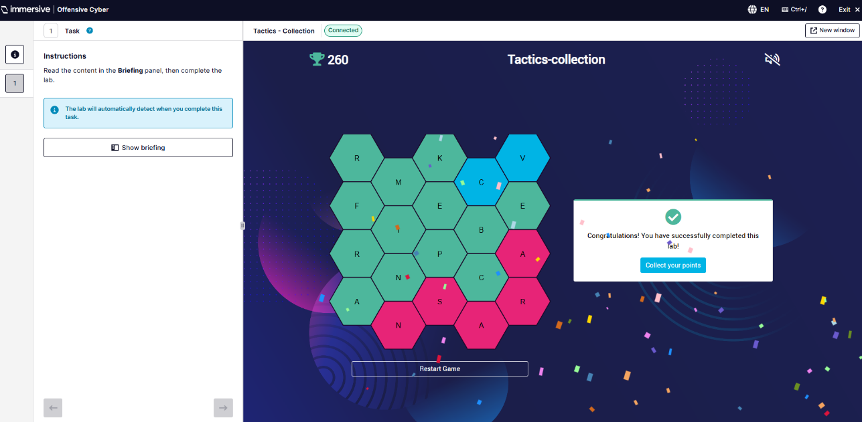
  - Command and Control.
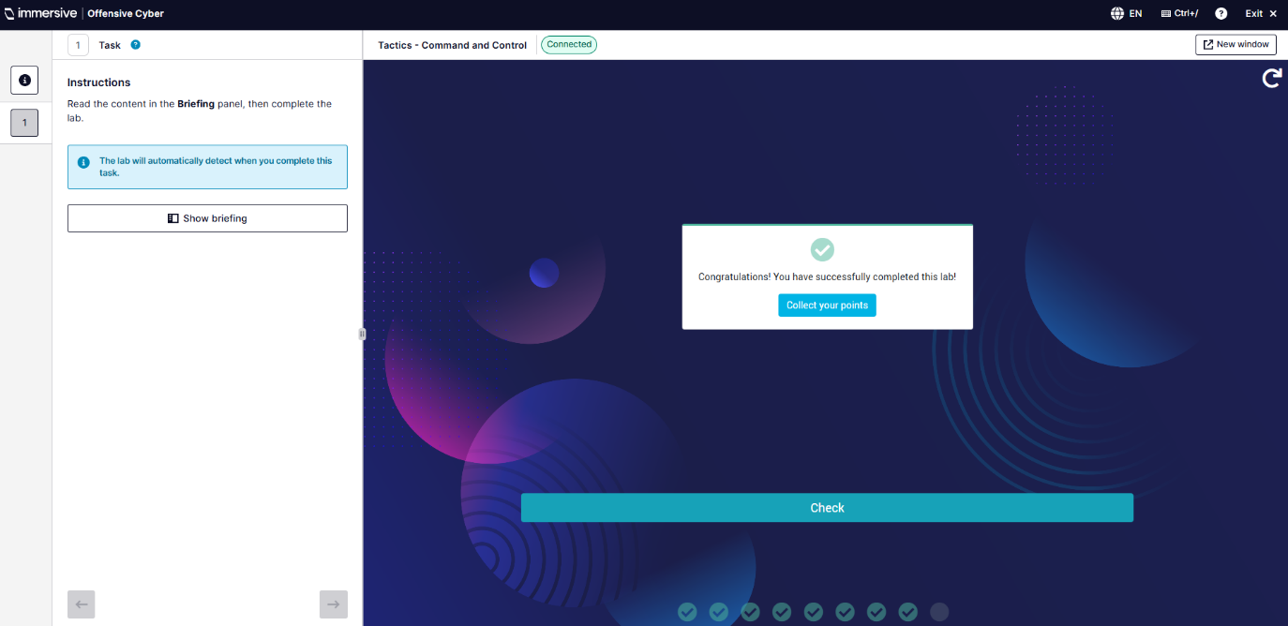
  - Exfiltration.
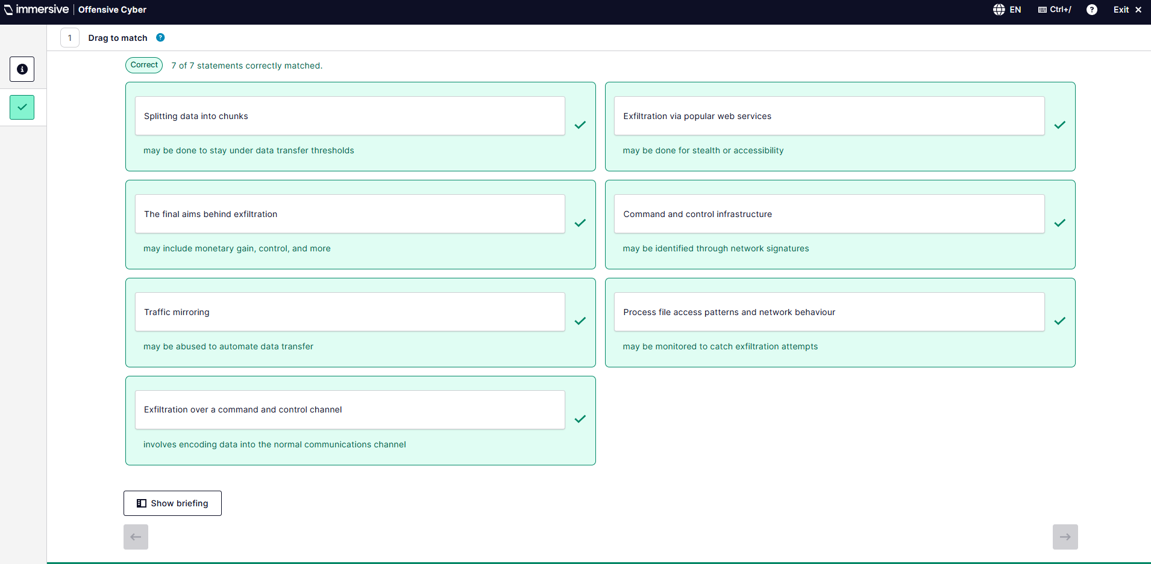
  - Impact.
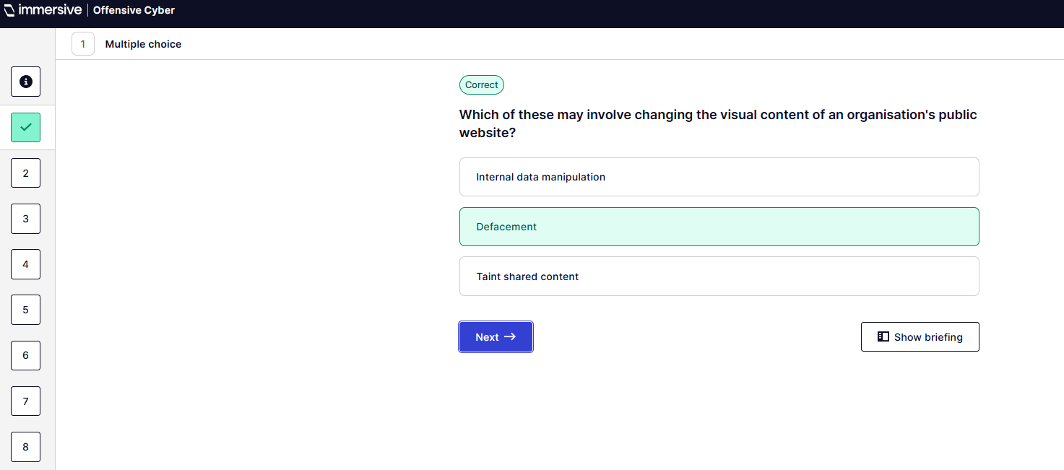
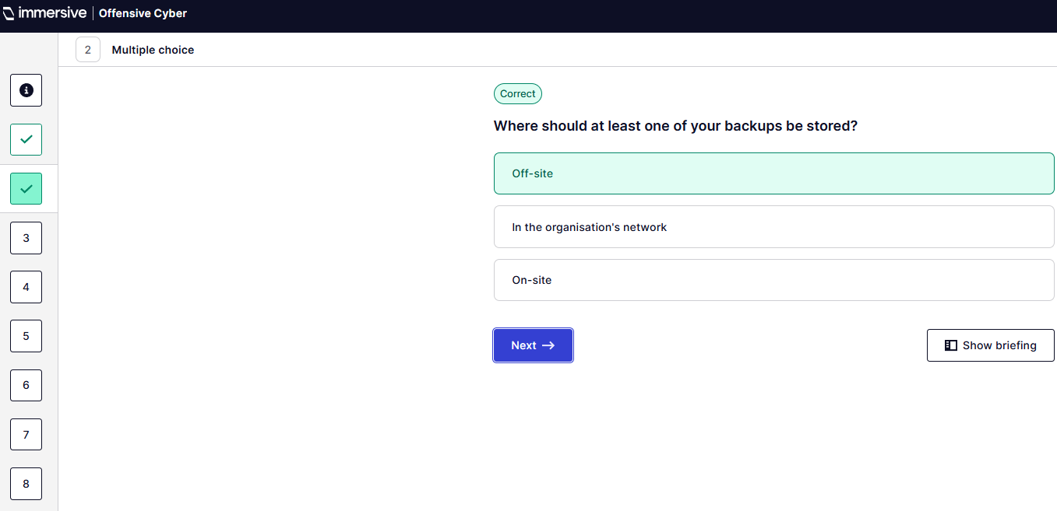
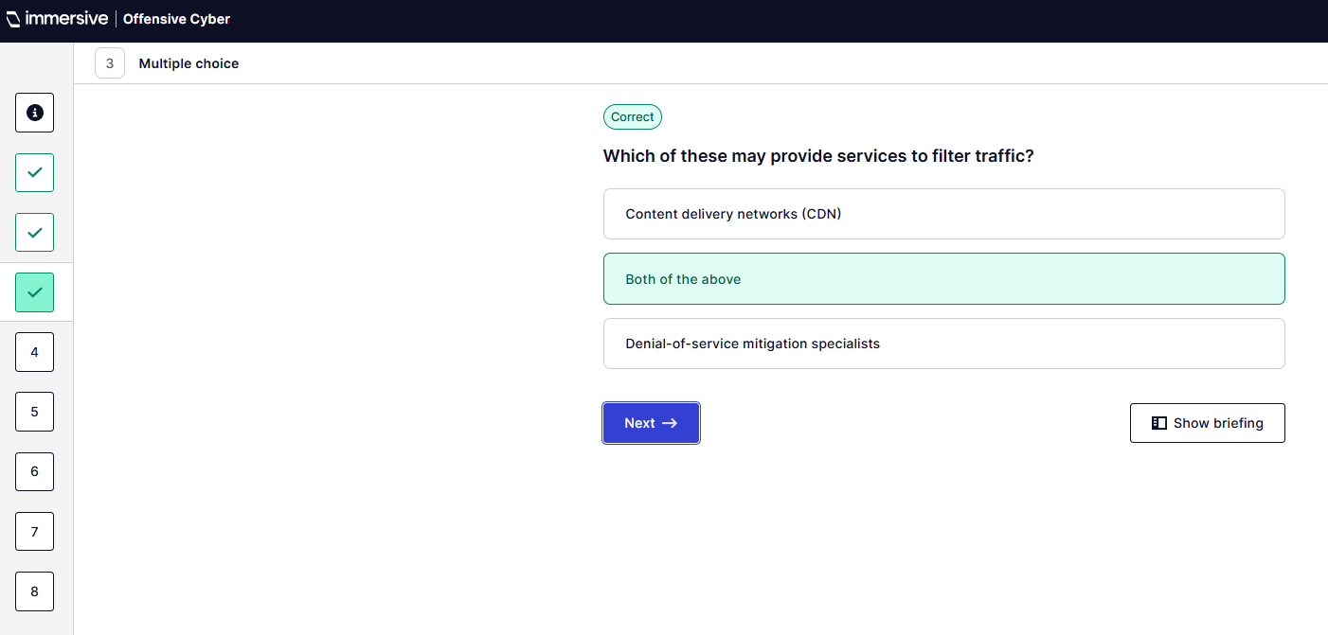
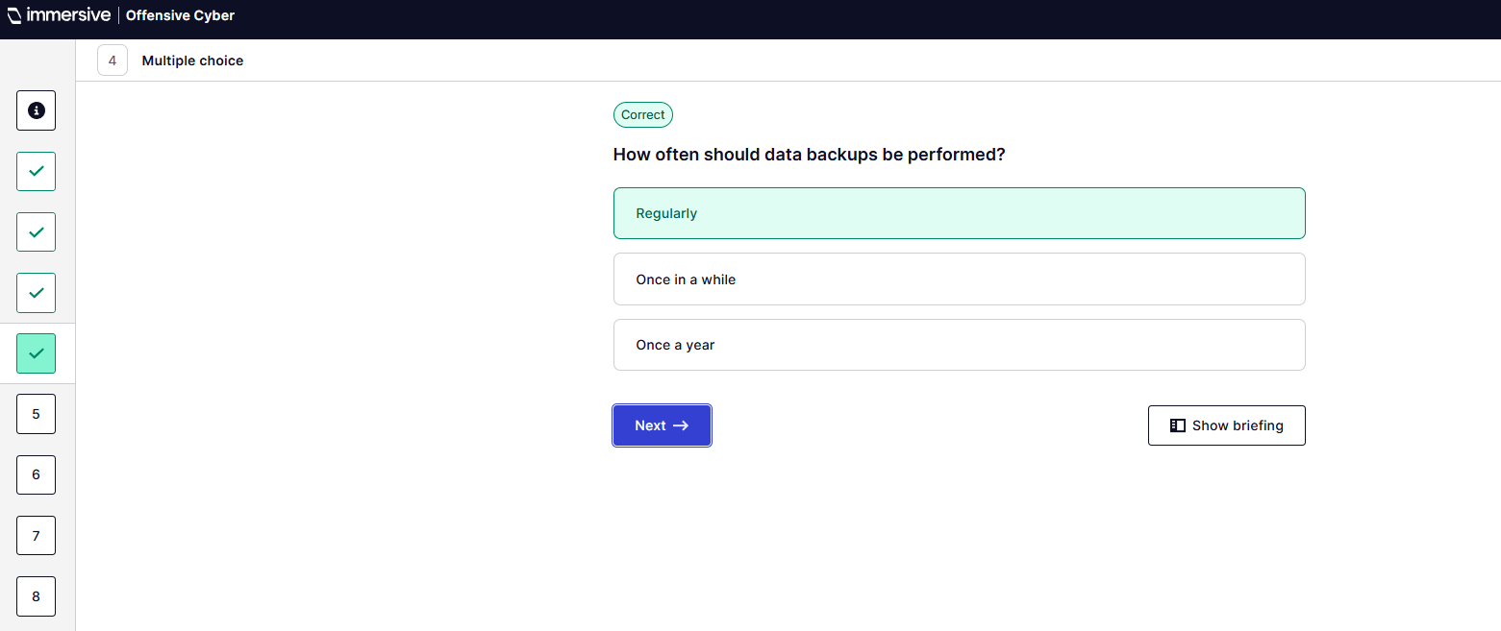
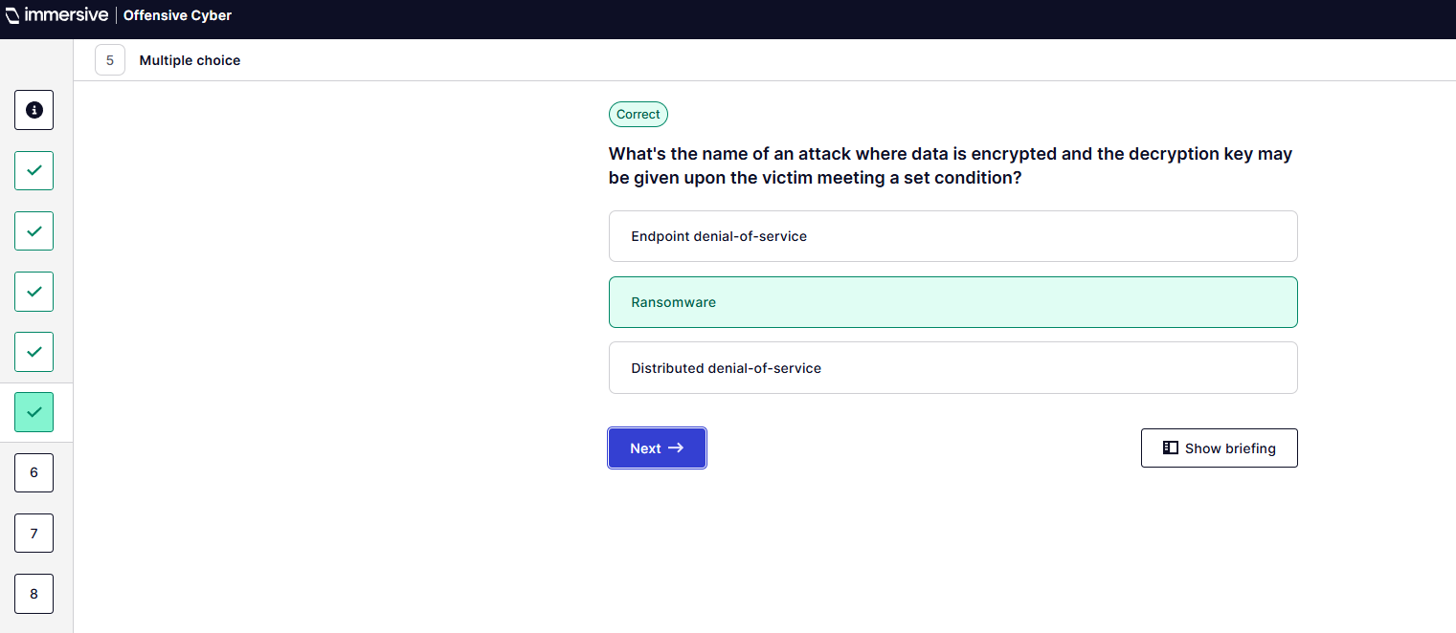
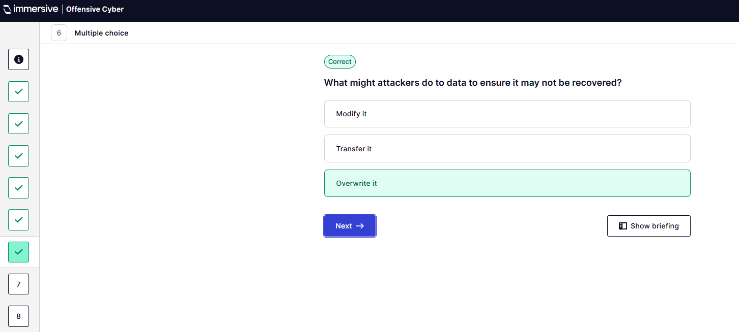
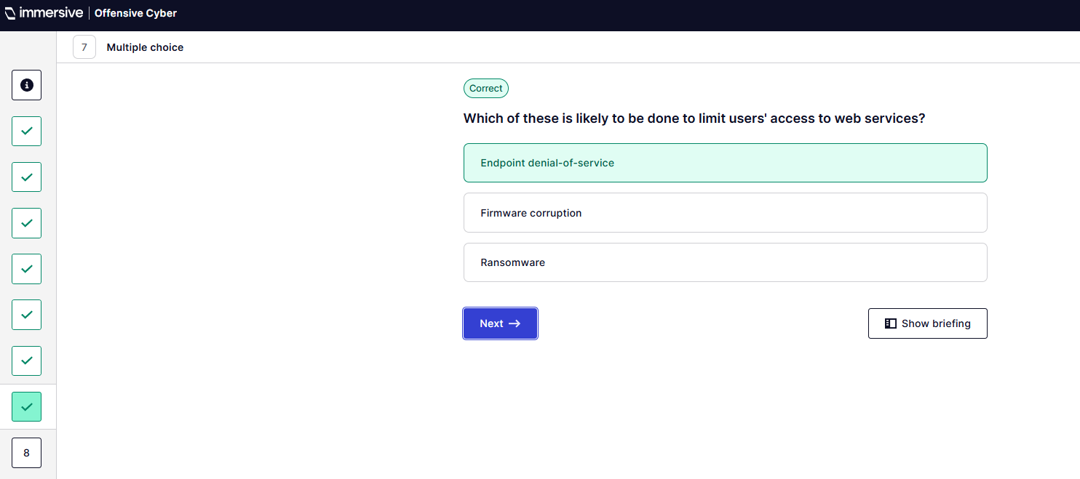
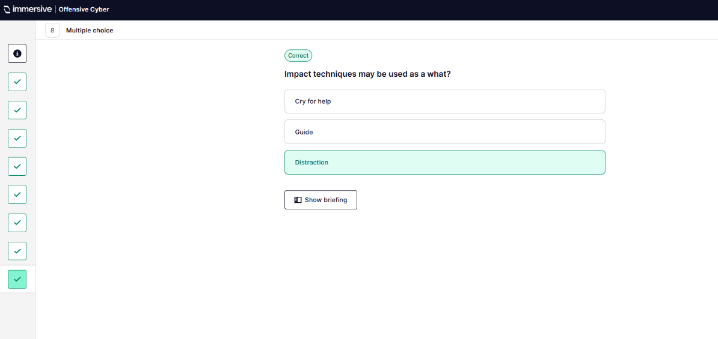
  - Demonstrate your knowledge.
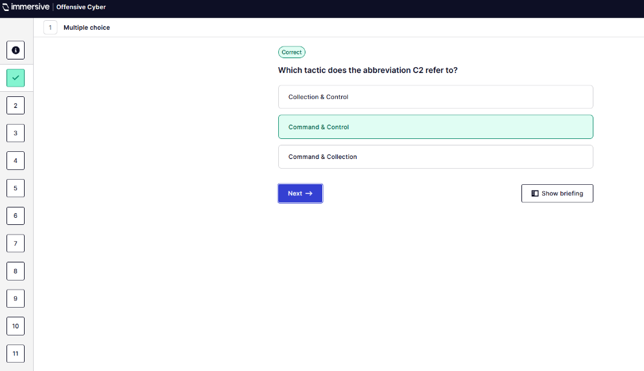
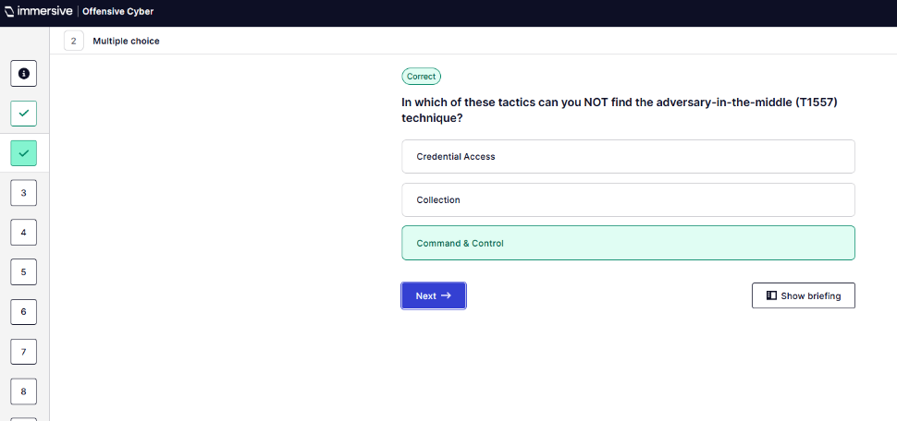
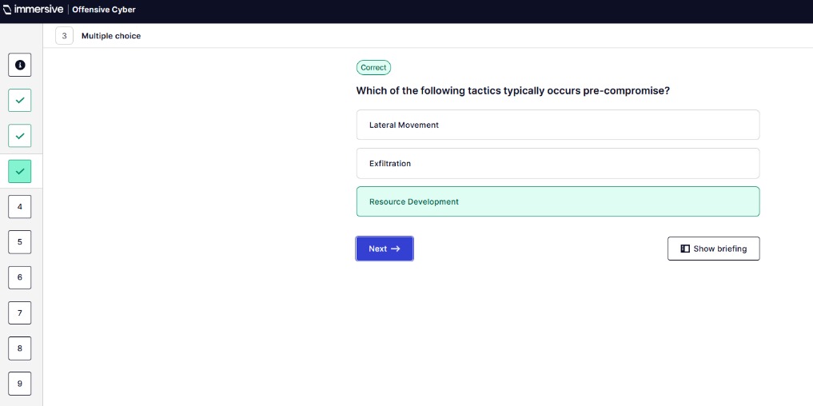
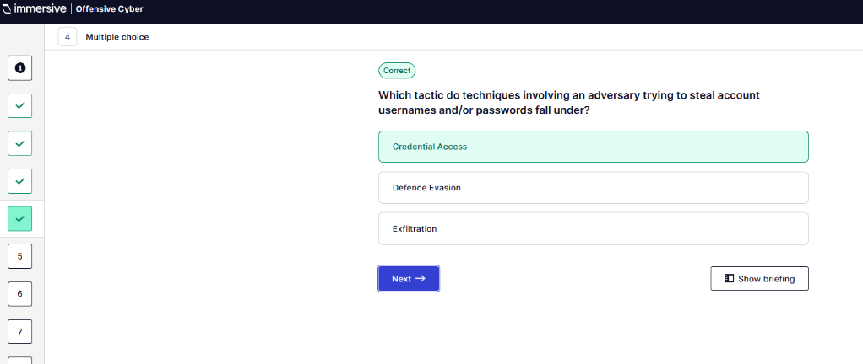
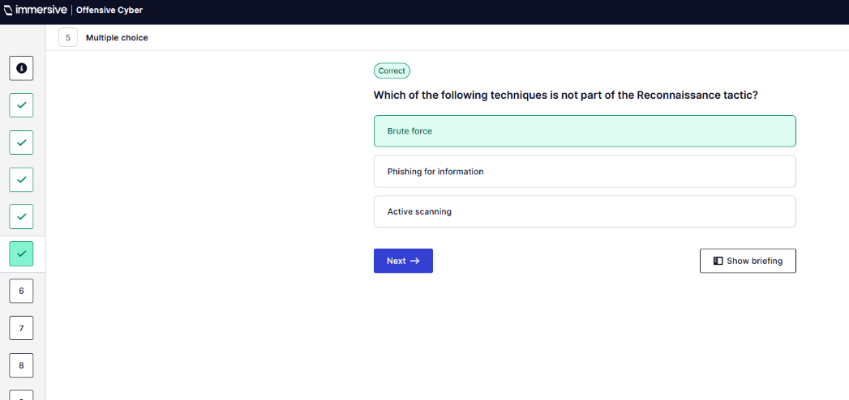
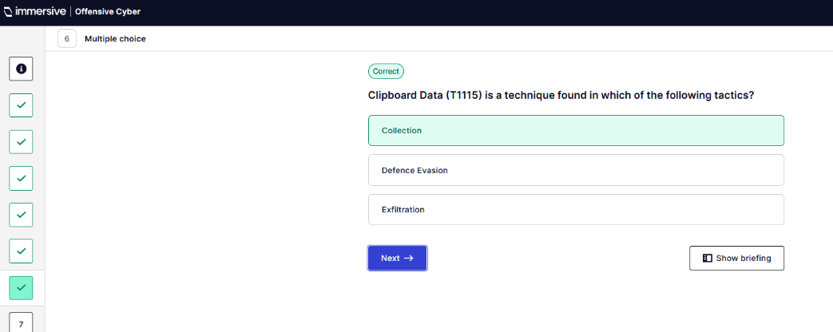
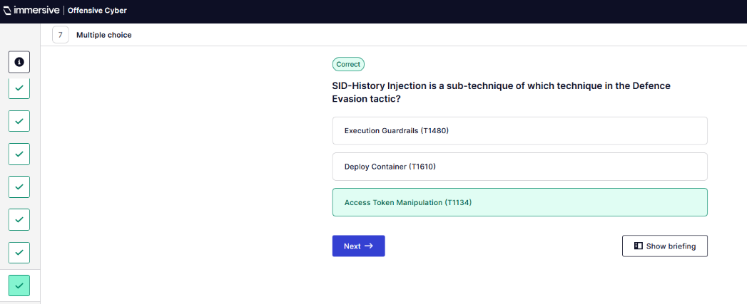
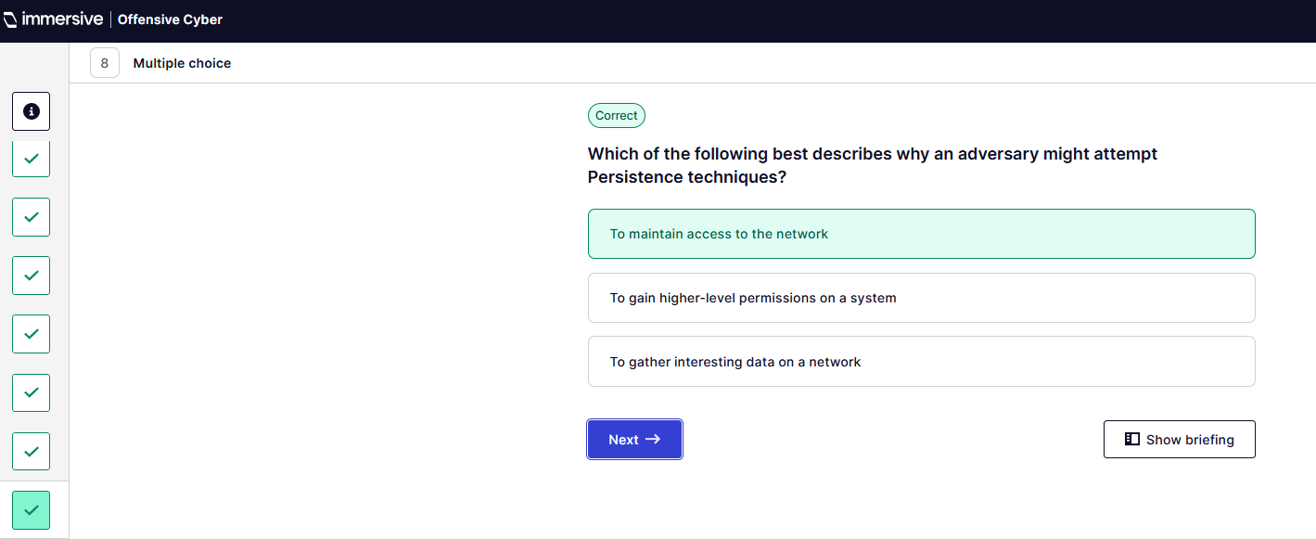
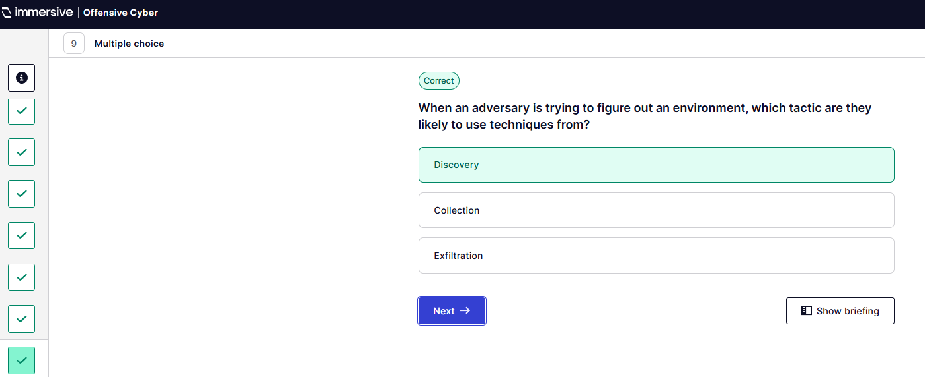
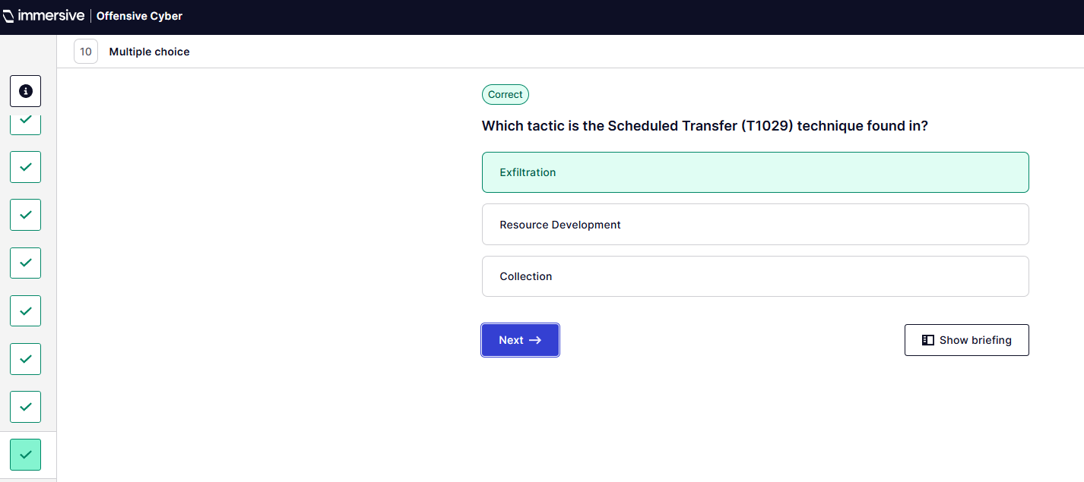
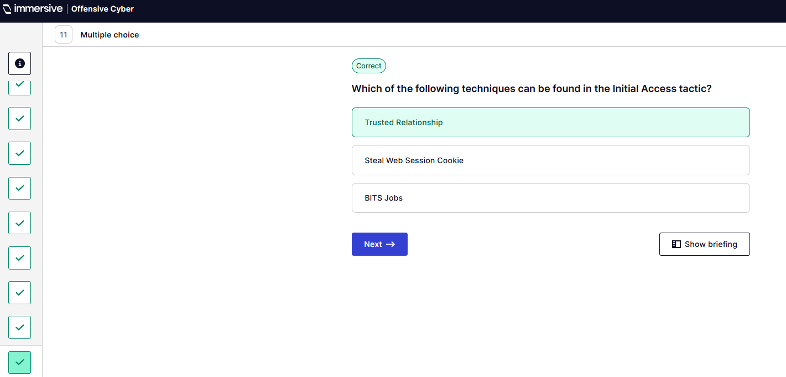
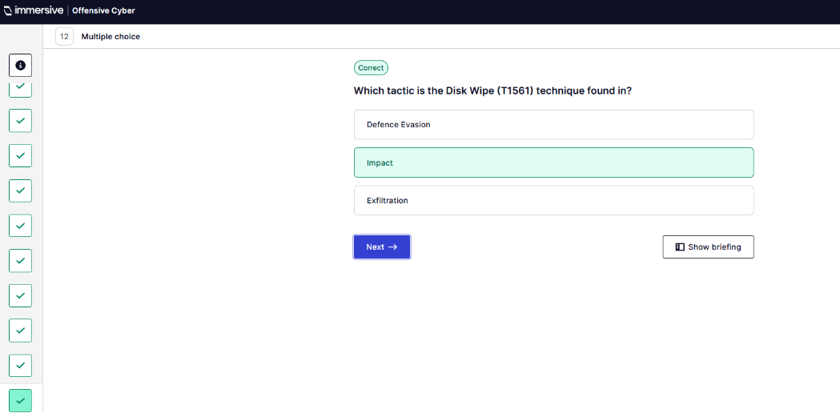
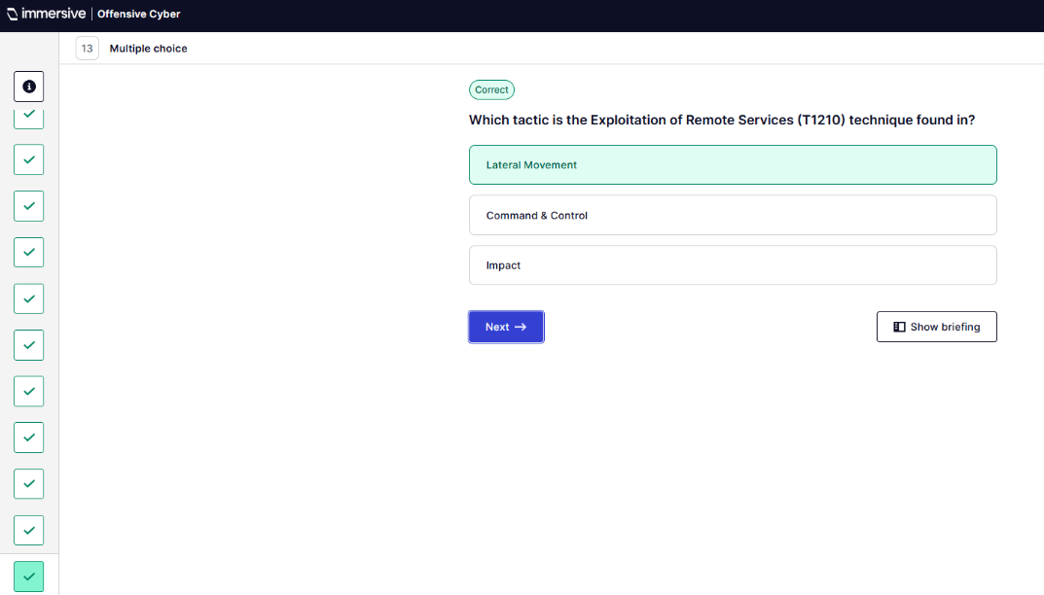
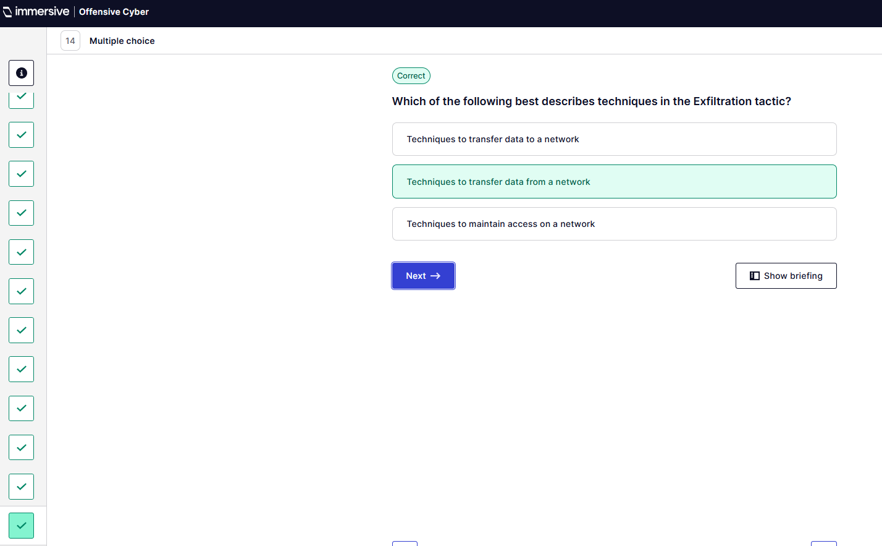
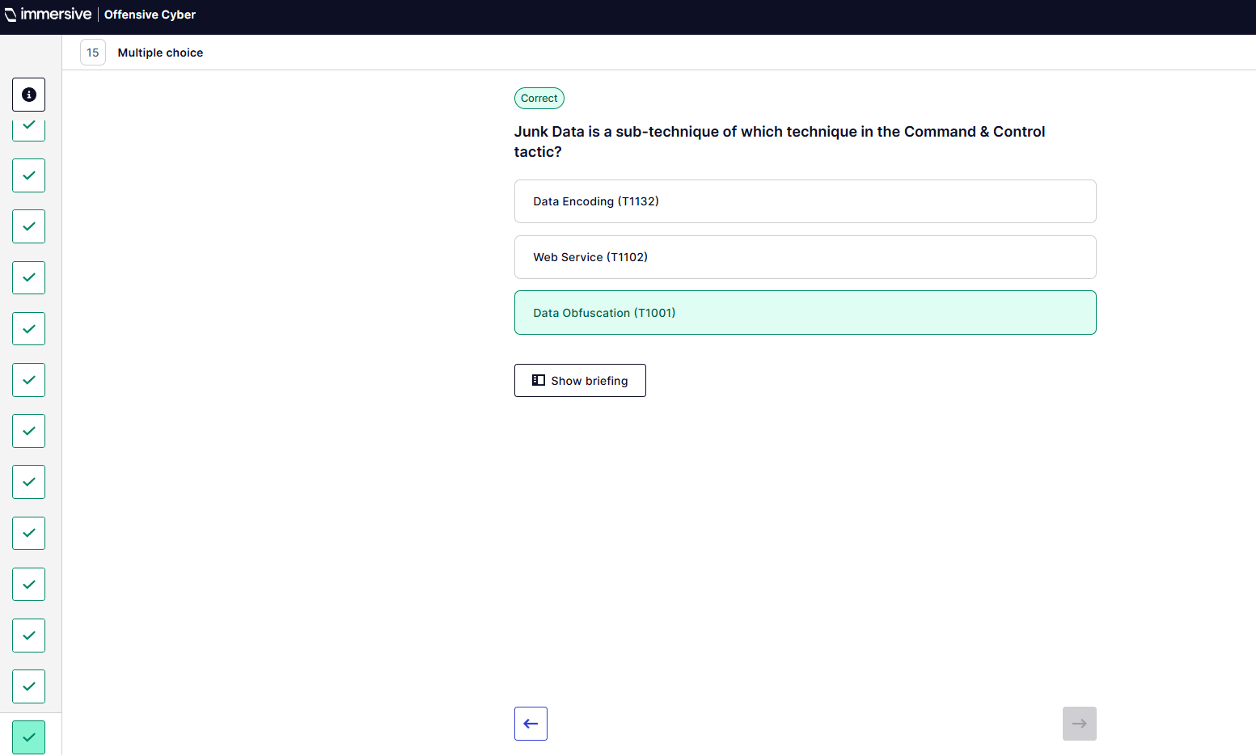
” (ImmersiveLabs MITRE ATT&CK, 2025).
- Introduction to Web App Hacking. “(ImmersiveLabs Web App Hacking, 2025)
  - Mapping Web Applications.
Q1 – Navigate to target site.
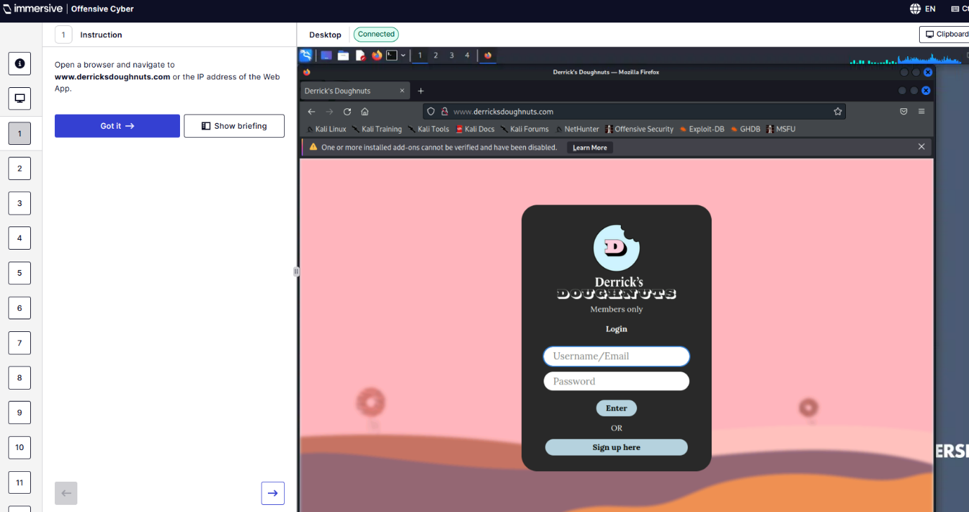
Q2 – Create account.
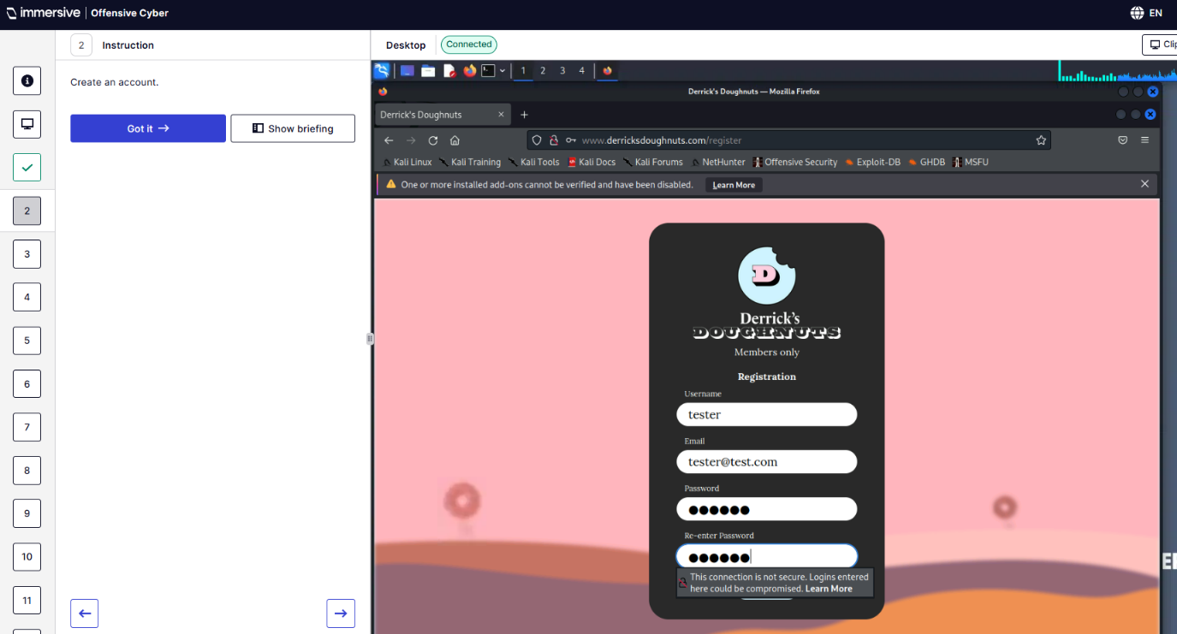
Q4 – What is the minimum password length?
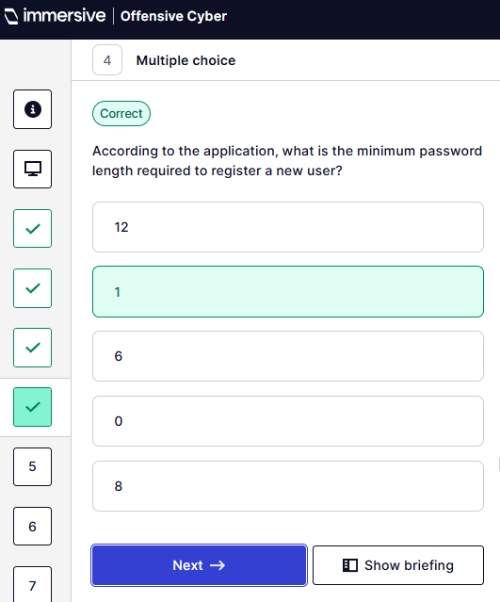
Q5 – Which page is out of scope for this pen-test?
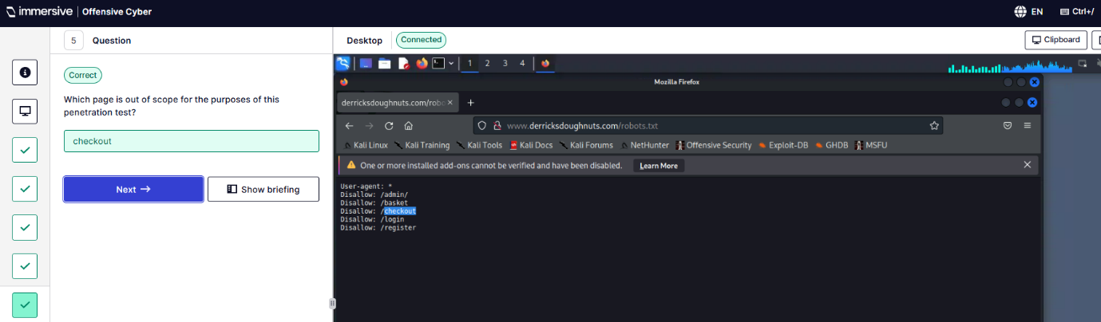
Q6 – What type of database does this application use?
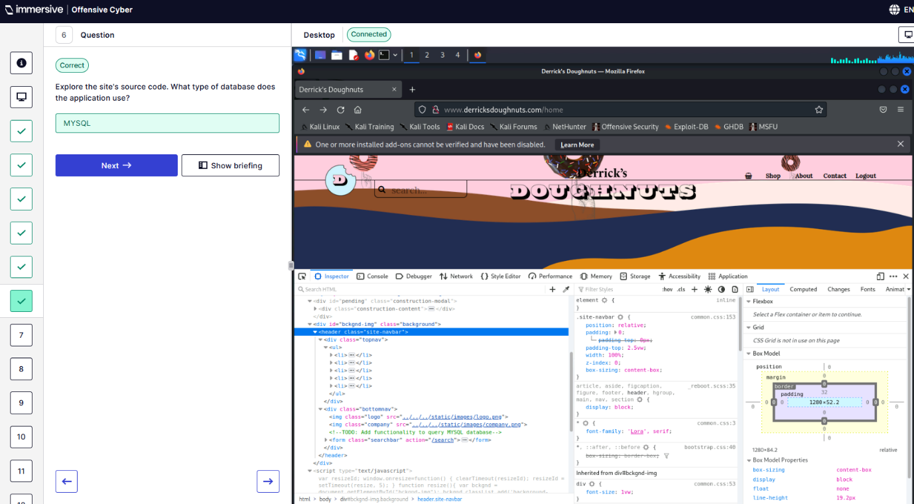
Q7 – What is the query string parameter?
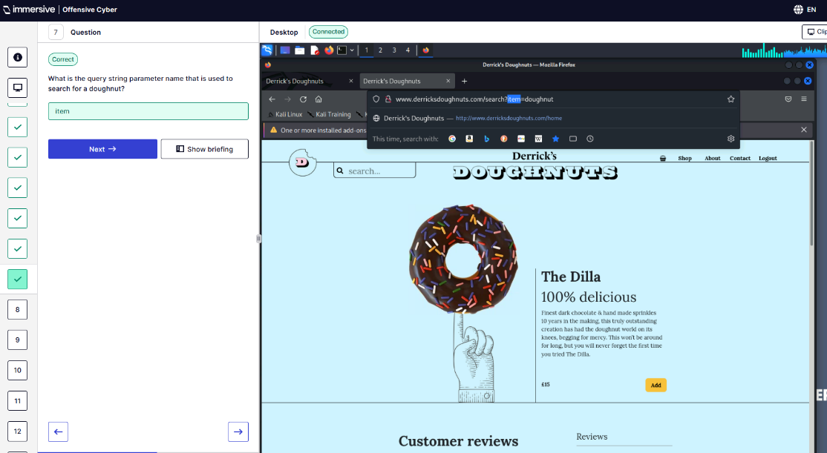
Q8 – What is the function to add an item to the basket?
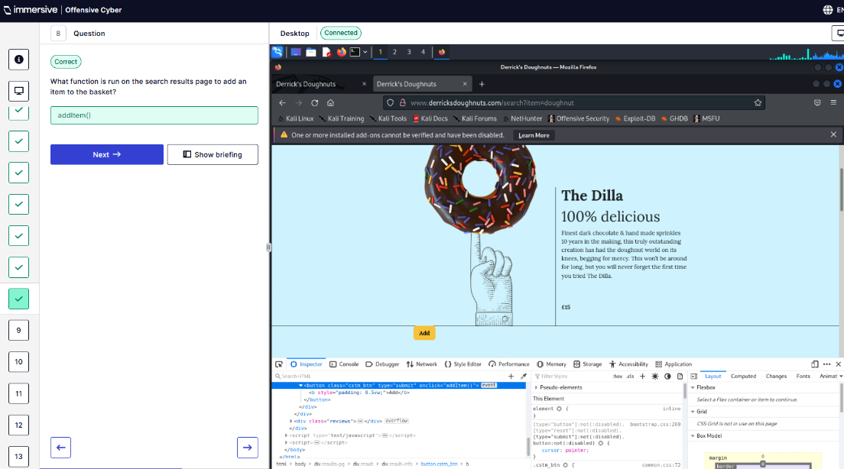
Q9 – How many HTML input tags are on the /shop page?
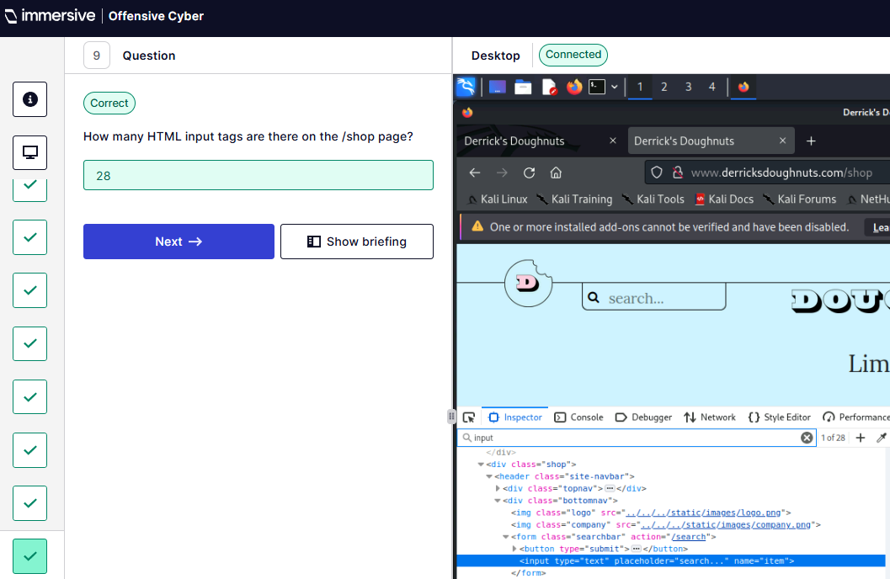
Q10 – What is the name of the cookie in the browser?
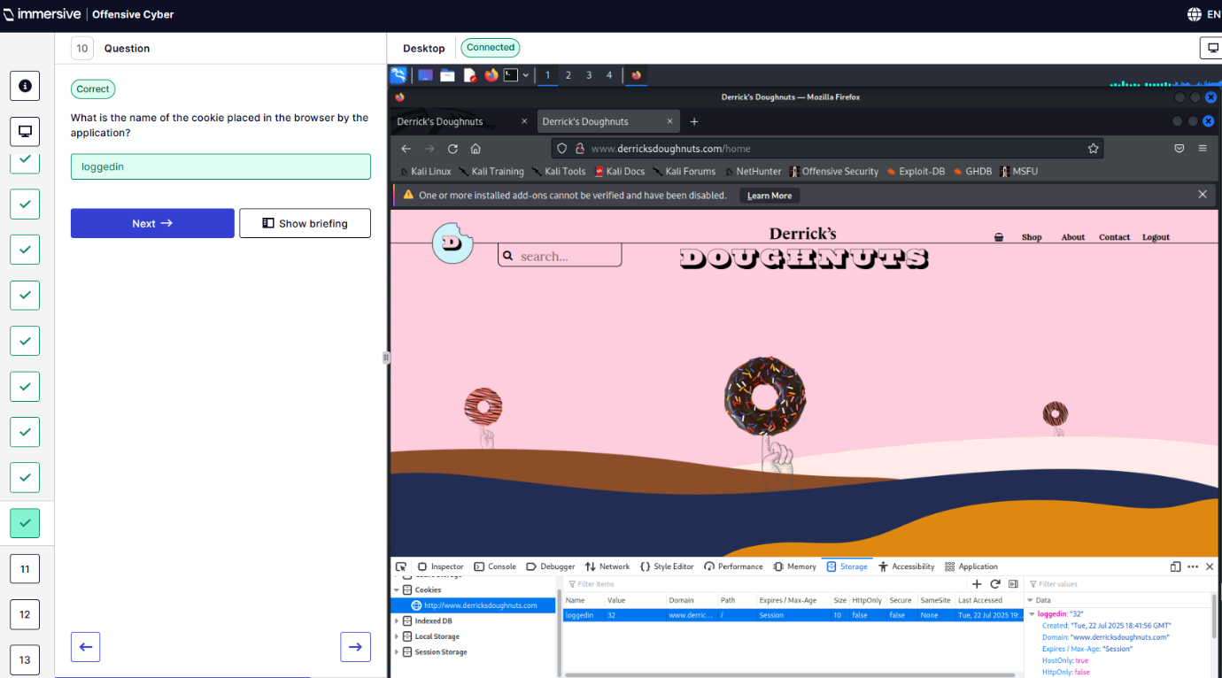
Q11 - Which of the following pages is a web robot allowed to crawl?
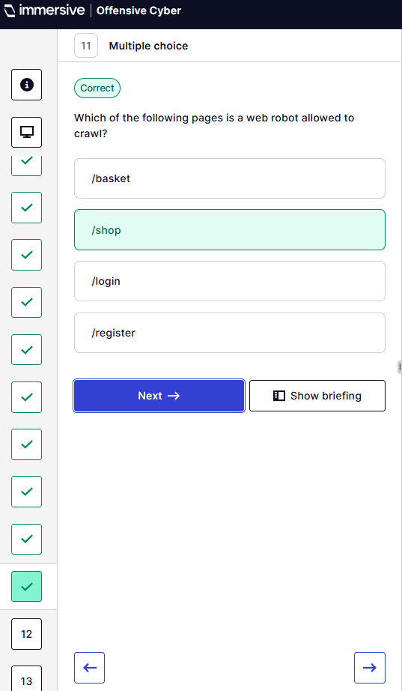
Q12 – There is a hidden page what is its name?
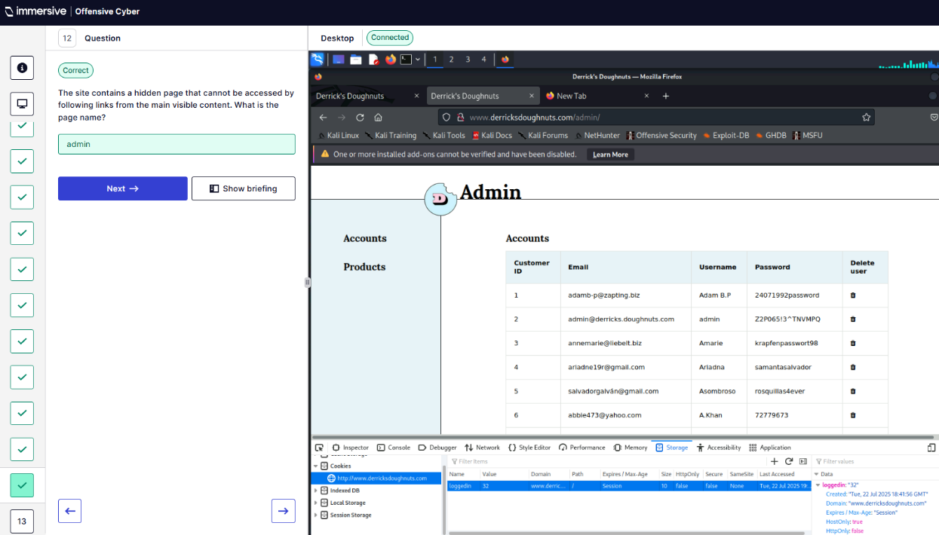
Q13 – Return to login page and login as admin.
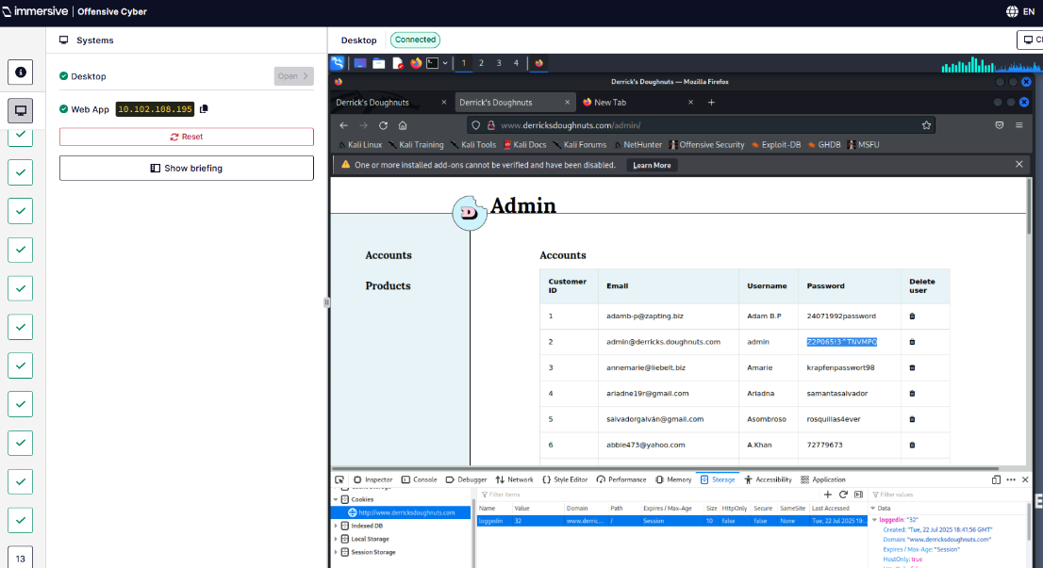
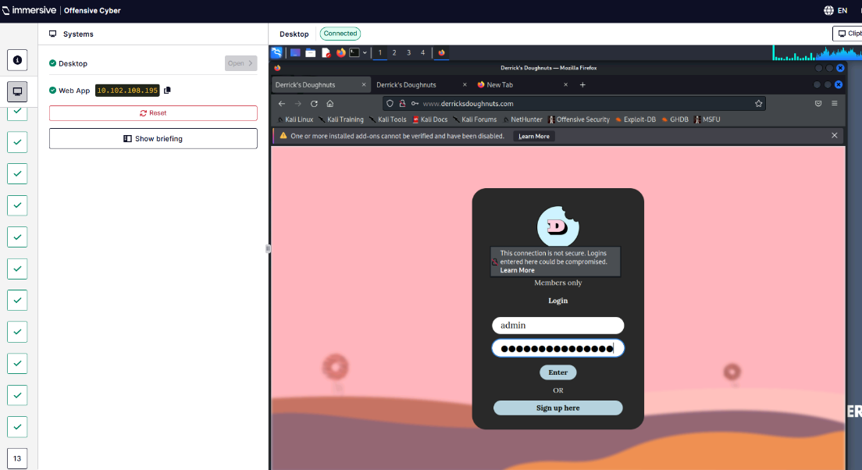
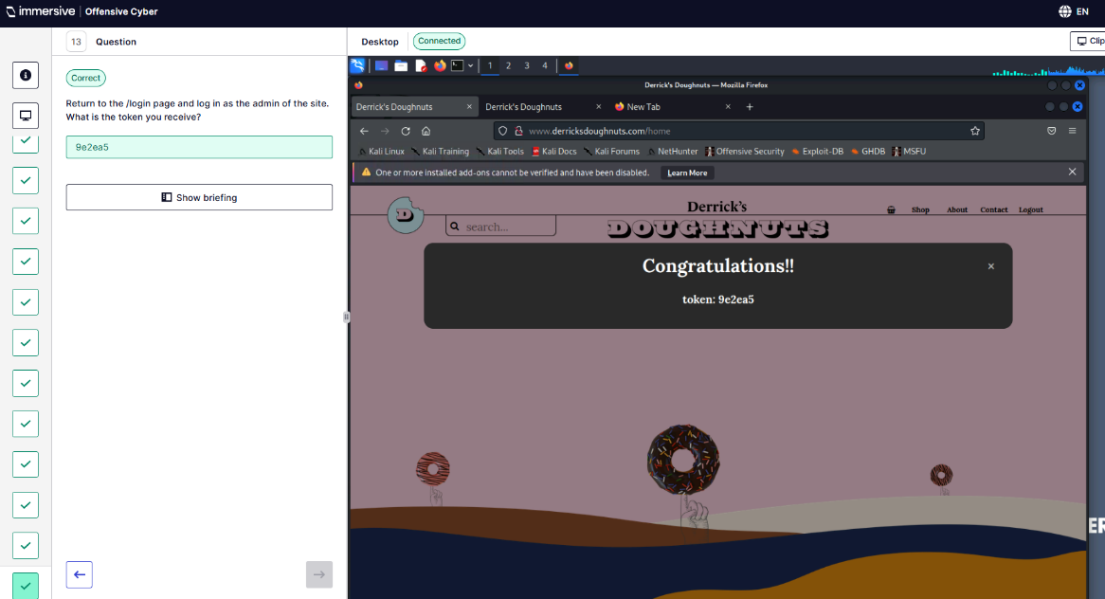
  - Dirbuster – Introduction.
Q1 – Navigate to target site.
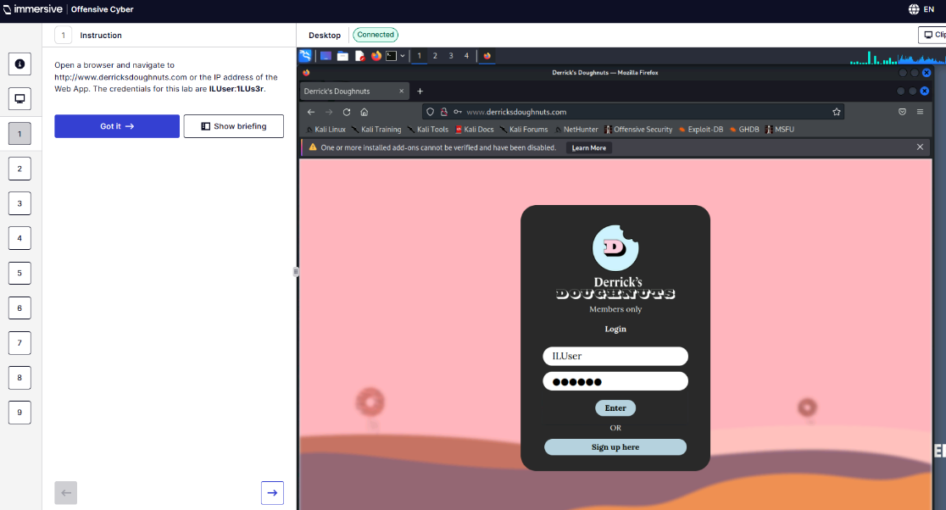
Q2 – Review target.
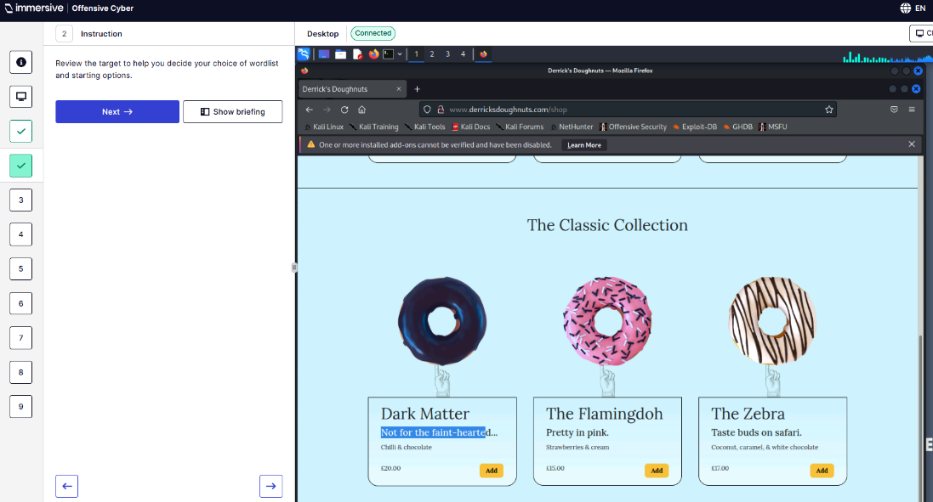
Q3 – Open DirBuster.
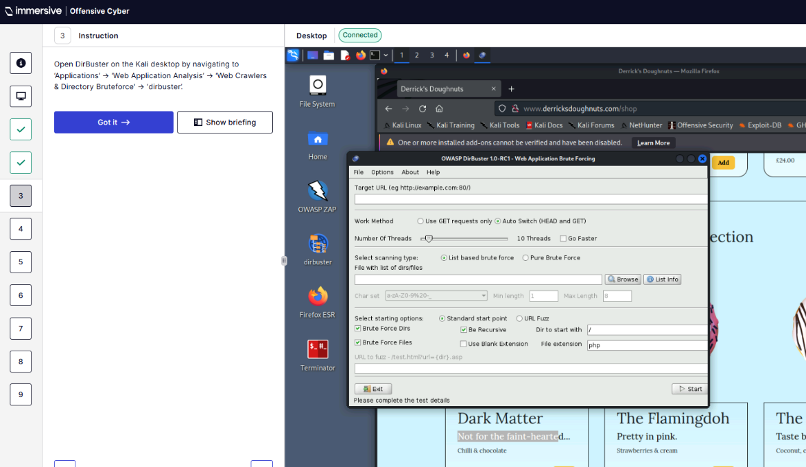
Q4 – Run DirBuster on target using a wordlist.
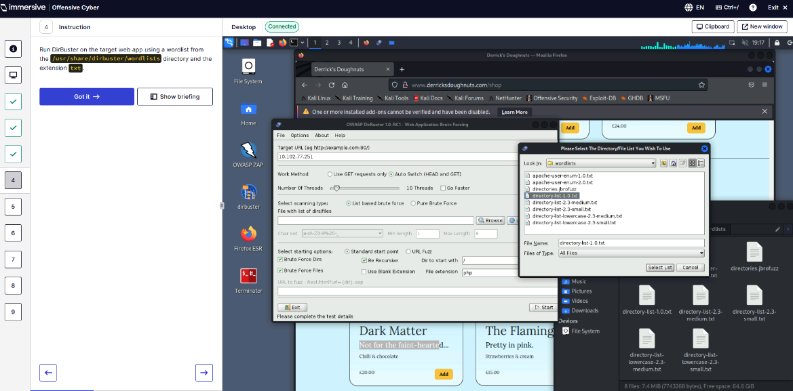
Q5 – Which wordlist should I use?
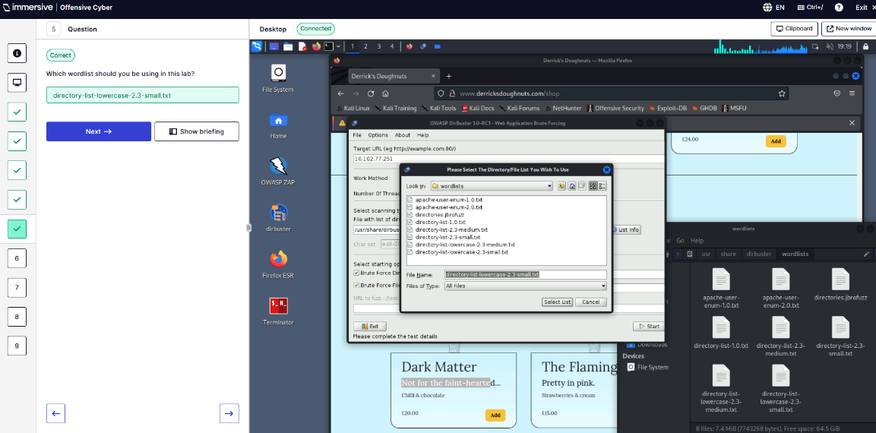
Q6 – What would produce the most results from the target?
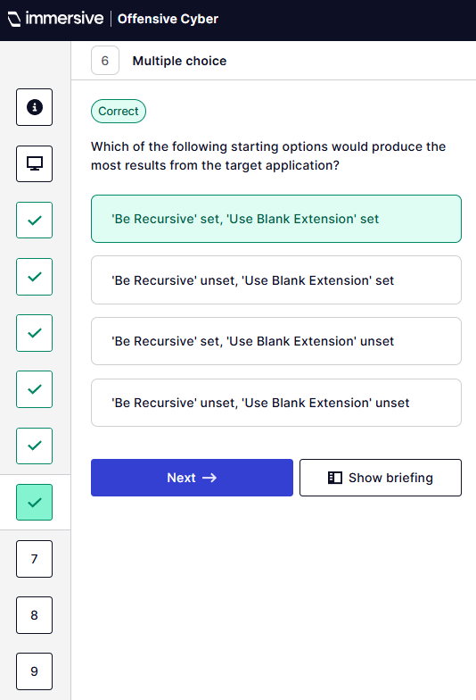
Q7 – What is the name of the txt file found from the scan?
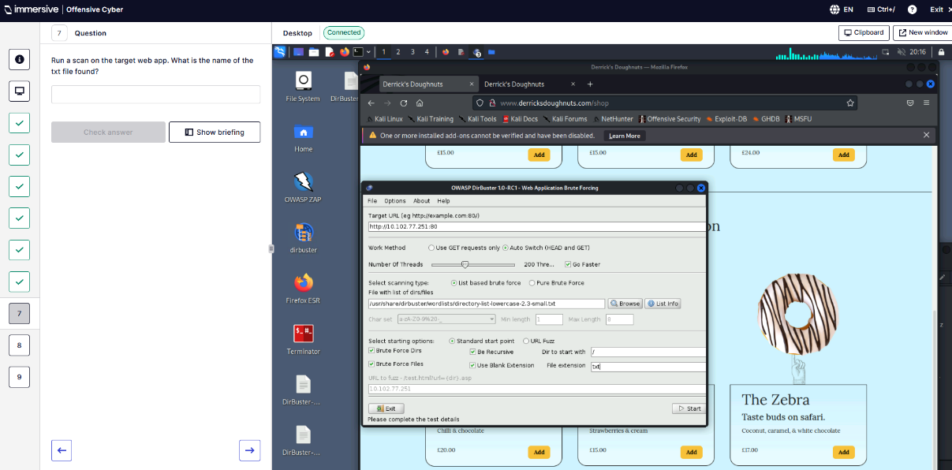
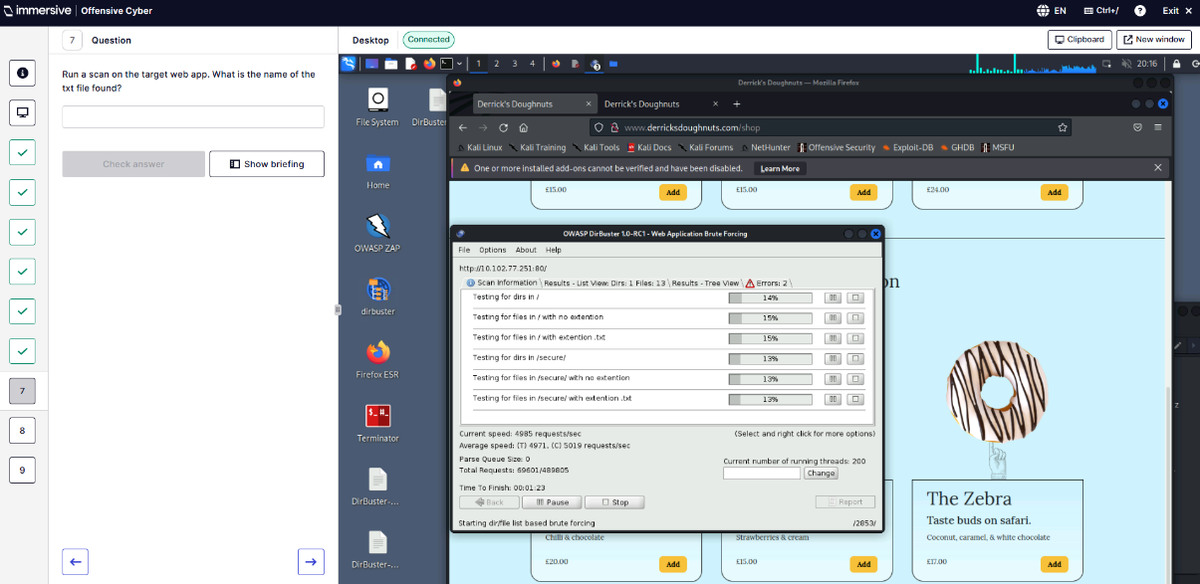
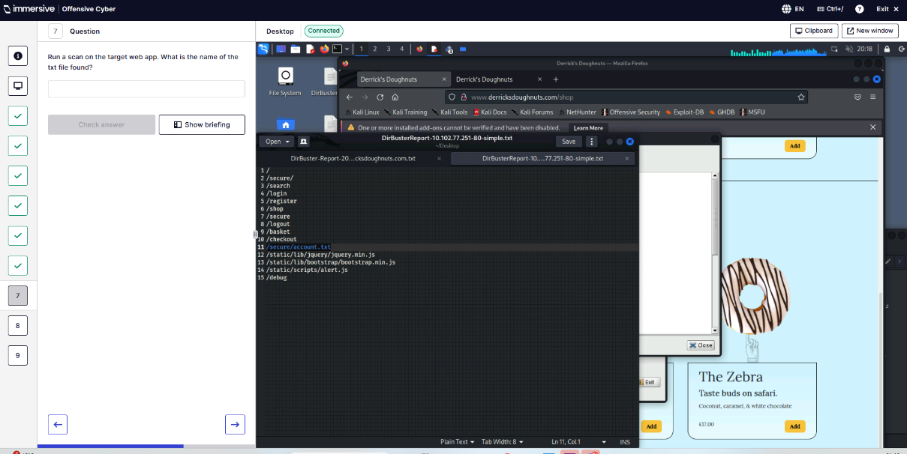
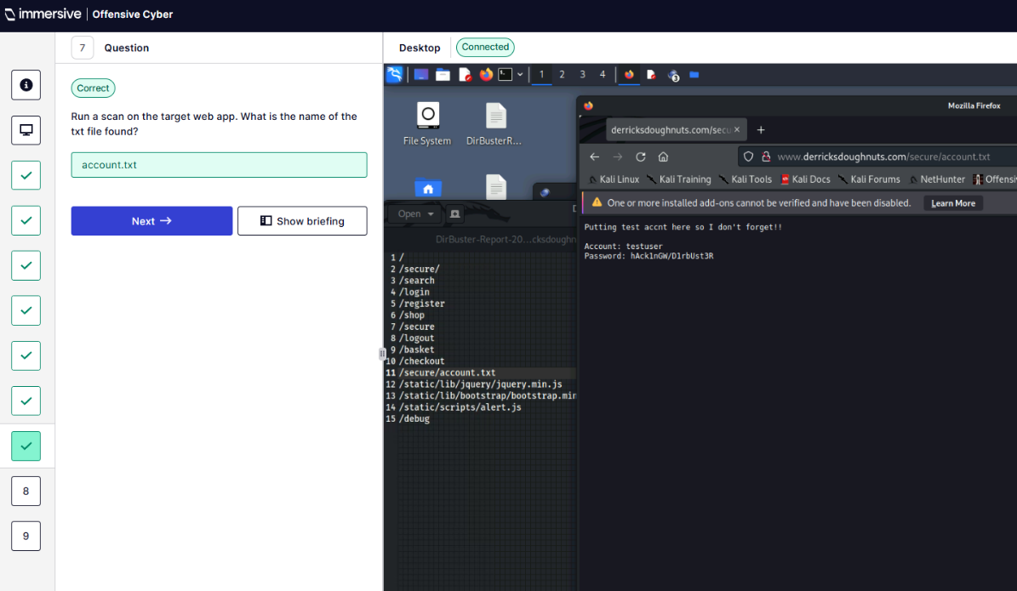
Q8 – What is username found?
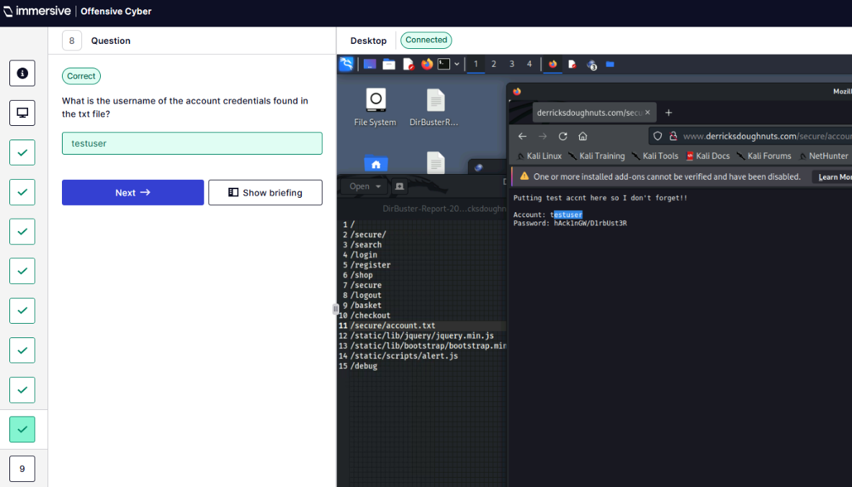
Q9 – Log in using found credentials. What is the token?
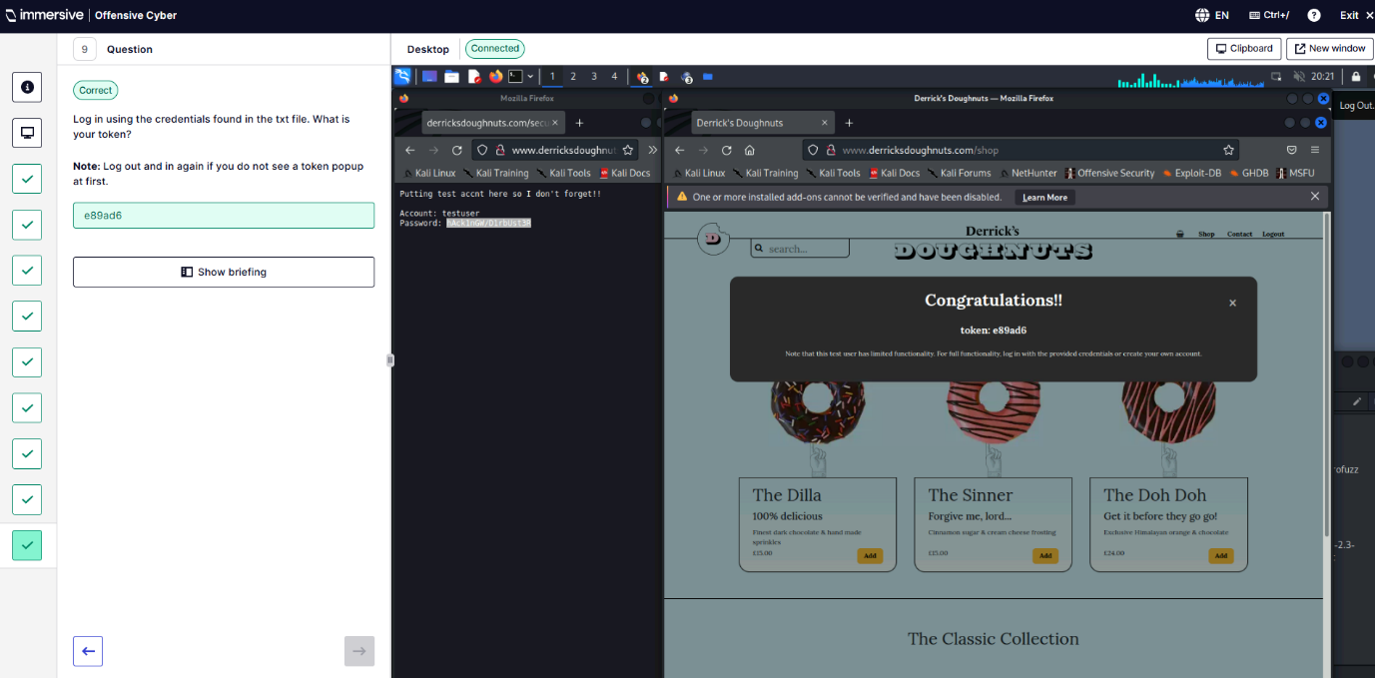
  - Page Source Review.
Q1 - Navigate to target.
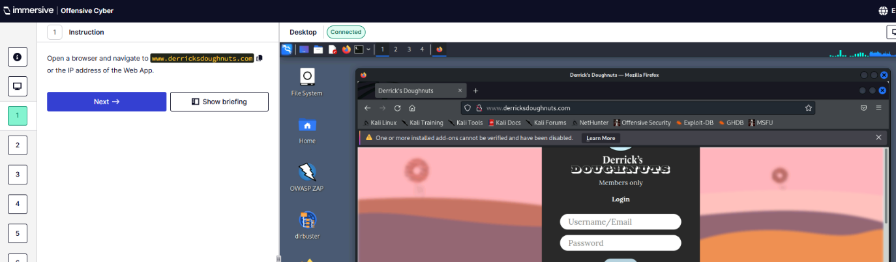
Q2 – Explore source code for comments.
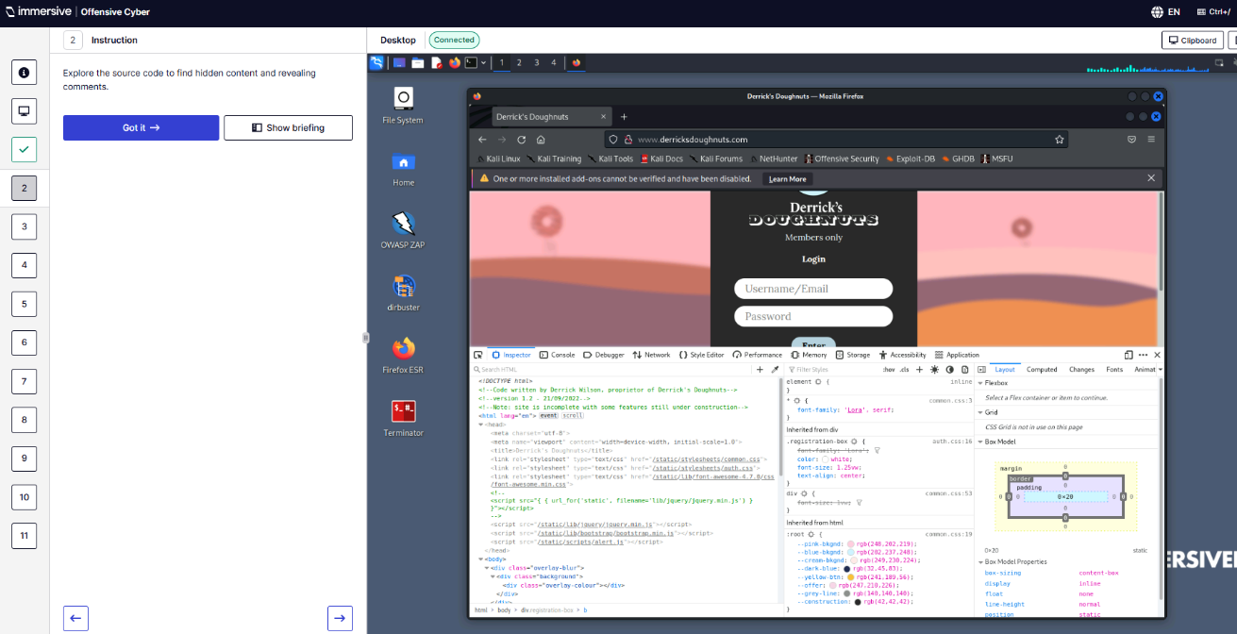
Q3 – What is the version number of website
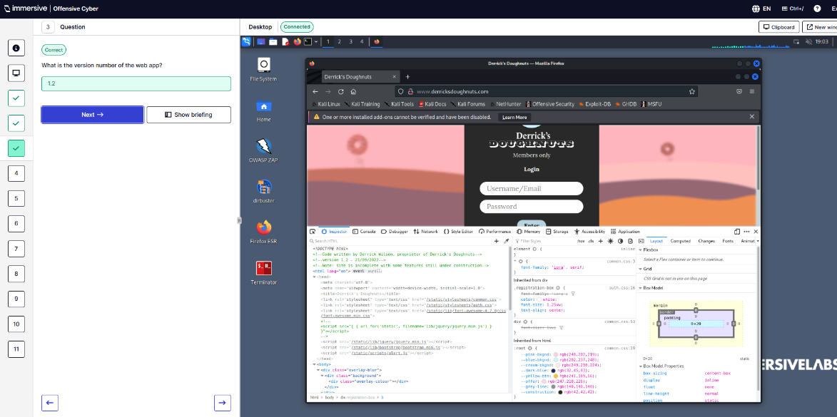
Q4 – What web framework is being used?
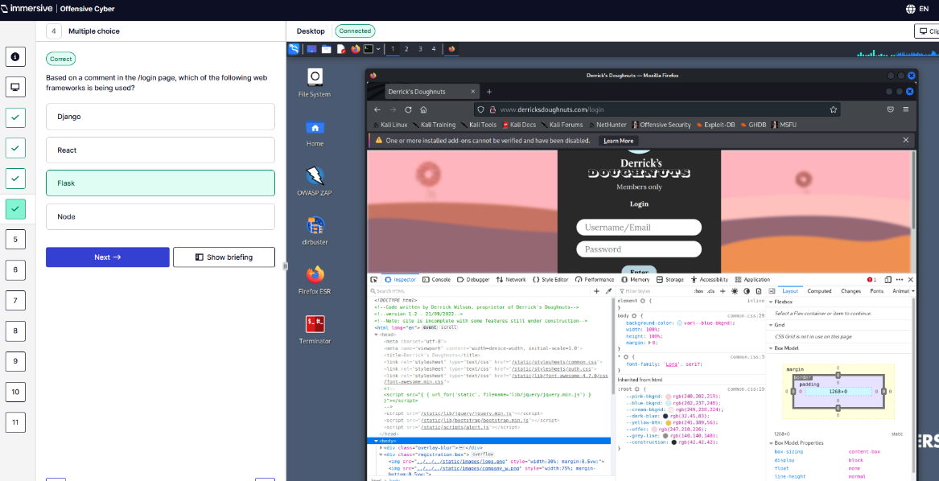
Q5 – Log in with credentials found in the comments. What is the token?
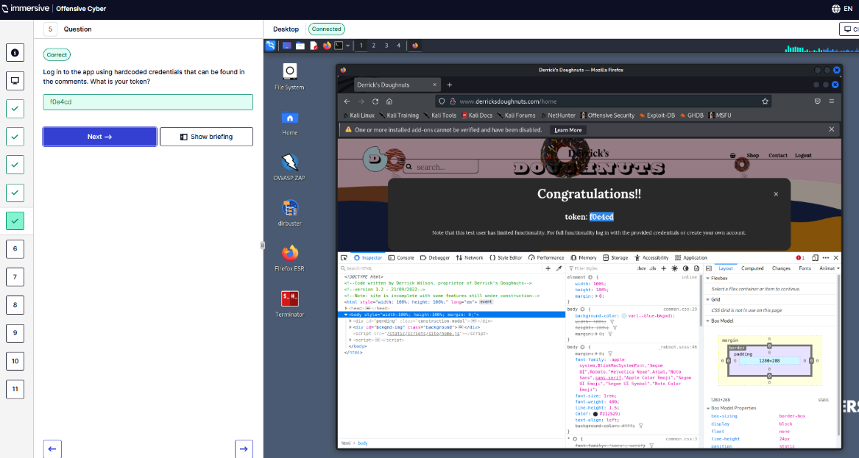
Q6 – Search for TODO comments. What database does the website use?
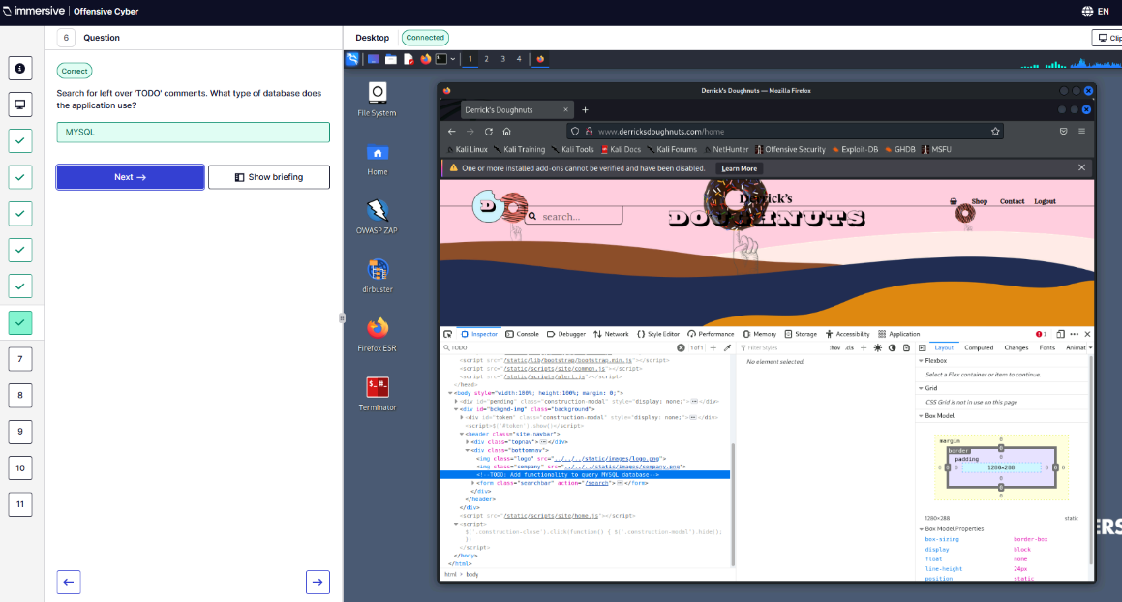
Q7 – What language is server-side written in?
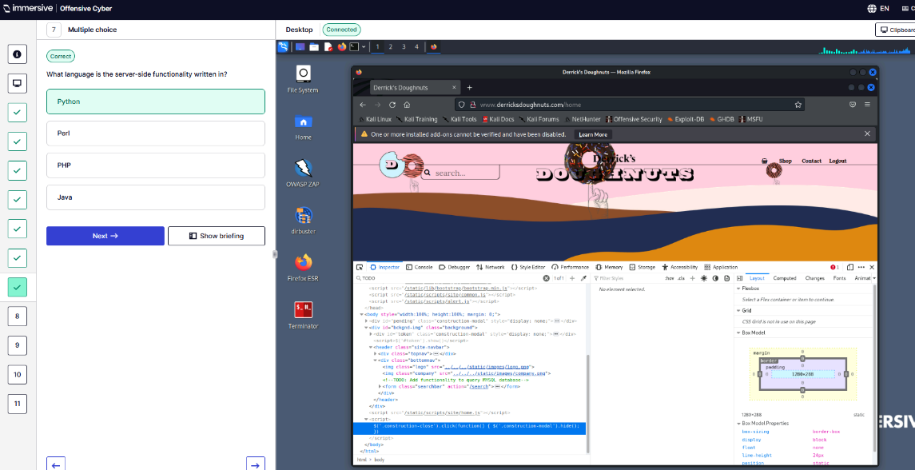
Q8 – What templating language is used?
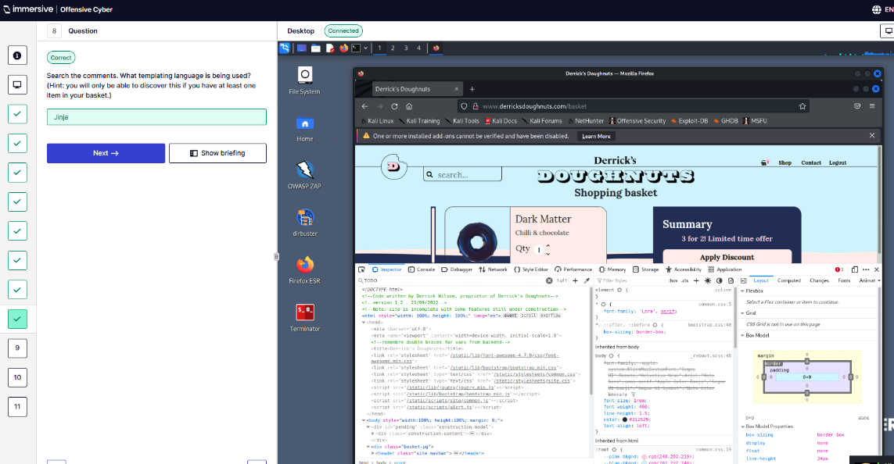
Q9 – What vulnerability can be found on the /shop page?
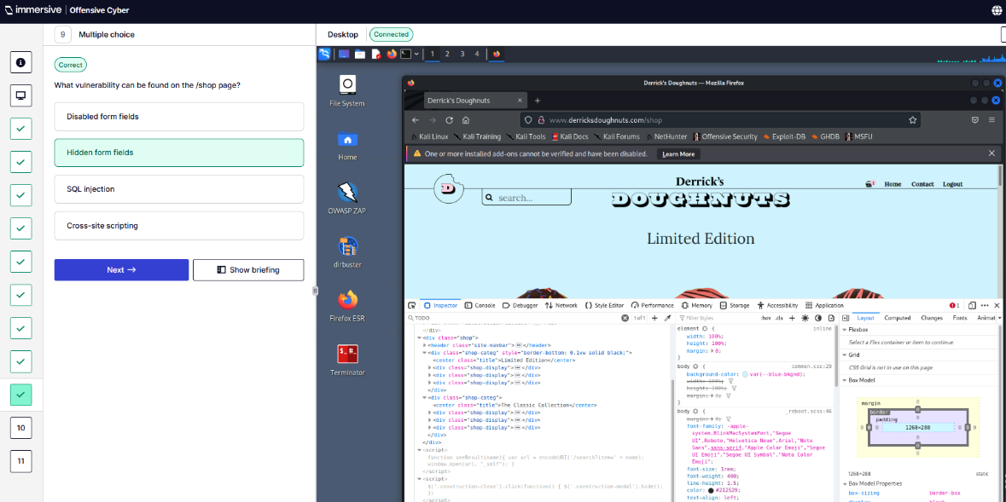
Q10 – What token is received?
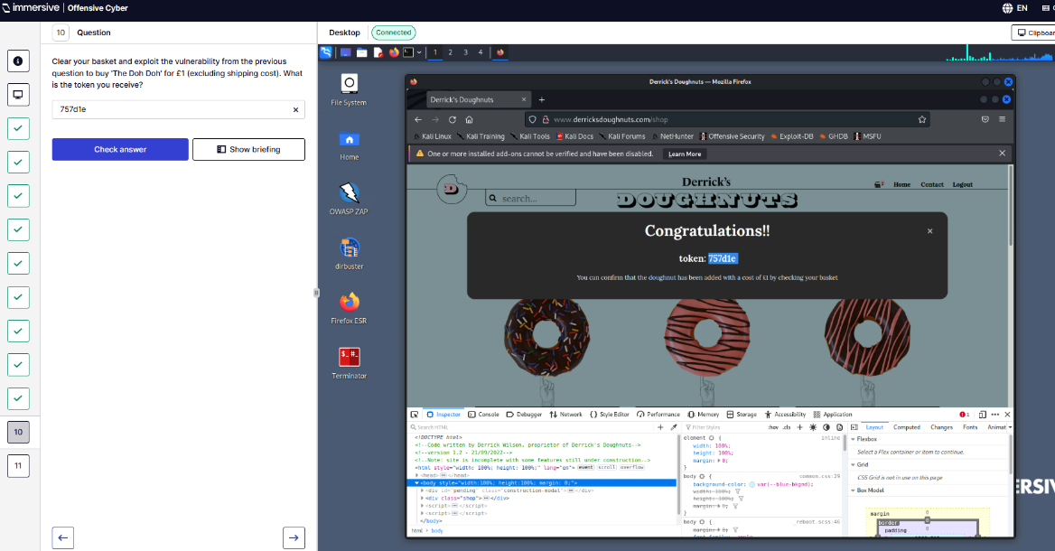
Q11 – Which JavaScript function does the developer highlight as having a security bug?
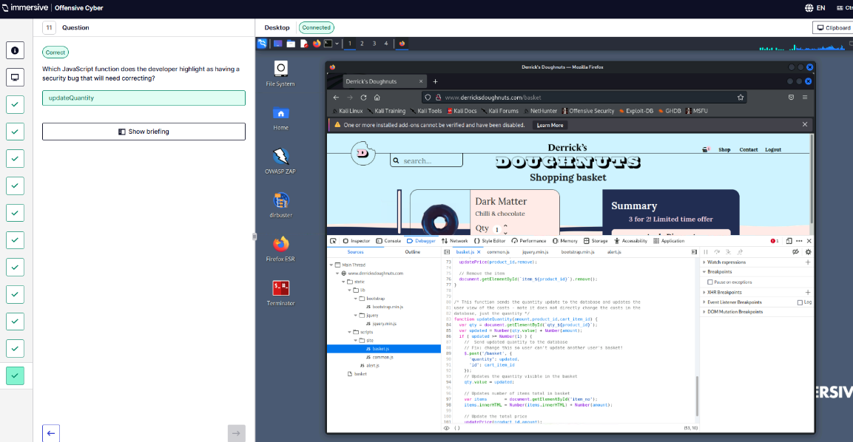
  - Introduction to OWASP ZAP.
Q1. What does ZAP spider not parse by default?
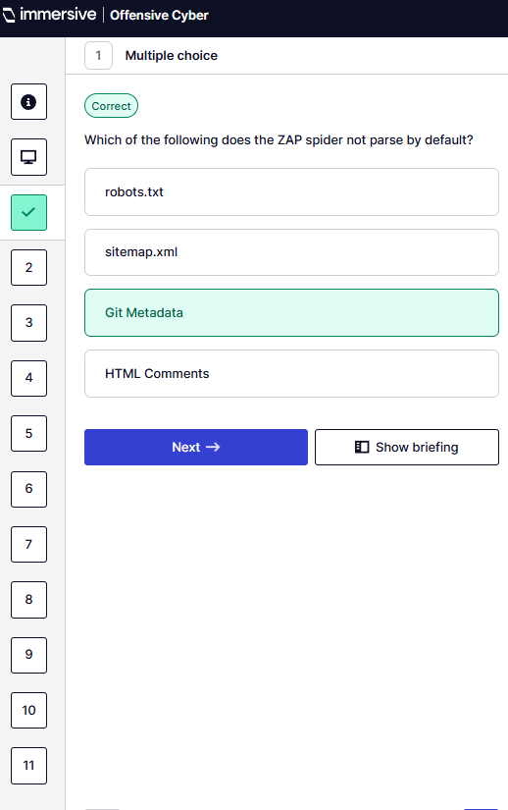
Q2. Configure Firefox proxy so ZAP can intercept.
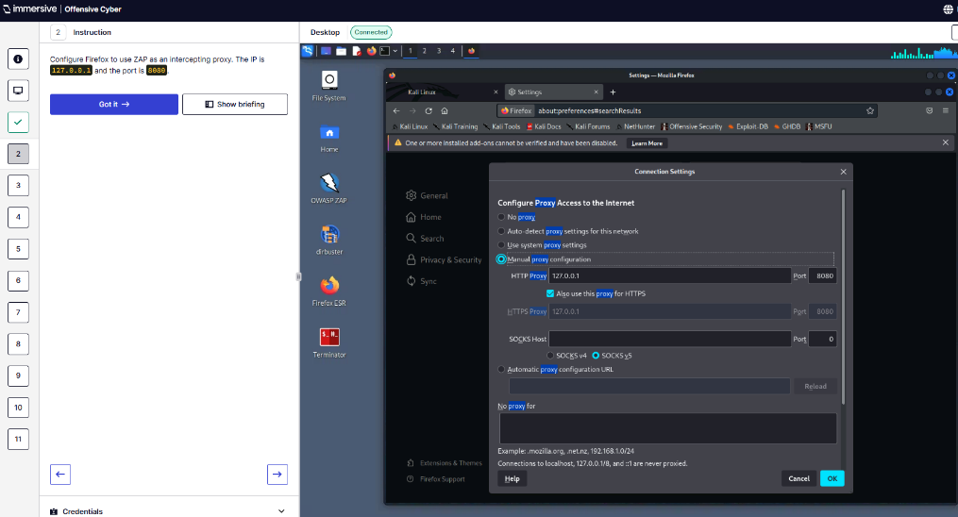
Q3 – Open ZAP
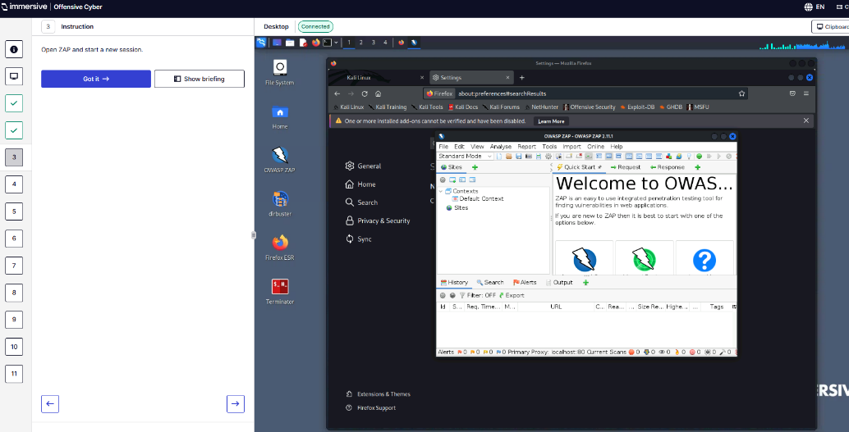
Q4 – Navigate to target webpage and login.
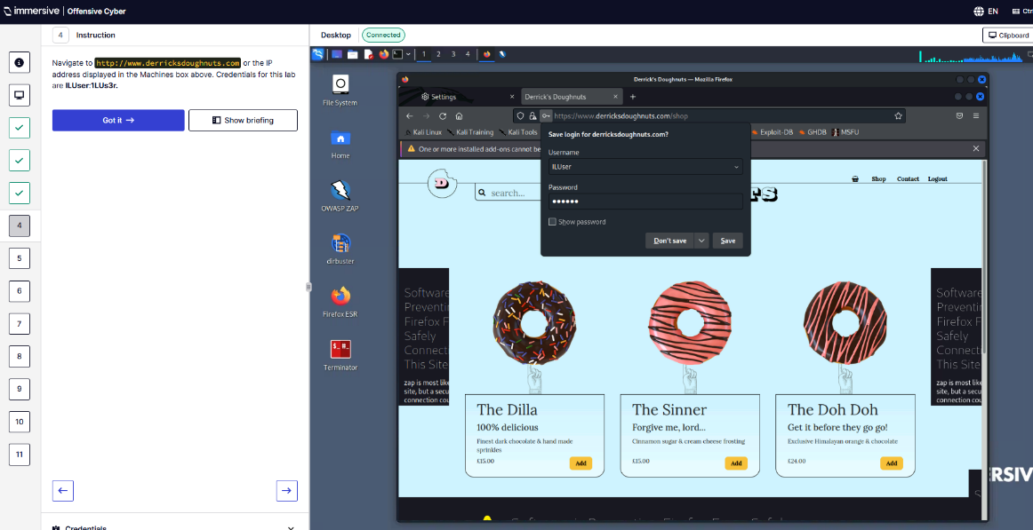
Q5 – Set up authentication in ZAP
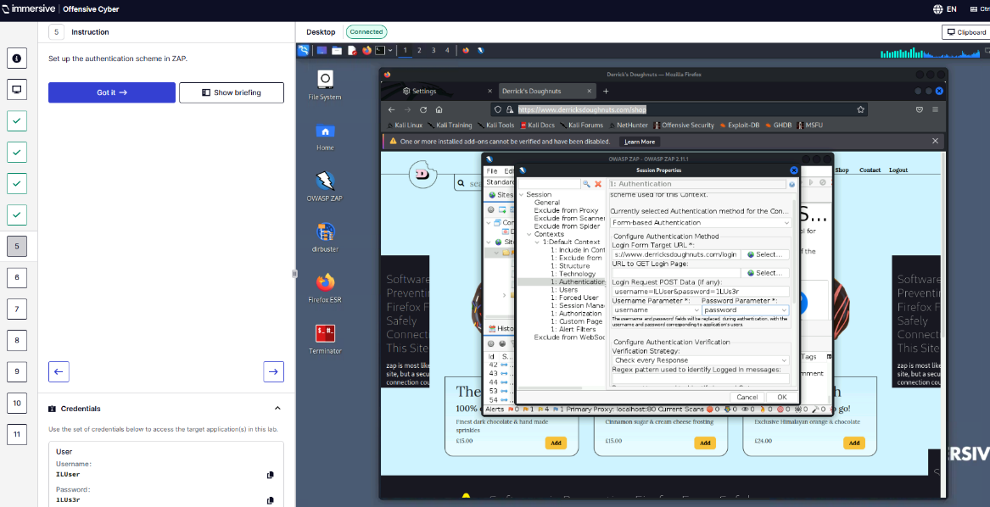
Q6 – Spider the webapp
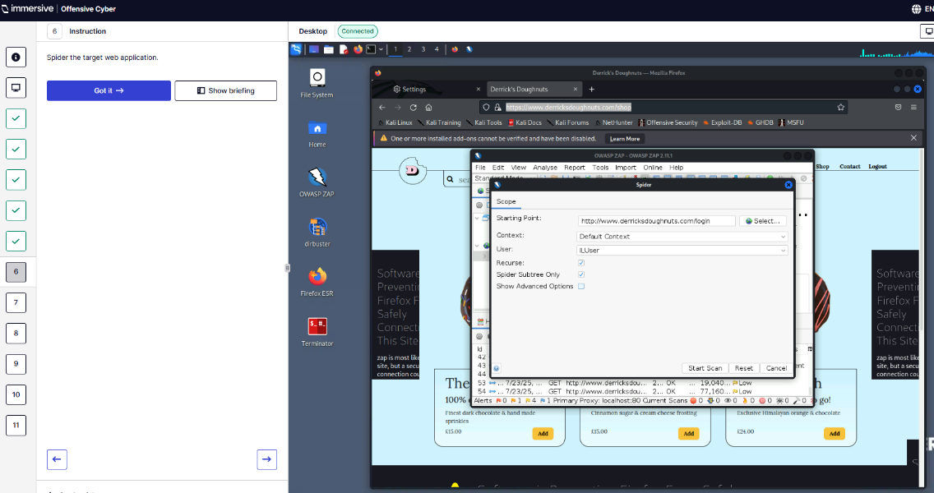
Q7 – What is the name of the admin page?
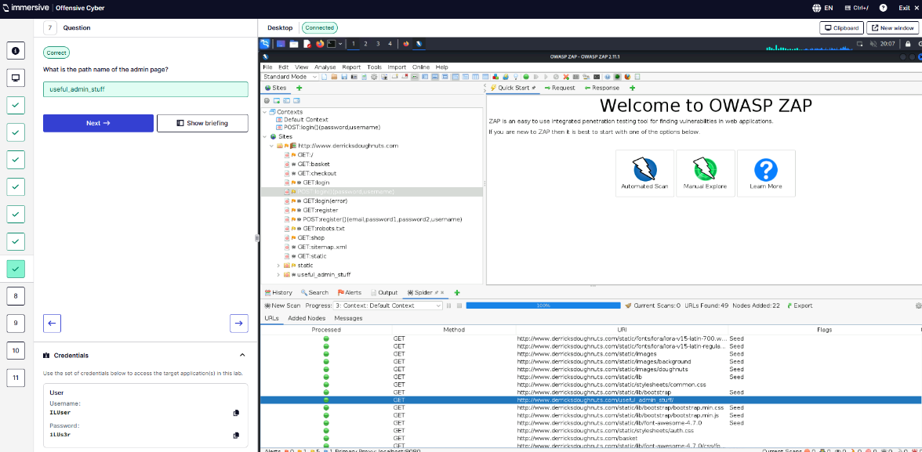
Q8 – What is the token from checkout_mockup? Found in the source code as a comment.
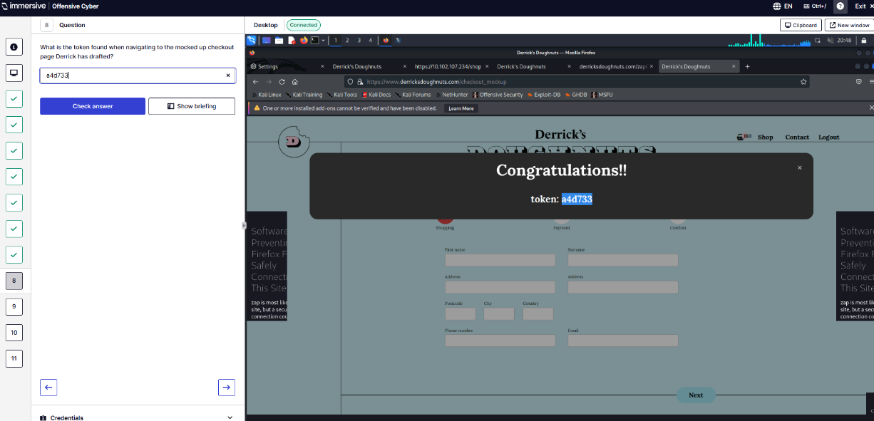
Q9 - Exclude add_basket from Default context on ZAP.
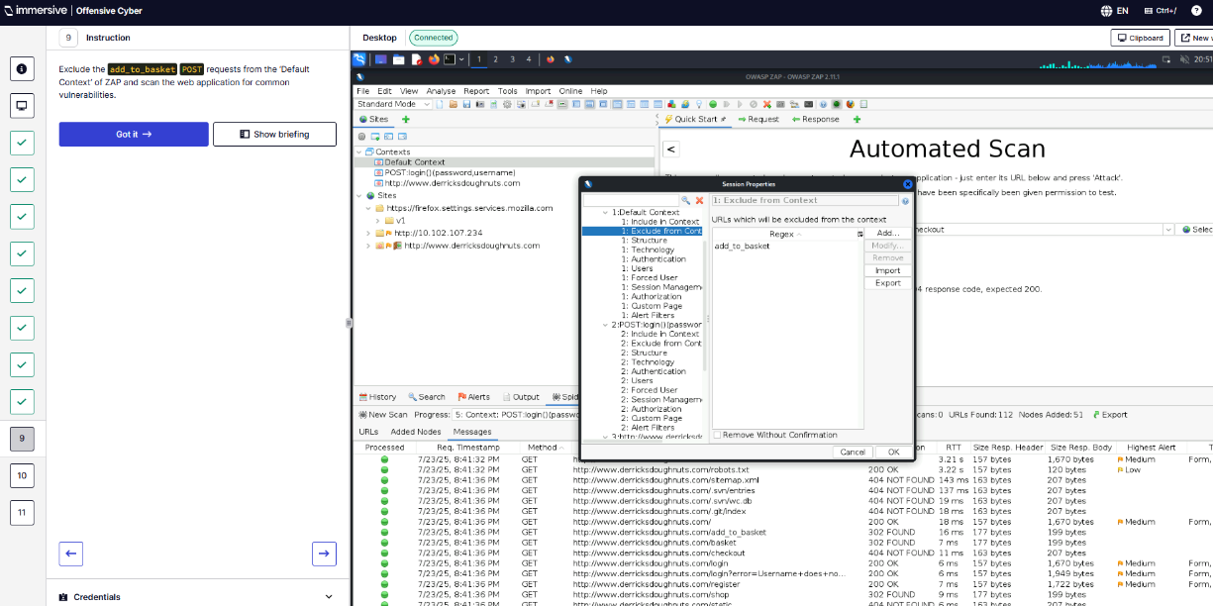
Q10 – Exploit XSS vulnerability with payload provided.
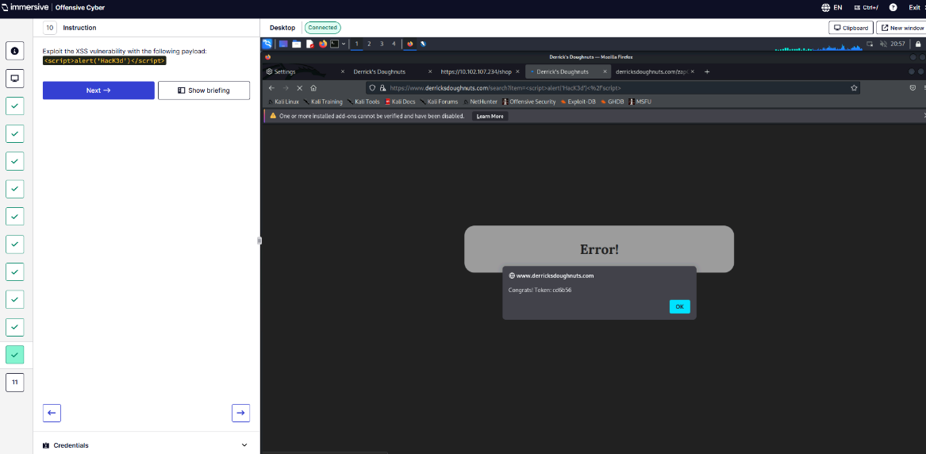
Q11 – What token is received?
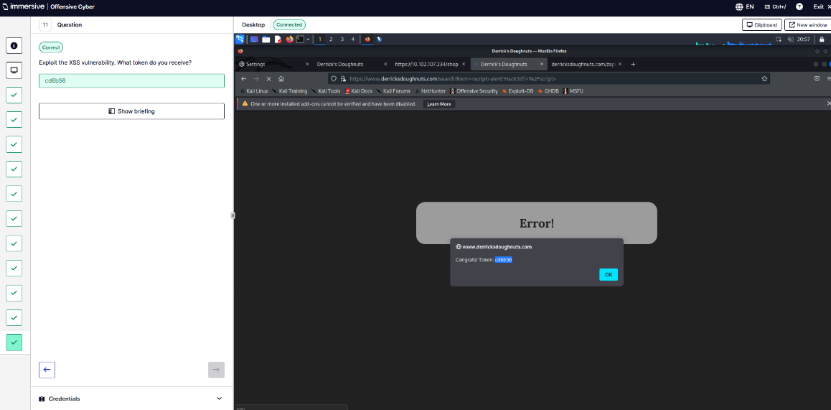
  - Bypassing HTTP Client-Side Controls.
Q1 – Navigate to target.
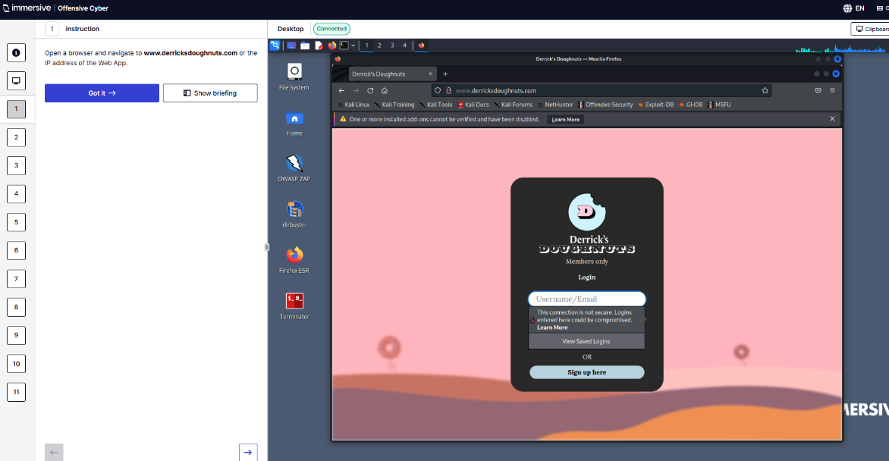
Q2 – Credentials
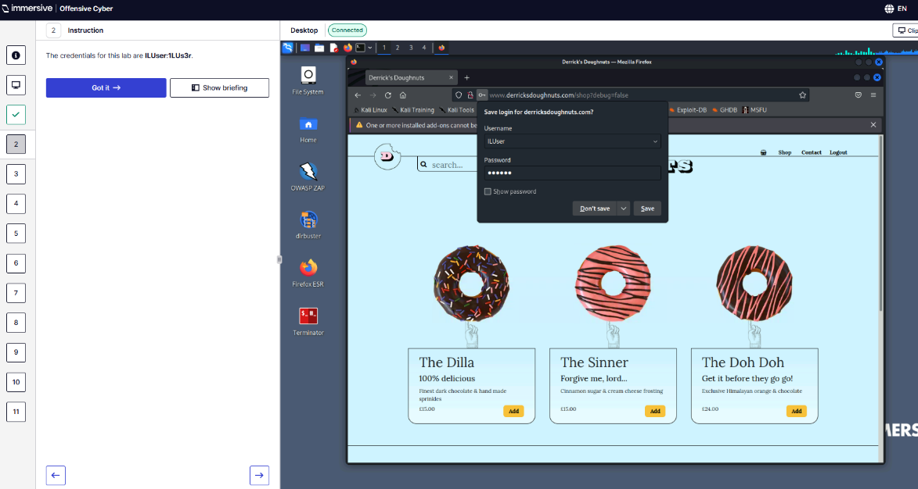
Q3 – Testing to see if I have access to /admin/, /hr, /userdetails.
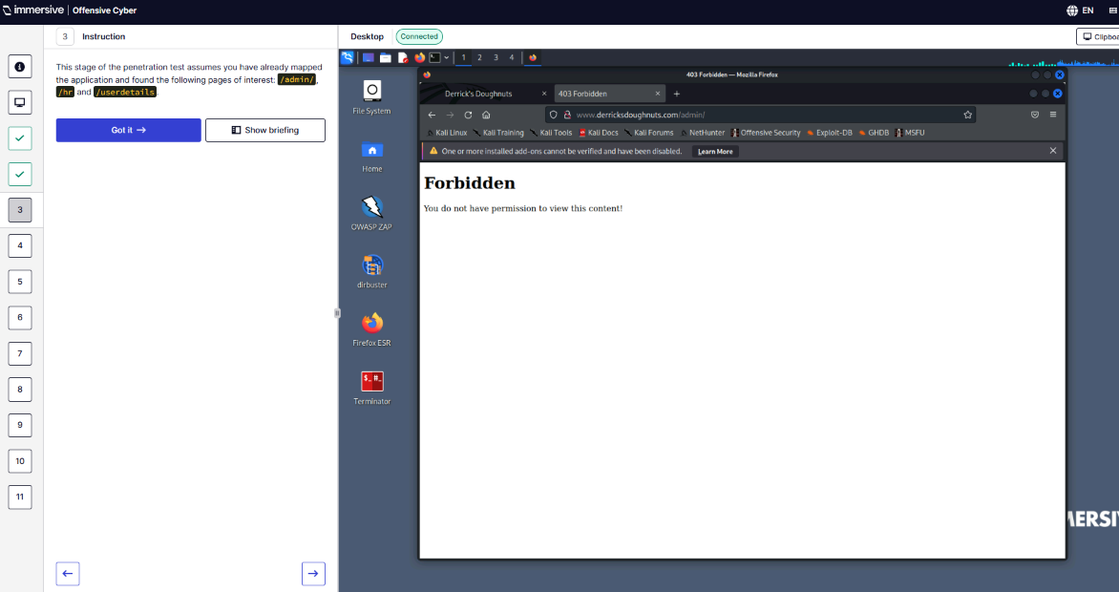
Q4 – Use ZAP or Inspect Element to adapt data transmitted.
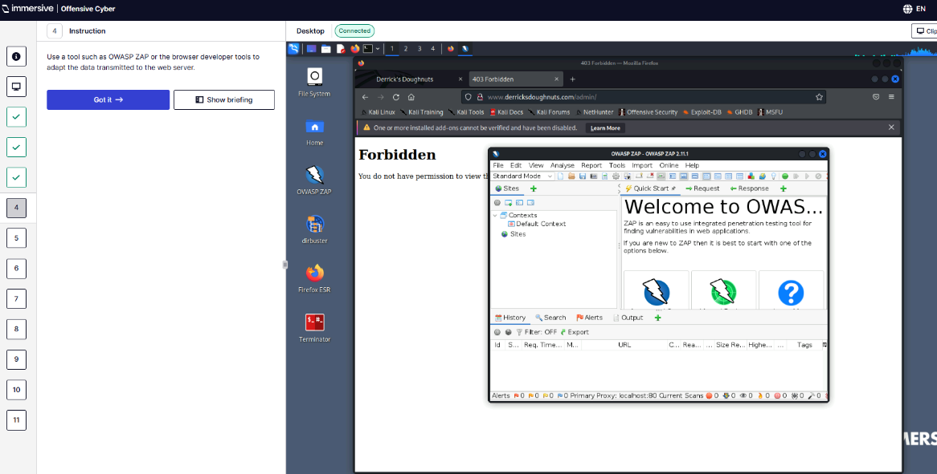
Q5 – What is the query string parameter on /shop page?
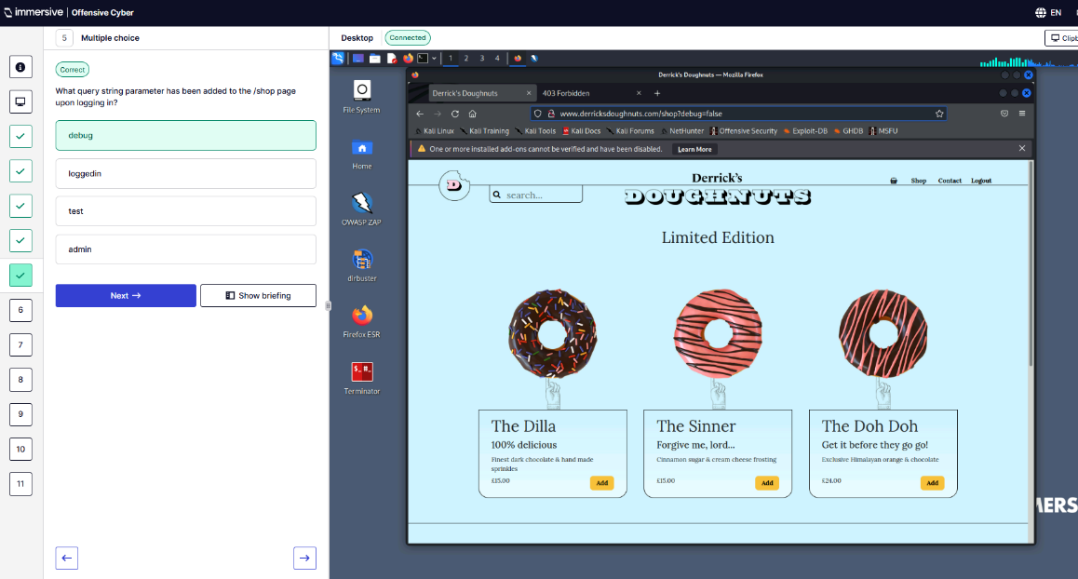
Q6 – What is the token when changing the parameter to true?
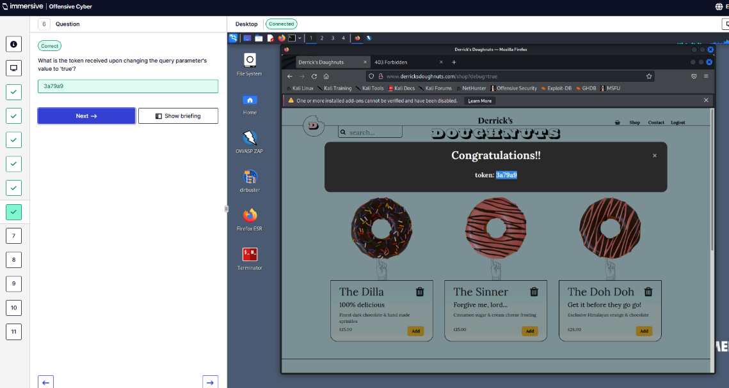
Q7 – What cookie has been placed in the webapp?
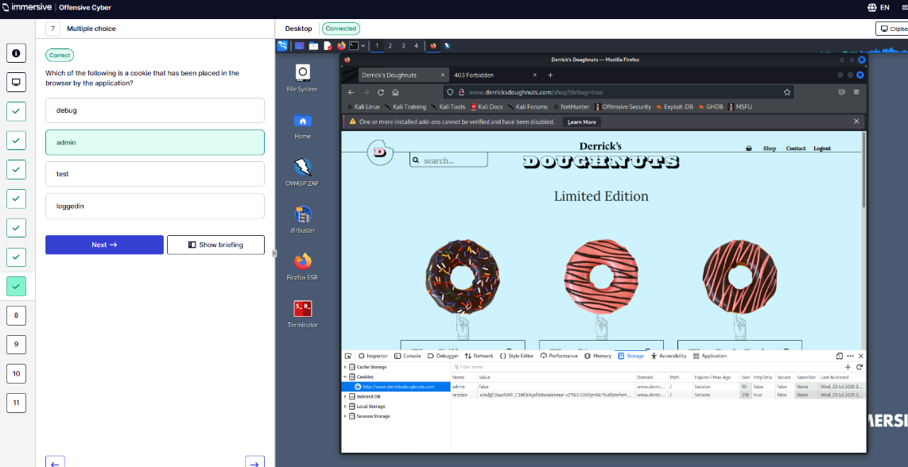
Q8 – Change the admin cookie to true to access /admin/ page. What is Jenny’s email?
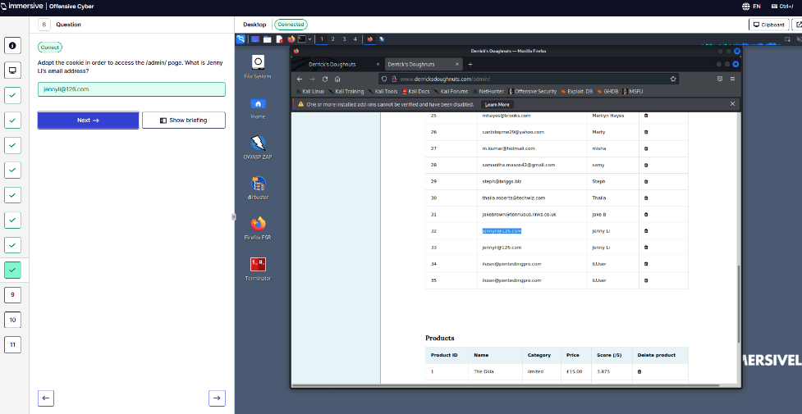
Q9 – Who has access to /userdetails?
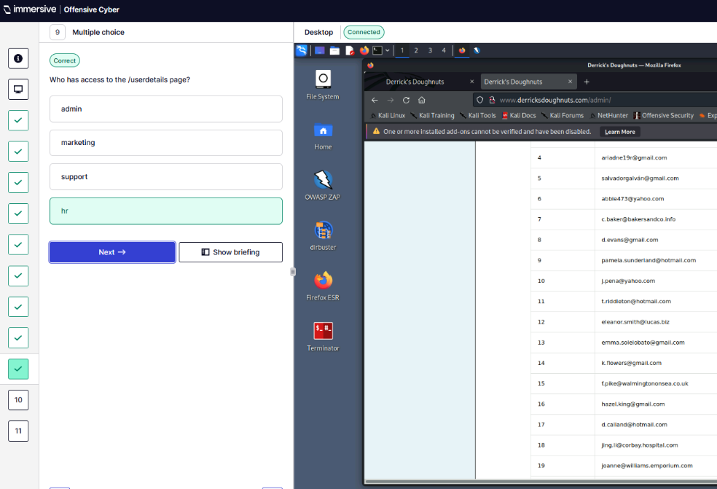
Q10 – Change the referrer header to access the /userdetails page. This was done using ZAP adding Referrer www.derricksdoughnuts.com/hr in the Request. This looked at the response to get Adam’s flat number.
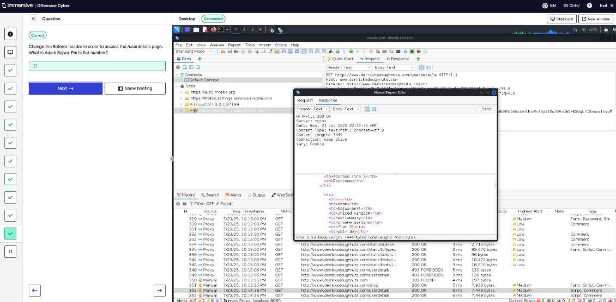
Q11 – Change URL parameters to buy The Zebra for £1. What is the token?
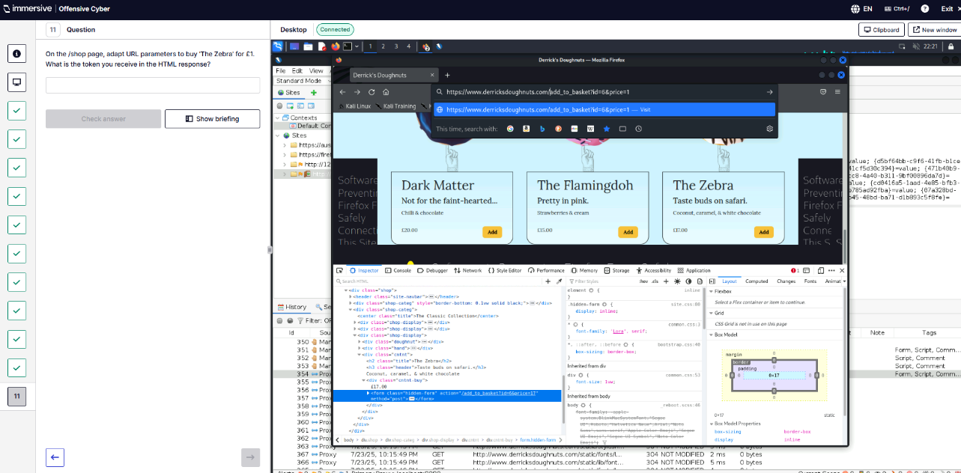
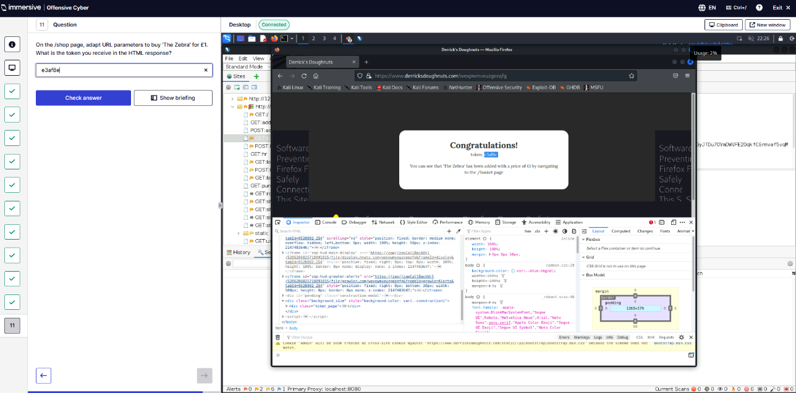
  - Authentication Design Flaws.
Q1 – Navigate to target site.
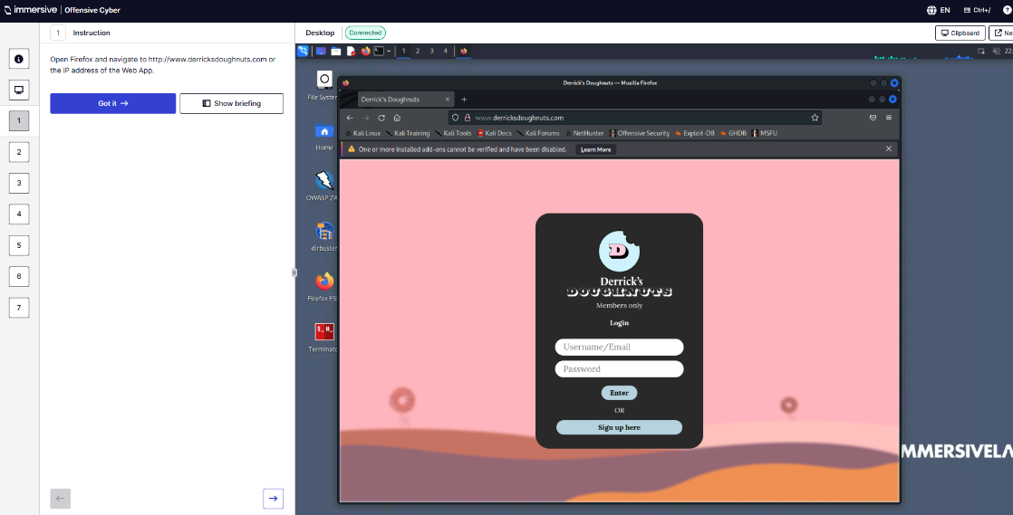
Q2 – Configure Firefox proxy.
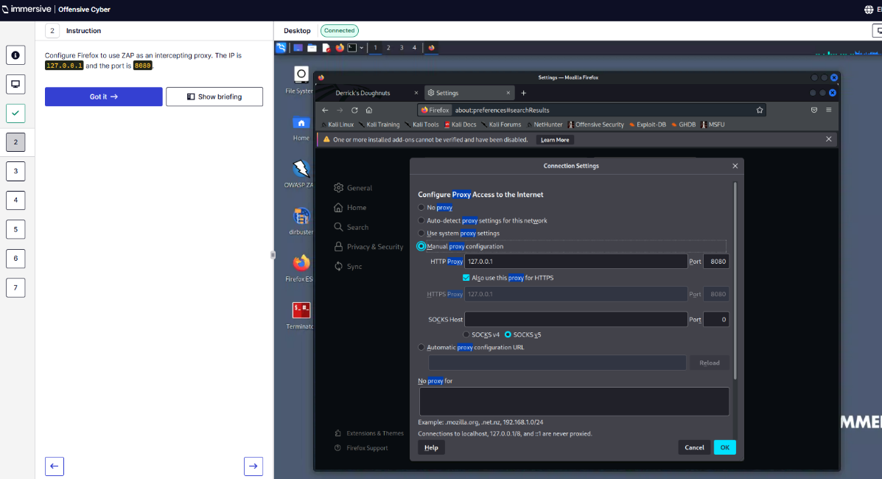
Q3 – Use ZAP to execute a brute force attack.
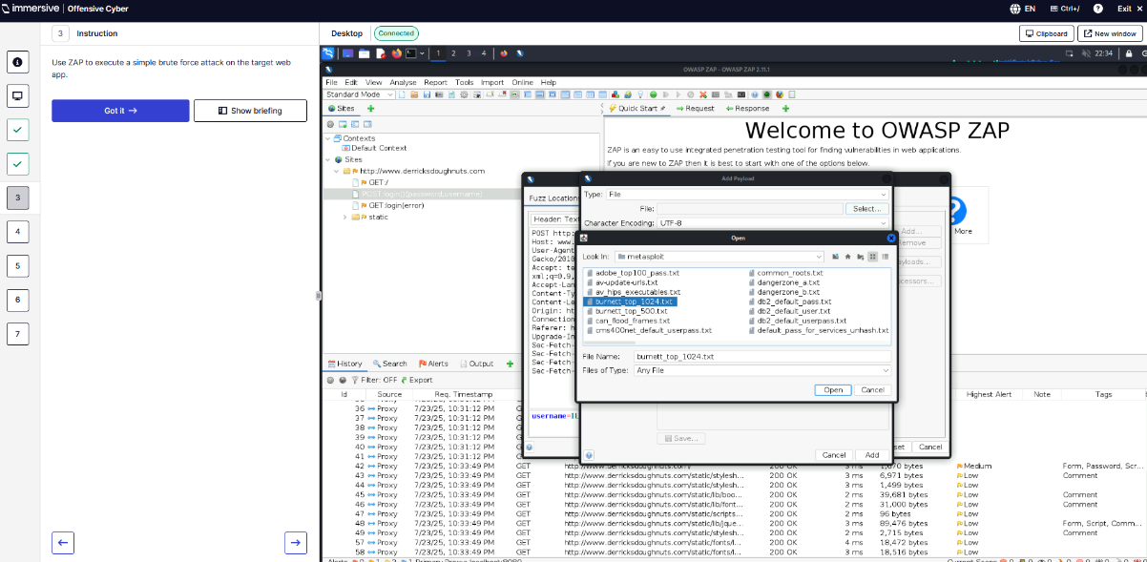
Q4 – What is the password for a.patel?
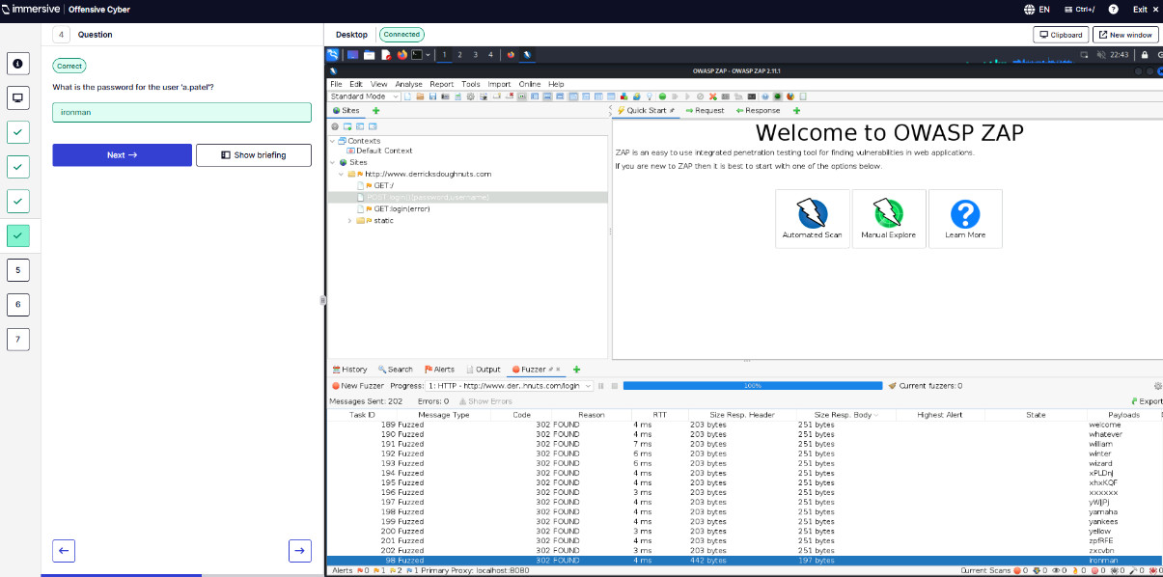
Q5 – Which username exists?
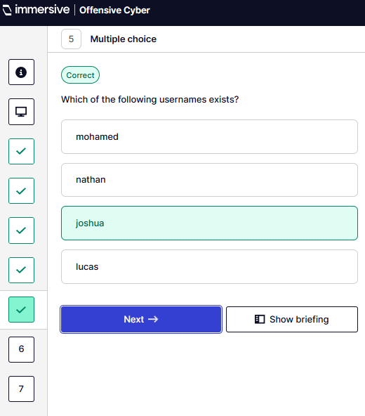
Q6 – What is the password used by Joshua?
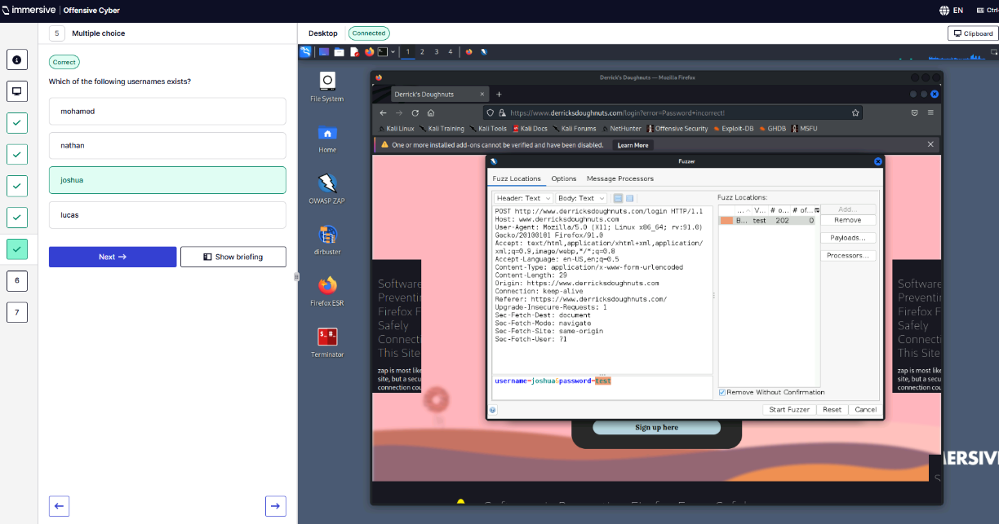
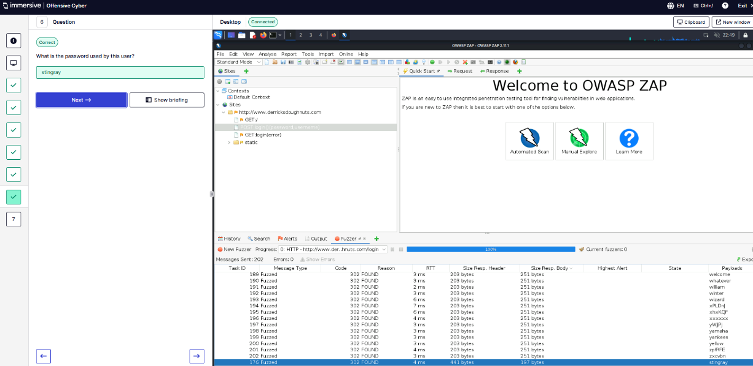
Q7 – What token is received when logging in as Joshua?
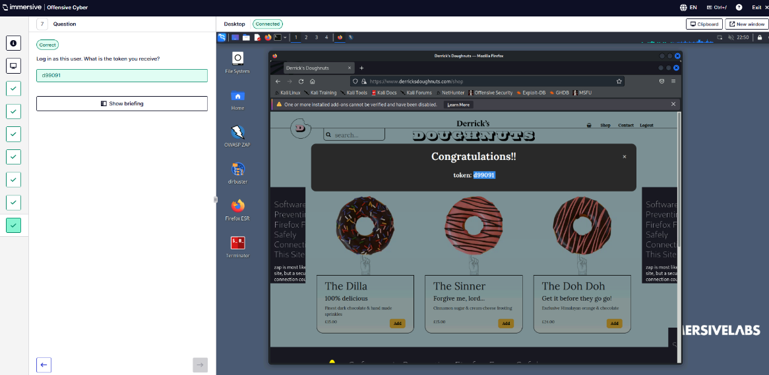
  - Server-Side Includes.
Q1 – Visit target.
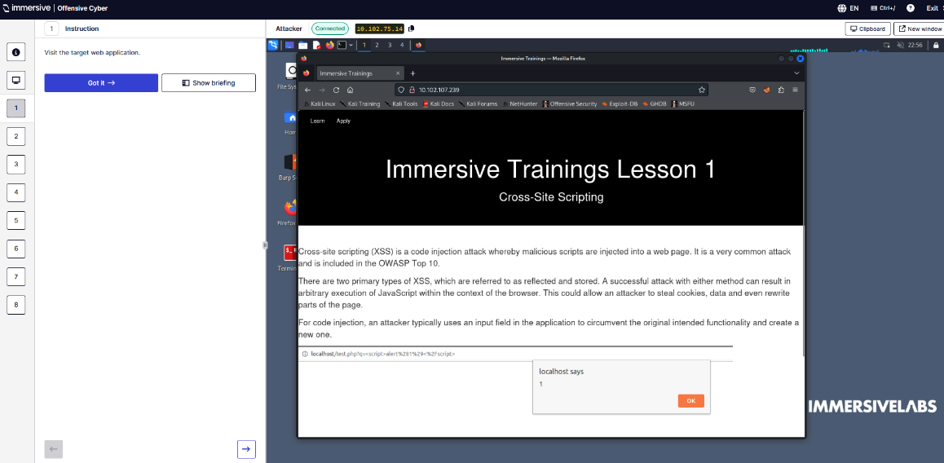
Q2 – Exploit HTML injection and use SSI to read variables.
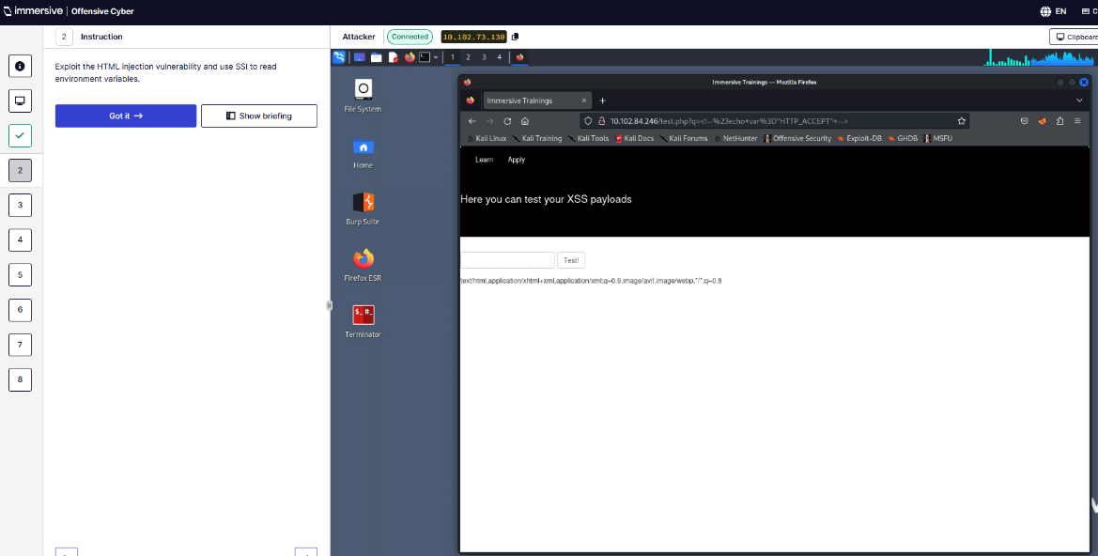
Q3 – Test payload
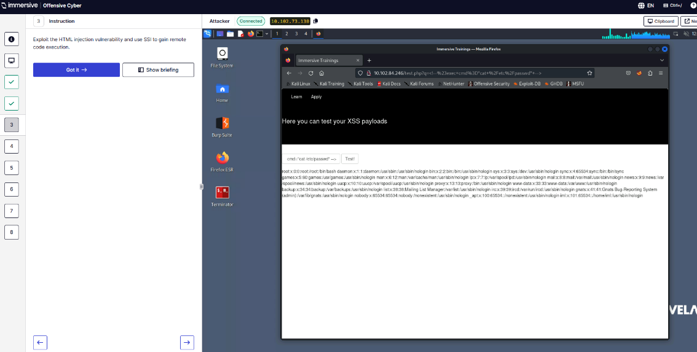
Q4 – Read the token in /etc/token.txt.
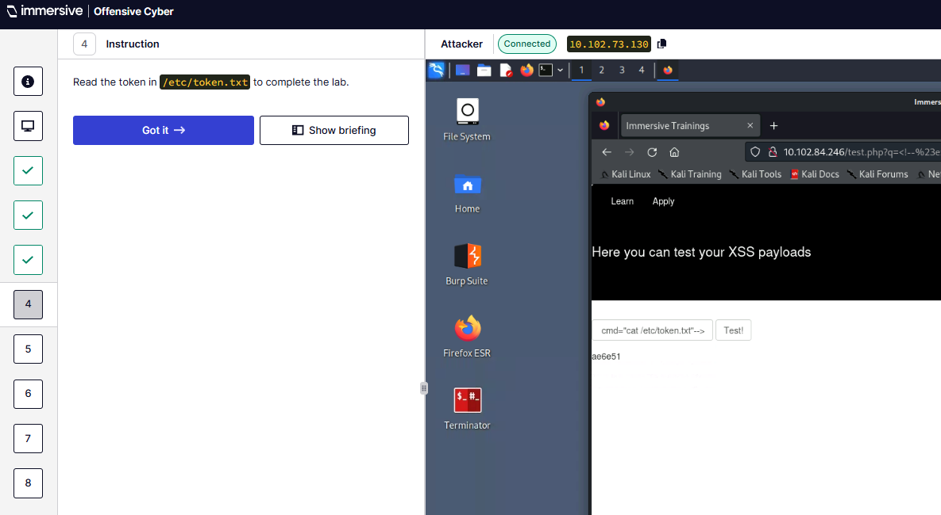
Q5 – What extension is used for files that parse SSI?
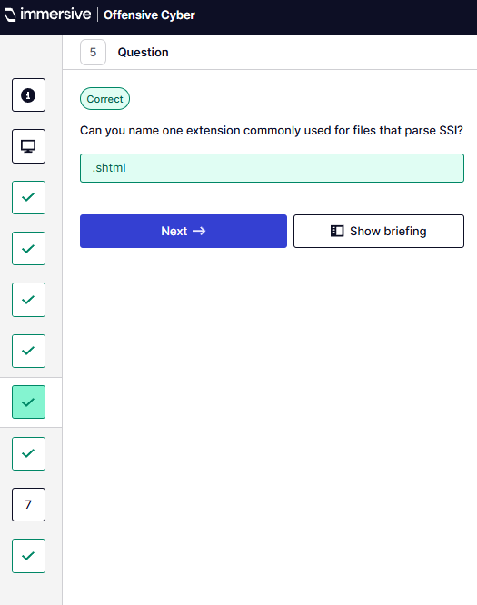
Q6 – Which Apache module must be loaded for SSI injection to result in remote code execution?
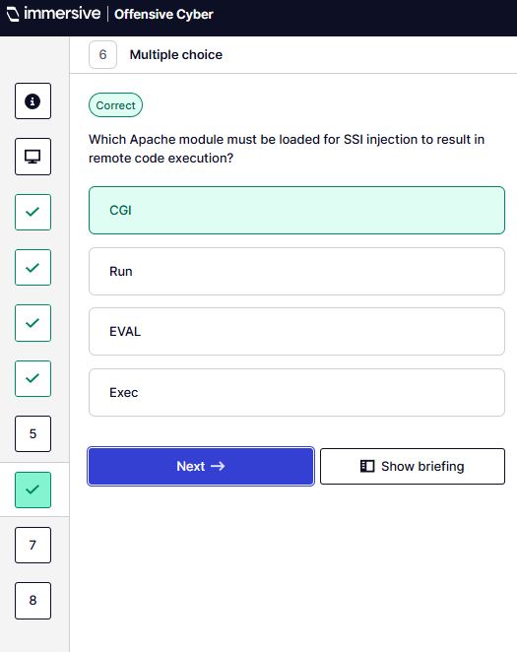
Q7 – What is the value of SERVER_ADMIN variable?
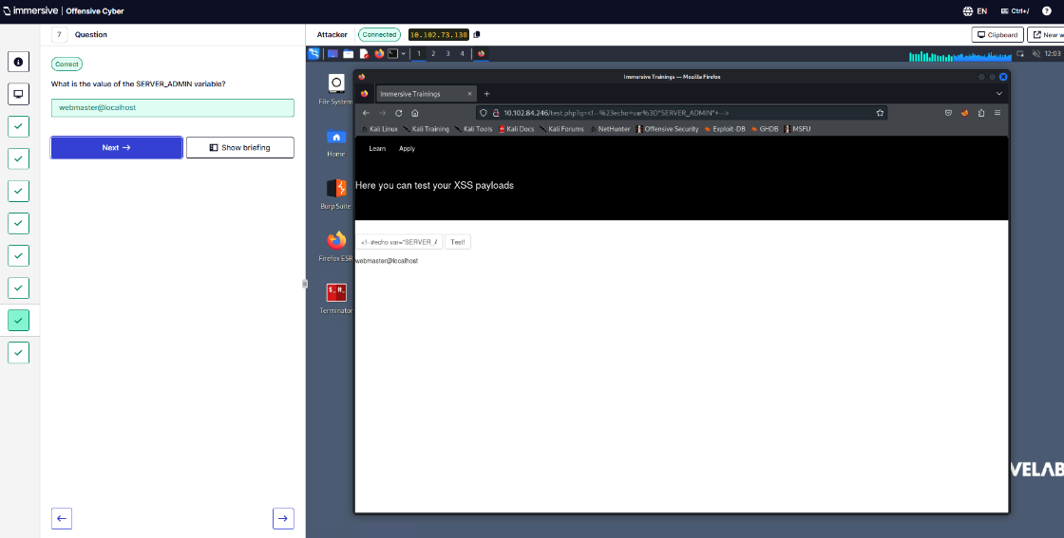
Q8 – What is the token?
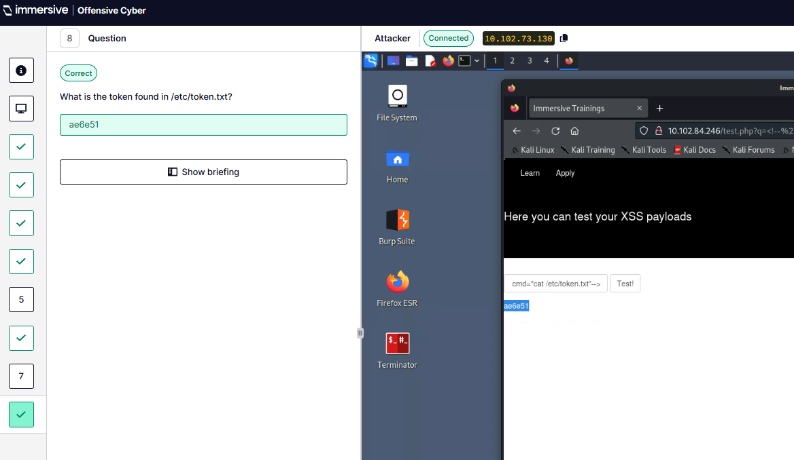
  - Command Injection.
Q1 – Navigate to IP address provided.
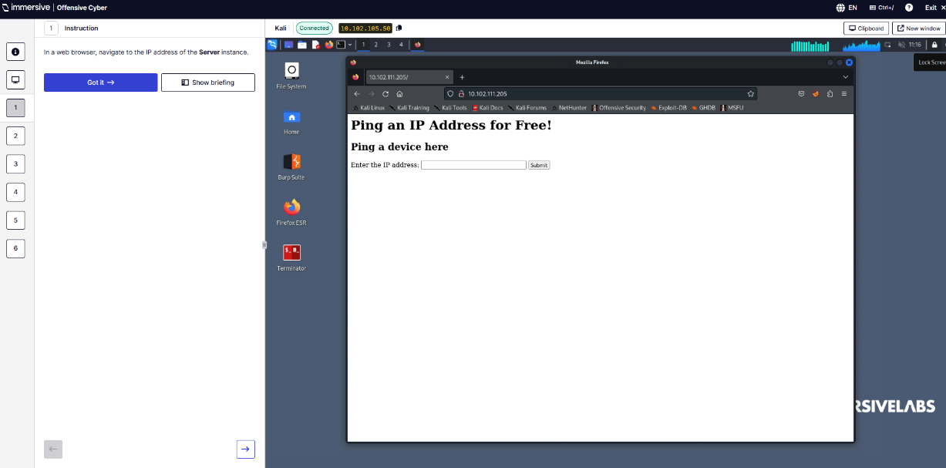
Q2 – Exploit the command injection vulnerability to execute commands.
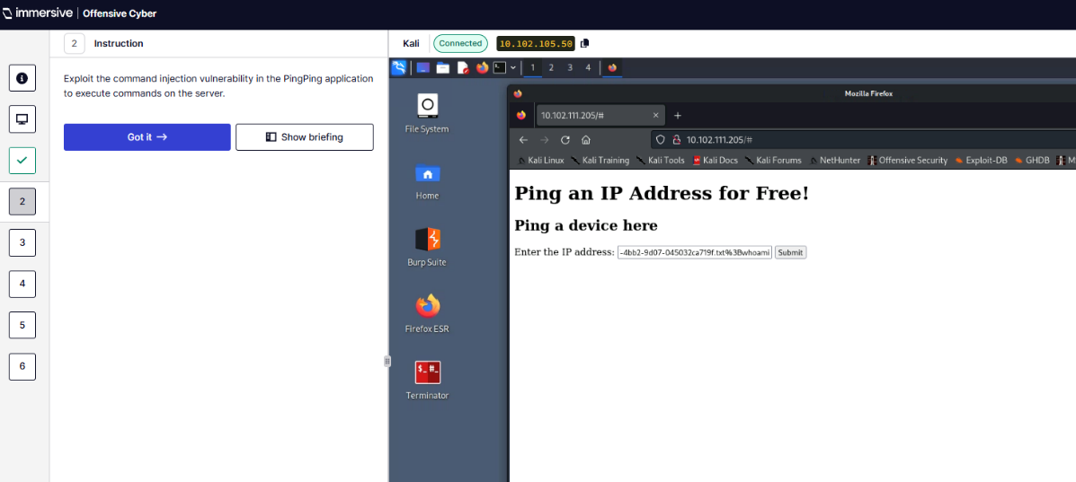
Q3 – Run the whoami command. What user account is running the queries?
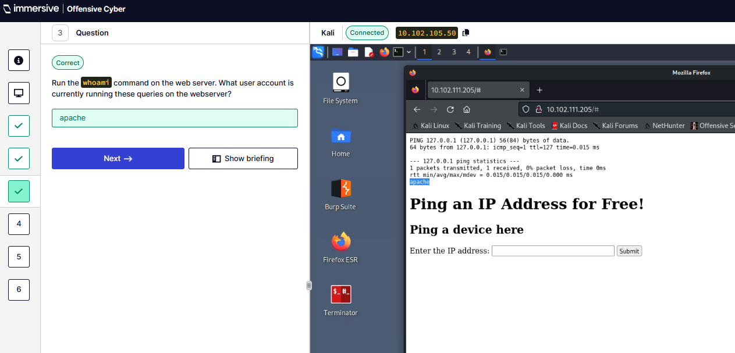
Q4 – Run id command. Which of the following groups is my user account a member of?
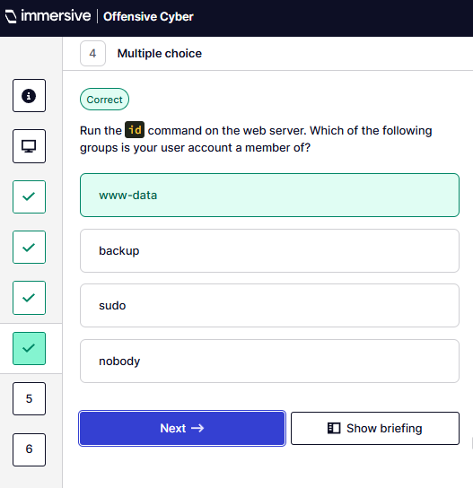
Q5 – Read /etc/passwd file. What user doesn’t exist?
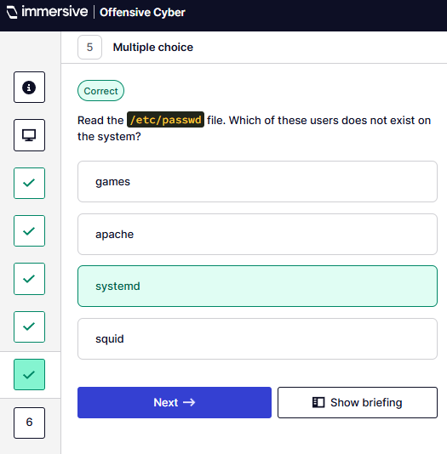
Q6 – What is the token?
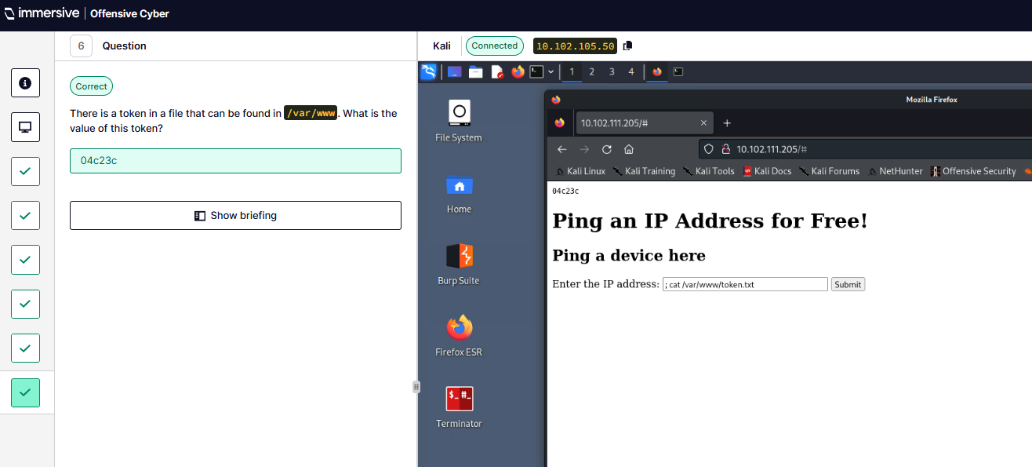
  - Stack Trace.
Q1 - Cause a stack trace error.
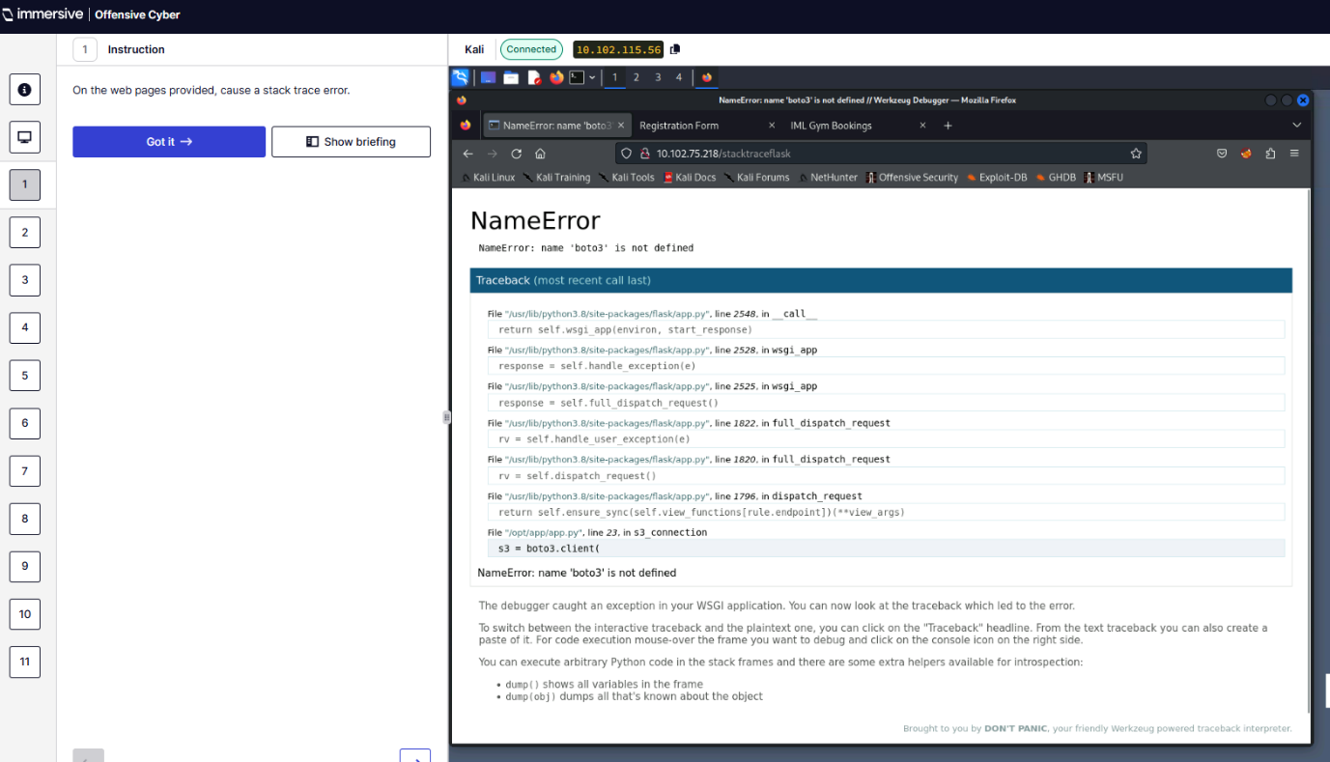
Q2 – Locate sensitive information.
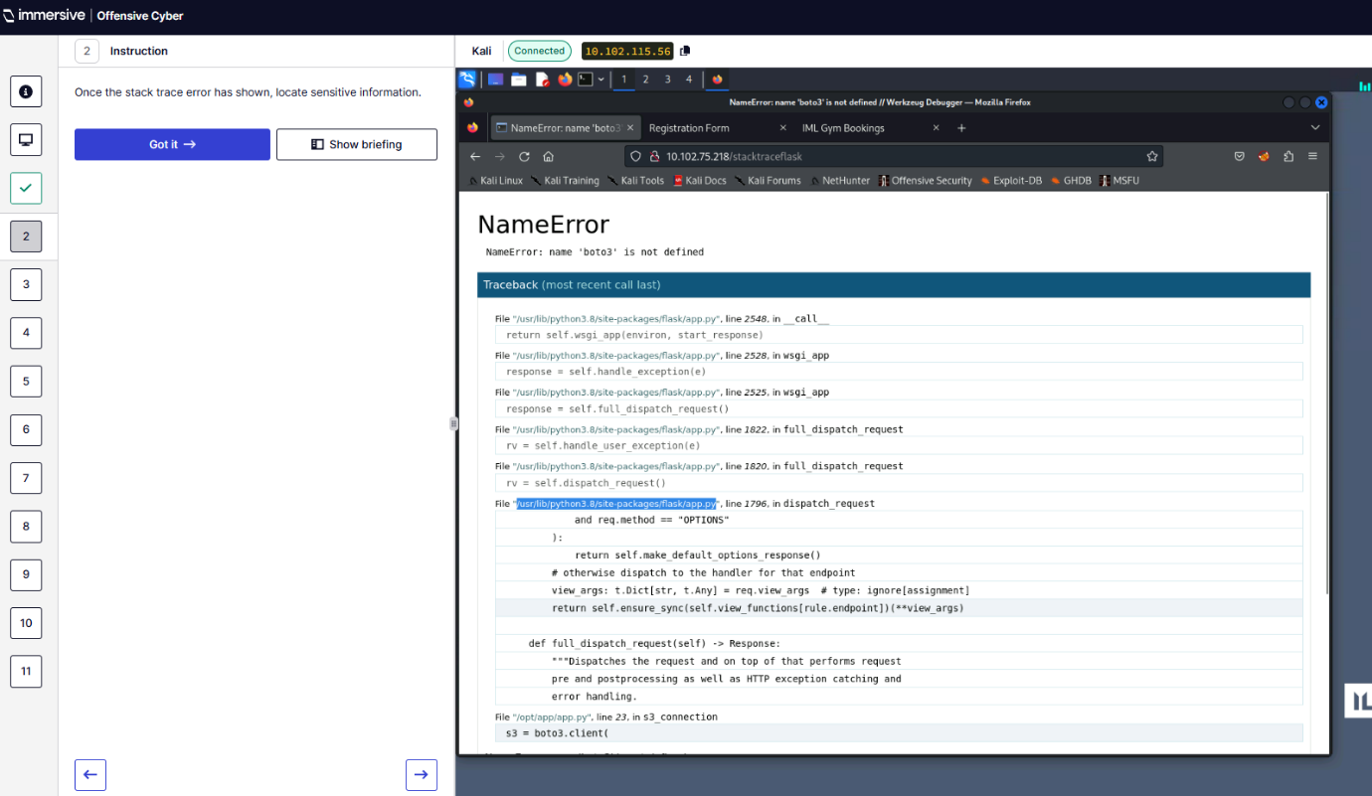
Q3 – First six characters of AWS secret in Java application?
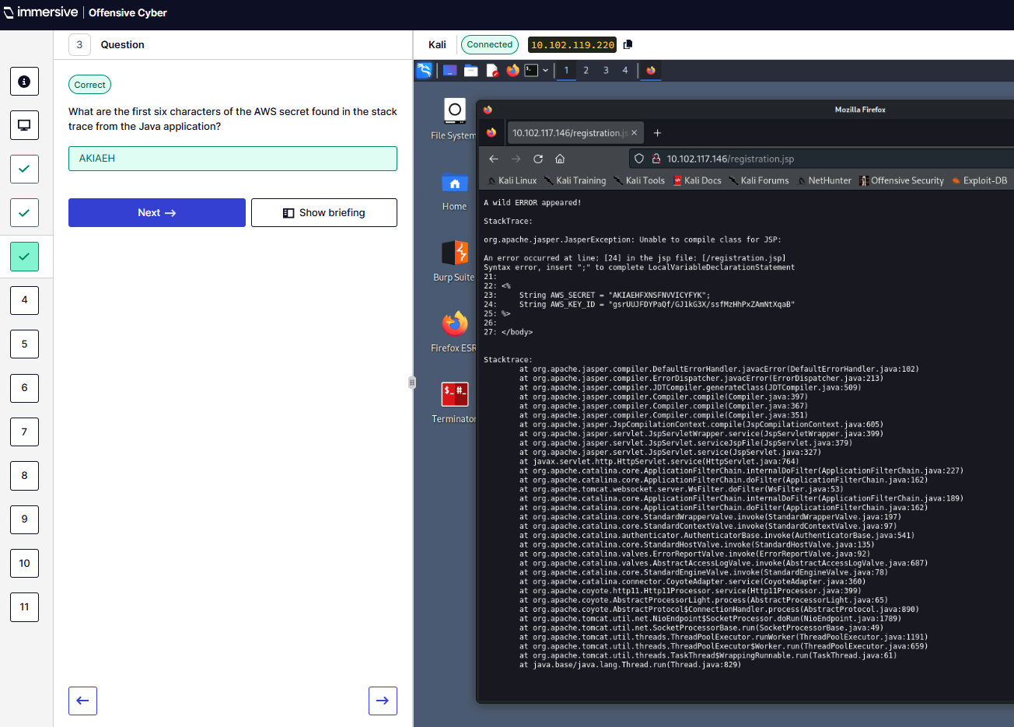
Q4 – What was the error caused in Java?
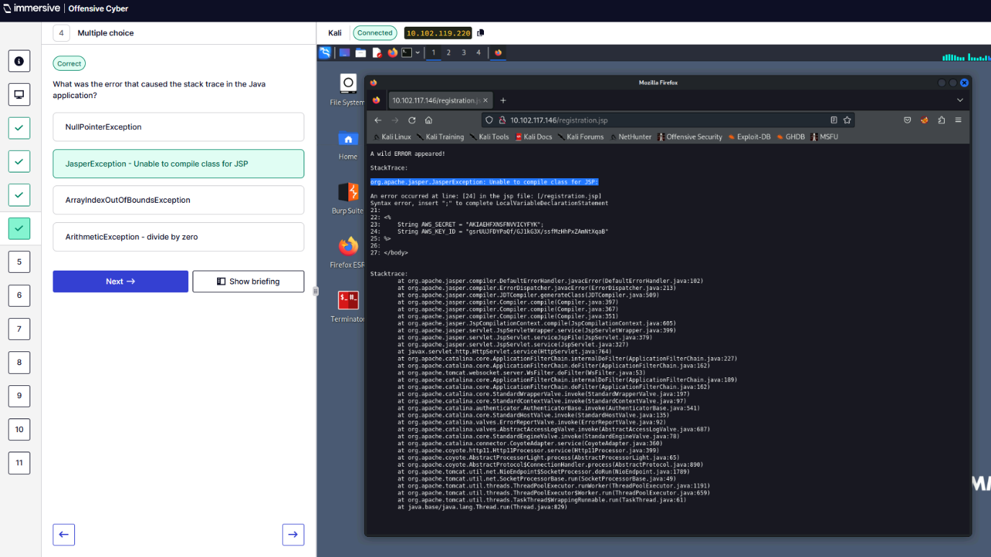
Q5 – What server is Java application running on?
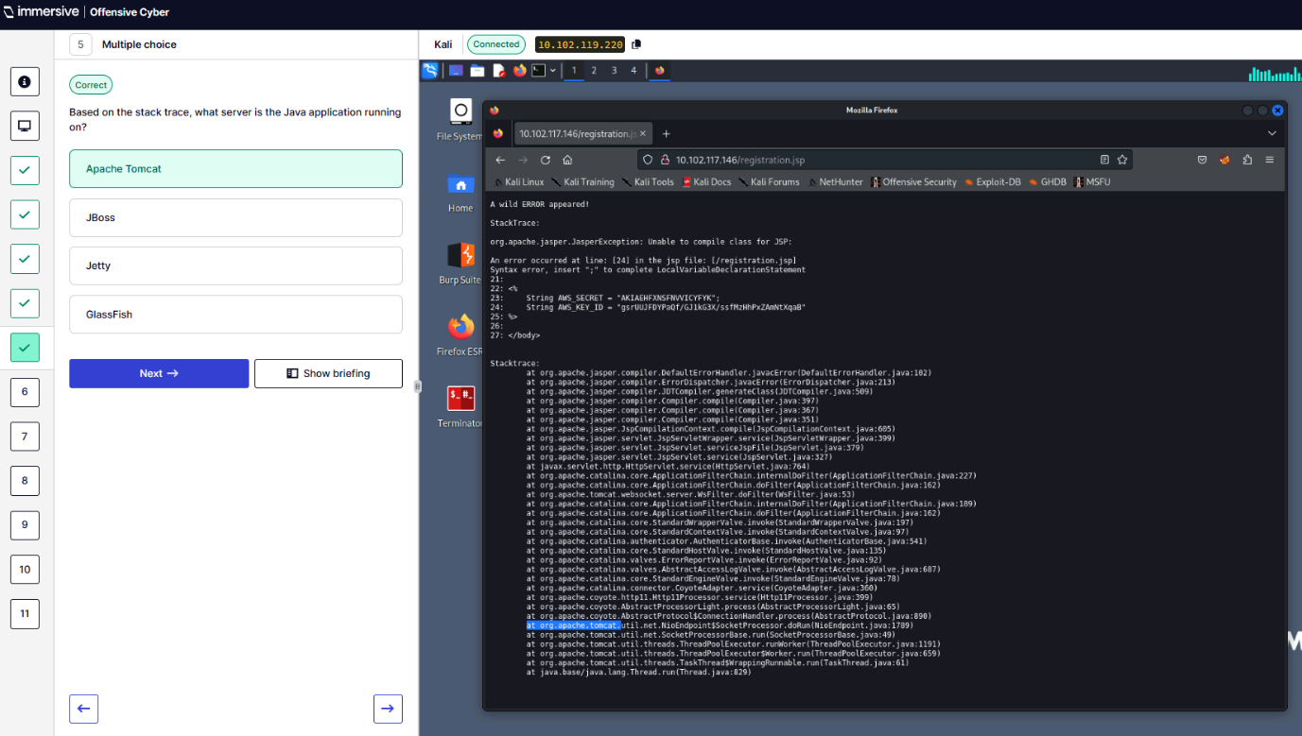
Q6 – First six characters of AWS Key ID in PHP application?
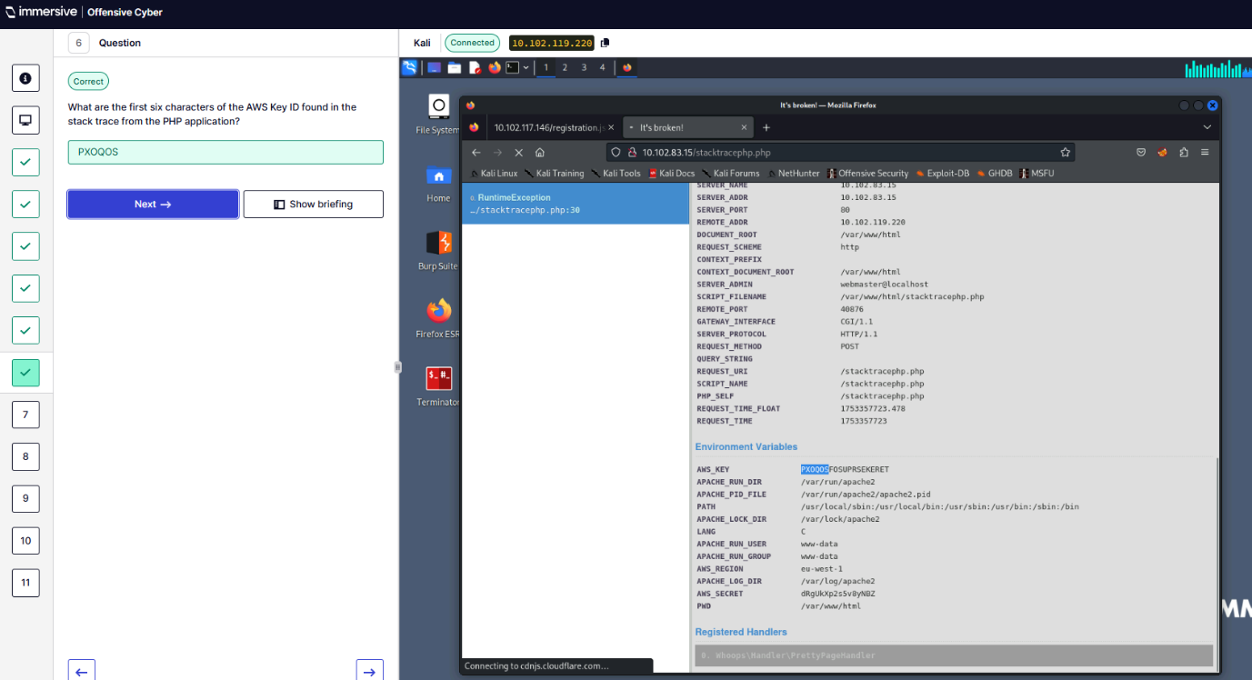
Q7 – AWS region of PHP?
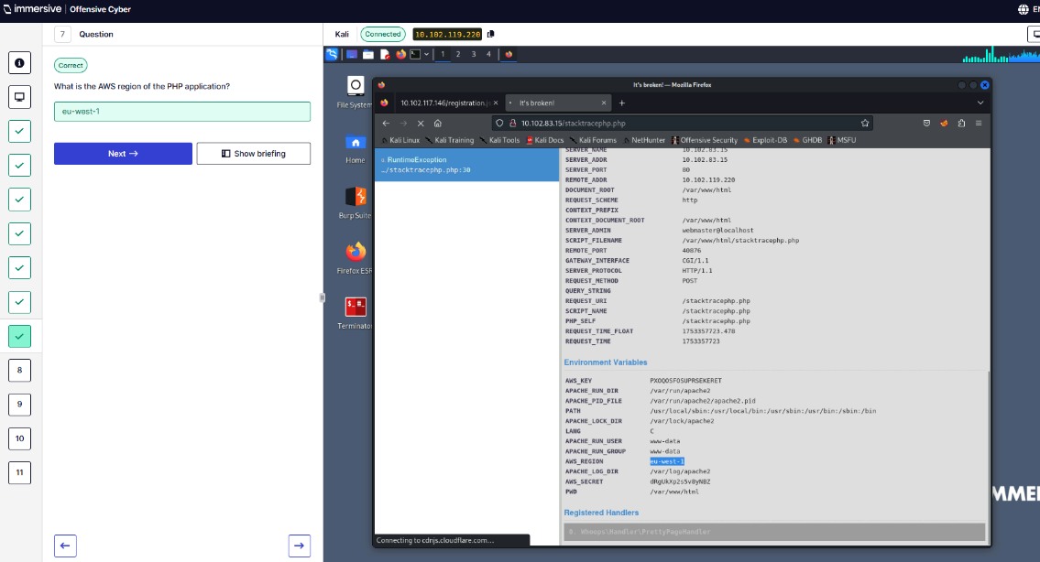
Q8 – Error that caused stack trace in PHP?
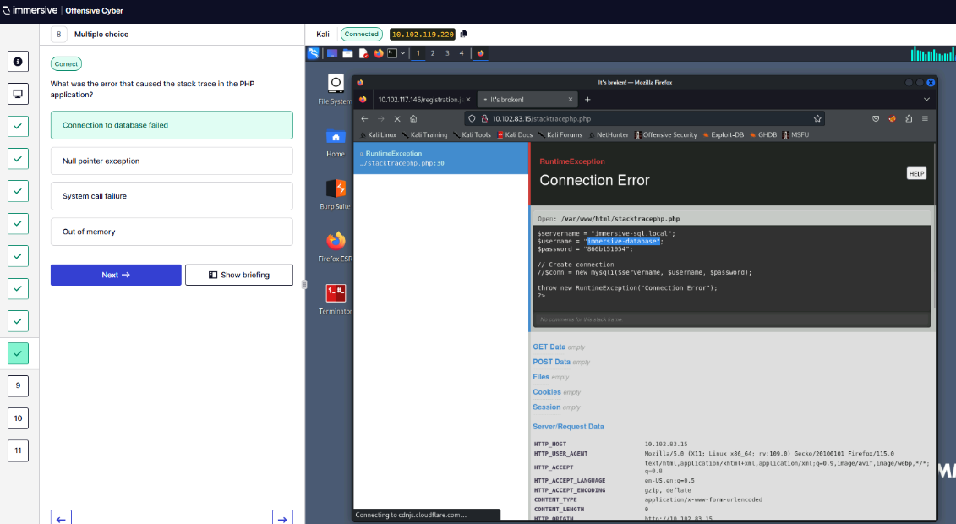
Q9 – First six characters of AWS secret in Python application?
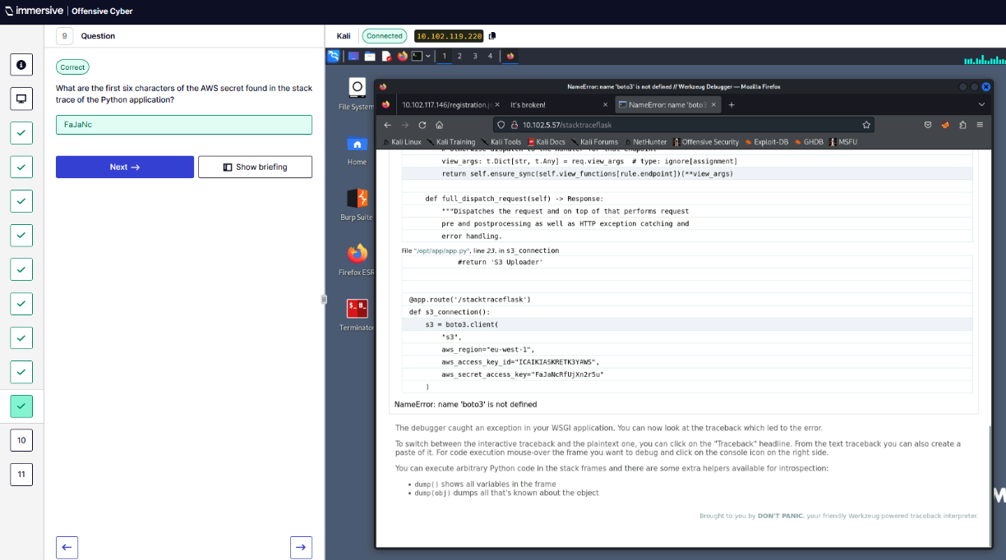
Q10 – What was the error in the Python application?
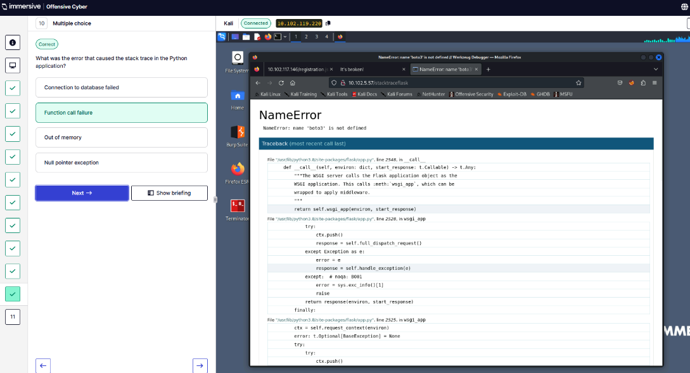
Q11 – Which line caused the first error in Python application?
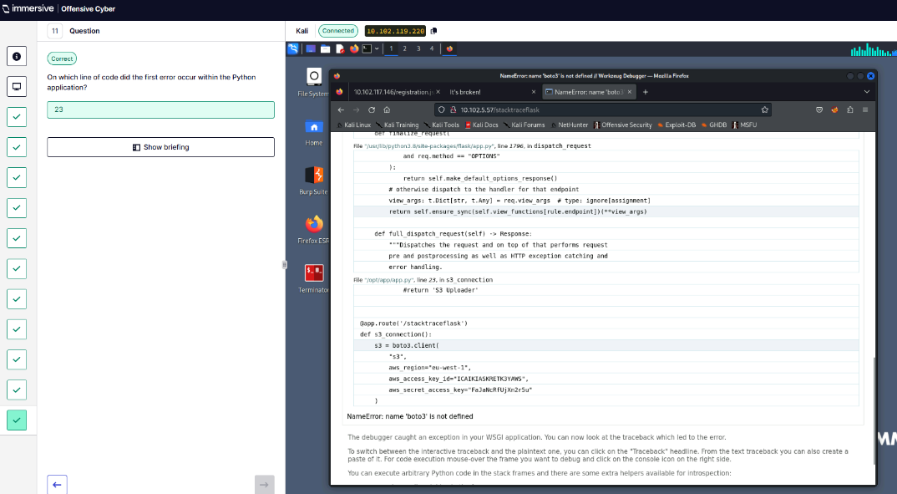
  - Apache Basic Authentication.
Q1 – SSH into target server.
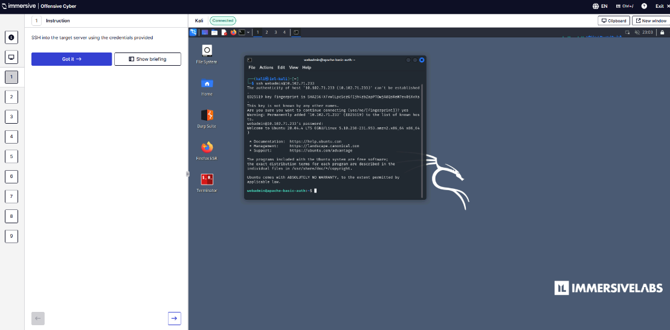
Q2 – Locate .htaccess file.
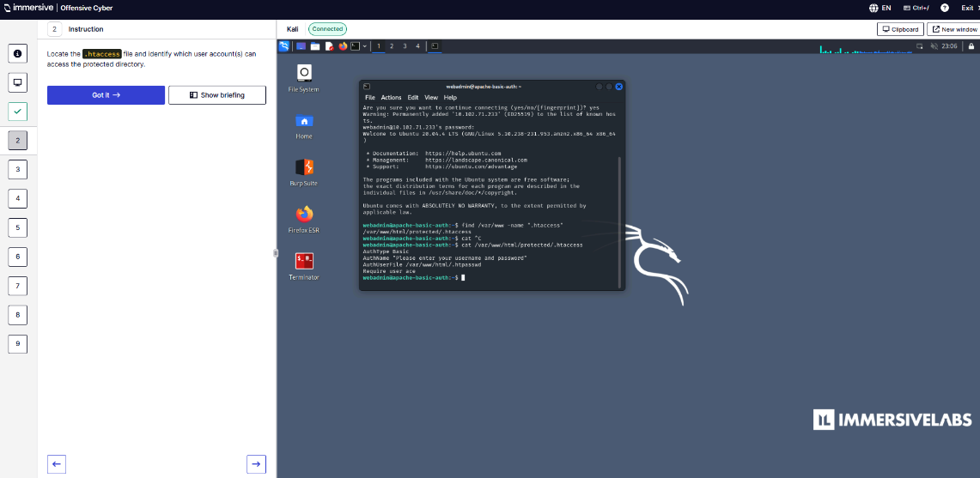
Q3 – Use htpasswd to modify the .htpasswd file.
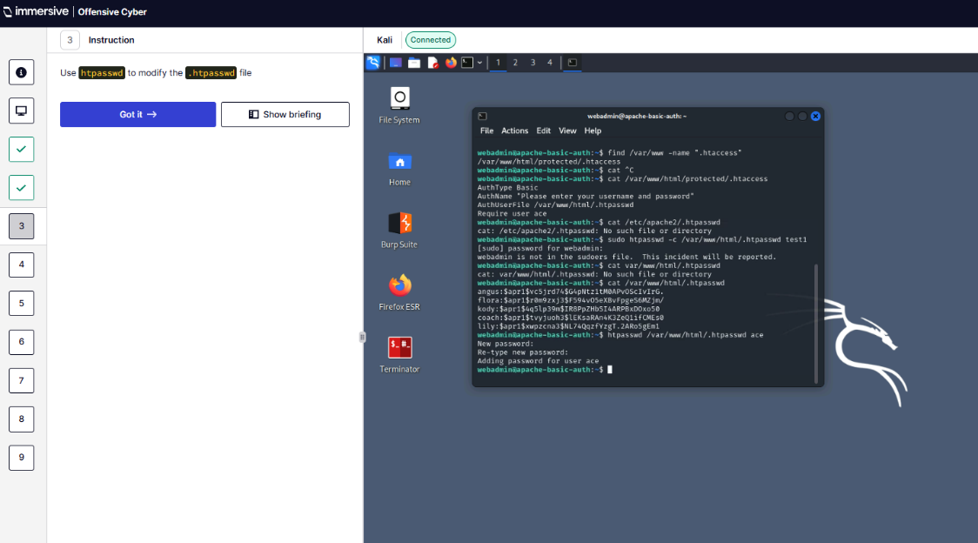
Q4 – Log into protected directory.
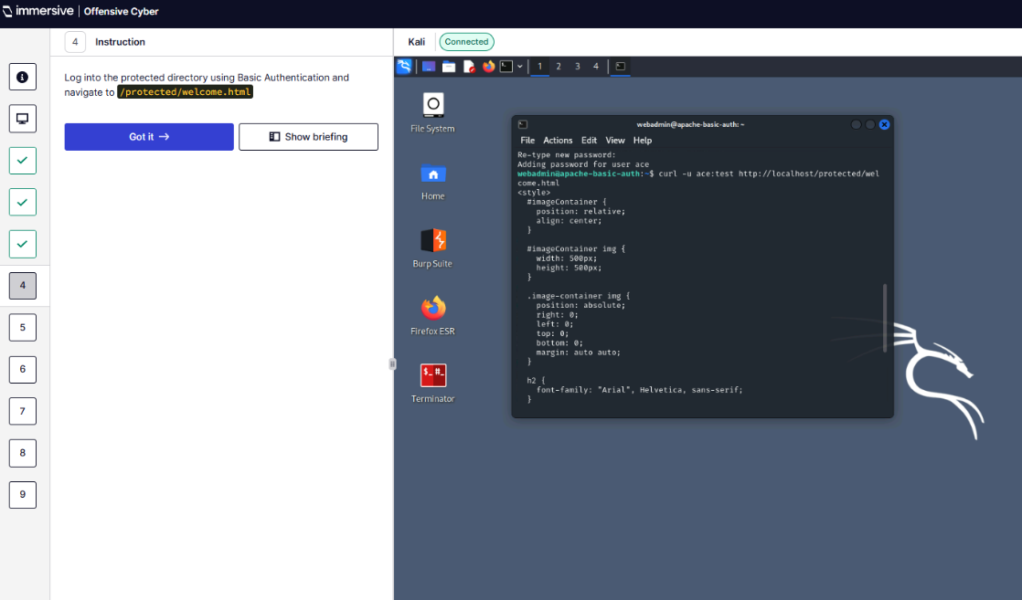
Q5 – Read token.html.
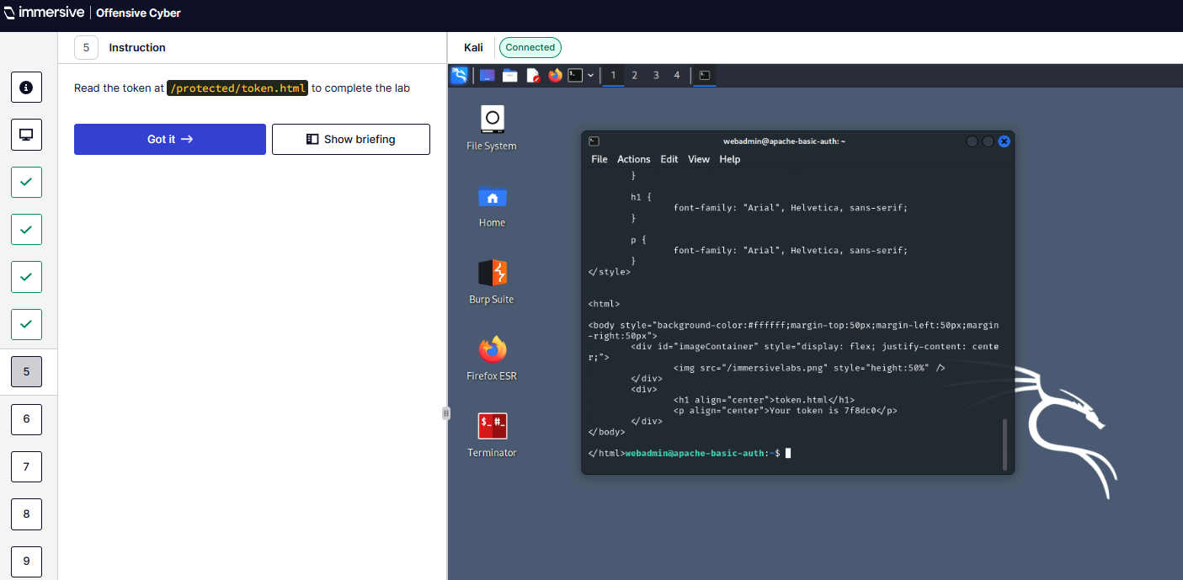Q6 – What users can be found?
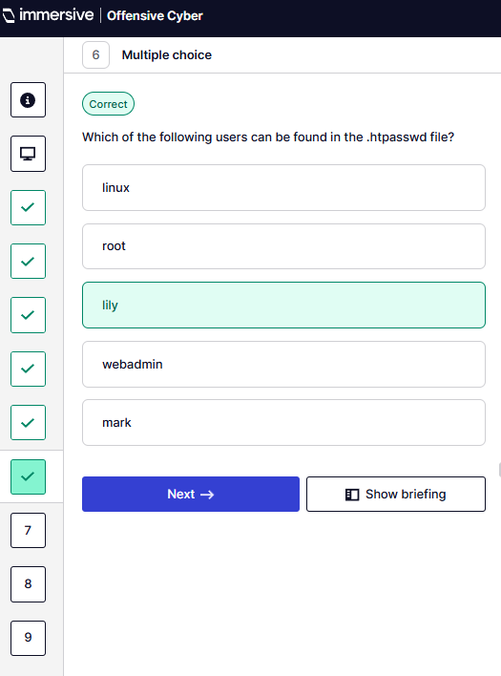
Q7 – First six characters of all Apache-MD5 hashed passwords?
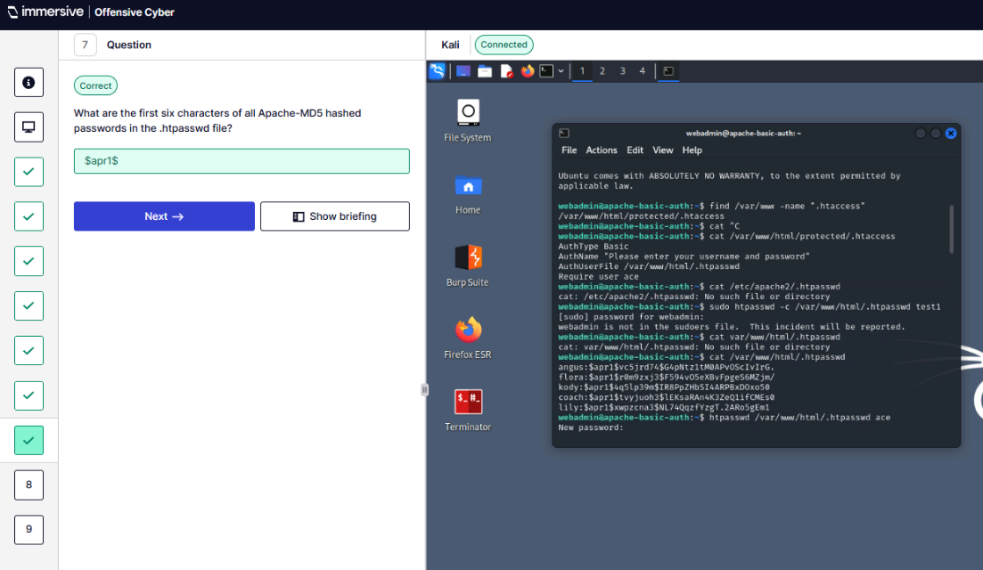
Q8 – What is the name of the user who has permissions to access the protected directory?
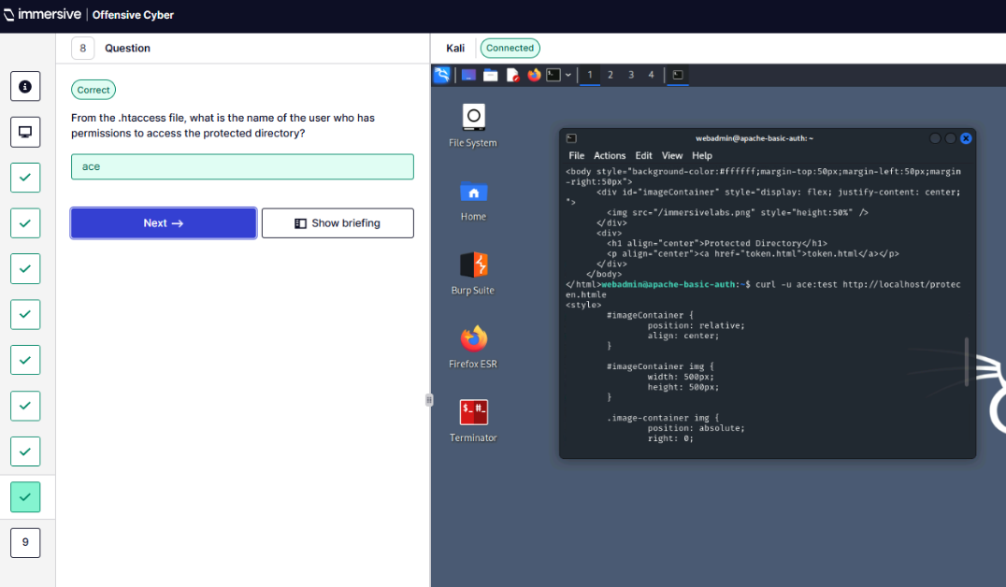
Q9 – What is the token?
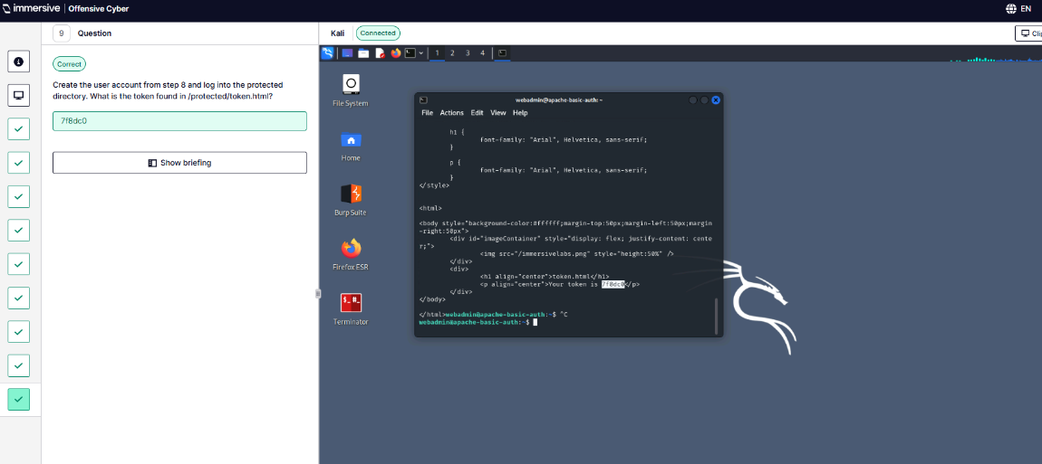
” (ImmersiveLabs Web App Hacking, 2025).
- Persistence. “(Immersive Labs Persistence, 2025)
  - Trap.
Q1 – Use trap command.
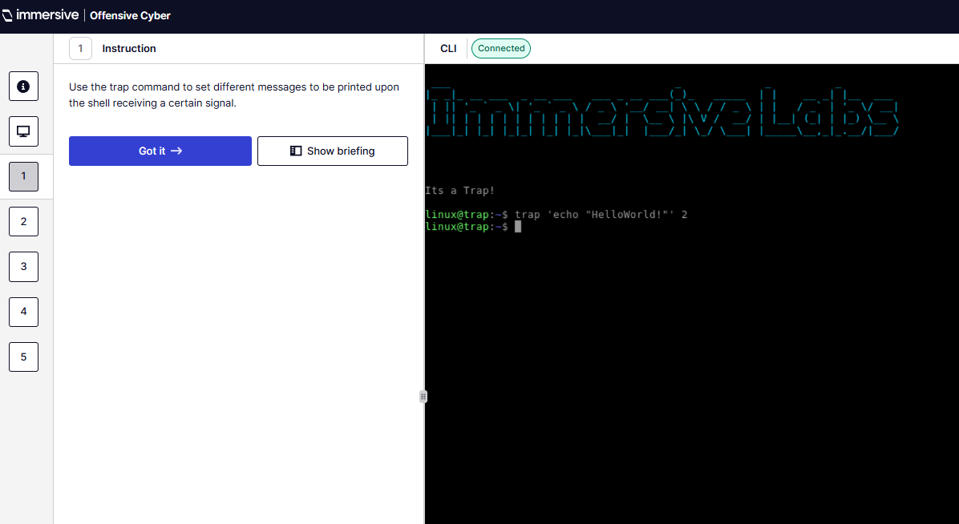
Q2 – What does the -l option do?
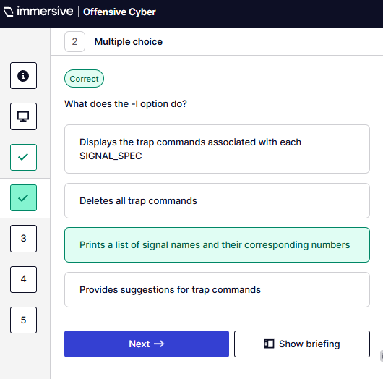
Q3 – Set a trap which prints I on SIGNIT. What token do you receive?
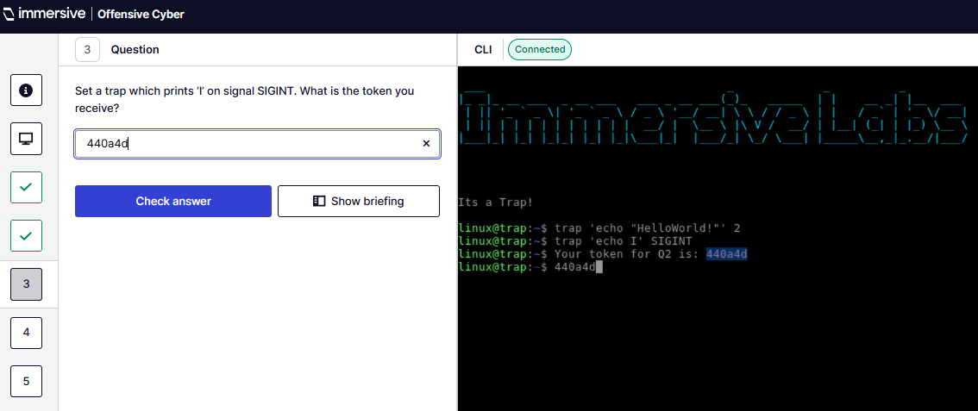
Q4 – Set a trap which prints Understand on SIGTSTP. What is the token you receive?
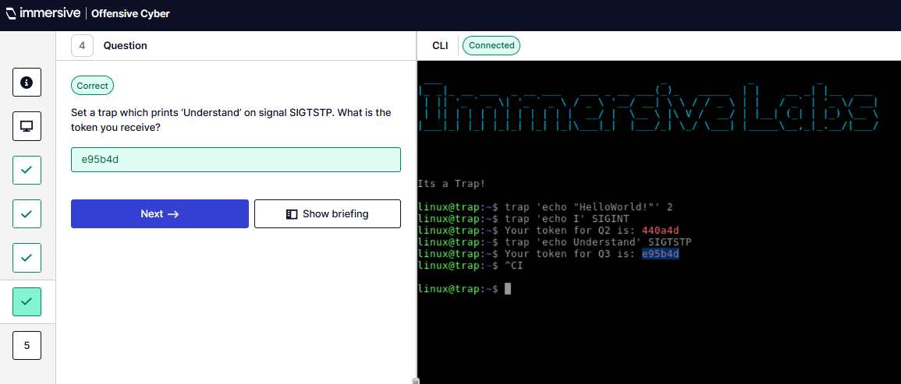
Q5 – Set a trap which prints TrapCmd on SIGQUIT. What is the token you receive?
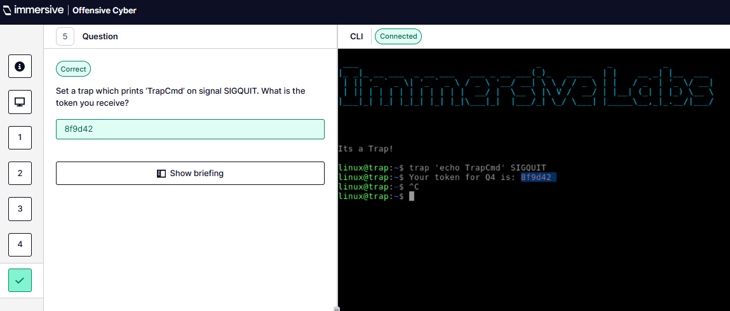

  - Component Object Model Hijacking.
Q1 – Apply filter in ProcMon to single out registry paths.
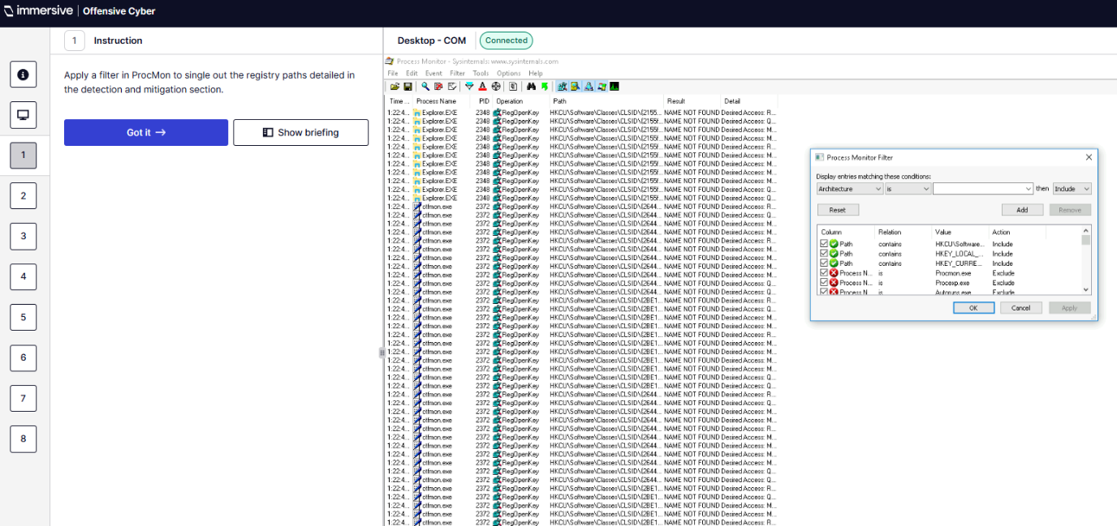
Q2 – Execute malware.exe
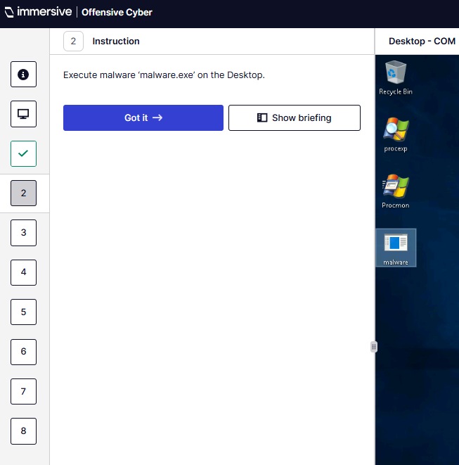
Q3 – Observe the registry key added by the malware to find IoCs.
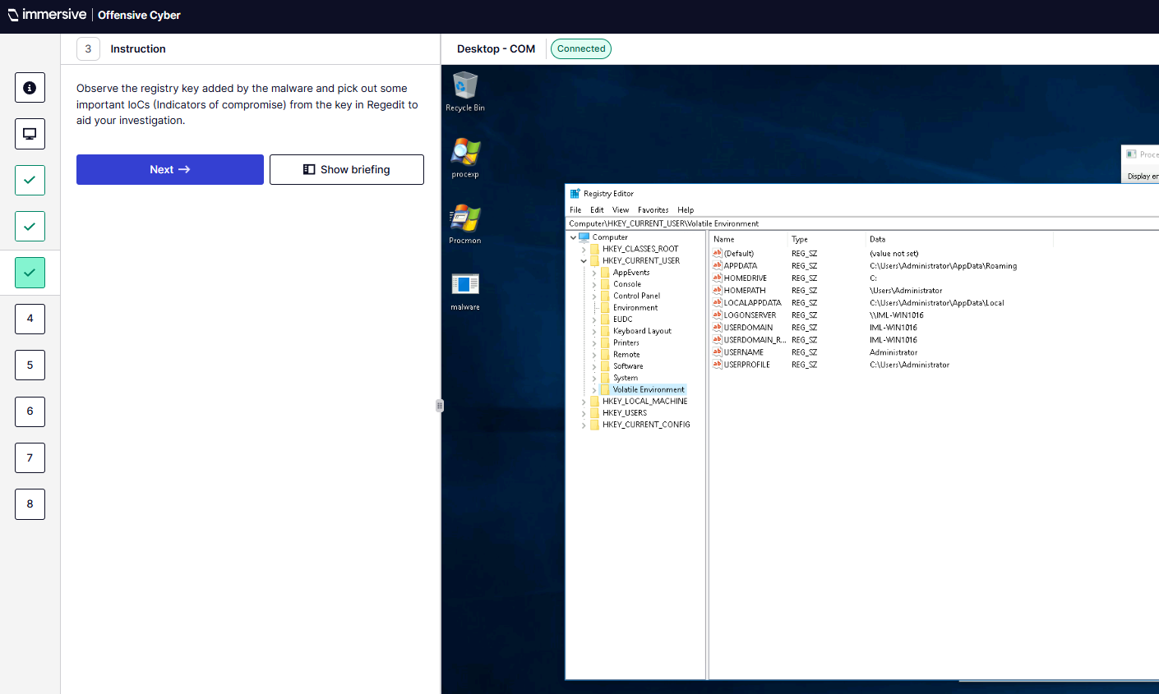
Q4 – What does COM stand for?
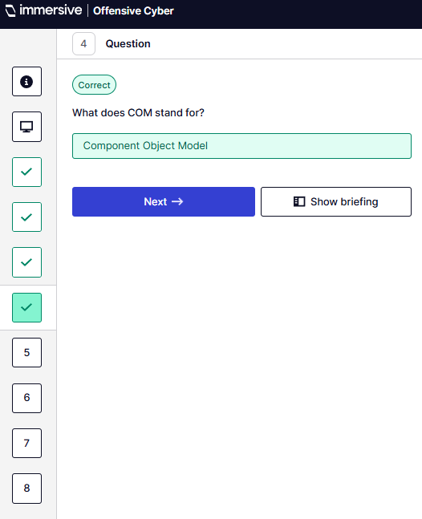
Q5 – Execute malware.exe. What is the full CLSID which is hijacked for the current user?
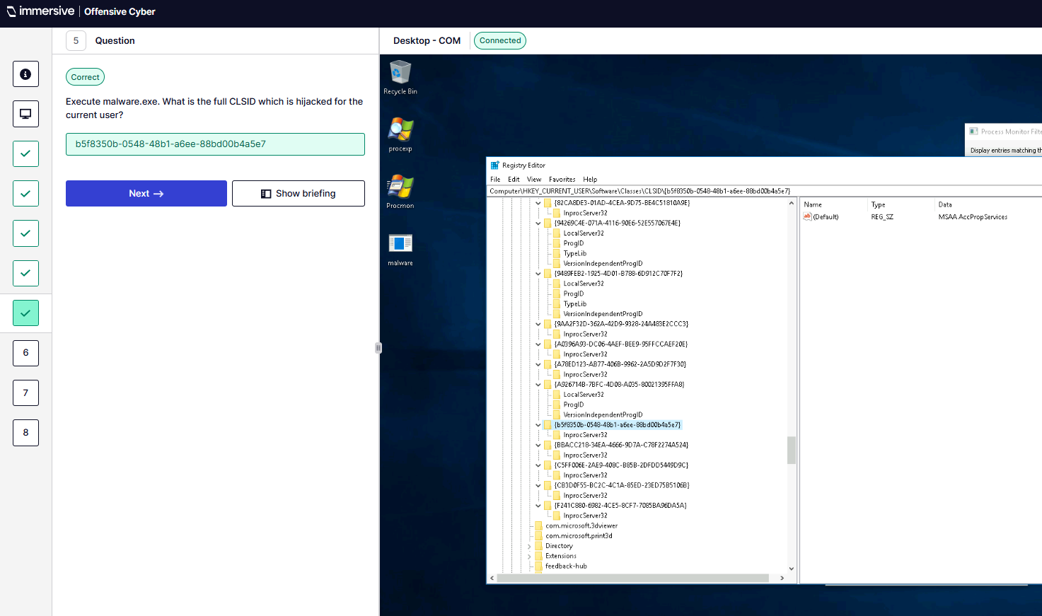
Q6 – Open RegEdit and find the full CLSID from Q5.
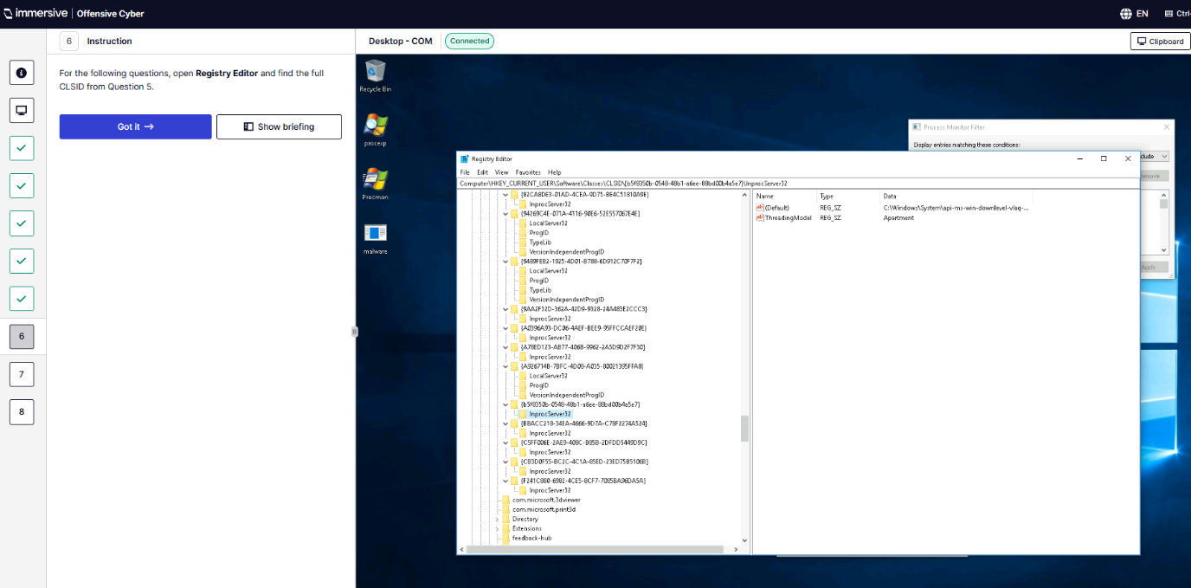
Q7 – What is the name of the registry key that has been added?
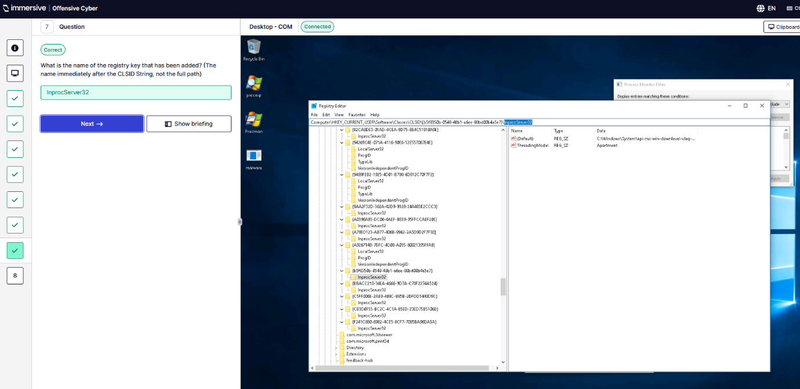
Q8 – What is the extension of the file dropped by the malware?
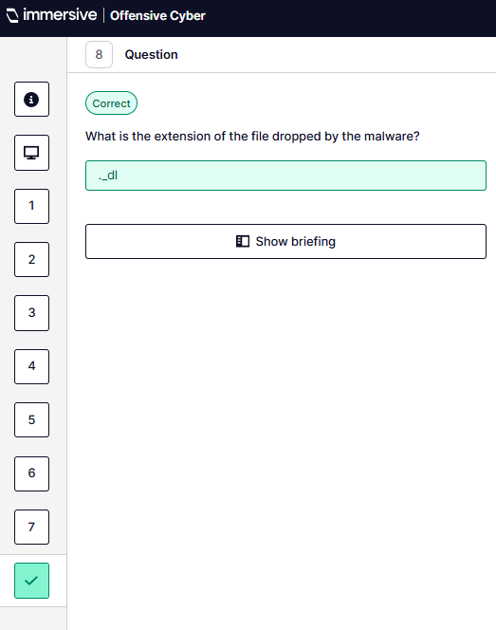
- Windows Logon.
Q1 – Analyse the Registry keys.
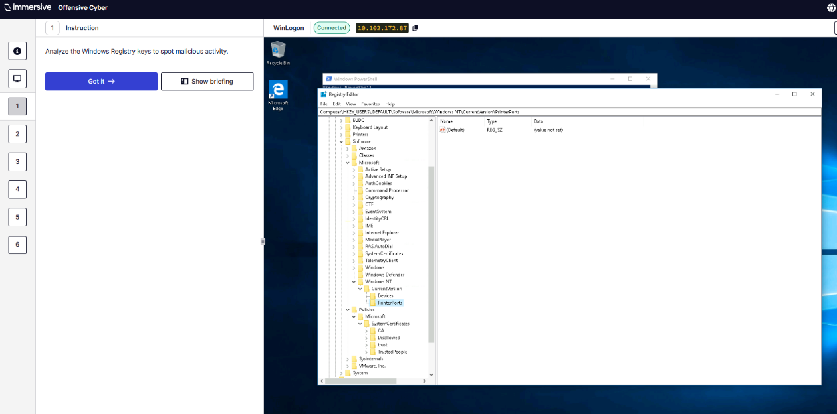
Q2 – Identify which file has been instructed to execute on startup.
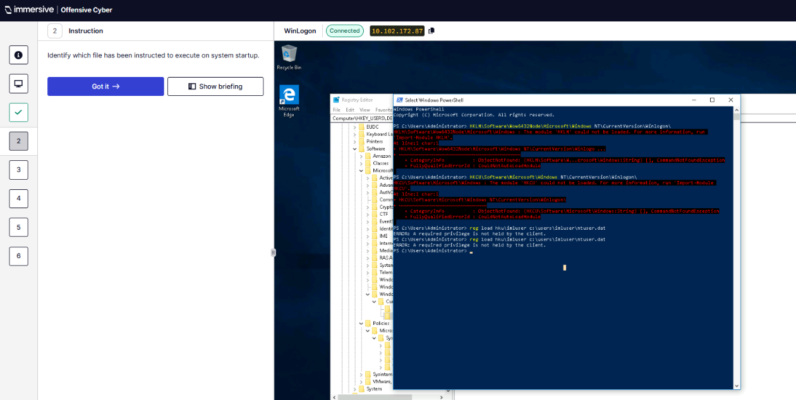
Q3 – What is the full path of the modified registry key?
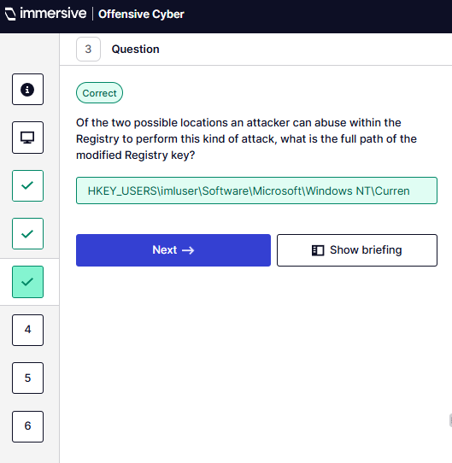
Q4 – What value has been modified for malicious purposes?
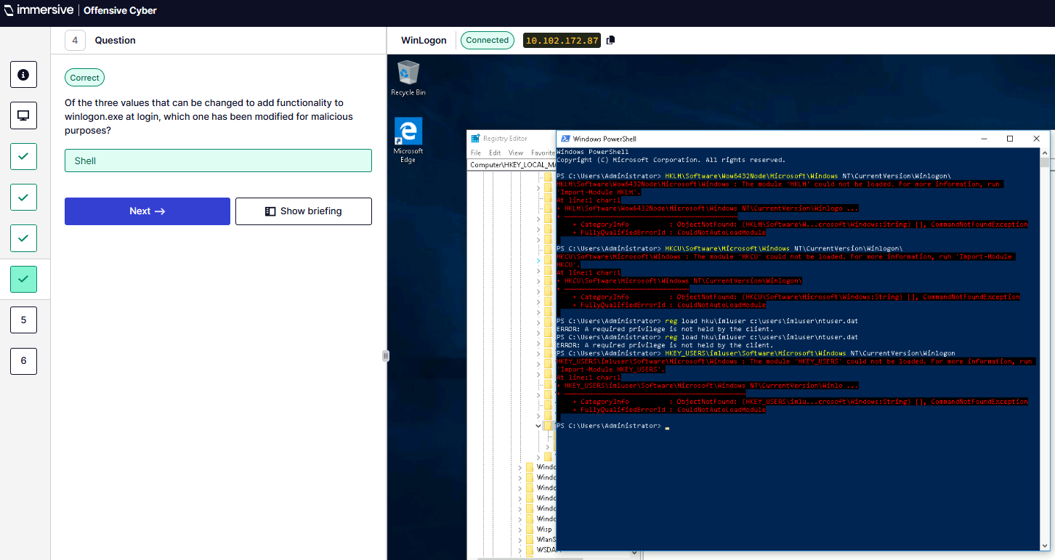
Q5 – What is the value of this registry key?
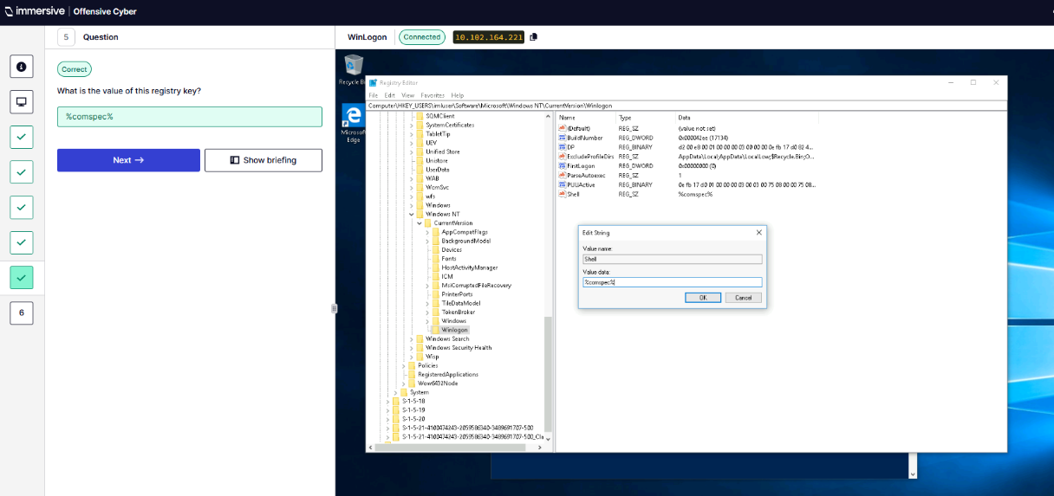
Q6 – What file is being executed on startup instructed by the malicious registry value?
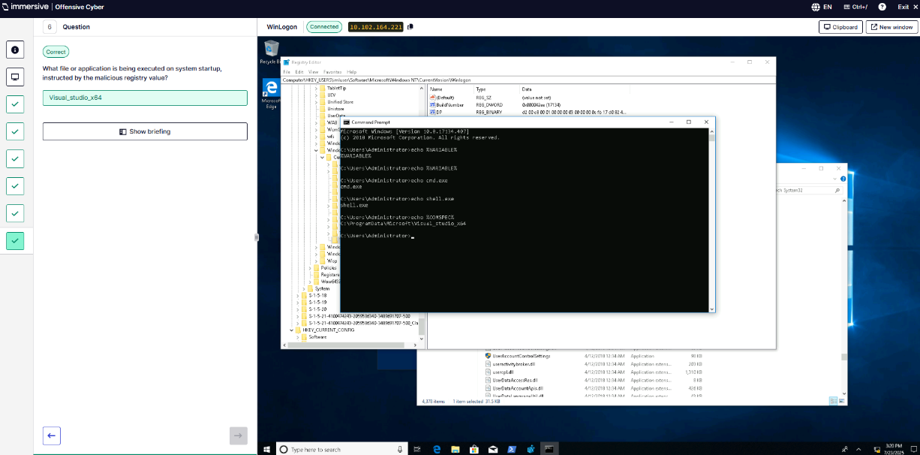
- .bashrc Files.
Q1 – Review the infected .bashrc file.
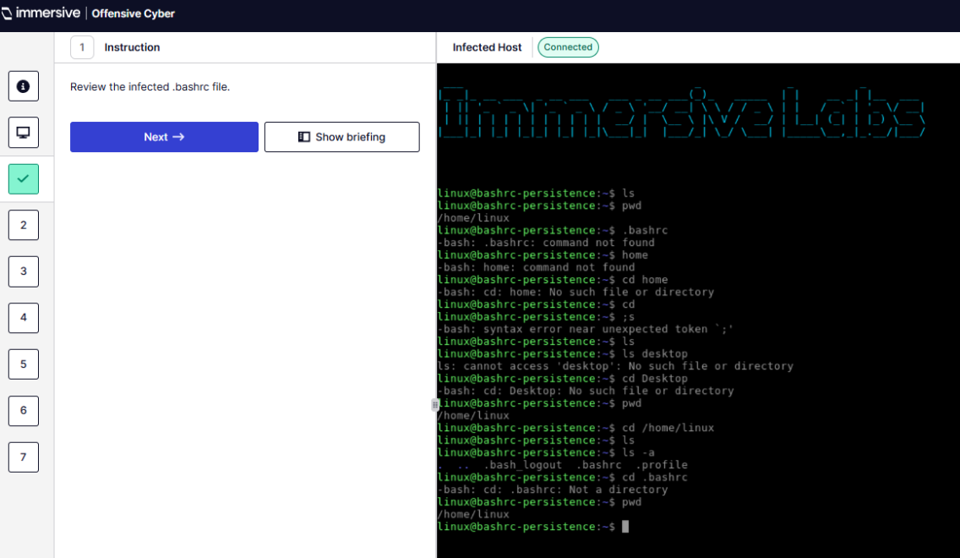
Q2 – Deobfuscate the malicious content to understand what its doing.
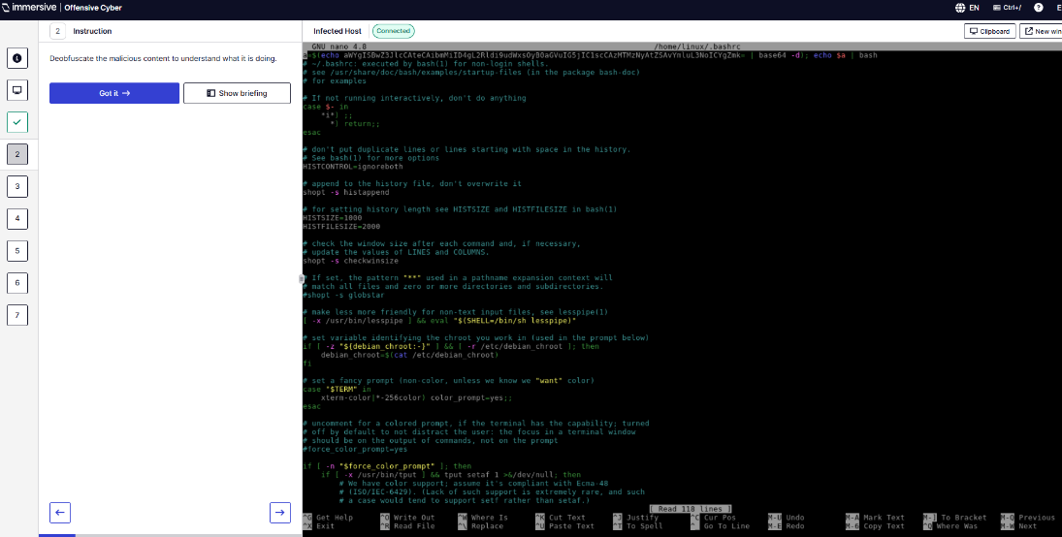
Q3 – Kill process used to maintain persistence.
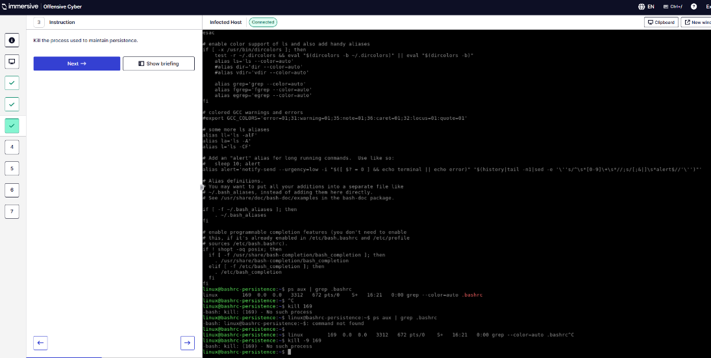
Q4 – What line number does the malicious content begin on?
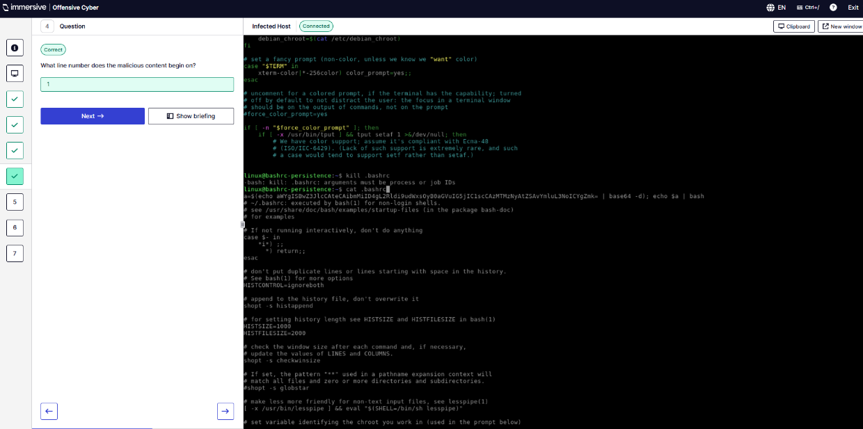
Q5 – What binary is utilised to allow attackers to gain persistent access to the host?
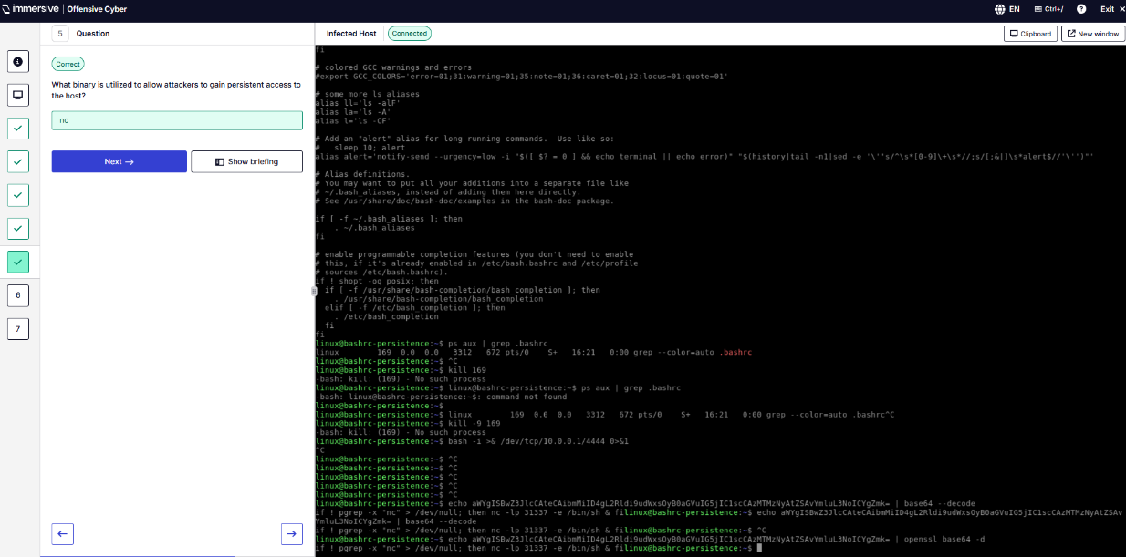
Q6 – Which port in exposed?
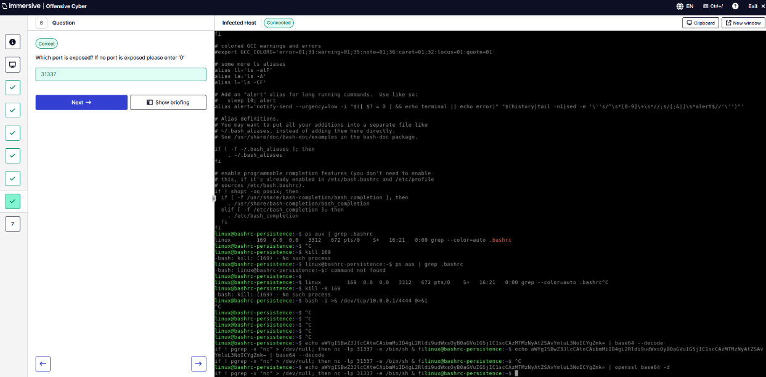
Q7 – Will the persistence run numerous times if a bashrc is triggered more than once?
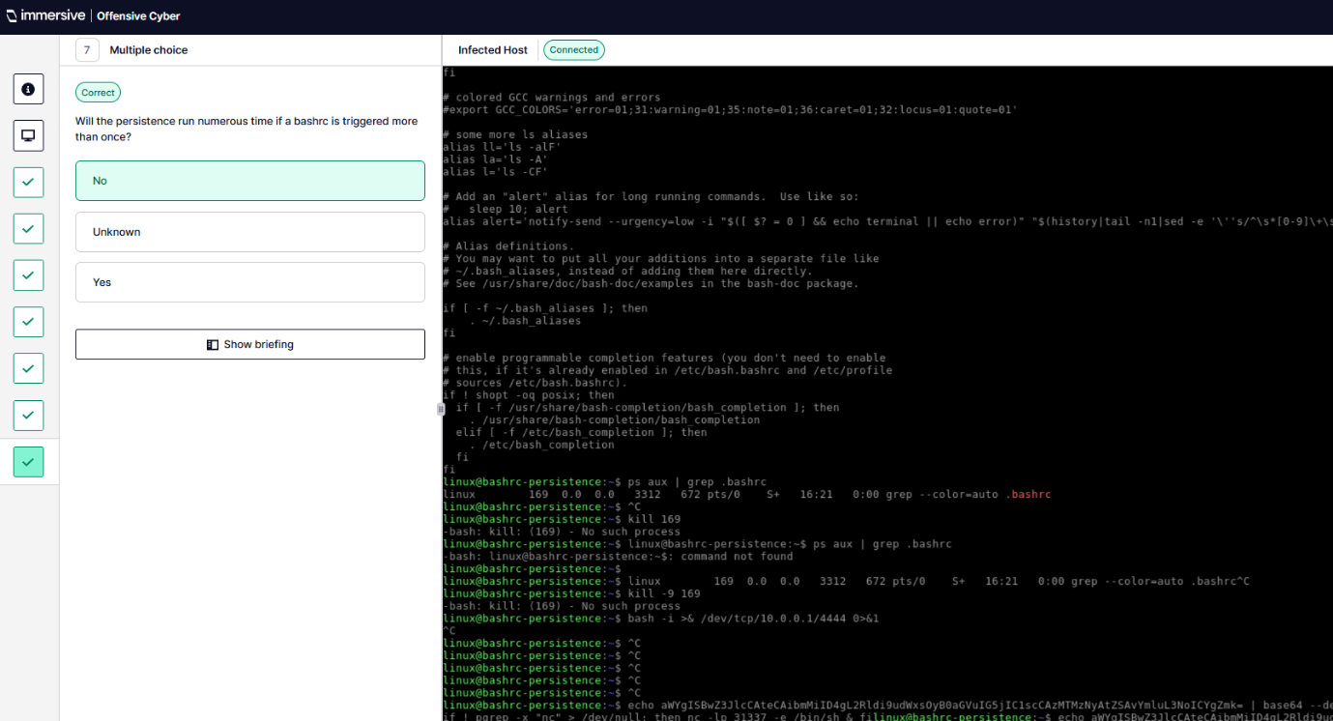
- Accessibility Features.
Q1 – Find the magnifier binary in System32.
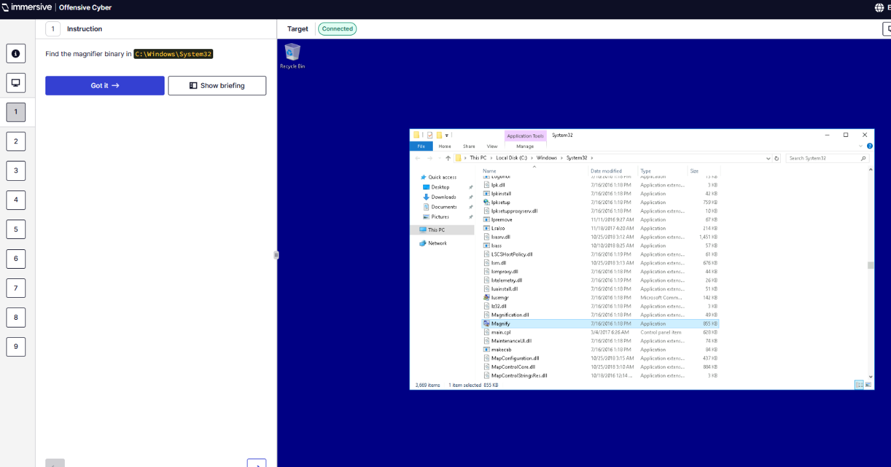
Q2 – What is the filename of the magnifier binary?
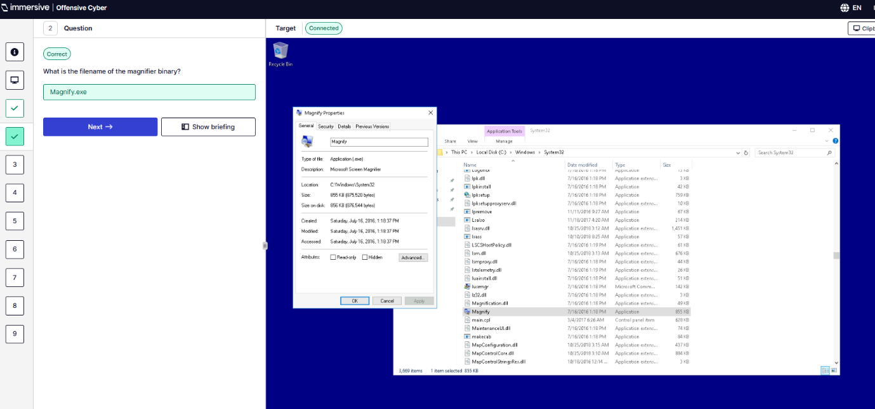
Q3 – What are the first five characters of the SHA256 hash?
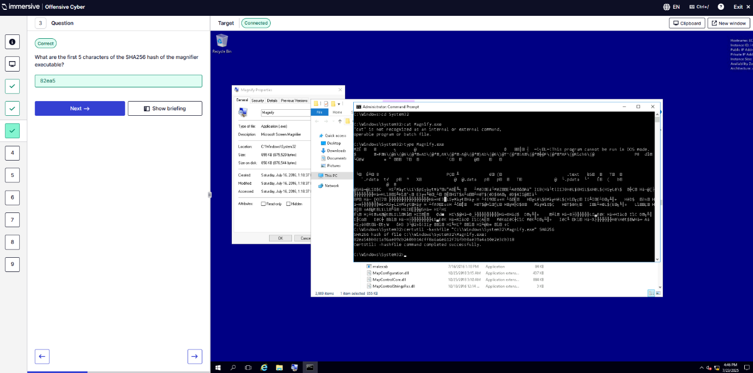
Q4 – What is the default owner of the legitimate magnifier binary?
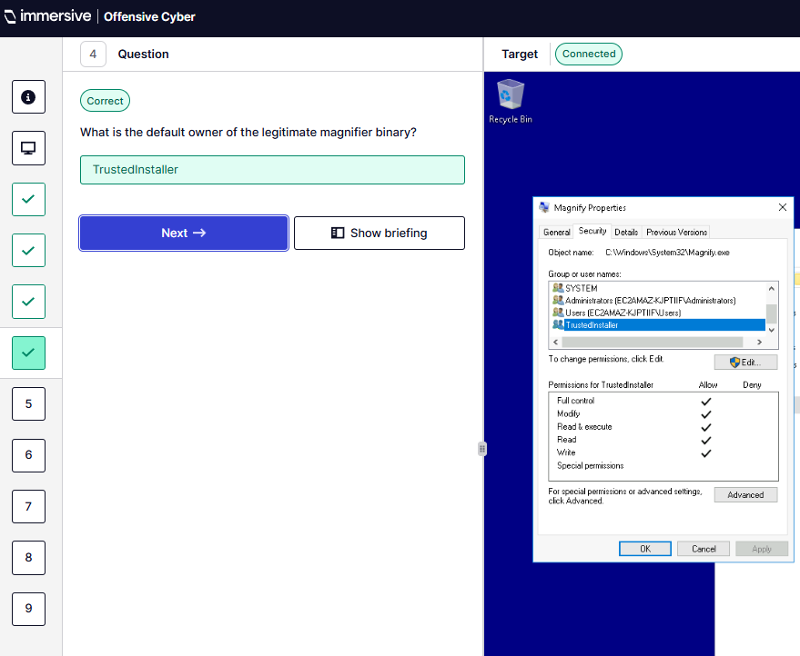
Q5 – Take ownership of magnifier binary and overwrite with cmd.exe.
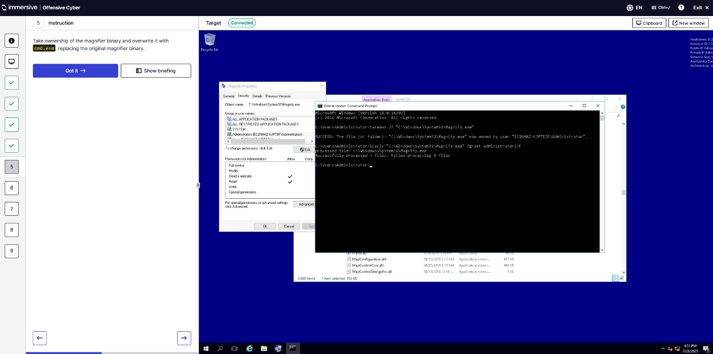
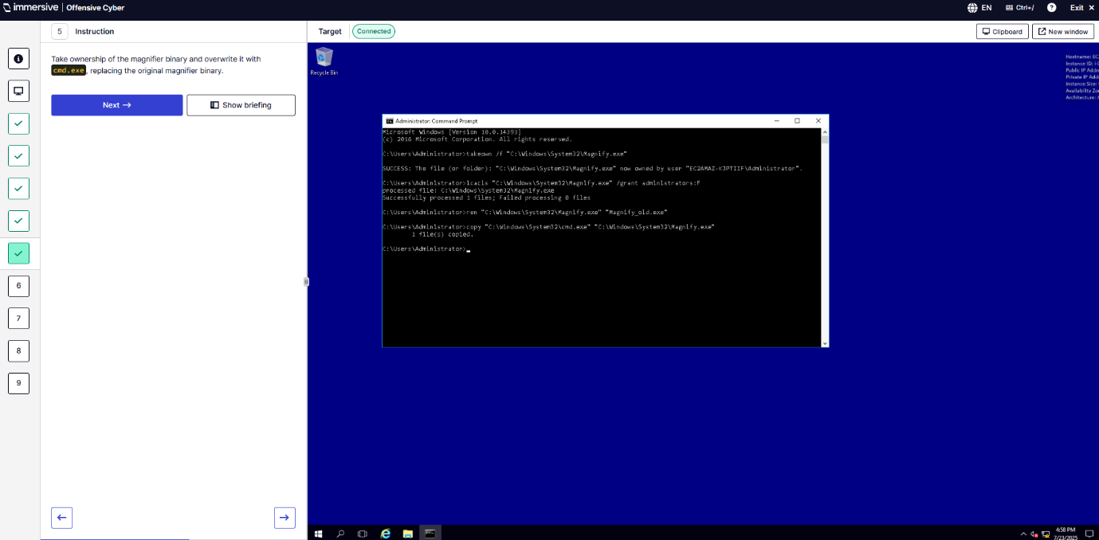
Q6 – Lock the workstation and trigger the shell to spawn.
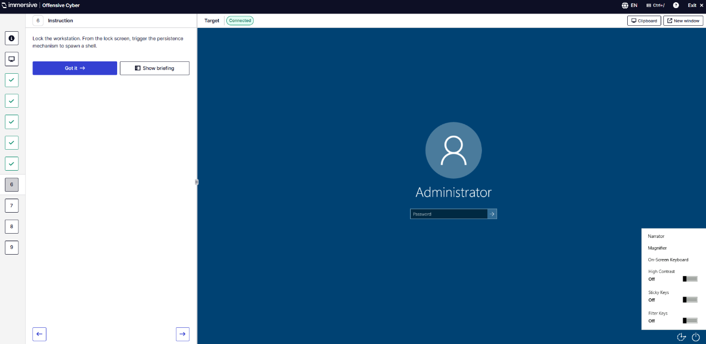
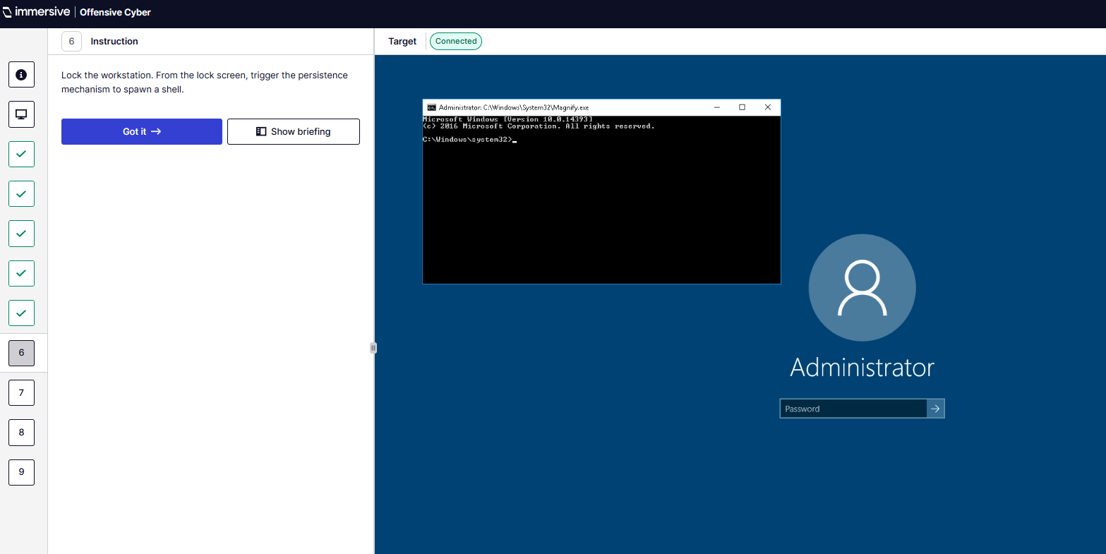
Q7 – When triggering the CMD from lockscreen what is the whoami command?
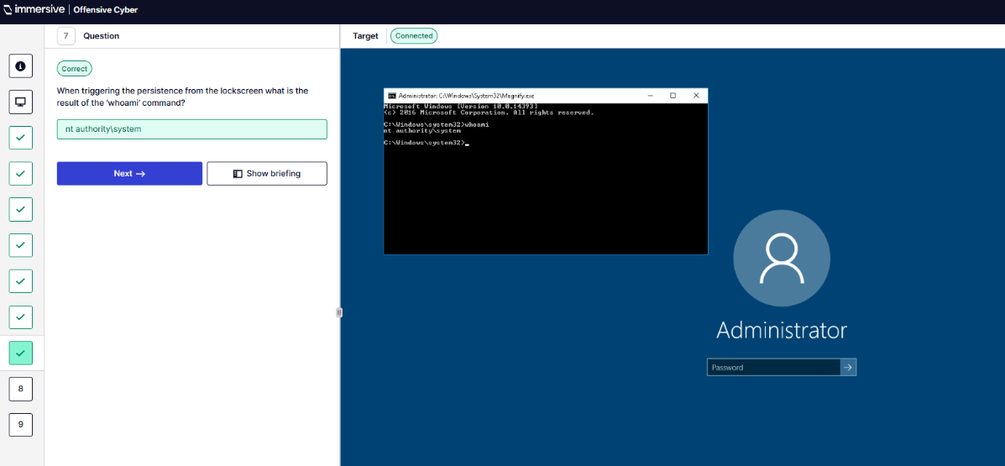
Q8 – Use cmd to read the token.
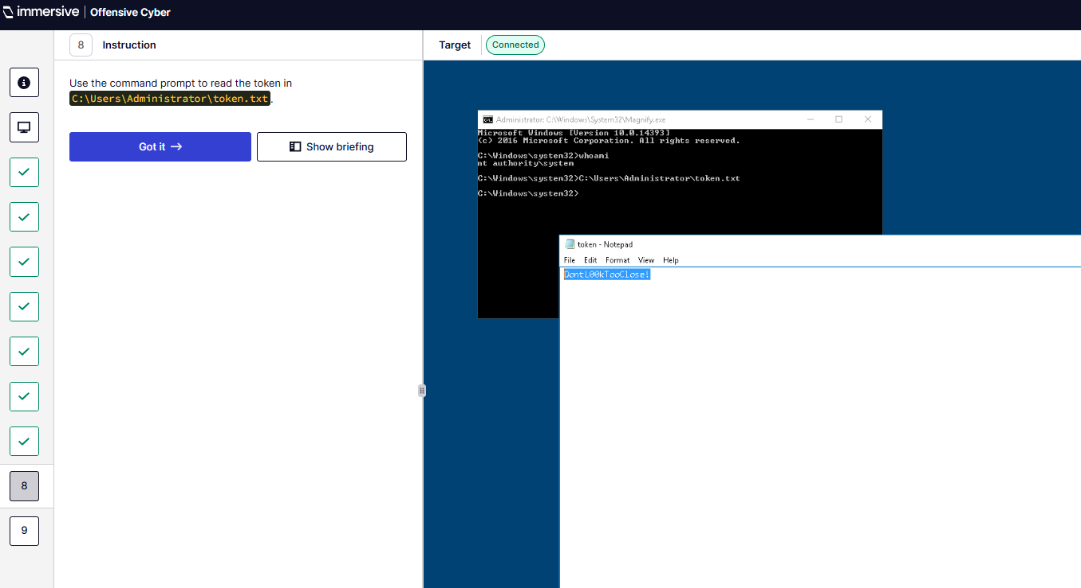
Q9 – What is the token?
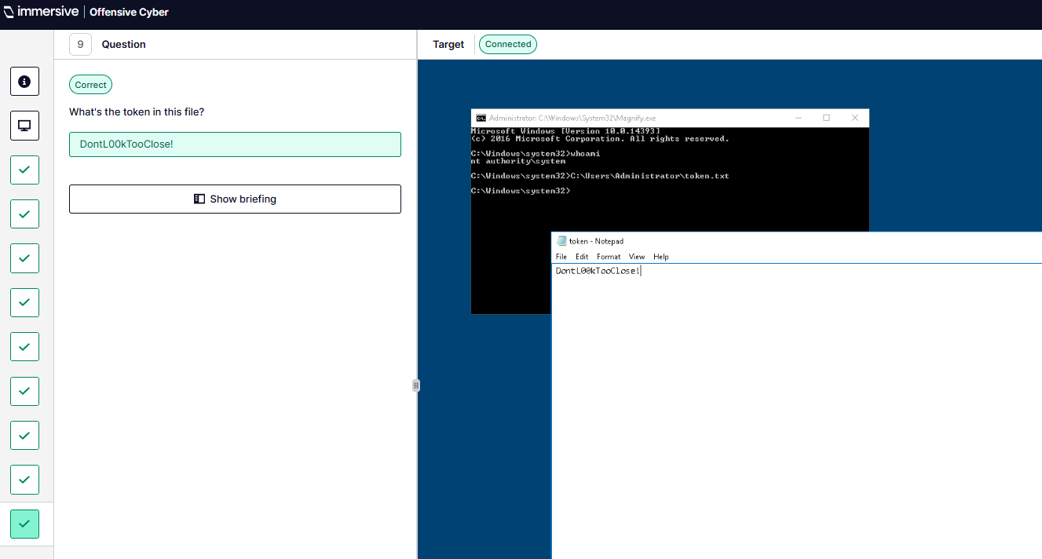
- Image File Execution Options (IFEO) Injection.
Q1 – Analyse the notepad.exe binary.
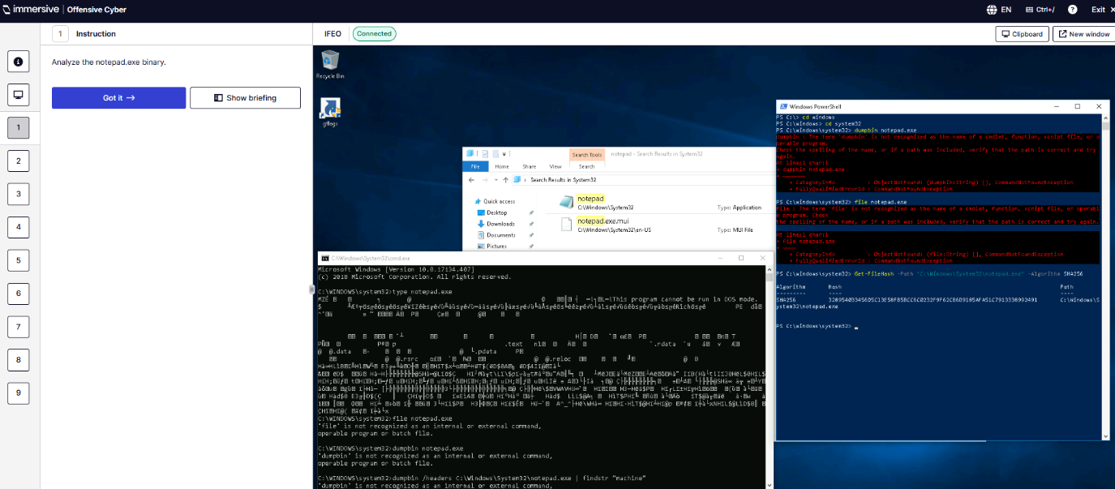
Q2 – What are the first five characters of the notepad.exe binary file SHA256 hash?
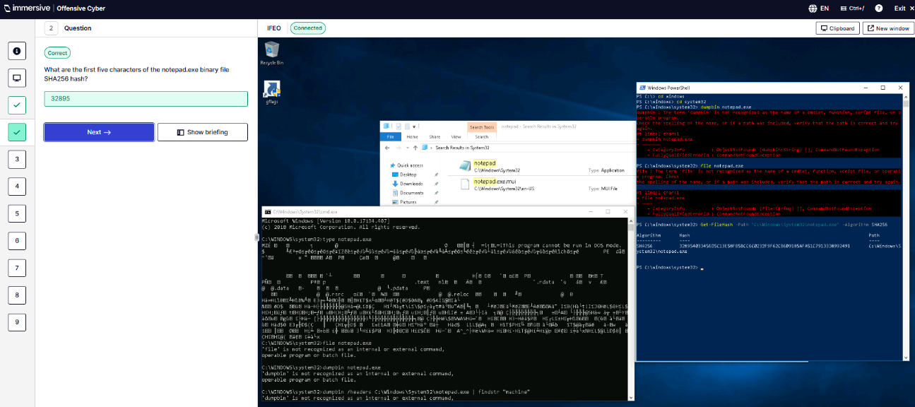
Q3 – Locate the IFEO registry key
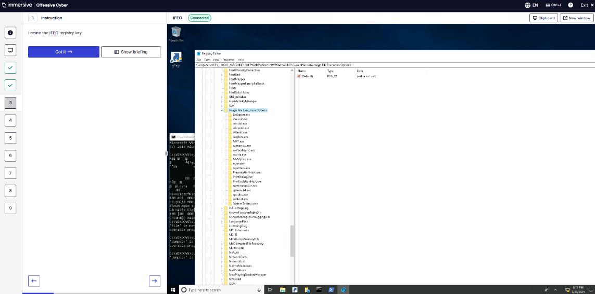
Q4 – Create an IFEO registry key for notepad.exe
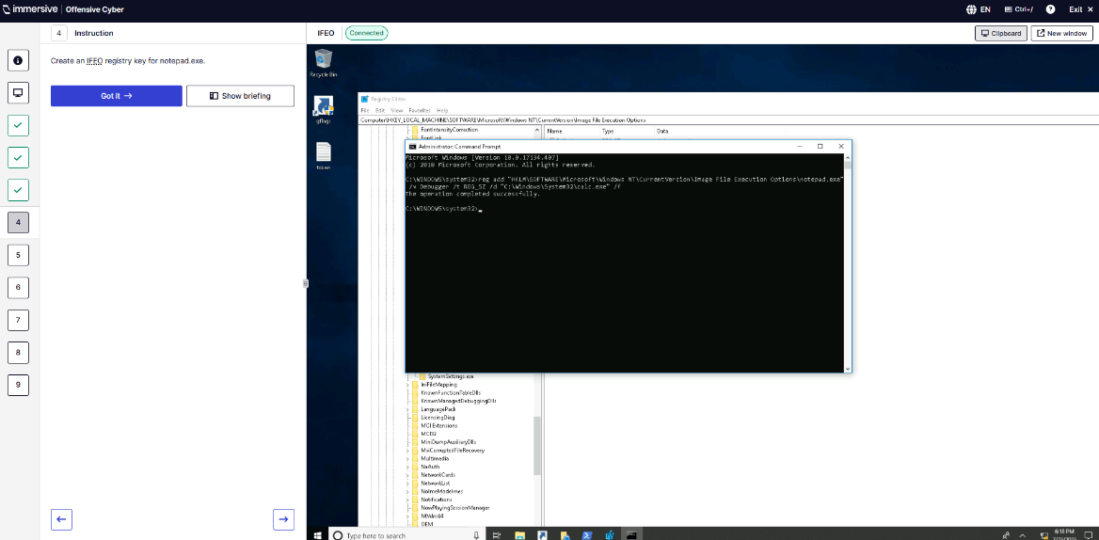
Q5 – What is the path of the IFEO registry key you created for notepad.exe
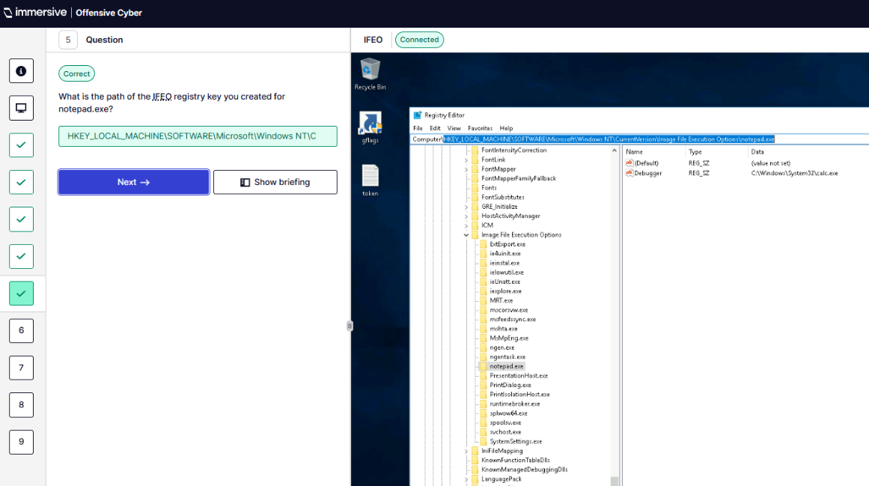
Q6 – Set notepads.exe Debugger to be calc.exe
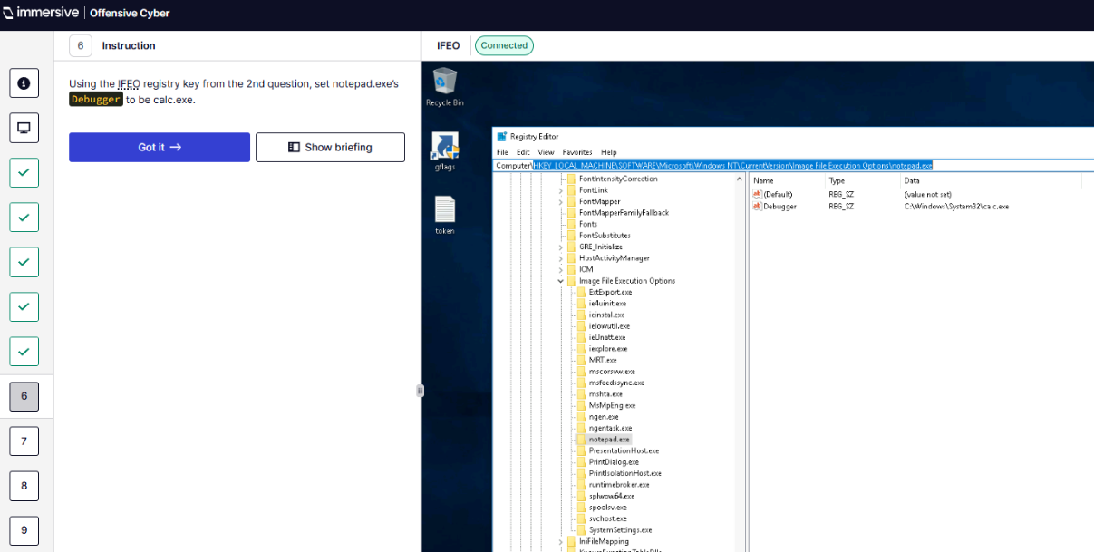
Q7 – What is the name of the registry value that is used for IFEO injection?
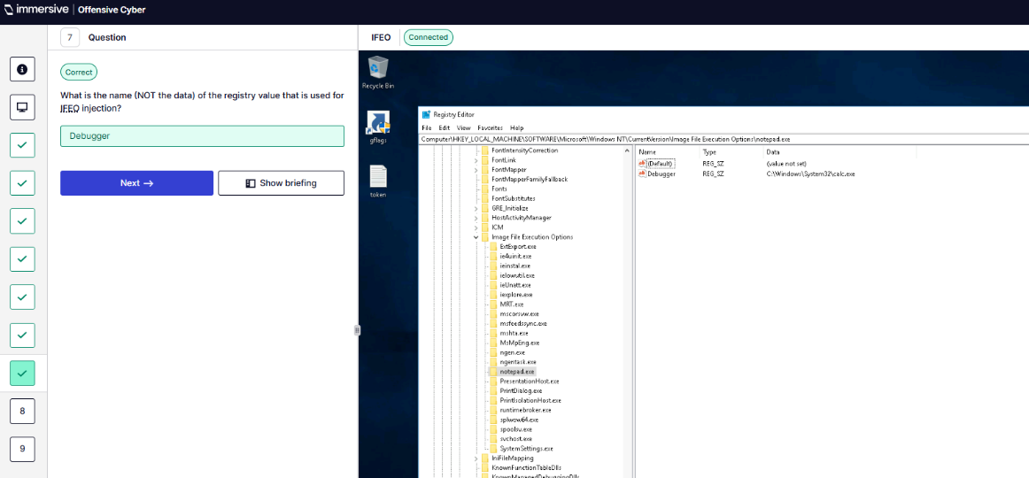
Q8 – Locate token.
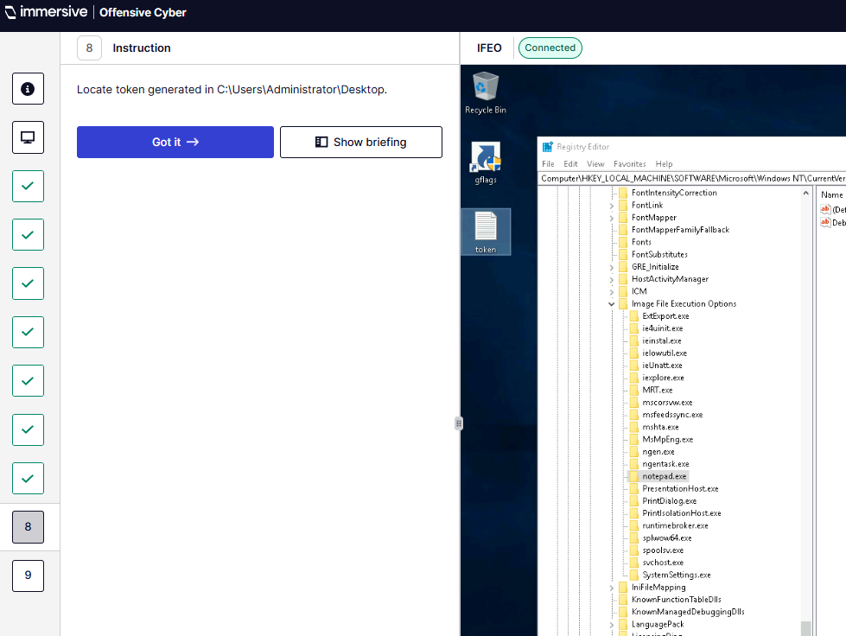
Q9 – What is the token generated?
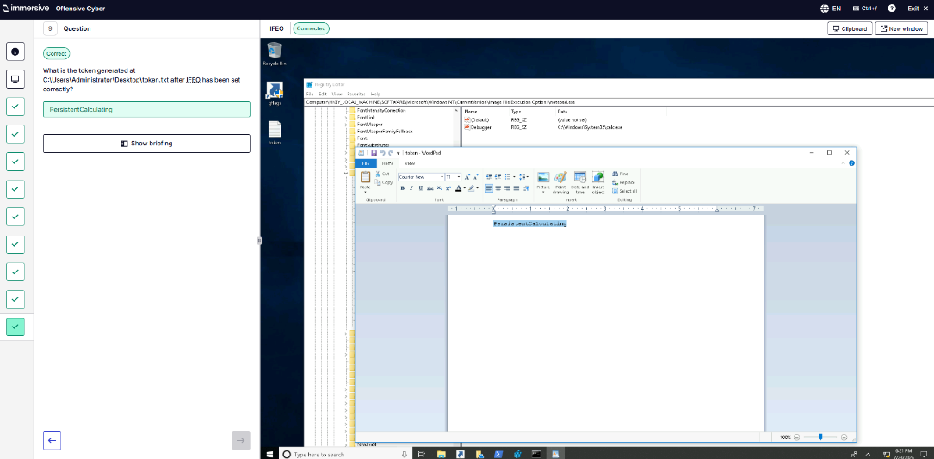
- Persistence via Accessibility Features.
Q1 – Figure out which feature has been tampered with.
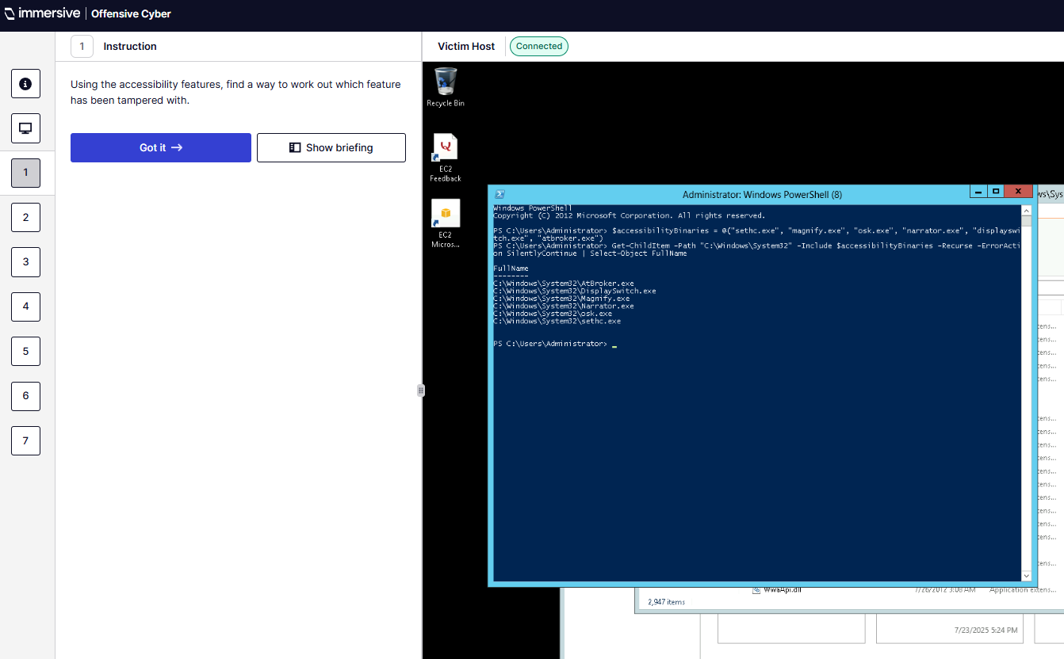
Q2 – Who is the default owner of the listed accessibility feature binaries?
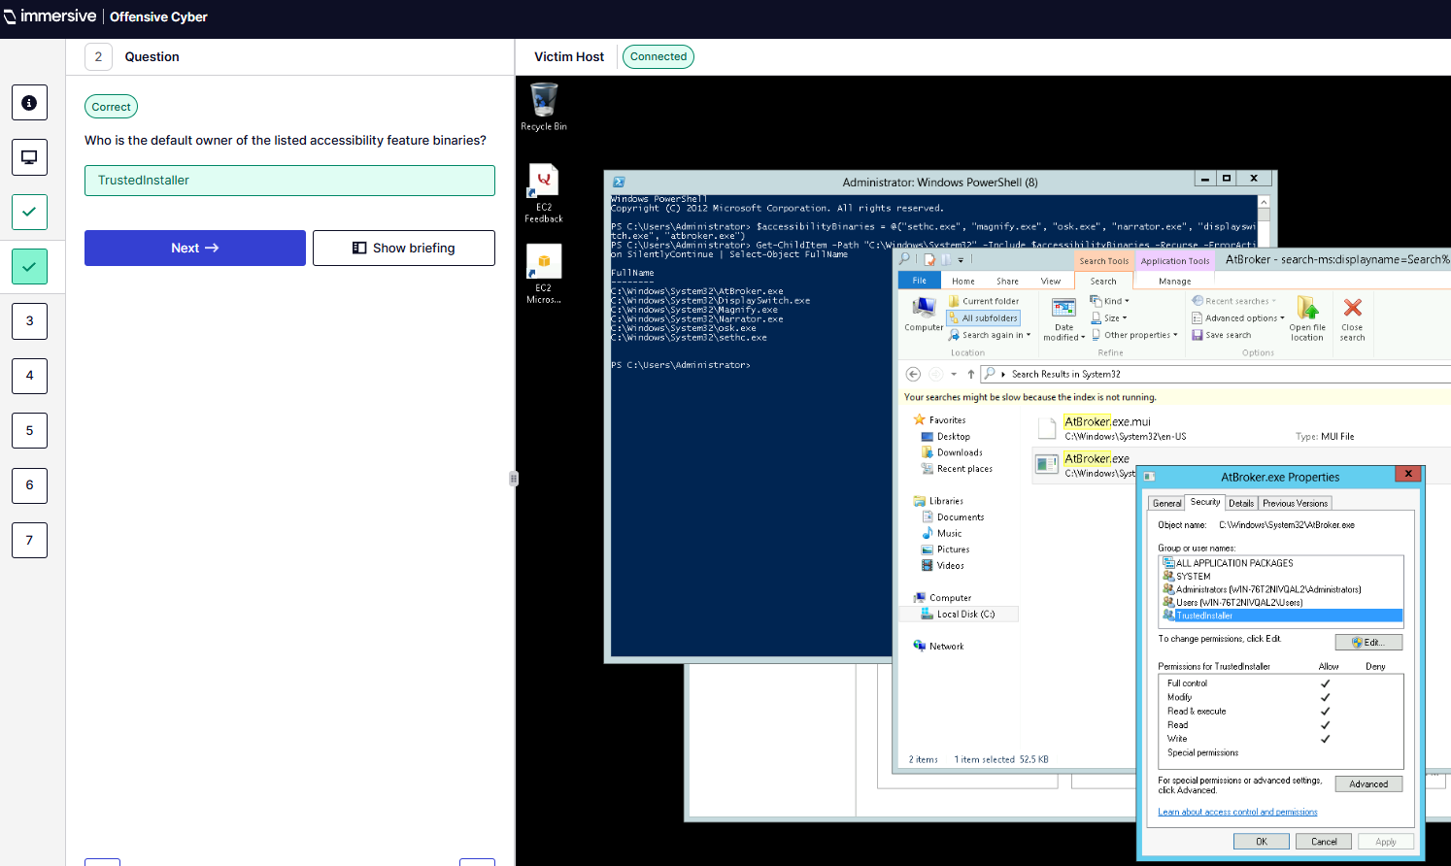
Q3 – Which accessibility feature has been tampered with?
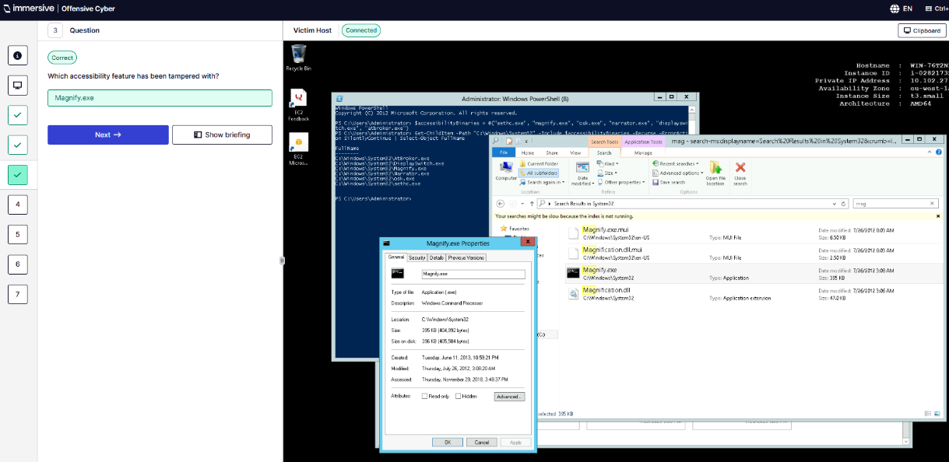
Q4 – Interrogate the tampered file.
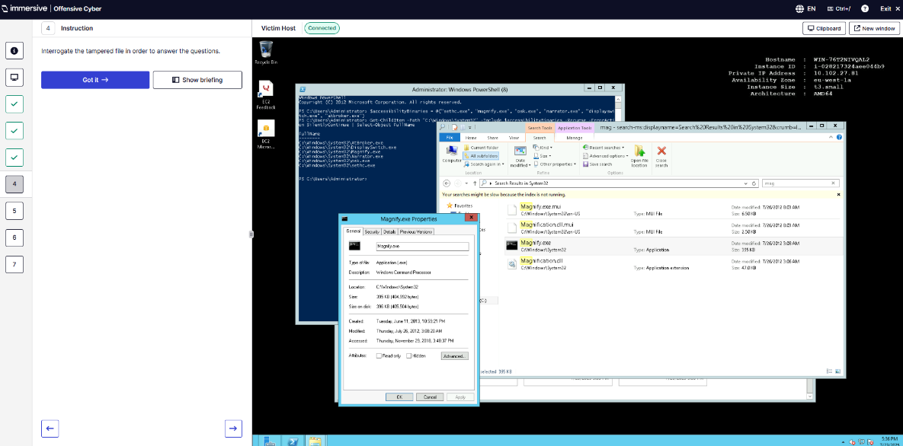
Q5 – What is the original file name of the new binary that replaced the accessibility feature?
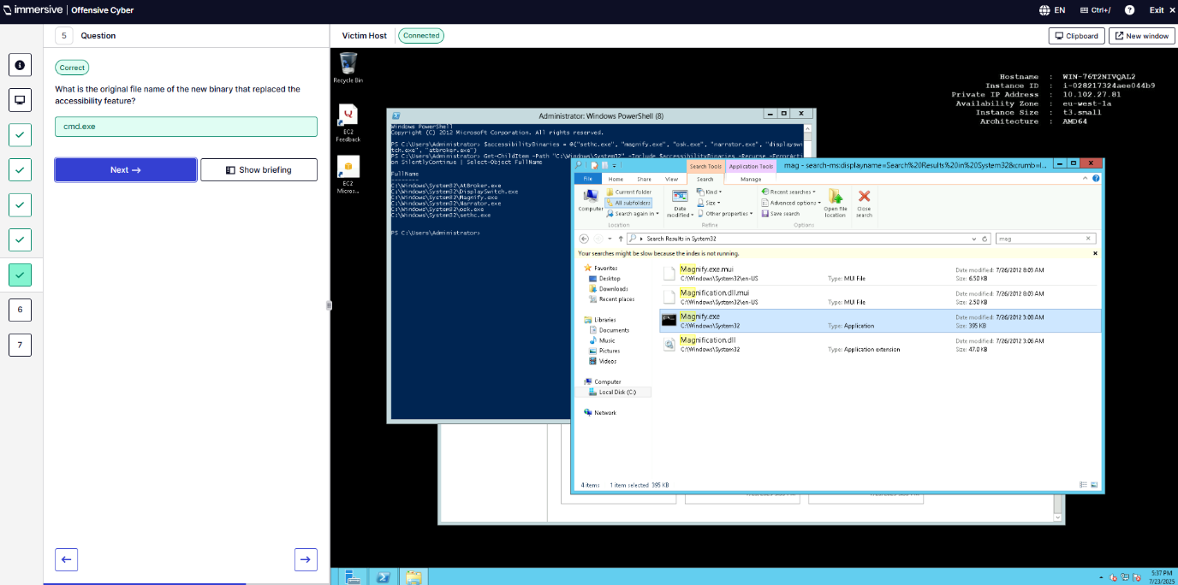
Q6 – Lock the workstation and trigger the persistence.
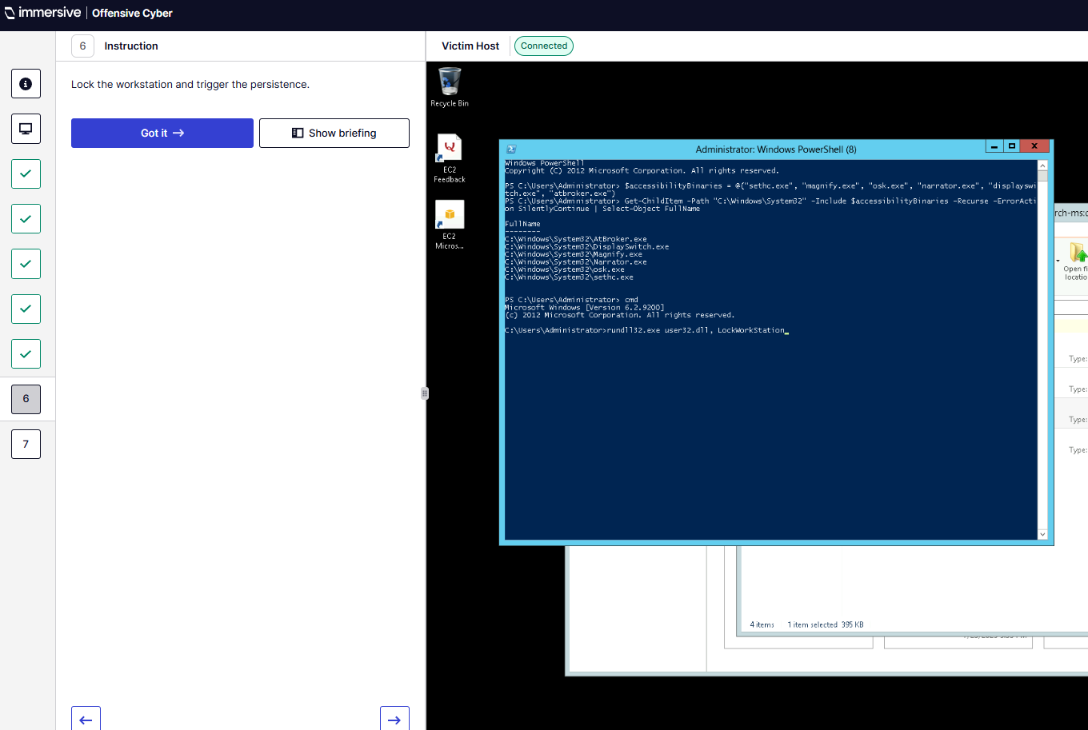
Q7 – What user account does the accessibility feature grant to the attacker from lockscreen?
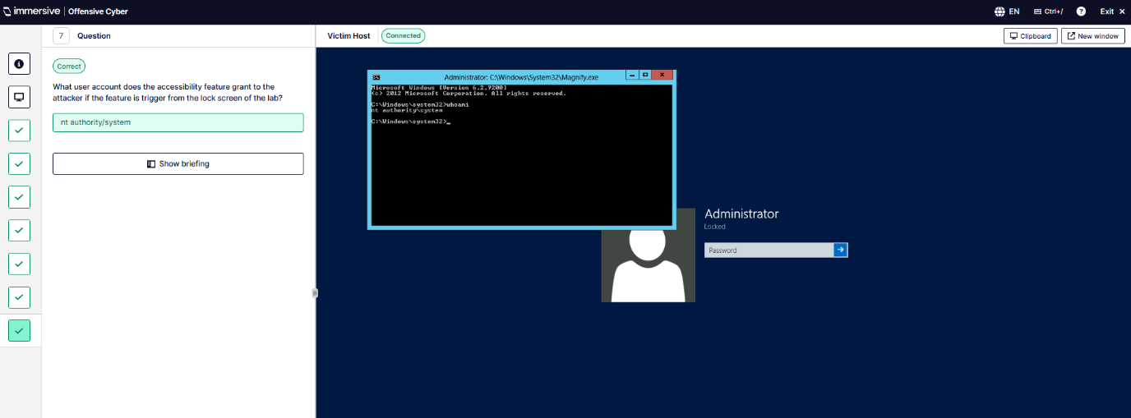
- Windows Services.
Q1 – Identify the suspicious process.
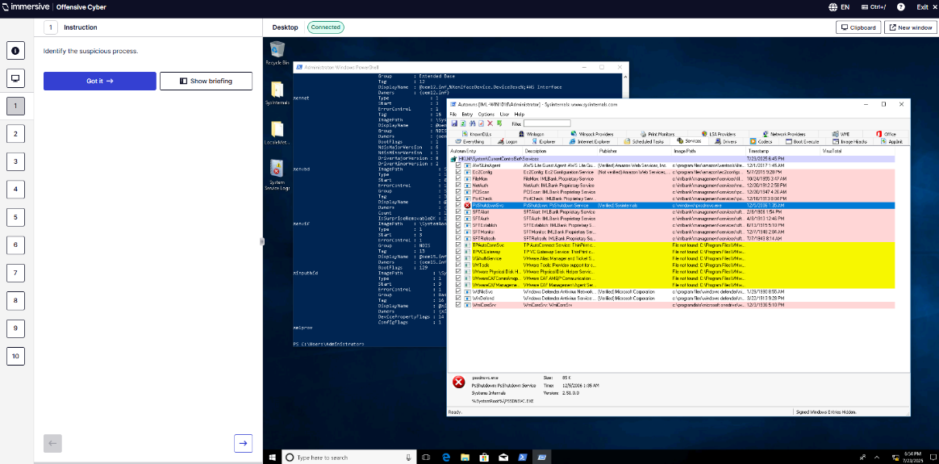
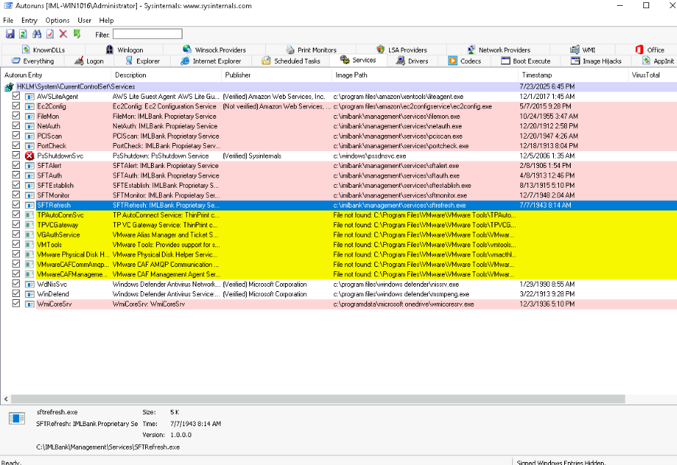
Q2 – Use logs and Autoruns to identify the source of the process.
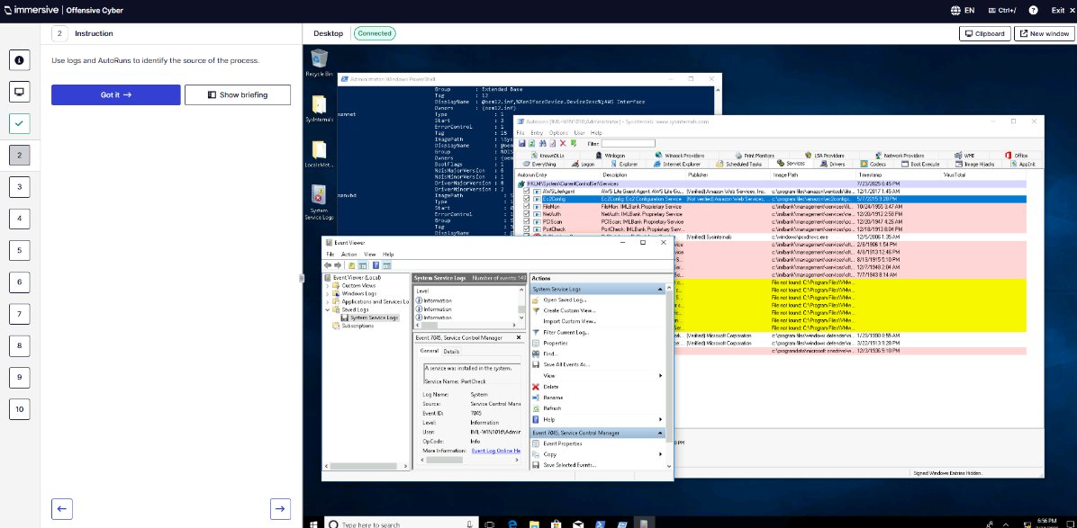
Q3 – Locate the suspicious executable started by the service.
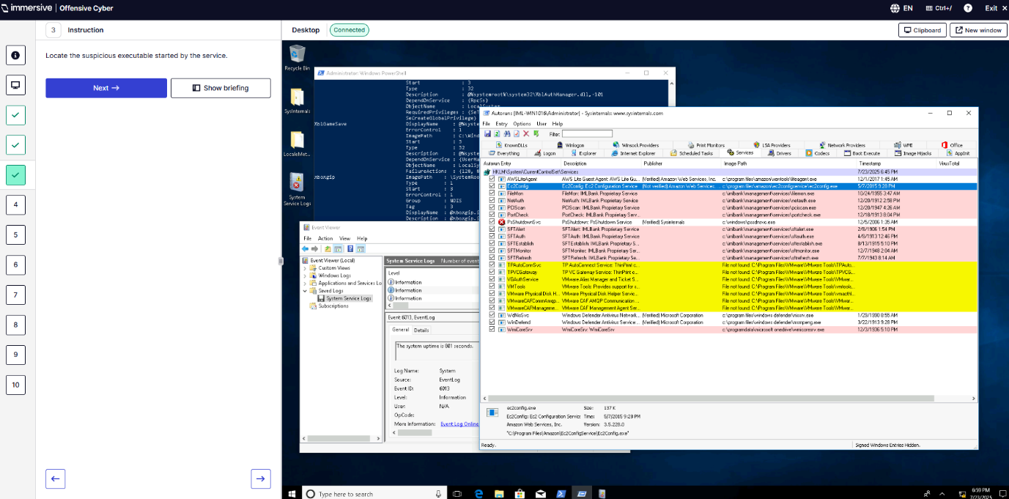
Q4 – What accounts do services not run under?
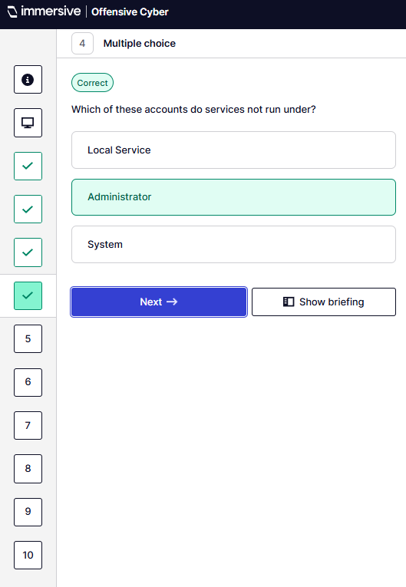
Q5 – What EventID is used to signify the creation of a new service?
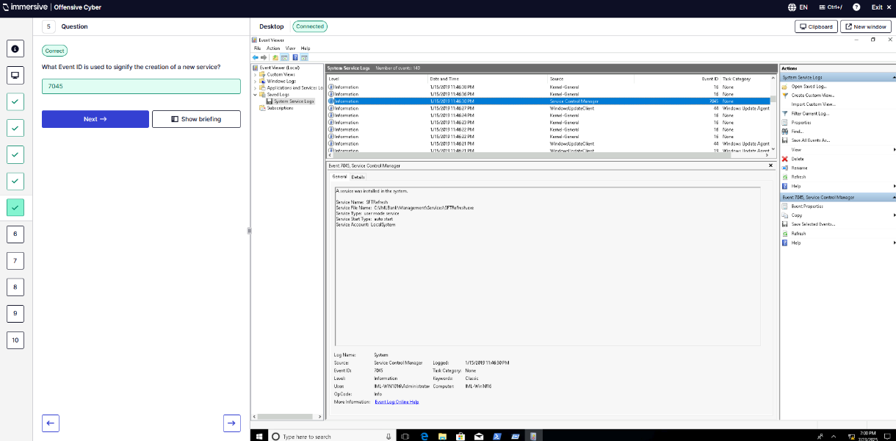
Q6 – What is the path of the registry tree that stores details about installed services?
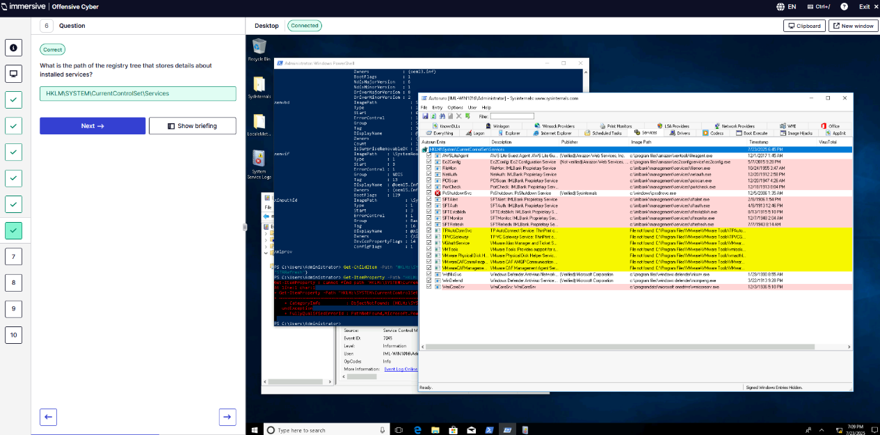
Q7 – What is the name of the unauthorized service?
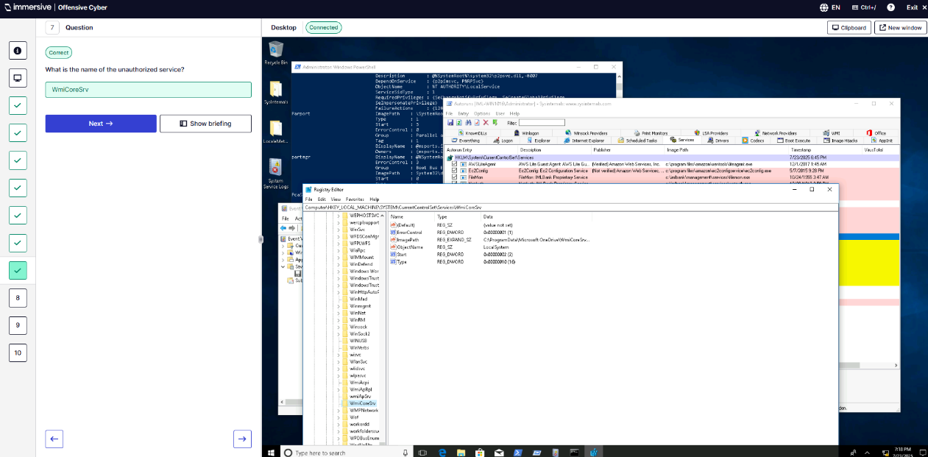
Q8 – When was the unauthorized service installed?
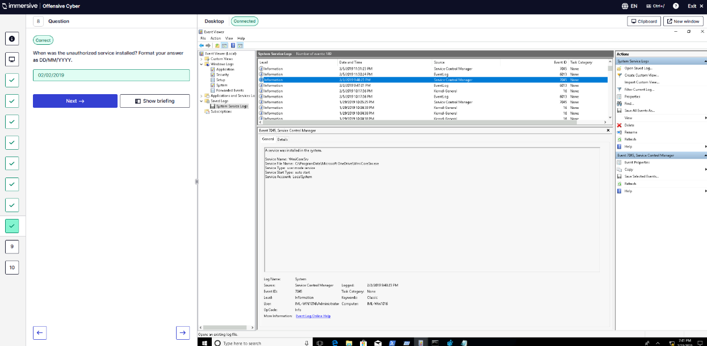
Q9 – What is the file path of the unauthorised service’s executable?
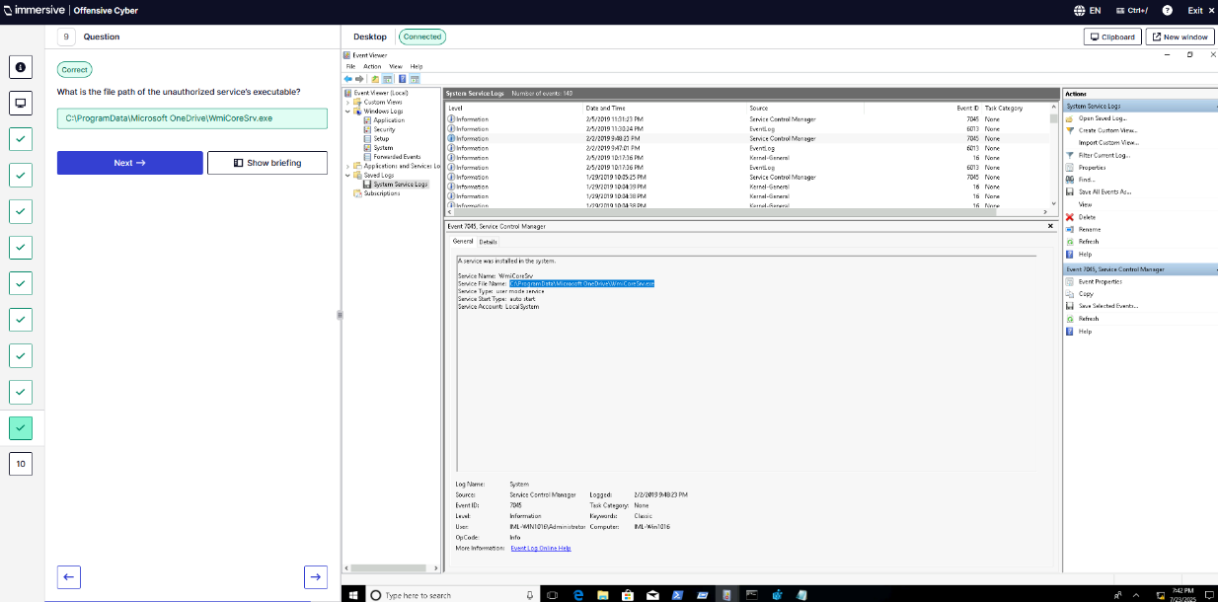
Q10 – What is the file path of the suspicious executable?
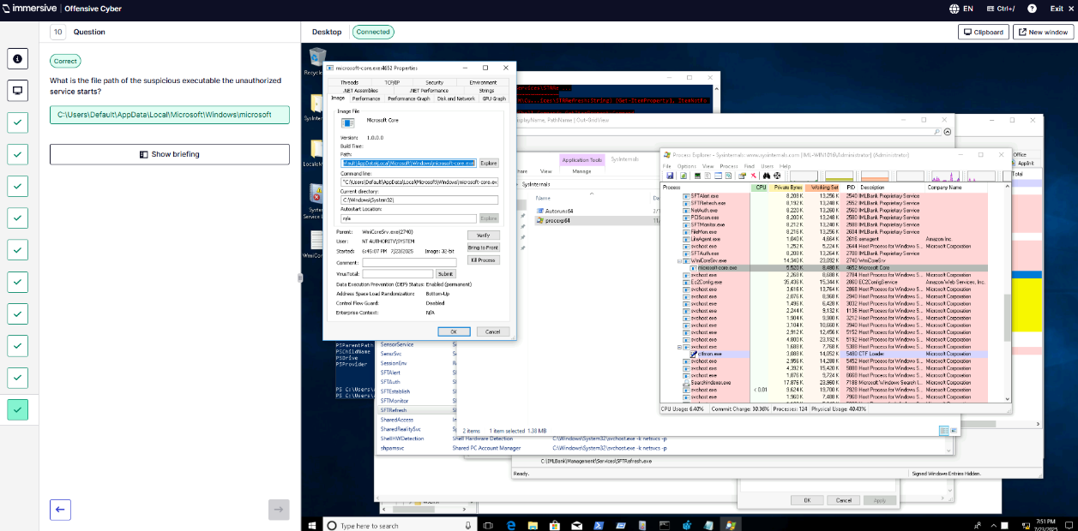
”(Immersive Labs Persistence, 2025).
- IoT & Embedded Devices. “(ImmersiveLabs, 2025b)
  - Supply Chain Hardware Tampering.
Q1 – Use IPMItool against the target server.
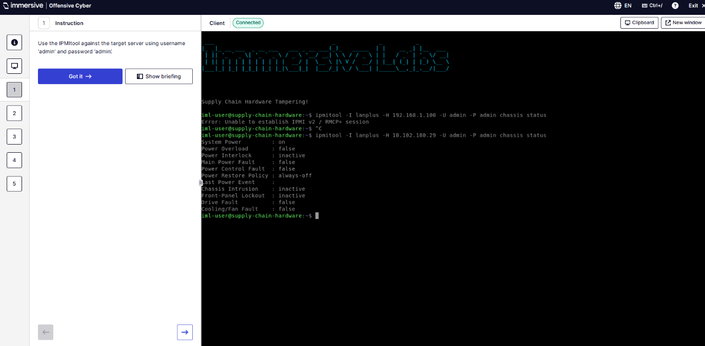
Q2 – What is the current System Power of the chassis?
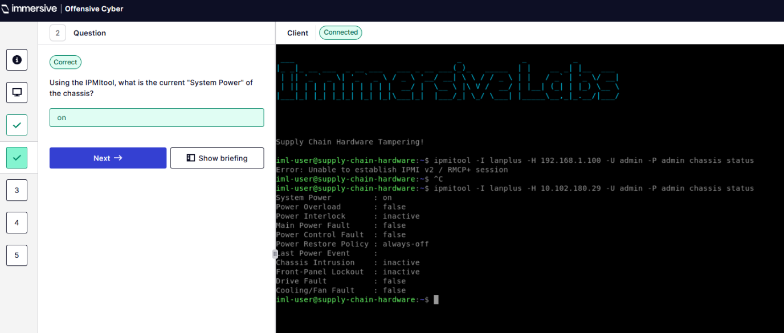
Q3 – What is the value of the Firmware revision for the management controller?
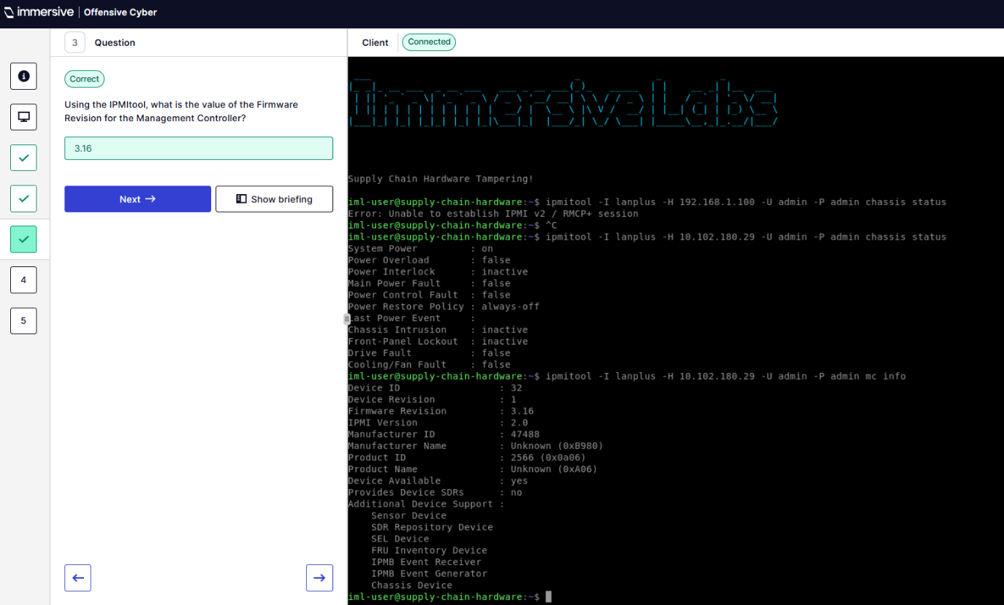
Q4 – How many sensors are being monitored? Answer was 13 couldn’t grab a screenshot as I did this question after Q5.
Q5 – How many boot devices are available?
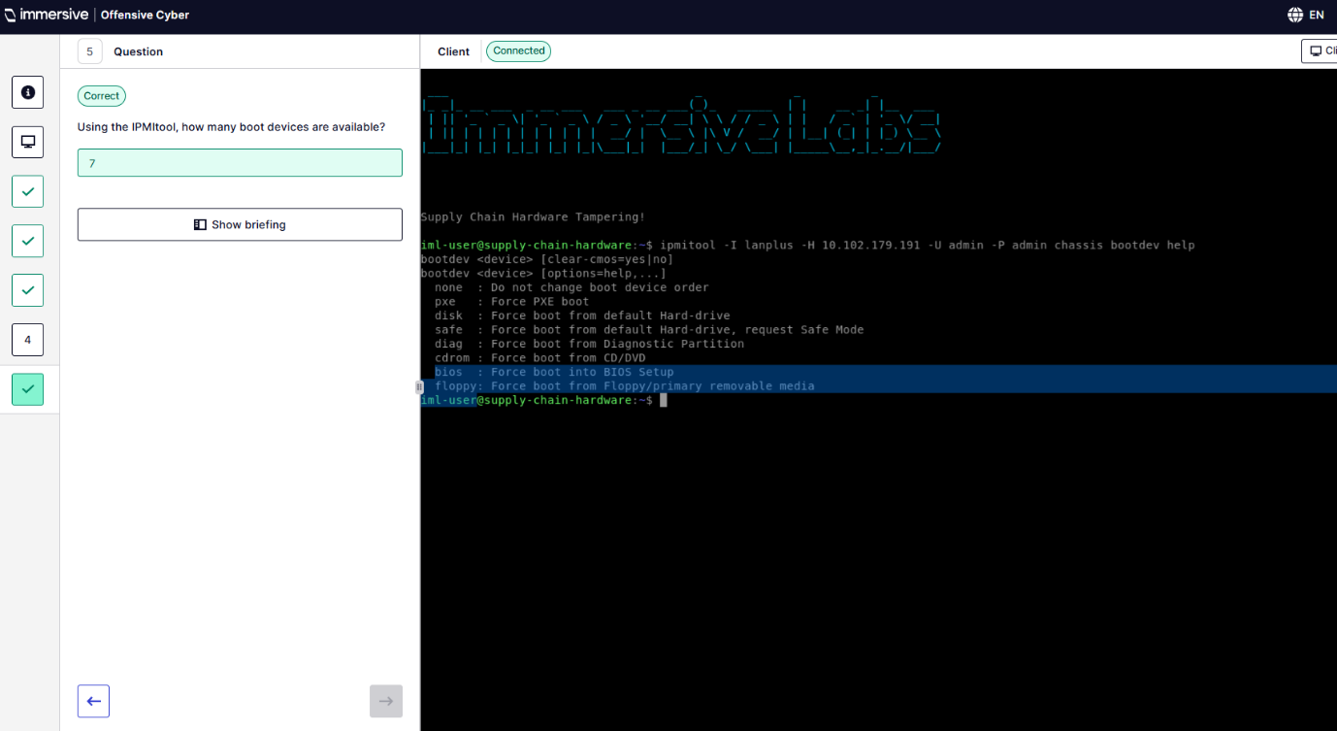
”(ImmersiveLabs, 2025b)

Critical analysis and red team reflections
- Introduction to pen-testing
  - This was all theoretical multiple-choice question labs that required no practical skills
  - Theory questions, topics/basis link.
  - This was the most basic quiz style considering the word count and the number of lab exercises. Did not include screenshots!
- OSINT
  - These labs showcased open-source intelligence (OSINT) which mainly focuses on gaining reconnaissance, digital footprint analysis and using them to weaponize collected data.
  - The only challenging I found to be the Boarding Pass lab, due to the attention of detail needed to parse through the details of information.
  - Bookmark!
- SQL Injection Basics
  - The SQL Injection labs gave me the basic practical knowledge of queries to inject; simple injection syntax, UNION based attacks, and filter evasion, etc. This lab highlighted how much impact user input can have on hidden data appearing or filters being bypassed. SQL injection is still a prevalent issue even though it’s a very old exploit; due to lack of knowledge setting up query sanitisers and procedures.
  - SQL basics are necessary base knowledge for any computer scientist, and Injection knowledge for any penetration-tester. Not challenging just, the basics of how to inject malicious queries into insecure template applications.
  - Bookmark!
- Cross-Site Scripting
  - This whole lab contained a quite a few time-consuming labs and showcased a lot of interesting XSS vulnerabilities in web applications and successfully test and exploit them?
  - XSS vulnerabilities that were exploited involved finding hidden tokens only accessible by exploiting the various vulnerabilities inside the template victim application usually triggering a JavaScript alert containing the answer/token.
  - Bookmark!
- Infrastructure Hacking
  - Using techniques like Sudo caching, SSL scanning, and SimpleHTTPServer. These labs are a practical approach to taking advantage of vulnerabilities in services running on hosts or networks. In-order to access unauthorised information that should be private.
  - This included finding hidden token found via CLIs and interpreting data from targets using the required technique for each exercise. Requires knowledge of Netcat, SSH, Payloads, Logs, Credentials and Servers.
  - Bookmark!
- Windows Sysinternal
  - Working with Sysinternal tools like Autoruns, RegEdit, ProcMon, and Sysmon; provided mostly practical labs that identified processes and registry changes which are useful in both offensive and defensive security.
  - This used mainly Blue Team investigation tools, though useful information for Red Team activities. All tools used are: SysMon, Autoruns, ProcMon, Process Explorer, AccessChk, PsExec, Strings, and Sigcheck. Examples are linked below.
  - Bookmark!
- MITRE ATT&CK
  - MITRE ATT&CK is a matrix of tactics and techniques used by attackers. These labs contained theory labs the “practical” labs I either did not have access to or where just mini-game quizzes testing the knowledge of MITRE tactics.
  - These were not very difficult or time consuming, felt like a bingo quiz of basic cyber knowledge.
  - Bookmark!
- Introduction to web-app hacking
  - Contained in these labs are a load of popular web app hacking techniques and are all practical. Using Kali Linux VMs to attack a mock website using tools and techniques such as OWASP ZAP, Apache, Command injection, Client side-controls, and Server Side Includes.
  - Every single lab in this required a little bit more setup and processes to access what the labs wanted to test my knowledge in and manged to hide the final answer behind many simple layers designed to help practice web-based hacking techniques.
  - Bookmark!
- Persistence
  - Labs based on maintaining persistence of and after initial access these included techniques such as COM hijacking, IFEO injection, and Windows logon manipulation via accessibility features. These were enjoyable practical exercises that utilises Command line and/or PowerShell to maintain access.
  - This required executing malware, manipulating windows, recognising malicious registry, manipulating accessibility features, and finding data or keeping access through a locked machine.
  - Bookmark!
- IoT & Embedded Devices
  - This covers Internet of Things and was mostly quick simple theory labs except for Supply Chain Hardware which was a practical lab using their command-line interface (CLI) client to use IMPI tool, using provided default admin credentials to query devices connected supply chain hardware information and data.
  - The theory labs were very simple and easy to work through required little knowledge as even if you get them wrong you can brute force the quiz since you have unlimited attempts. I did not bother including screenshots of them and instead decided to include keywords that the two theory-based quizzes answers were based off. Most likely able to get all questions correct just off the keywords provided for the theory questions.
  - Theory questions, topics/basis link.
  - Only practical lab evidence link.

Conclusion
In conclusion, the variety of Immersive Labs topics promote a well-rounded red team perspective by covering the full range from information gathering to sophisticated offensive simulation.
OSINT lab sets an aspect of reconnaissance to favourably identify and analyse open-source information that leads to target selection and strategies. The practical exploits on SQL injection and cross site scripting are intended to cultivate fundamental vulnerability comprehension and lateral pivoting methodology; and the DOM based XSS lab took practitioners to a whole new level by devising methods to exploit client-based document object models for malicious purposes (Gupta, Govil and Singh, 2014).
The infrastructure hacking modules build on this skill set by introducing network and systems compromise concepts that span beyond high level applications to a strategy that necessitates deep penetration of complex environments (Browning et al., 2005b).
Windows Sysinternals investigations and focused tasks, especially targeted at advanced IFEO injection scenarios, increase understanding of process manipulation and living off the land with escalation privileges on a host platform.
The adoption of the MITRE ATT&CK framework provides a formalized lens of visually categorizing and aligning tactics and techniques and relating new knowledge to broader patterns of adversarial behaviour so that practical hands-on discoveries find purpose within the strategic threat model.
Web application hacking exercises such as XSLT command injection add more variety into the exploits and allow for complexity based on interacting multiple technologies in the attack pathways. Persistence challenges train practitioners to maintain access using an anonymous backdoor and continuing to evade the organization in a reliable manner.
Similarly, IoT and embedded device labs extend into unique architecture, firmware level exploits, further building the red team experience and showing that red team thinking can be applied in diverse situations. The curriculum was designed to demonstrate to practitioners how the full series of educational experiences from OSINT reconnaissance exercises, through intermediate exploitation exercises, through adversary simulation and constructing long-term persistent methods differentiates each sub-field in situating red team perspectives (Ahamed and Rajan, 2016). There is a learning pattern for the most difficult technical and conceptually demanding labs (for example - DOM based XSS, IFEO injection, XSLT command injection), which exhibit knowledge of persistence and cross-site scripting exploits.
Overall, there is a developmental process whereby the constructs (theory) and basic exploits become established to support complex adversarial operations while understanding a fully matured red team mindset. Importantly, the labs were structured to ensure that learners progressed from singular exploits against targets to complex attack chains while comprehending defensive countermeasures signalling an overall adversary mindset that matured into a more flexible attribution of the adversary across physical and digital spaces (Browning et al., 2005).

References
Ahamed, J. and Rajan, A.V., 2016. Internet of Things (IoT): Application systems and security vulnerabilities [Online]. 2016 5th International Conference on Electronic Devices, Systems and Applications (ICEDSA), 1(1). Available from: https://doi.org/10.1109/icedsa.2016.7818534 [Accessed 30 July 2025].
Browning, B., Bruce, J., Bowling, M. and Veloso, M., 2005a. STP: Skills, tactics, and plays for multi-robot control in adversarial environments [Online]. Proceedings of the Institution of Mechanical Engineers, Part I: Journal of Systems and Control Engineering, 219(1), pp.33–52. Available from: https://doi.org/10.1243/095965105x9470 [Accessed 30 July 2025].
Browning, B., Bruce, J., Bowling, M. and Veloso, M., 2005b. STP: Skills, tactics, and plays for multi-robot control in adversarial environments [Online]. Proceedings of the Institution of Mechanical Engineers, Part I: Journal of Systems and Control Engineering, 219(1), pp.33–52. Available from: https://doi.org/10.1243/095965105x9470 [Accessed 30 July 2025].
Gupta, M.K., Govil, M.C. and Singh, G., 2014. Static analysis approaches to detect SQL injection and cross site scripting vulnerabilities in web applications: A survey [Online]. IEEE Xplore. pp.1–5. Available from: https://doi.org/10.1109/ICRAIE.2014.6909173 [Accessed 30 July 2025].
Immersive Labs Persistence, 2025. Immersive [Online]. Immersivelabs.online. Available from: https://immersivelabs.online/labs/tactics-persistence/category/offensive/series/persistence [Accessed 25 July 2025].
ImmersiveLabs, 2025a. Immersive [Online]. Immersivelabs.online. Available from: https://immersivelabs.online/labs/introduction-to-penetration-testing-infrastructure/category/offensive/series/introduction-to-penetration-testing [Accessed 24 July 2025].
ImmersiveLabs, 2025b. Immersive [Online]. Immersivelabs.online. Available from: https://immersivelabs.online/labs/what-are-iot-and-cyber/category/offensive/series/iot-embedded [Accessed 24 July 2025].
ImmersiveLabs Infrastructure Hacking , 2025. Immersive [Online]. Immersivelabs.online. Available from: https://immersivelabs.online/labs/command-history/role/penetration-tester-beginner/series/service-exploitation [Accessed 25 July 2025].
ImmersiveLabs MITRE ATT&CK, 2025. Immersive [Online]. Immersivelabs.online. Available from: https://immersivelabs.online/labs/introduction-to-mitre-att-ck/category/offensive/series/mitre-att-ck [Accessed 25 July 2025].
ImmersiveLabs OSINT, 2025. Immersive [Online]. Immersivelabs.online. Available from: https://immersivelabs.online/v2/labs/cached-and-archived-websites/role/penetration-tester-beginner/series/cyber-investigator [Accessed 24 July 2025].
ImmersiveLabs SQL, 2025. Immersive [Online]. Immersivelabs.online. Available from: https://immersivelabs.online/labs/sqli-series-episode-1/category/offensive/series/sql-injection-basics [Accessed 25 July 2025].
ImmersiveLabs Sysinternals, 2025. Immersive [Online]. Immersivelabs.online. Available from: https://immersivelabs.online/labs/windows-sysinternals/role/infrastructure-pentester-intermediate/series/windows-sysinternals [Accessed 25 July 2025].
ImmersiveLabs Web App Hacking, 2025. Immersive [Online]. Immersivelabs.online. Available from: https://immersivelabs.online/v2/labs/mapping-web-applications/category/offensive/series/web-app-hacking [Accessed 25 July 2025].
ImmersiveLabs XSS, 2025. Immersive [Online]. Immersivelabs.online. Available from: https://immersivelabs.online/labs/cross-site-scripting-ep-1-what-is-cross-site-scripting/category/offensive/series/cross-site-scripting-xss [Accessed 25 July 2025].

